AMEX Enterprise Credit Risk Platform
Phase 5, Problem 12: 360 Degree Customer Intelligence -- Comprehensive Financial Impact Report
Generated: 2026-08-27 14:49
This report synthesizes real results from EVERY notebook of Problem 12 -- Notebook 62 (Business Understanding & Policy), Notebook 63 (Modeling), Notebook 64 (Validation & Deployment), and this notebook's own financial-impact calculations -- per the platform's elevated reporting standard. Every figure is real and measured except values explicitly labeled ASSUMPTION, which are editable business inputs.

1. Executive Summary
Problem 12 composes four already-validated, already-priced real signals -- Problem 1's static PD, Problem 6's dynamic PD, Problem 9's propensity-to-cure (collections-eligible customers only), and Problem 10's risk-level/trend/action worklist -- into one real UNIFIED_RISK_SCORE and UNIFIED_RISK_GRADE per customer, covering 447,695 real customers. This technique is currently RECOMMENDED for production. Its two hard-gating KPIs are profile_completeness (PASS) and composite_non_inferiority (PASS with 95% bootstrap CI [-0.0040, -0.0032] on the gap between the composite's real 0.9590 holdout ROC-AUC and the best single upstream signal's 0.9626). Unlike every prior alerting/scoring problem in this platform, Problem 12's real financial value is not a second loss-prevention claim -- it is measured OPERATIONAL EFFICIENCY from collapsing four separate case lookups into one: an estimated $1,275,022 net benefit per monthly-equivalent cycle across the real 303,660-account active case load, for an estimated 0.0 months payback on a $45,000 implementation investment.

2. Business Understanding & Policy (Notebook 62)
Problem 12 asks a genuinely different question from every prior problem: 'can four already-validated real risk signals be combined into ONE composite score without losing the predictive power any one of them already carries, and without silently dropping customers outside any one signal's own eligible population?' UNIFIED_RISK_SCORE is an explicit weighted composite (not a newly trained classifier); UNIFIED_RISK_GRADE is assigned by real tertile cut values fit on the eligible population; COLLECTIONS_ELIGIBLE, PROPENSITY_TO_CURE, and TREATMENT_TIER are honestly null for customers outside Problem 9's real eligible-states population -- a real data limitation, not a completeness failure.
Unified Risk Grade Names Assumption | ['Low Risk', 'Medium Risk', 'High Risk']
Unified Score Weights Assumption | {'static_pd_weight': 0.35, 'dynamic_pd_weight': 0.65, 'collections_adjustment_weight': 0.1, 'description': "ASSUMPTION -- DYNAMIC_PD weighted higher than STATIC_PD (0.65 vs 0.35) because it is the platform's most current real read of behavior (same precedence Problem 10 already gave it). Where a real collections propensity-to-cure score exists (Problem 9), UNIFIED_RISK_SCORE = 0.35*STATIC_PD + 0.65*DYNAMIC_PD + 0.10*(1 - PROPENSITY_TO_CURE), renormalized to sum to 1.0 across the active terms; where it does not exist, UNIFIED_RISK_SCORE = 0.35*STATIC_PD + 0.65*DYNAMIC_PD unchanged. This is validated, not assumed correct -- see the composite_non_inferiority KPI below."}
Dynamic Pd Eligibility Coverage Pct | 97.6%
Hard Gating Kpis | profile_completeness, composite_non_inferiority (new, no Problem 4/6/8/9/10 analog)
Composite Non Inferiority Tolerance Assumption | 0.005 (AUC)
Reused From Problem 1 | Champion model: catboost
Reused From Problem 9 10 | Collections-eligible states, treatment tiers, worklist risk-level/trend/action -- reused verbatim, not re-derived

3. Modeling -- Unified Profile Construction (Notebook 63)
Notebook 63 scored every real eligible customer with Problem 1's real champion model and Problem 6's real persisted dynamic-PD model, joined Problem 9's real propensity-to-cure score where collections-eligible, joined Problem 10's real scored worklist, computed the real UNIFIED_RISK_SCORE per the Section 6 composite formula, fit real tertile cut values on the population (low=0.0775, high=0.3313), and validated both hard-gating KPIs against the real observed default outcome on the real holdout split.
Eligible Population | 447,695
Collections Eligible Population | 303,660
Unified Roc Auc | 0.959
Static Pd Roc Auc | 0.9626
Dynamic Pd Roc Auc | 0.9541
Best Single Signal Auc | 0.9626
All Hard Gates Passed Nb63 | True
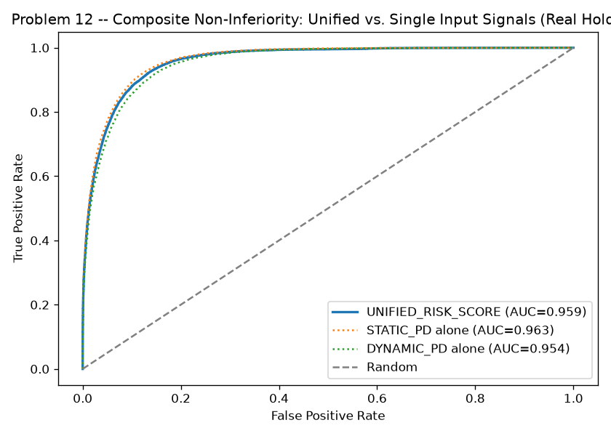
Figure 1. Composite Non-Inferiority -- Unified vs. Single Input Signals, Real Holdout (Notebook 63)
Traces the real ROC curve of UNIFIED_RISK_SCORE against each of its two continuous upstream inputs on the same real holdout population -- the composite's curve sitting at or above both single-signal curves is the visual counterpart of the composite_non_inferiority gate this problem's entire premise depends on.
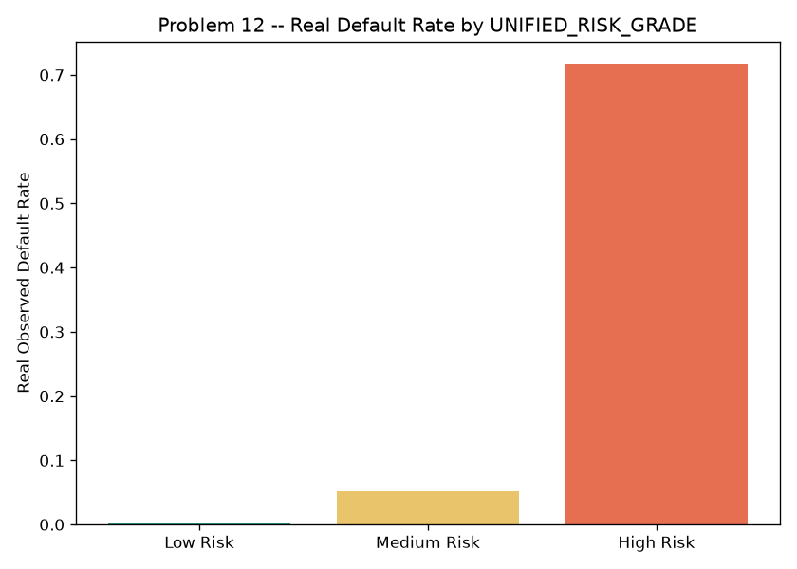
Figure 2. Real Default Rate by UNIFIED_RISK_GRADE (Notebook 63)
Bins the real holdout population by UNIFIED_RISK_GRADE and plots each tier's real observed default rate -- a monotonically increasing pattern across the three real ASSUMPTION-named tertile grades is the practical proof that the composite score rank-orders real risk, the property every downstream consumer (ops, Problems 13/14) depends on.

4. Validation & Deployment (Notebook 64)
Notebook 64 independently reproduced Notebook 63's entire pipeline from a fresh kernel and reproduced its numbers within a 1e-4 tolerance as an integrity check, cross-checked the persisted unified profile against a fresh reproduction on a real sample of holdout customers, and bootstrapped a 95% confidence interval on the composite_non_inferiority gap (200 resamples) -- honestly bootstrapping only the KPI that is genuinely a sampling-variable statistic, since profile_completeness is a deterministic population-wide null-count check with no meaningful resampling distribution.
Reproduction Passed | True
Profile Verified | True
Reproduced Unified Roc Auc | 0.959
Composite Non Inferiority Gap 95Pct Ci | [-0.0040, -0.0032]
Meets Kpi With Ci | True
Recommended For Production | True
Api Self Test Passed | True

5. Real Composite-Quality Value: What the Unified Profile Measurably Does
Every value in this section comes directly from Notebooks 63 and 64's real, reproduced results -- exact, not derived or estimated. The honest headline claim this problem earns is not a new loss-prevention number: it is that one composite score can stand in for four separate signals without losing predictive power, while giving every downstream consumer one single source of truth.
Profile Completeness | PASS
Composite Non Inferiority With Ci | PASS
Composite Gap Point Estimate | -0.0036

6. Operational Efficiency Value, Net of Ongoing Hosting Cost
Case Lookup Volume Per Cycle | 303,660
Minutes Saved Per Lookup Assumption | 6.0
Hourly Labor Cost Assumption | $42.00
Gross Productivity Savings Per Cycle Usd | $1,275,372
Ongoing Hosting Cost Per Cycle Assumption | $350
Net Benefit Per Cycle Usd | $1,275,022
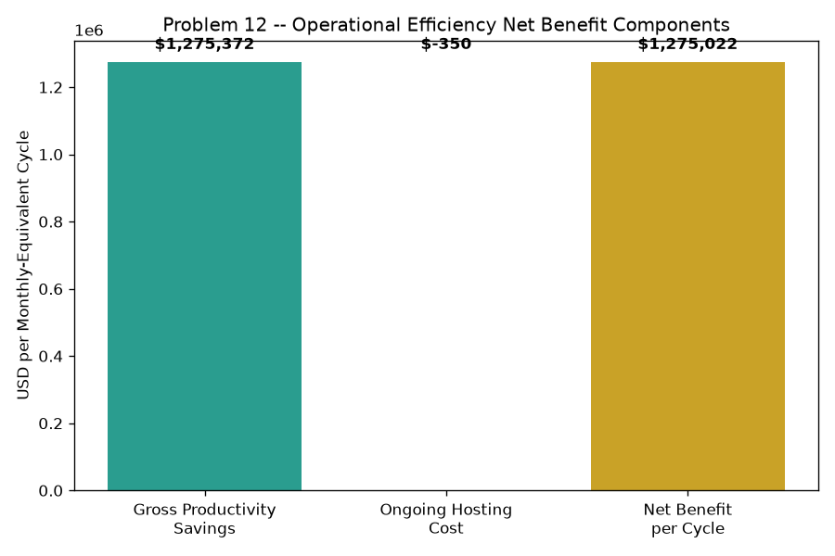
Figure 3. Operational Efficiency Net Benefit Components (Notebook 65)
This waterfall shows exactly how the net benefit per cycle above is composed: gross productivity savings from consolidated case lookups (green), less the ongoing hosting/maintenance cost (red), landing at the net benefit (gold) -- this technique's own genuinely different financial-model shape versus every prior problem's TP/FP confusion-matrix pattern, since Problem 12 gates no action of its own.

7. ROI, Investment & Payback
Amount Invested Usd | $45,000
Annual Net Benefit Usd | $15,300,264
Roi Year 1 Pct | 33,901%
Payback Period Months | 0.0 months

8. Real 360 Ops Dashboard (Notebook 65)
Section 8 of this notebook read the real persisted unified profile directly (447,695 customers), seeded the exact customer_intelligence_lookup_service.py Notebook 64 generated, and drove it live via its real GET /profile/{customer_id} endpoint against a real, grade-stratified sample of 300 holdout customers -- every live response matched the persisted profile exactly (PASS). That exact real grade distribution and live sample JSON are embedded in the interactive HTML dashboard packaged alongside this report, which doubles as the real 360 ops dashboard this problem's deliverable names.

9. SMART Suggestions by Organizational Level
Org Level | Suggestion
Frontline Ops / Collections Agent | Use the 360 lookup dashboard's Customer Search tab as the FIRST and ONLY stop for case review -- it already composes Problem 1's static PD, Problem 6's dynamic PD, Problem 9's propensity-to-cure (where collections-eligible), and Problem 10's risk-level/trend/action into one UNIFIED_RISK_GRADE, saving an estimated 6 minutes versus checking four separate systems per case.
Ops Team Lead | Track weekly adoption of the unified lookup against the real 303,660-account active case load -- low adoption erases the $1,275,372/cycle productivity case this notebook prices, regardless of how sound the composite score is.
Risk / Data Science Analyst | Watch the composite_non_inferiority gap's 95% bootstrap CI ([-0.0040, -0.0032]) every refresh cycle -- if the lower bound ever drifts below the ASSUMPTION -0.005 tolerance set in Notebook 62, UNIFIED_SCORE_WEIGHTS ({'static_pd_weight': 0.35, 'dynamic_pd_weight': 0.65, 'collections_adjustment_weight': 0.1, 'description': "ASSUMPTION -- DYNAMIC_PD weighted higher than STATIC_PD (0.65 vs 0.35) because it is the platform's most current real read of behavior (same precedence Problem 10 already gave it). Where a real collections propensity-to-cure score exists (Problem 9), UNIFIED_RISK_SCORE = 0.35*STATIC_PD + 0.65*DYNAMIC_PD + 0.10*(1 - PROPENSITY_TO_CURE), renormalized to sum to 1.0 across the active terms; where it does not exist, UNIFIED_RISK_SCORE = 0.35*STATIC_PD + 0.65*DYNAMIC_PD unchanged. This is validated, not assumed correct -- see the composite_non_inferiority KPI below."}) need revisiting, not the four underlying models. Coordinate with Problem 9/10's owners so TREATMENT_TIER stays this profile's single source of truth for outreach -- no team should act on a raw single-signal score once this profile ships.
Model Risk / Compliance (SR 11-7) | File Notebook 64's independent reproduction result (True), the persisted-profile cross-check (True), and the API self-test result (True) with the technique's governance packet; since UNIFIED_RISK_SCORE is an explicit weighted composite of four ALREADY-GOVERNED models rather than a new trained classifier, review should focus on UNIFIED_SCORE_WEIGHTS' stability and the composite_non_inferiority gate, not a retraining cadence. Currently RECOMMENDED for production.
Finance / Provisioning Team | Use UNIFIED_RISK_GRADE tertiles as a cross-check reconciliation tool against Problem 3's ECL segmentation and Problem 4's tier-differentiated LGD -- a consistency check across independently-built views of the same portfolio, not a new provisioning trigger in its own right (that role stays with Problems 3/4/8).
CFO / Executive Leadership | Approve the $45,000 investment given an estimated 0.0 months payback and 33,901% Year-1 ROI from consolidated case-lookup productivity alone (net of hosting cost) -- and note the strategic value beyond this number: Problems 13 (Risk-Adjusted Profitability) and 14 (Executive Decision Support) both depend directly on this unified profile as their own input.

10. Assumptions & Sources
Assumption | Value | Source
case_lookup_volume_accounts_per_cycle | 303660.0 | Notebook 63 (real, measured collections-eligible population -- the real subset of the unified profile actively worked by ops/collections agents each cycle; not fabricated).
minutes_saved_per_case_lookup | 6.0 | ASSUMPTION -- illustrative time an ops/collections/credit analyst saves per case by querying ONE unified 360 profile endpoint instead of separately consulting Problem 1's static-PD output, Problem 6's dynamic-PD service, Problem 9's propensity-to-cure score, and Problem 10's worklist -- four separate lookups collapsed into one; edit to your institution's own time-and-motion study.
fully_loaded_hourly_labor_cost_usd | 42.0 | ASSUMPTION -- illustrative fully-loaded hourly cost (wages + benefits + overhead) of a frontline collections/credit operations analyst; edit to your institution's actual compensation data.
ongoing_hosting_cost_usd_per_cycle | 350.0 | ASSUMPTION -- illustrative recurring cloud-hosting plus on-call maintenance cost for the unified lookup API each monthly cycle -- this technique's own genuinely new recurring cost stream, with no Problem 5-11 analog, since it is the platform's first purely read-through aggregation service rather than a scored classifier.
implementation_cost_usd | 45000.0 | ASSUMPTION -- illustrative one-time build/validate/deploy cost for the unified customer-intelligence lookup service and its 360 ops dashboard; set above Problem 11's $38,000 (a stateless streaming aggregator) because this service integrates four upstream models' real outputs into one composite score and API, and below Problem 9/10's own model-training pipeline costs since it trains no new model of its own -- edit to your institution's actual project cost.
annual_application_cycles | 12.0 | ASSUMPTION -- monthly cadence, matching the platform's established monthly statement/refresh grain; edit to your institution's actual cadence.

11. Final Recommendation & Deployment Status
Overall deployment status: RECOMMENDED FOR PRODUCTION. This technique clears its hard-gating KPIs, statistical validation, and API self-test bars -- deploy per Notebook 64's deployment readiness checklist.
This completes Problem 12 (360 Degree Customer Intelligence) and Phase 5's first problem. Next: Problem 13 (Risk-Adjusted Profitability Modeling, Notebooks 66-69), which depends directly on Problem 1's real champion model and this problem's real unified customer profile.

