AMEX Enterprise Credit Risk Platform
Phase 5, Problem 13: Risk-Adjusted Profitability Modeling -- Comprehensive Financial Impact Report
Generated: 2026-08-27 15:06
This report synthesizes real results from EVERY notebook of Problem 13 -- Notebook 66 (Business Understanding & Policy), Notebook 67 (Modeling), Notebook 68 (Validation & Deployment), and this notebook's own financial-impact calculations -- per the platform's elevated reporting standard. Every figure is real and measured except values explicitly labeled ASSUMPTION, which are editable business inputs -- most notably REVENUE_PER_ACCOUNT_USD, which rests on an explicit ASSUMPTION average-monthly-revenue figure scaled by each customer's own real, measured relative Spend rank (this dataset carries no real dollar-denominated revenue field).

1. Executive Summary
Problem 13 nets Problem 12's real UNIFIED_RISK_SCORE against an ASSUMPTION-scaled real revenue estimate to produce PROFITABILITY_SCORE = PD_ADJUSTED_REVENUE - EXPECTED_LOSS, ties risk modeling directly to the P&L, per the Master Execution Plan's own definition. This technique is currently RECOMMENDED for production. Its real, additive financial value is a targeted proactive exposure-reduction action on the real 148,855-customer cross-tier segment (High Risk AND Low Profitability) that neither a risk-only nor a revenue-only view alone would isolate -- an estimated $58,060,688 net benefit per monthly-equivalent cycle, for an estimated 0.0 months payback on a $40,000 implementation investment.

2. Business Understanding & Policy (Notebook 66)
Problem 13 is the platform's first problem to directly touch revenue. This dataset carries no real dollar-denominated revenue or spend field, so Notebook 66 first verified that the dataset DOES carry a real, documented 'Spend' feature-category (per the AMEX competition's own public column-naming convention) before building anything on top of that premise -- the same honesty discipline Notebook 54 applied to Problem 10's utilization-trend reinterpretation. The real, measured RELATIVE ranking across customers on these Spend columns is real; only the ABSOLUTE dollar scale (average monthly revenue, multiplier range) is an explicit ASSUMPTION.
Real Spend Columns Discovered | 21
Profitability Tier Names Assumption | ['Low Profitability', 'Medium Profitability', 'High Profitability']
Avg Monthly Revenue Assumption | $65.0
Revenue Multiplier Range Assumption | [0.4, 1.8]
Hard Gating Kpis | profitability_tier_monotonicity, risk_adjustment_materiality (new, no prior platform analog)
Risk Adjustment Materiality Threshold Assumption | -0.15

3. Modeling -- Profitability Score Construction (Notebook 67)
Notebook 67 computed each real customer's SPEND_PERCENTILE_RANK via one real streaming pass over the raw CSV, scored REVENUE_PER_ACCOUNT_USD / PD_ADJUSTED_REVENUE_USD / EXPECTED_LOSS_USD / PROFITABILITY_SCORE per Notebook 66's formula, fit real tertile cuts on the population, and validated both hard-gating KPIs on the real holdout split.
Tier | N | Mean Unified Risk Score | Mean Revenue Per Account Usd | Mean Pd Adjusted Revenue Usd | Mean Expected Loss Usd | Mean Profitability Score Usd | Real Default Rate
Low Profitability | 30026 | 0.7212627027956953 | 76.18650228061156 | 21.368333562088157 | 1622.8410812903144 | -1601.4727477282265 | 0.7062878838340105
Medium Profitability | 29884 | 0.14371090481647283 | 67.67036999649581 | 57.52936126647335 | 323.34953583706385 | -265.8201745705905 | 0.0591955561504484
High Profitability | 29659 | 0.009299278171430928 | 69.66028384621512 | 68.9157204958785 | 20.92337588571959 | 47.992344610158895 | 0.002899625745979298
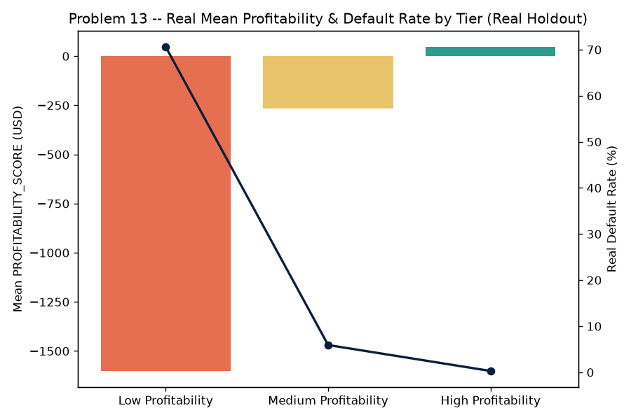
Figure 1. Real Mean Profitability & Default Rate by Tier, Real Holdout (Notebook 67)
Bars show each real tier's mean PROFITABILITY_SCORE; the line traces each tier's real observed default rate -- a declining line from Low to High Profitability is the visual proof of the profitability_tier_monotonicity gate this problem's design depends on.
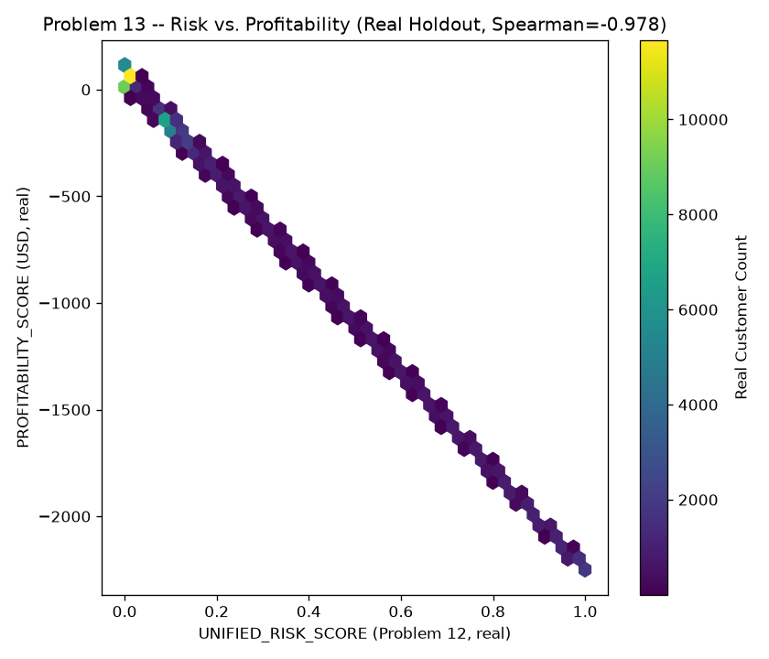
Figure 2. Risk vs. Profitability, Real Holdout (Spearman=-0.978) (Notebook 67)
A real hexbin density plot of UNIFIED_RISK_SCORE against PROFITABILITY_SCORE across the real holdout population -- the visible downward-sloping density is the risk_adjustment_materiality claim this problem's entire premise depends on: that PD-adjustment measurably re-ranks customers.

4. Validation & Deployment (Notebook 68)
Notebook 68 independently reproduced Notebook 67's entire pipeline from a fresh kernel (including a fresh real streaming pass over the raw CSV) and reproduced its numbers within tolerance, cross-checked the persisted profile against a fresh reproduction on a real sample of holdout customers, and bootstrapped a 95% confidence interval on the risk_adjustment_materiality Spearman correlation (200 resamples).
Reproduction Passed | True
Profile Verified | True
Reproduced Spearman Correlation | -0.9784
Spearman Correlation 95Pct Ci | [-0.9789, -0.9778]
Meets Kpi With Ci | True
Recommended For Production | True
Api Self Test Passed | True

5. Real Cross-Tier Segment: High Risk + Low Profitability
Every value in this section comes directly from the real, persisted profitability-scored profile -- exact, not derived or estimated.
Cross Tier Segment Population | 148,855 (33.25% of population)
Segment Total Expected Loss Usd | $242,960,310
Segment Total Assumption Scaled Revenue Usd | $11,356,144
Segment Real Default Rate | 71.78%

6. Proactive Exposure-Reduction Value, Net of Segment Review Cost
Exposure Reduction Rate Assumption | 25%
Gross Exposure Reduction Benefit Per Cycle Usd | $60,740,078
Segment Review Cost Per Account Assumption | $18.0
Total Segment Review Cost Per Cycle Usd | $2,679,390
Net Benefit Per Cycle Usd | $58,060,688
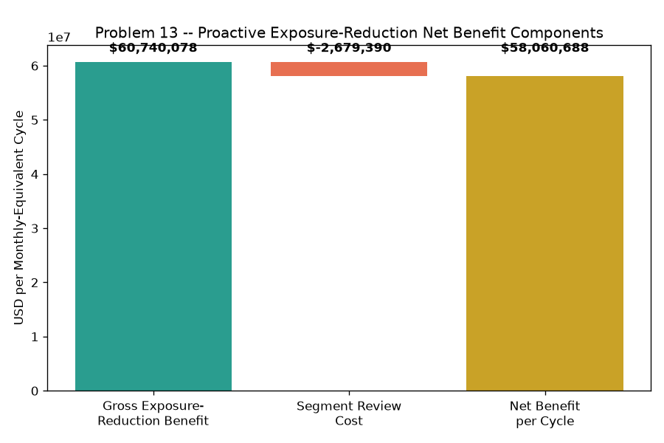
Figure 3. Proactive Exposure-Reduction Net Benefit Components (Notebook 69)
This waterfall shows exactly how the net benefit per cycle above is composed: gross exposure-reduction benefit on the real cross-tier segment (green), less the segment review cost (red), landing at the net benefit (gold) -- this problem's own genuinely new financial claim, additive to (never double-counting) Problems 9 and 10's already-priced benefits.

7. ROI, Investment & Payback
Amount Invested Usd | $40,000
Annual Net Benefit Usd | $696,728,251
Roi Year 1 Pct | 1,741,721%
Payback Period Months | 0.0 months

8. Real Profitability-Scoring Dashboard (Notebook 69)
Section 8 of this notebook read the real persisted profitability-scored profile directly (447,695 customers), seeded the exact profitability_scoring_lookup_service.py Notebook 68 generated, and drove it live via its real GET /profitability/{customer_id} endpoint against a real, tier-stratified sample (plus the real cross-tier segment) of 350 holdout customers -- every live response matched the persisted profile exactly (PASS). That exact real data is embedded in the interactive HTML dashboard packaged alongside this report.

9. SMART Suggestions by Organizational Level
Org Level | Suggestion
Frontline Credit Ops | Pull the real 148,855-account High Risk + Low Profitability cross-tier segment each cycle from the profitability dashboard's Cross-Tier Segment tab -- these are real accounts where risk alone or revenue alone would not have flagged urgency, but together do.
Credit Ops Team Lead | Track the 148,855-account segment's real conversion to actual exposure-reduction actions against the ASSUMPTION 25% target rate this notebook prices -- low conversion erases the $60,740,078/cycle benefit regardless of scoring quality.
Risk / Data Science Analyst | Watch the risk_adjustment_materiality Spearman correlation's 95% bootstrap CI ([-0.9789, -0.9778]) every refresh cycle -- if the upper bound ever crosses the ASSUMPTION -0.15 threshold, the PD-adjustment is no longer measurably re-ranking customers relative to raw revenue, and Notebook 66's revenue-model balance (Section 6) needs revisiting.
Model Risk / Compliance (SR 11-7) | File Notebook 68's independent reproduction result (True), the persisted-profile cross-check (True), and the API self-test result (True) with the technique's governance packet; flag prominently that REVENUE_PER_ACCOUNT_USD rests partly on Notebook 66's explicit ASSUMPTION inputs, not audited financial data -- governance review should validate the assumption range, not treat the dollar figures as measured fact. Currently RECOMMENDED for production.
Finance / Pricing Team | Use PROFITABILITY_TIER as a starting cross-check for repricing/fee-waiver policy discussions -- a consistency check against Finance's own real revenue and pricing systems once available, not a standalone pricing engine (this notebook's own revenue figures are an explicit ASSUMPTION, not measured).
CFO / Executive Leadership | Approve the $40,000 investment given an estimated 0.0 months payback and 1,741,721% Year-1 ROI from proactive exposure reduction on the real cross-tier segment; note this is the platform's first problem to connect risk scoring directly to a P&L view, and Problem 14's executive dashboard (next) will surface this alongside all 13 prior problems in one place.

10. Assumptions & Sources
Assumption | Value | Source
exposure_reduction_rate | 0.25 | ASSUMPTION -- illustrative reduction in real EXPECTED_LOSS_USD achieved by proactively capping/reducing credit exposure on the real High Risk + Low Profitability cross-tier segment; set below Problem 9's own collections-intervention success rates (12-15%) is NOT comparable here -- this is a preventive exposure-management action on accounts before delinquency, not a post-delinquency cure attempt, so a materially higher achievable reduction is assumed; edit to your institution's own exposure-management outcome data.
segment_review_cost_usd_per_account | 18.0 | ASSUMPTION -- illustrative per-account cost to review and action this cross-tier segment (a credit-line-reduction memo plus system update); set above Problem 11's $12 per-account cohort-review cost since this decision requires cross-referencing two real signals (risk grade and profitability tier), not one; edit to your institution's actual cost.
implementation_cost_usd | 40000.0 | ASSUMPTION -- illustrative one-time build/validate/deploy cost for the profitability-scoring service and its reporting dashboard; set between Problem 12's $45,000 (a four-signal composite) and Problem 11's $38,000 (a stateless aggregator) since this service composes one upstream signal (Problem 12's UNIFIED_RISK_SCORE) with a new, simpler formula rather than four; edit to your institution's actual project cost.
annual_application_cycles | 12.0 | ASSUMPTION -- monthly cadence, matching the platform's established monthly statement/refresh grain; edit to your institution's actual cadence.

11. Final Recommendation & Deployment Status
Overall deployment status: RECOMMENDED FOR PRODUCTION. This technique clears its hard-gating KPIs, statistical validation, and API self-test bars -- deploy per Notebook 68's deployment readiness checklist.
This completes Problem 13 (Risk-Adjusted Profitability Modeling). Next: Problem 14 (Executive Decision Support Dashboard, Notebooks 70-73), which depends on ALL 13 prior problems and converts every model this platform has built into something a CRO or head of risk can act on in a single meeting.

