AMEX Enterprise Credit Risk Platform
Phase 2, Problem 5: Early Payment Default Detection -- Validation & Deployment Report
Generated: 2026-08-25 02:03

1. Scope & Selected Window
Statistical validation and deployment packaging for the early-window model at K=3 statements, selected from Notebook 35's real AUC-retention curve across candidates [3, 6, 9, 12]. This window meets Notebook 34's AUC-retention KPI target.

2. Statistical Validation Summary
Test | Value | Target | Pass
Holdout AUC (reproduced) | 0.9265 | >0.5 | True
Holdout AUC 95% CI lower bound | 0.9248 | >0.5 | True
Mean calibration gap (deciles) | 0.0026 | <0.05 | True
Split-half score PSI | 0.0004 | <0.1 | True
AUC retention vs. full history (K=3) | 96.3 | >=80% | True

3. Honest Limitation -- Deployment Scope & Assumptions
Fixed Window Assumption: This model was trained and validated on customers' first 3 chronological statements ONLY. It assumes exactly (or up to) 3 statements are available at scoring time -- a customer with MORE history available should be scored by Problem 1's full-history champion model instead (it retains more signal), not this restricted model. This service does not enforce that choice; it is an operational integration decision for whoever calls it.
Kpi Status: MEETS the 80% AUC-retention KPI set in Notebook 34.
Data Limitation: Same limitation Notebook 34 documented: this dataset has no account-origination date, so 'early' means each customer's own earliest statements, not literal time-since-account-opening.
Single Architecture Scope: Only the champion architecture (xgboost) was evaluated (see Notebook 35's Section 7 scope note) -- a full model-zoo tournament at this window length was not run.

4. Deployment Readiness Checklist
Dimension | Status
Model reproducibility | PASS
Statistical validation (all checks) | PASS
AUC-retention KPI (Notebook 34 target) | MET
Model + preprocessing artifacts persisted | PASS
API self-test (live, generated service) | PASS
API p99 latency < 500ms | PASS
Overall recommendation | RECOMMENDED FOR PRODUCTION

5. API Performance
Latency over 150 real TestClient calls to /score: p50=13.727ms, p95=18.436ms, p99=27.875ms, max=102.729ms.

6. Charts
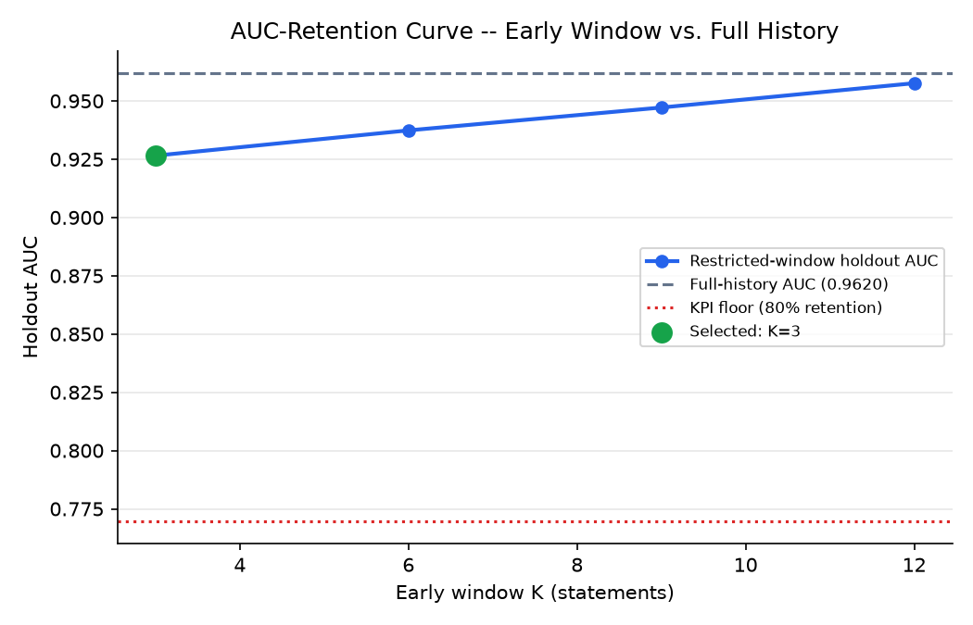
AUC-retention curve across candidate early windows
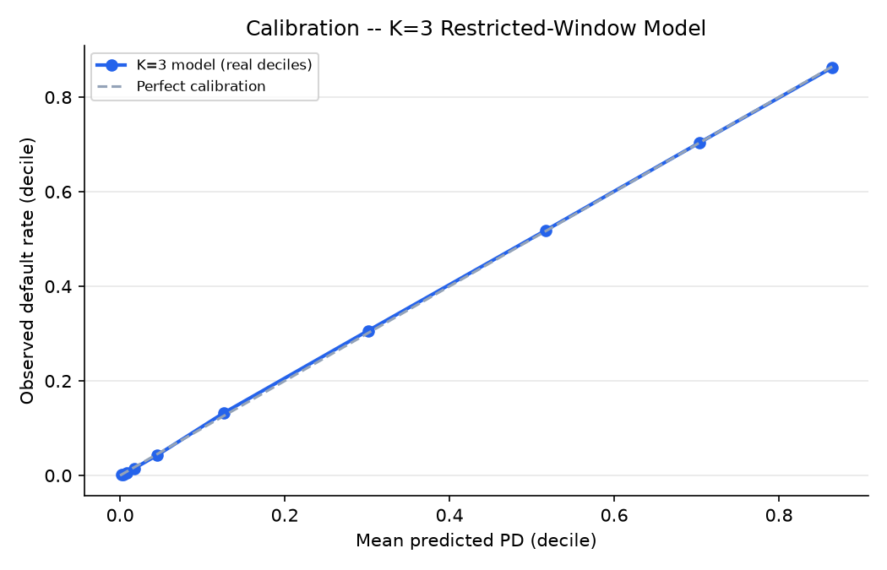
Calibration -- K=3 model, real holdout deciles

