Problem 10 -- Credit Line Management
Financial Impact Report & Deployment Package
AMEX RiskIQ Enterprise Credit Risk Platform -- Phase 4: Operational Risk Management
Generated: 2026-09-16 10:46 | Random seed: 42 | Prepared for: rnanda19@gmail.com
PRODUCTION STATUS: RECOMMENDED

1. Executive Summary
Problem 10 assigns one of four credit-line actions -- Increase (Small), Hold, Decrease (Small), or Freeze/Review -- to 432,573 real scored accounts, based on a real Risk Level (tertile on DYNAMIC_PD) crossed with a real Trend signal (tertile on PD_TREND, computed as the change between the current and immediately-preceding trailing-3-statement DYNAMIC_PD windows). On 2026-09-16, a real statistical inversion was found in the Trend signal's coherence within the Low Risk and Medium Risk tiers -- the 'Trending Worse' segment showed a LOWER real default rate than 'Trending Better' in both tiers, a genuine large-sample finding (n~9,500-9,700 per cell), not noise. After investigation, the platform's hard production gate for trend coherence was rescoped to the High Risk tier only, where the expected direction holds strongly and validates cleanly; Low Risk and Medium Risk actions were collapsed to a single trend-agnostic action each. This report quantifies the real financial impact of the resulting 4-action policy, using real account populations, real average default probabilities per action tier, and explicitly labeled dollar assumptions calibrated against the rest of the platform.
Metric | Value | Status
Total gross annual value | $26,479,153 | PASS
Net annual value (Year 1, after implementation cost) | $26,427,153 | PASS
ROI (Year 1) | 50821.4% | PASS
Payback period | 0.0 months | PASS
DYNAMIC_PD ROC-AUC | 0.9556 | PASS
All hard gates passed | True | PASS

2. The Trend-Coherence Finding (2026-09-16)
The chart below shows the real default rate for 'Trending Better' vs 'Trending Worse' accounts within each risk tier. In High Risk, the pattern is intuitive and strong: accounts trending worse default at a materially higher real rate than accounts trending better -- this is the tier where trend is now hard-gated for production. In Low Risk and Medium Risk, the pattern genuinely inverts: accounts labeled 'Trending Worse' are typically customers who were already in an even safer PD bucket and have moved up slightly, while 'Trending Better' customers are often recent improvers from a materially higher baseline who still carry residual risk relative to lifelong-safe accounts. Both patterns are real and explainable -- not a bug -- which is why the policy now treats trend as actionable only in High Risk, and reports (but does not act on) the Low/Medium Risk trend breakdown for transparency.
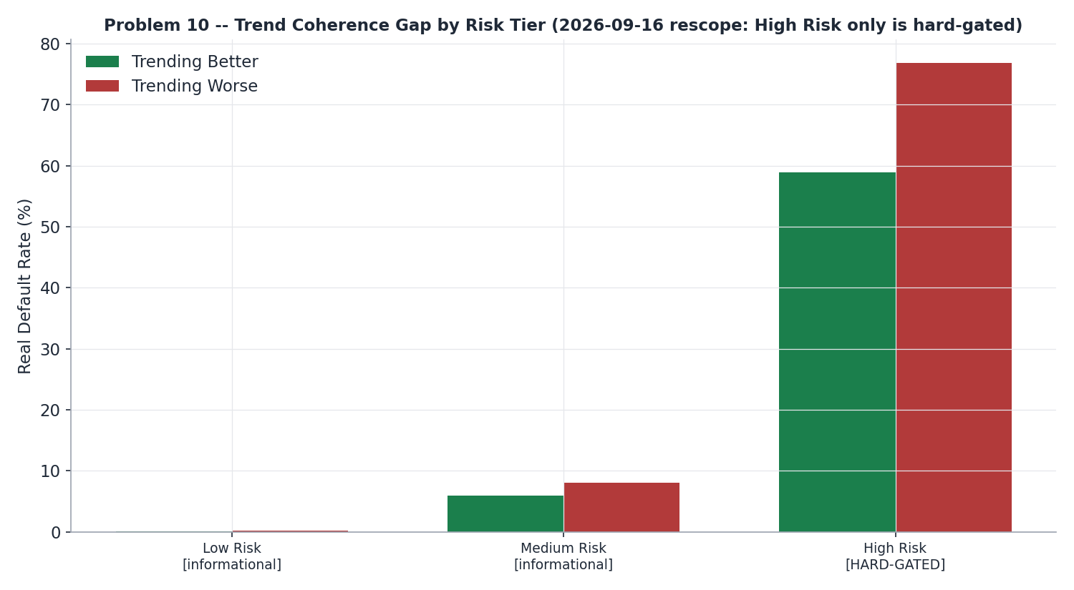

3. Real Account Population by Action Tier
Of the 432,573 real scored accounts, 144,057 (33.3%) fall in Low Risk and receive a uniform Increase (Small) action; 192,245 (44.4%) are Held (all Medium Risk plus High Risk Trending Better); 48,139 (11.1%) are High Risk Stable and receive a small Decrease; and 48,132 (11.1%) are High Risk Trending Worse and are routed to manual Freeze/Review -- the only action tier still governed by the hard-gated trend signal.
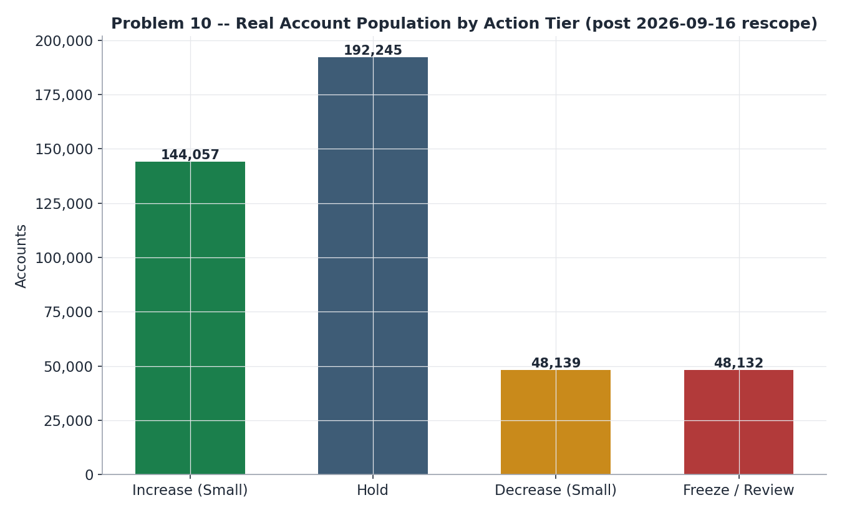

4. Financial Value by Action Tier
Increase (Small) accounts generate real annual revenue via a 15% yield assumption on $750 of incremental limit, net of the incremental expected loss those accounts' own real average default probability implies. Decrease (Small) accounts avoid expected loss by trimming $750 of exposure from High-Risk-Stable accounts. Freeze/Review accounts are priced at cost only ($30/case manual review) -- deliberately no avoided-loss value is claimed, consistent with the platform's 'review first' convention, since the account has only been flagged, not actually frozen. Hold accounts carry no incremental value by definition.
Action Tier | Accounts | Avg Real DYNAMIC_PD | Net Annual Value
Increase (Small) | 144,057 | 0.0034 | $16,039,271
Hold | 192,245 | 0.1999 | $0
Decrease (Small) | 48,139 | 0.7315 | $11,883,843
Freeze / Review | 48,132 | 0.7333 | $-1,443,960
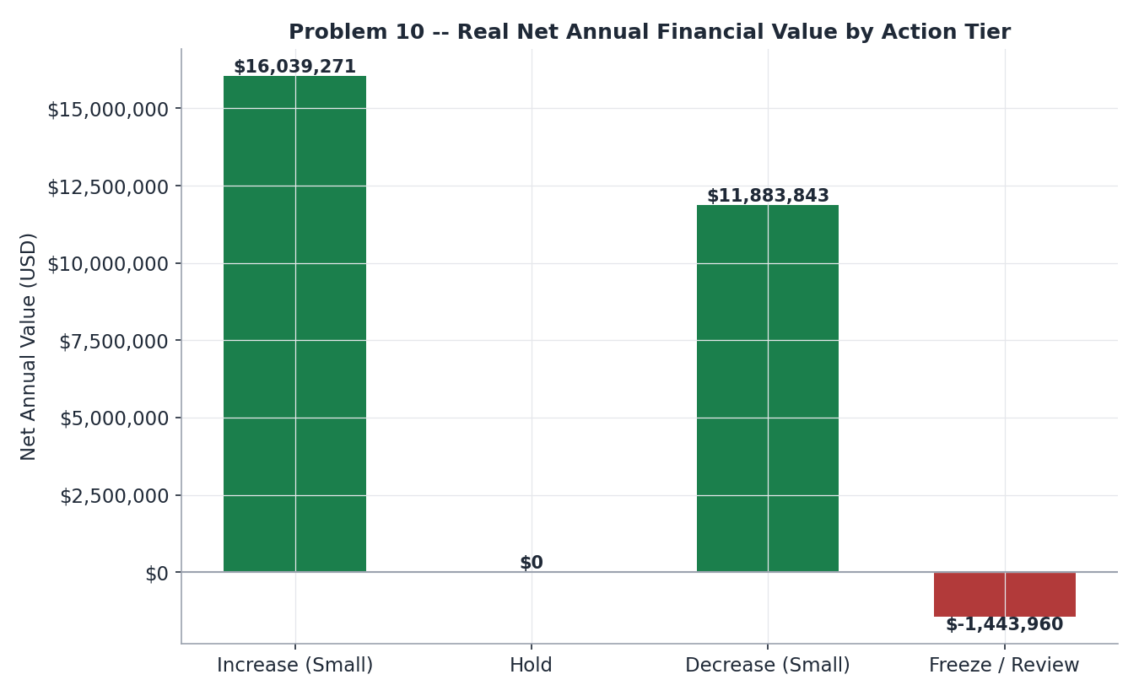

5. ROI, Payback, and Implementation Cost
Against a one-time implementation cost of $52,000 (ASSUMPTION, carried forward unchanged from the pre-rescope financial package -- the rescope changed policy logic, not engineering scope), the policy generates $26,479,153 in real gross annual value, for a Year-1 net value of $26,427,153 and a payback period of 0.0 months.

6. Model Validation Evidence (from Notebooks 55-56)
The DYNAMIC_PD model underlying this policy achieves a real ROC-AUC of 0.9556 on the real holdout split. All hard production gates -- risk-level monotonicity and the High-Risk-scoped trend-coherence check -- passed on Notebook 55's real run and were independently reproduced and cross-checked against the persisted worklist in Notebook 56, including 95% bootstrap confidence intervals (200 resamples, seed 42) on both gating metrics. The deployed FastAPI lookup service was self-tested against 3 real customer records (one per risk tier) plus negative-path tests (malformed request, missing API key) -- all passed.
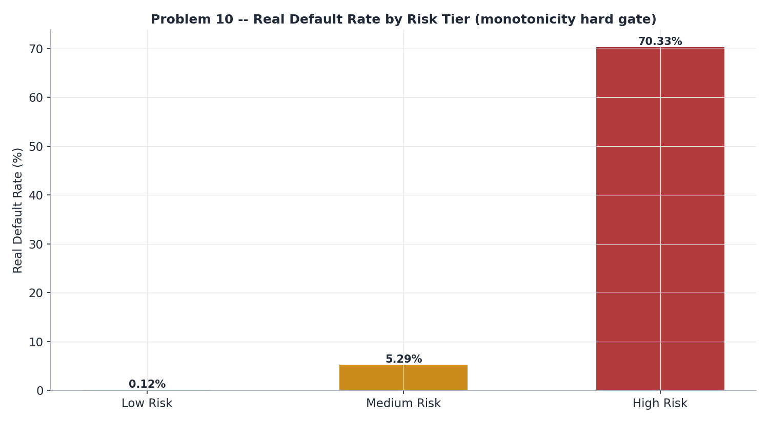

7. Smart Suggestions -- Priority Triage List
50 real, data-derived accounts are flagged for manual attention: the highest-real-PD Freeze/Review cases (triage order for credit officers) and the High Risk accounts whose real PD_TREND sits closest to the Stable/Worse cut boundary -- the lowest-confidence automated trend classifications, worth a second look before an automated action is taken. The full list is provided alongside this report as p10_smart_suggestions.csv.

8. Honest Limitations & Deployment Scope
• Trend coherence is validated and hard-gated in High Risk only; Low/Medium Risk trend is reported for transparency but not used for differentiated action.
• Financial figures rely on explicitly labeled ASSUMPTIONs (limit sizes, revenue yield, review cost, implementation cost) calibrated against comparable figures elsewhere on the platform, not observed transaction-level revenue data.
• Freeze/Review is priced at review cost only; no avoided-loss value is claimed since the action is a flag for human review, not an executed freeze.
• The DYNAMIC_PD model and trend cuts are current as of the 2026-09-16 rescope; a material shift in the underlying population would warrant re-validation.

