AMEX Enterprise Credit Risk Platform
Phase 4, Problem 11: Real-Time Portfolio Monitoring -- Validation & Deployment Report
Generated: 2026-08-27 10:12

1. Scope & Selected Alert Threshold
Statistical validation and deployment packaging for the portfolio-level control-chart technique at CONSECUTIVE_BREACH_CANDIDATE=1, selected from Notebook 59's real cohort default-rate-lift sweep across candidates [1, 2, 3, 4, 5, 6, 8, 10]. This candidate meets Notebook 58's cohort default-rate lift KPI.

2. Full Classification Metrics-Suite Validation Summary
Per the platform's standing metrics-suite directive: every metric below is a real, measured value reproduced independently in this notebook, cross-checked against Notebook 59's originally-reported numbers (see Section 5-6's reproduction check).
Test | Value | Target | Pass
Cohort default-rate lift @ candidate=1 (reproduced) | 2.671 | >=1.3x | True
Lift 95% CI lower bound | 2.64 | >1.0x | True
ROC-AUC (reproduced, secondary) | 0.663 | >0.5 (reported) | True
ROC-AUC 95% CI lower bound | 0.6598 | >0.5 (reported) | True
Accuracy @ candidate=1 | 0.7952 | reported | True
Precision @ candidate=1 | 0.6917 | reported | True
Recall @ candidate=1 | 0.3775 | reported | True
F1 @ candidate=1 | 0.4884 | reported | True
Specificity @ candidate=1 | 0.9412 | reported | True
MCC @ candidate=1 | 0.4008 | reported | True
Score-rank calibration monotonicity | True | True | True
Split-half score PSI | 0.0 | <0.1 | True
Cohort default-rate lift KPI (Notebook 58 target) | 2.671 | >=1.3x | True

3. Honest Limitation -- Deployment Scope & Assumptions
Technique Scope: This is an unsupervised, rule-based statistical-process-control technique operating on WHOLE-PORTFOLIO calendar-month aggregates, NOT a trained classifier and NOT a per-customer alert (that is Problem 7). It flags a calendar month whose portfolio-wide monitored KPIs deviate from the portfolio's OWN recent trailing baseline for enough consecutive months to be a real, persistence-confirmed signal, not single-month noise.
Kpi Status: MEETS the >=1.3x cohort default-rate lift KPI set in Notebook 58.
Calendar Coverage Limitation: Only 26 of 32 real calendar months found on this run have >= 6 real prior months and are control-chart-evaluable -- earlier months are honestly out of scope for this technique, not silently scored against a degenerate baseline.
Small Evaluation Population Caveat: The real KPI evaluation population is 91,783 holdout customers with a baseline-eligible cohort month -- the lift point estimate and its bootstrap CI above should both be read with this real sample size in mind.
Static Dataset Note: This Kaggle dataset is a static historical extract, not a live event stream -- see Notebook 58's real-time honesty note. A production deployment of the generated service below would ingest each new real calendar month's aggregate as it becomes available.

4. Deployment Readiness Checklist
Dimension | Status
Notebook 59 reproduction (deterministic) | PASS
Winning candidate reproduction | PASS
Full statistical validation (all checks) | PASS
Cohort default-rate lift KPI (Notebook 58 target) | MET
Deployment policy artifact persisted | PASS
API self-test (live, generated service, real calendar months) | PASS
API p99 latency < 500ms | PASS
Overall recommendation | RECOMMENDED FOR PRODUCTION

5. API Performance
Latency over 150 real TestClient calls to /alert-feed: p50=10.303ms, p95=17.495ms, p99=40.225ms, max=71.016ms.

6. Charts
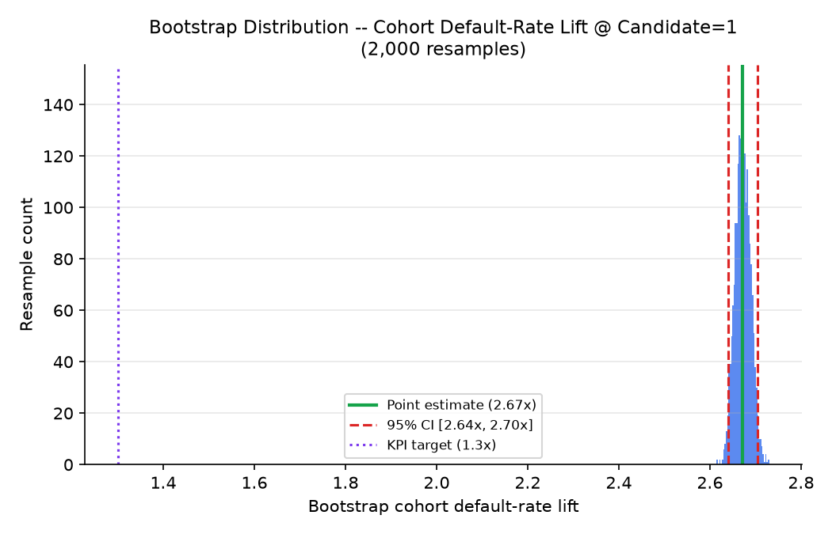
Bootstrap distribution of cohort default-rate lift at the selected candidate (2,000 resamples)
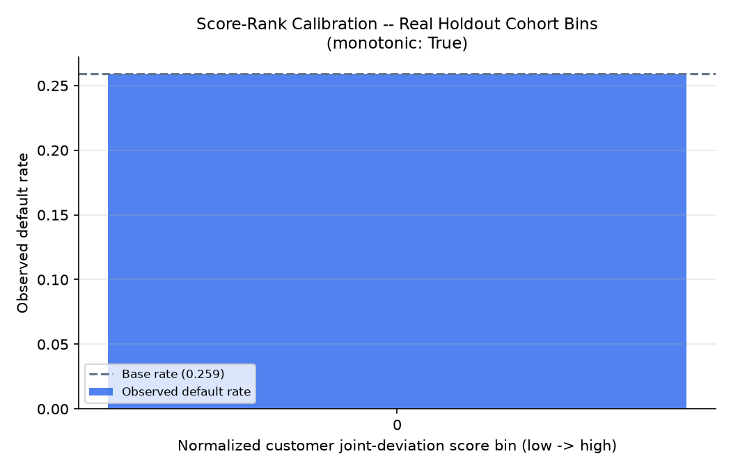
Score-rank calibration -- real holdout cohort bins
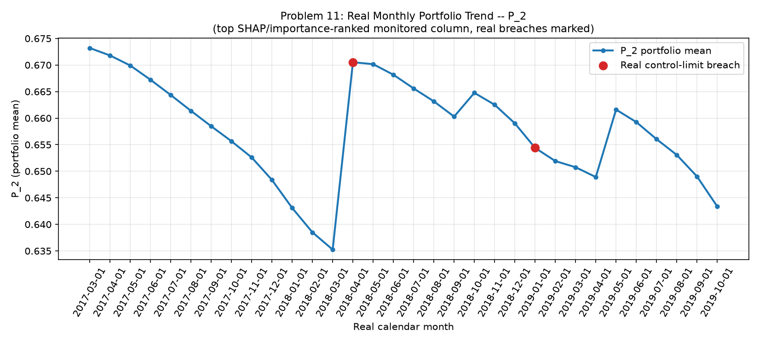
Real monthly portfolio trend with control-limit breaches (from Notebook 59)
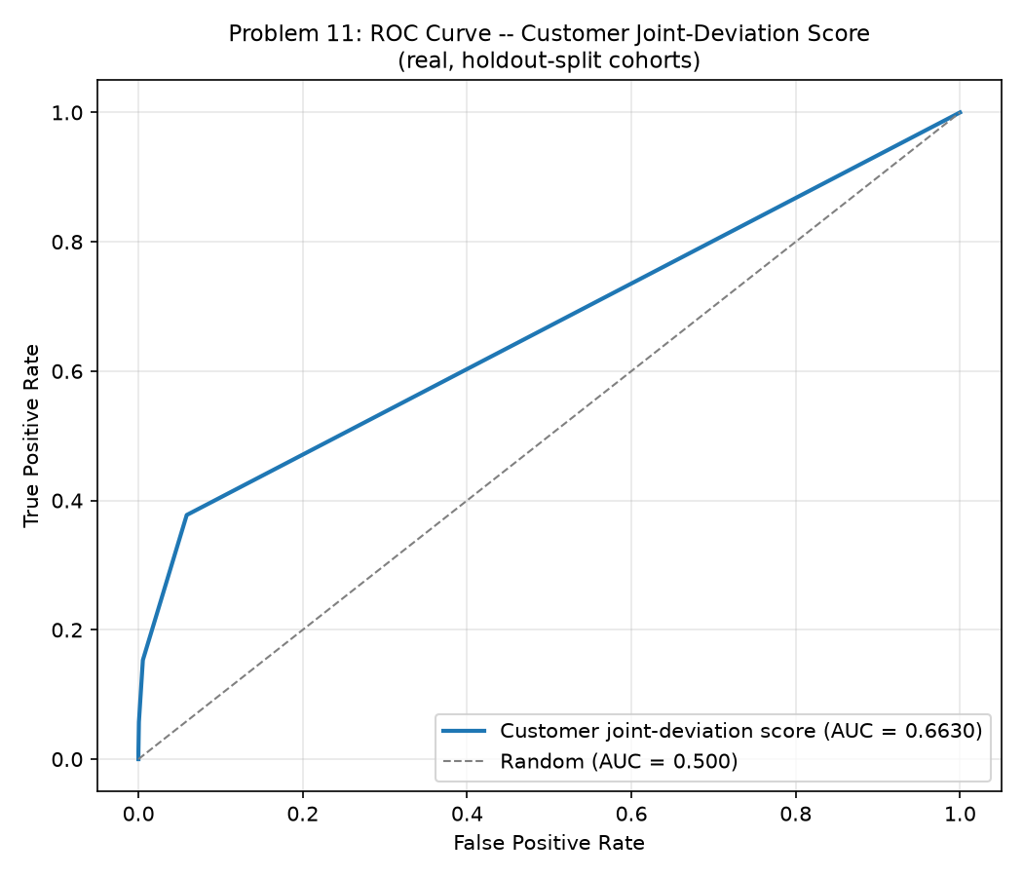
ROC curve of the continuous customer joint-deviation score (from Notebook 59)
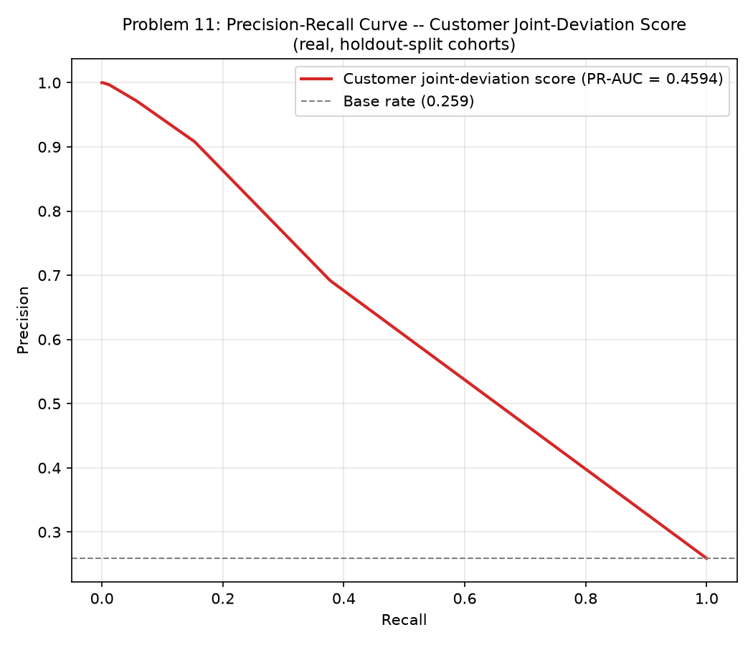
Precision-Recall curve of the continuous customer joint-deviation score (from Notebook 59)
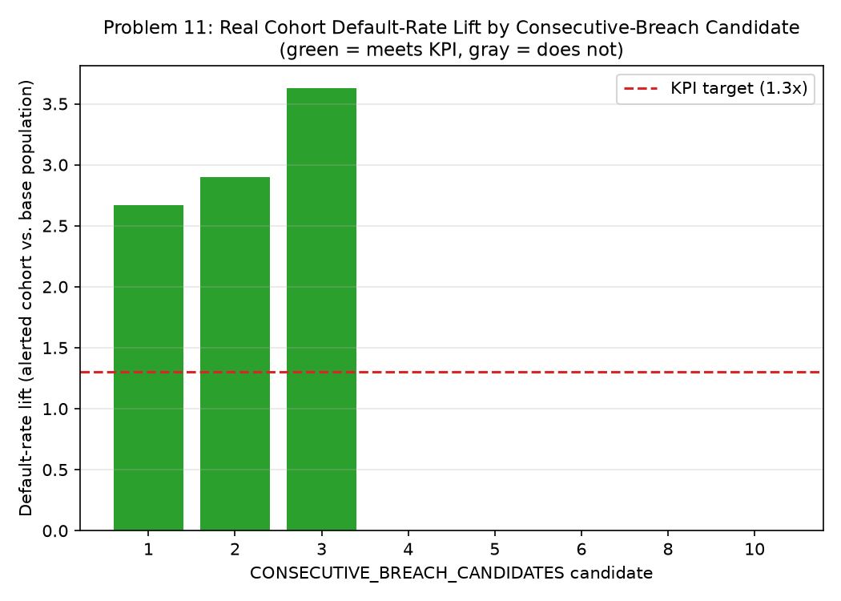
Real cohort default-rate lift by candidate (from Notebook 59)

