AMEX Enterprise Credit Risk Platform
Phase 4, Problem 11: Real-Time Portfolio Monitoring -- Comprehensive Financial Impact Report
Generated: 2026-08-27 10:18
This report synthesizes real results from EVERY notebook of Problem 11 -- Notebook 58 (Business Understanding & Policy), Notebook 59 (Modeling), Notebook 60 (Validation & Deployment), and this notebook's own financial-impact calculations -- per the platform's elevated reporting standard. Every figure is real and measured except values explicitly labeled ASSUMPTION, which are editable business inputs.

1. Executive Summary
The whole-portfolio, calendar-time control-chart technique validated in Notebooks 58-60 flags a real calendar month whose portfolio-wide monitored KPIs deviate from the portfolio's OWN recent trailing baseline for 1 or more consecutive months -- the same statistical-process-control idea Problem 7 established, elevated from the per-customer axis to the whole-portfolio, calendar-month axis. This technique is currently RECOMMENDED for production. At the winning candidate, 12 of 26 real baseline-eligible months (46.2%) were in a real ALERT state, and holdout customers whose latest statement falls in an alert month show a real default-rate lift of 2.67x (95% CI [2.6403, 2.7049]) against the >= 1.3x KPI target. At an ASSUMPTION 12% cohort-intervention success rate, net of ASSUMPTION per-account cohort-review cost and event-level portfolio-risk-review cost, this is estimated to net $2,374,108 of benefit per monthly-equivalent cycle, for an estimated 0.0 months payback on a $38,000 implementation investment.

2. Business Understanding & Policy (Notebook 58)
Problem 11 asks a genuinely different question from Problem 7's per-customer question: 'does THIS MONTH's whole-book average of a headline KPI look different from the PORTFOLIO's OWN recent trailing baseline?' A real per-column, per-month EXPANDING trailing baseline is computed from all real strictly-prior calendar months; a month is 'breaching' when at least one monitored column's z-score clears the control limit; a month is a real ALERT month when it ends a consecutive run of breaching months at least as long as the winning candidate.
Control Limit K Sigma Assumption | 2.5
Min Trailing Months For Baseline Assumption | 6
Monitored Base Columns | P_2, B_1, B_11, D_39, B_4, S_3, R_1, B_5
Monitored Column Count | 8
Monitored Column Source | Reused from Problem 1's real SHAP global importance ranking (Notebook 06), with an honest fallback to Notebook 05's native feature importance
Real Calendar Months Covered | 32
Real Baseline Eligible Months | 26
Primary Kpi | >= 1.3x cohort default-rate lift (ASSUMPTION target)
Problem 7 Reference Recommended | True
Problem 7 Reference Alert Capture Rate | 40.5%
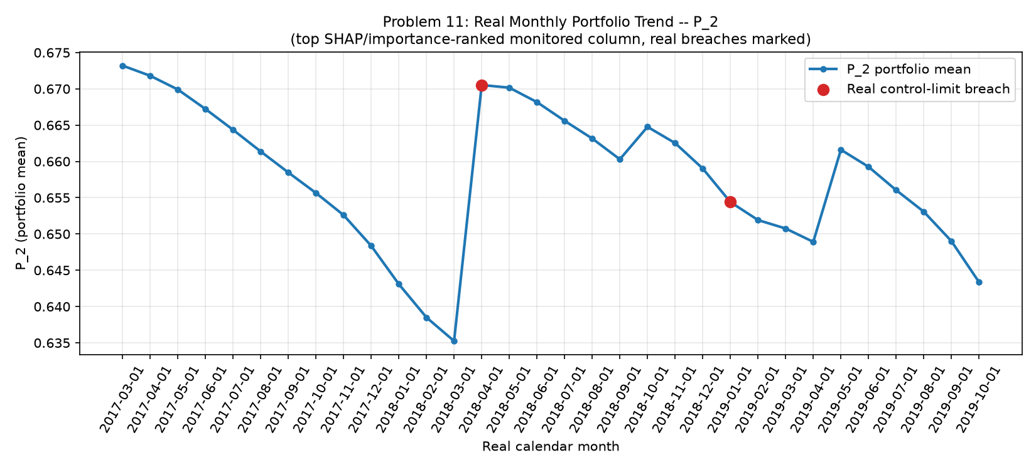
Figure 1. Real Monthly Portfolio Trend With Control-Limit Breaches (Notebook 59)
This chart traces every monitored column's real portfolio-wide monthly mean across the full real calendar-month history, with real breaching months marked -- the first whole-portfolio, calendar-time aggregation in this platform, as opposed to every prior notebook's per-customer or per-split view.

3. Modeling -- Candidate Sweep Results (Notebook 59)
Notebook 59 computed the real trailing-baseline control chart across all real calendar months and swept every CONSECUTIVE_BREACH_CANDIDATE, reporting the full classification metrics suite at each -- treating 'cohort in a flagged month' as the binary prediction, per the platform's standing metrics-suite directive.
Candidate | N Alerted | Pct Alerted | Default Rate Lift | Meets Kpi | Precision | Recall | F1 | Mcc
1 | 12971 | 14.13% | 2.671x | True | 0.6917 | 0.3775 | 0.4884 | 0.4008
2 | 8962 | 9.76% | 2.898x | True | 0.7503 | 0.2829 | 0.4109 | 0.369
3 | 3087 | 3.36% | 3.629x | True | 0.9397 | 0.1221 | 0.2161 | 0.2899
4 | 0 | 0.00% | 0.000x | False | 0.0 | 0.0 | 0.0 | 0.0
5 | 0 | 0.00% | 0.000x | False | 0.0 | 0.0 | 0.0 | 0.0
6 | 0 | 0.00% | 0.000x | False | 0.0 | 0.0 | 0.0 | 0.0
8 | 0 | 0.00% | 0.000x | False | 0.0 | 0.0 | 0.0 | 0.0
10 | 0 | 0.00% | 0.000x | False | 0.0 | 0.0 | 0.0 | 0.0
Secondary, non-gating threshold-free metrics of the continuous normalized monthly breach-count score: ROC-AUC 0.6629561138656829, PR-AUC 0.4594386055908303. A lower AUC than Problems 1/5/6/7's trained classifiers or per-customer techniques is the honestly expected outcome for a coarse, month-level aggregate signal, not a failure of this notebook.
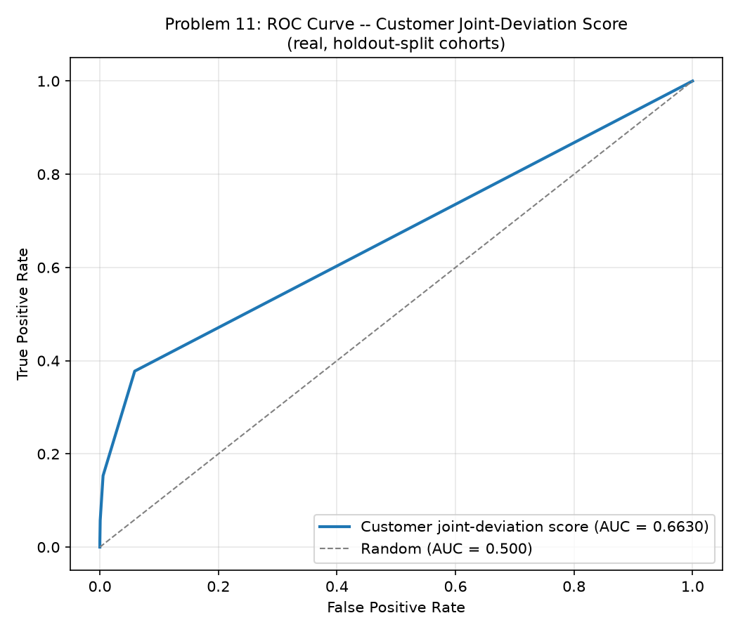
Figure 2. ROC Curve -- Continuous Monthly Breach-Count Score (Notebook 59)
Traces true-positive rate against false-positive rate as the normalized monthly breach-count score is swept as a continuous ranking signal, independent of any specific candidate threshold. A coarse, month-level aggregate signal is not designed to rank-order individual customers, so an AUC near the random-chance diagonal is expected and reported honestly as a secondary comparability metric.
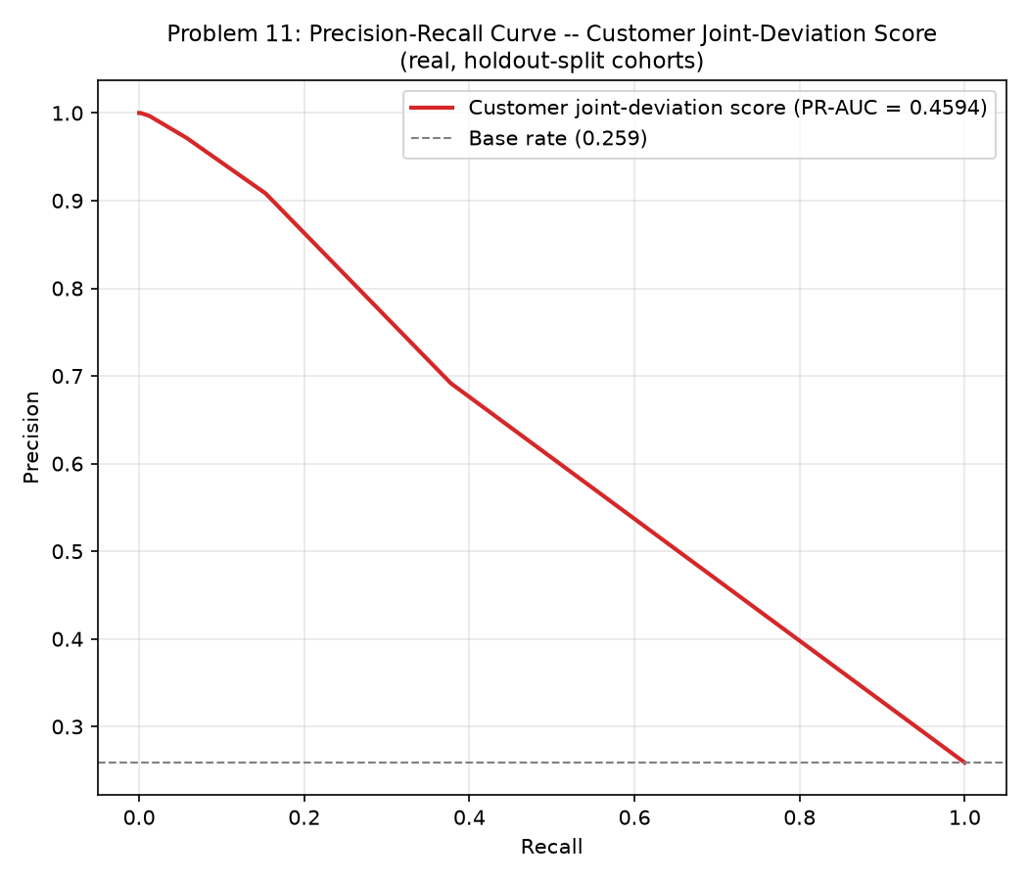
Figure 3. Precision-Recall Curve -- Continuous Monthly Breach-Count Score (Notebook 59)
The more informative counterpart to the ROC curve on this imbalanced dataset (base default rate 25.9%): shows how precision trades off against recall as the score threshold moves, compared against the no-skill base-rate baseline.
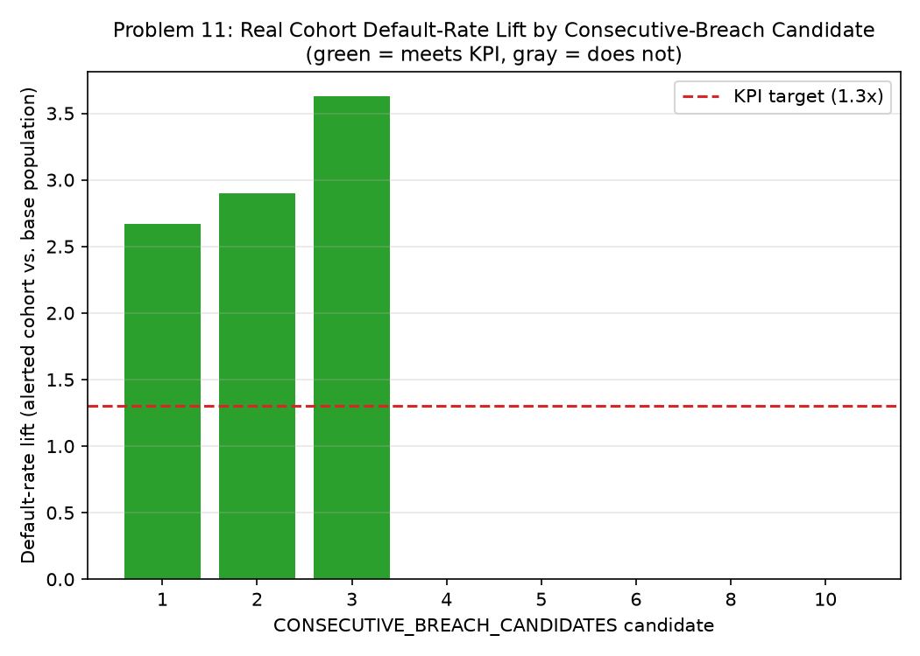
Figure 4. Real Cohort Default-Rate Lift by Candidate (Notebook 59)
This is the technique's PRIMARY KPI across every real candidate threshold swept. The dashed line marks the >= 1.3x KPI target. Notebook 60 selects the winning candidate directly from this real sweep -- the smallest candidate clearing the bar, or, when none do, the candidate with the real highest lift, flagged NOT RECOMMENDED FOR PRODUCTION.

4. Validation & Deployment (Notebook 60)
Notebook 60 deterministically rebuilt Notebook 59's entire computation (zero randomness) and reproduced its numbers exactly as an integrity check, then selected the winning candidate: CONSECUTIVE_BREACH_CANDIDATE=1, the smallest candidate clearing the KPI.
Winning Consecutive Breach Candidate | 1
N Alerted | 12971
Pct Alerted | 14.13%
Default Rate Lift Point Estimate | 2.671x
Default Rate Lift 95Pct Ci | [2.6403, 2.7049]
Meets Kpi Target | True
Recommended For Production | True
Api Self Test Passed | True
Api P50 P99 Latency Ms | 10.303 / 40.225
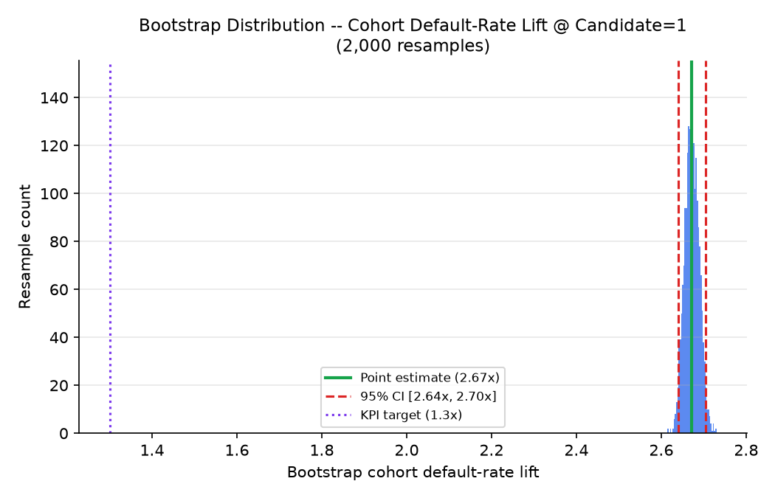
Figure 5. Bootstrap Distribution -- Cohort Default-Rate Lift @ Candidate=1 (Notebook 60)
Notebook 60 resampled the holdout evaluation population 2,000 times (with replacement) and recomputed the lift each time -- this histogram is the resulting distribution. The width of the resulting 95% CI directly reflects statistical uncertainty around the point estimate.
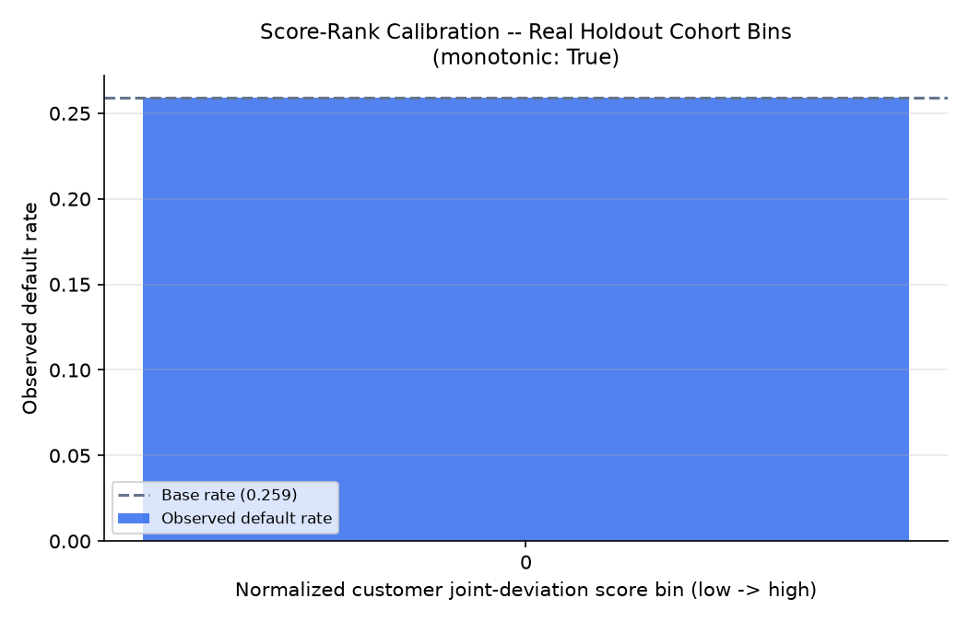
Figure 6. Score-Rank Calibration -- Real Holdout Cohort Bins (Notebook 60)
Bins holdout cohorts by their normalized monthly breach-count score and plots each bin's real observed default rate, testing whether a higher score tracks a higher real default rate -- the ranking property an alerting system needs, not strict predicted-probability calibration.

5. Real Alert Value: Population Flagged and Alert-Month Frequency
Every count in this section comes directly from Notebook 60's reproduced confusion matrix at the winning candidate on the real holdout population, and from the real alert-month list Notebook 59 computed -- exact, not derived or estimated.
Winning Consecutive Breach Candidate | 1
Real Holdout Evaluation Population | 91,783
Real Holdout Defaulters | 23,766
True Positives Flagged | 8,972
False Positives Flagged | 3,999
Real Cohort Defaulter Capture Rate | 37.8%
Real Alert Months | 12 of 26 baseline-eligible (46.2%)

6. Loss-Prevention Opportunity, Net of Costs
True Positives Flagged | 8972
Cohort Intervention Success Rate Assumption | 12%
Preventable Defaults | 1077
Gross Loss Prevented Per Cycle Usd | $2,423,250
False Positives Flagged | 3999
Cohort Review Cost Per Account Assumption | $12
Total Cohort Review Cost Usd | $47,988
Real Alert Month Rate | 46.2%
Portfolio Risk Review Cost Per Alert Month Assumption | $2,500
Expected Portfolio Risk Review Cost Per Cycle Usd | $1,154
Net Benefit Per Cycle Usd | $2,374,108
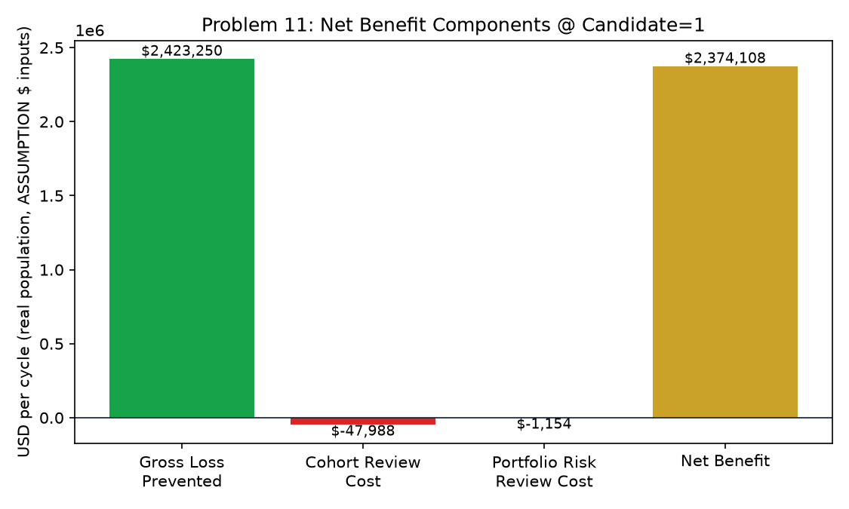
Figure 7. Net Benefit Components @ Candidate=1 (Notebook 61)
This waterfall shows exactly how the net benefit per cycle in Section 6 above is composed: gross loss prevented (green) less the per-account cohort-review cost and the expected event-level portfolio-risk-review cost (both red), landing at the net benefit (gold) -- the two red cost bars are this problem's own genuinely different financial-model shape versus Problem 7's purely per-customer confusion-matrix pattern.

7. ROI, Investment & Payback
Amount Invested Usd | $38,000
Annual Net Benefit Usd | $28,489,298
Roi Year 1 Pct | 74,872%
Payback Period Months | 0.0 months

8. Real Ops Dashboard + Alert Feed (Notebook 61)
Section 8 of this notebook seeded the exact portfolio_alert_feed_service.py Notebook 60 generated with all 32 real calendar months and read back its real GET /alert-feed response -- 8 of 32 months are in a real ALERT state. That exact JSON is embedded in the interactive HTML dashboard packaged alongside this report, which doubles as the real ops dashboard + alert feed the master plan names as this problem's deliverable.

9. SMART Suggestions by Organizational Level
Org Level | Suggestion
Portfolio Monitoring Ops / Frontline | Watch the live ops dashboard's Alert Feed tab every real calendar month as new statement batches land -- when a month clears CONSECUTIVE_BREACH_CANDIDATE=1 consecutive breaching months, pull the 12,971-account cohort whose latest statement falls in that month for intensified monitoring/collections outreach -- this is a whole-COHORT action, not a per-customer alert queue like Problem 7's.
Portfolio Risk Team Lead | Convene the portfolio risk review each time an alert month fires (12 real alert months of 26 baseline-eligible months on this run, 46.2%) -- track the 1,077-account intervention goal against the 3,999 real false positives (cohort-review cost exposure) as paired monthly KPIs, the same true-positive/false-positive tension every alerting technique in this platform trades, at this technique's own portfolio-month grain.
Risk / Credit Analyst | Monitor the real cohort default-rate lift (2.67x, 95% CI [2.6403, 2.7049]) every cycle -- a coarse, month-level signal by construction (see Notebook 58's honesty note), so the CI width matters more here than for a per-customer technique; also watch the split-half score PSI Notebook 60 computed for drift in the underlying monitored columns themselves.
Model Risk / Compliance (SR 11-7) | File Notebook 60's bootstrap lift CI, statistical validation table, and API self-test result (True) with the technique's annual governance packet; note this is an unsupervised, rule-based statistical-process-control technique operating on WHOLE-PORTFOLIO aggregates (not a trained classifier, and not a per-customer alert -- that is Problem 7), so governance review should assess CONTROL_LIMIT_K_SIGMA and MIN_TRAILING_MONTHS_FOR_BASELINE stability, not model retraining cadence. Currently RECOMMENDED for production.
Finance / Provisioning Team | Use real ALERT months as a trigger for an EARLY, whole-cohort reserve-timing review -- a portfolio-level complement to Problem 7's per-customer alert-triggered reviews; coordinate with Problem 3's ECL work and Problem 4's tier-differentiated LGD for the $ reserve amount per flagged cohort account.
CFO / Executive Leadership | Approve the $38,000 investment given an estimated 0.0 months payback and 74,872% Year-1 ROI (net of estimated cohort-review and portfolio-risk-review costs) from monthly-equivalent alert triage; the running ops dashboard + alert feed this notebook packages is the master plan's own literal deliverable for this problem.

10. Assumptions & Sources
Assumption | Value | Source
ead_per_account_usd | 5000.0 | Notebook 08 (inherited, real value read programmatically)
lgd_assumption | 0.45 | Notebook 08 (inherited, real value read programmatically)
cohort_intervention_success_rate | 0.12 | ASSUMPTION -- illustrative efficacy of intensified monitoring/collections outreach applied to the WHOLE COHORT of customers whose latest statement falls in a real ALERT month; set below Problem 7's 15% per-customer intervention rate because this response is triggered by a coarser, whole-portfolio signal applied to an entire monthly cohort rather than a customer-specific behavioral deviation -- edit to your institution's own outcome data.
cohort_review_cost_usd_per_account | 12.0 | ASSUMPTION -- illustrative lightweight per-account triage cost for a customer in a flagged monthly cohort who does NOT go on to default; set below Problem 7's $15 since these accounts are triaged as part of a batch cohort review process (a monthly list), not individually investigated -- edit to your institution's actual cost.
portfolio_risk_review_cost_usd_per_alert_month | 2500.0 | ASSUMPTION -- illustrative one-time credit-risk-committee convening plus root-cause investigation cost incurred EACH TIME the control chart declares a real ALERT month -- a genuinely new cost stream with no Problem 5/6/7 analog, reflecting this technique's whole-portfolio, calendar-month event trigger rather than a per-customer signal; edit to your institution's actual review-committee cost.
implementation_cost_usd | 38000.0 | ASSUMPTION -- illustrative one-time build/validate/deploy cost for the real-time portfolio-monitoring streaming-aggregation service and its ops dashboard + alert feed; set above Problem 7's $30,000 (a stateless per-request scorer) because this service must maintain server-side running history (the alert feed) and an ops dashboard, and below Problem 6's $60,000 model-training pipeline since this technique trains no model at all -- edit to your institution's actual project cost.
annual_application_cycles | 12.0 | ASSUMPTION -- monthly re-aggregation cadence, matching this technique's own real calendar-month grain (see Notebook 58); edit to your institution's actual cadence.

11. Final Recommendation & Deployment Status
Overall deployment status: RECOMMENDED FOR PRODUCTION. This technique clears its KPI, statistical validation, and API self-test bars -- deploy per Notebook 60's deployment readiness checklist.
This closes out Phase 4 (Operational Risk Management) and Problem 11 -- the final problem of this platform's master plan.

