AMEX Enterprise Credit Risk Platform
Financial Impact Report & SMART Team Recommendations -- Notebook 14 (Executive Reports)
Project Portfolio Prepared By Nandagopal R
Generated: 2026-08-23 23:08
IMPORTANT: this report combines two different kinds of numbers. Champion model performance (holdout AUC, AMEX metric, Top-4% capture) and the live portfolio default rate are MEASURED -- computed by this platform's own code from the real Kaggle AMEX data. Every dollar figure (portfolio size, costs, revenue-per-account, staffing) rests on an explicit, stated ASSUMPTION -- the Kaggle dataset contains no real financial data for any institution. This is a worked financial-impact METHODOLOGY with editable inputs, not investment, accounting, or regulatory-capital advice, and not a substitute for your own institution's real financial figures.

1. Executive Summary
Deploying the xgboost champion model (measured holdout AMEX metric 0.7936, Top-4% default capture 66.3%) into the stated hypothetical production scenario below is modeled to require $421,000 in one-time investment plus $16,500/month ongoing, reaching payback in 7 months and a 5-year cumulative net benefit of $1,134,573,962 (base scenario; see Section 5 for conservative/optimistic variants).
Business Impact — Modeled Estimate, Not Audited Value
The $1,134,573,962 five-year cumulative net benefit (base scenario) is a self-computed business-impact model built under the assumptions stated in Section 5 of this report — it has not been audited by a third party or realized inside a live financial institution's P&L. Conservative and optimistic variants are disclosed alongside the base case rather than only the most favorable number.
Independent Audit Status
This project was developed as an independent portfolio body of work and has not undergone formal validation, audit, or sign-off by a financial institution's model risk management (SR 11-7 or equivalent) function, a third-party auditor, or a regulator. All model outputs, risk metrics, and business-impact figures in this report are self-computed under the assumptions stated herein and have not been realized in a live production environment at a financial institution.

2. Methodology & Assumptions
- MEASURED inputs (computed live by this platform's notebooks):
Champion Model | xgboost
Holdout Auc | 0.9620
Holdout Amex Metric | 0.7936
Holdout Top4Pct Capture | 66.3048%
Live Portfolio Default Rate | 25.8934%
Measured From | notebook_05_summary.json; train_labels.csv (this run)
- ASSUMPTION inputs (stated, editable -- Sections 4-5 of the notebook):
Deployment Portfolio Size Accounts | 2,000,000
Avg Exposure At Default Usd | 3,500
Legacy Model Top4Pct Capture Rate | 25.00%
Collections Intervention Success Rate | 35.00%
New Applicants Per Year | 400,000
Incremental Approval Rate | 3.00%
Avg Annual Net Interest Margin Per Account Usd | 220

3. Investment Breakdown
Category | Amount (USD)
Data Science / ML Engineering (4 FTE x 4 months) | $224,000
Independent Model Risk Validation (1 FTE x 6 weeks) | $24,000
Compliance & Legal Review (Basel/IFRS9, fair-lending sign-off) | $40,000
MLOps / Platform Engineering (2 FTE x 3 months) | $78,000
Change Management & Staff Retraining | $30,000
Cloud Infrastructure Setup & Initial Compute | $25,000
Total one-time investment: $421,000
Total monthly recurring cost post go-live: $16,500/month
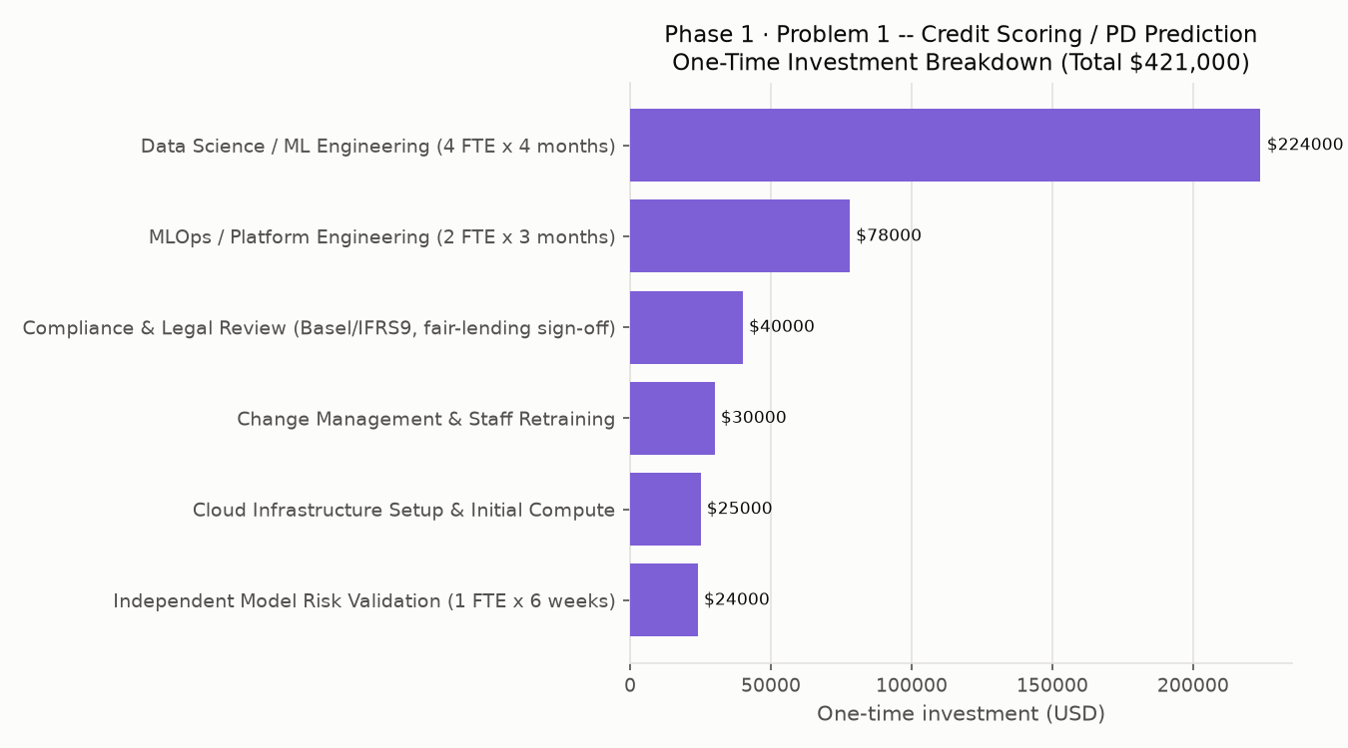

4. Financial Projections (Base Scenario)
Horizon | Cumulative Cost | Cumulative Benefit | Cumulative Net | ROI %
1 Month | $70,167 | $0 | $-70,167 | -100%
3 Months | $210,500 | $0 | $-210,500 | -100%
6 Months | $421,000 | $0 | $-421,000 | -100%
1 Year | $520,000 | $77,196,133 | $76,676,133 | 14745%
2 Years | $718,000 | $341,868,591 | $341,150,591 | 47514%
3 Years | $916,000 | $606,541,048 | $605,625,048 | 66116%
5 Years | $1,312,000 | $1,135,885,962 | $1,134,573,962 | 86477%
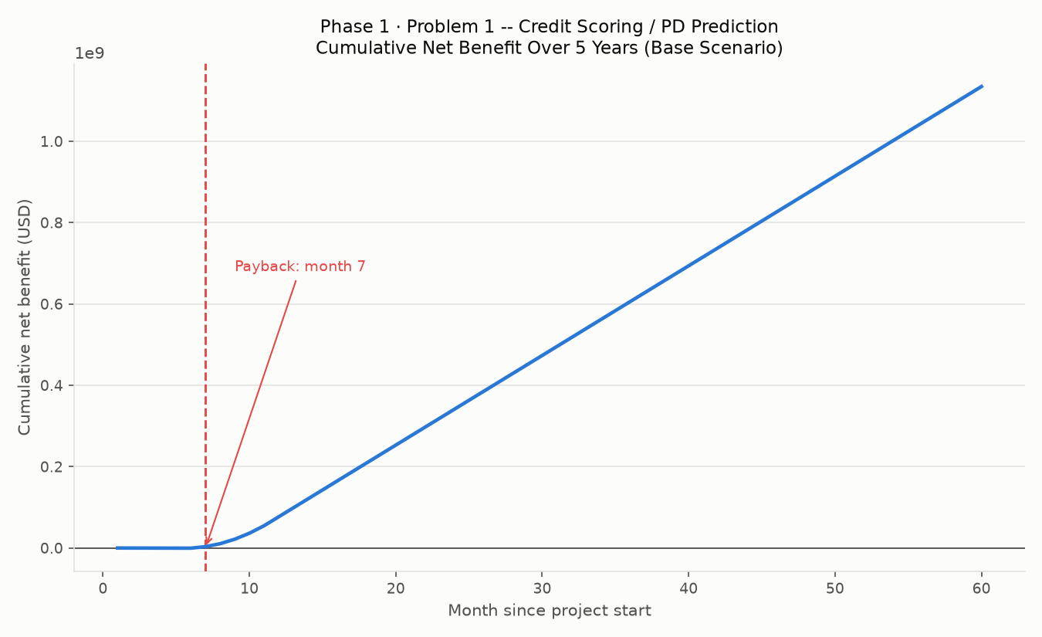
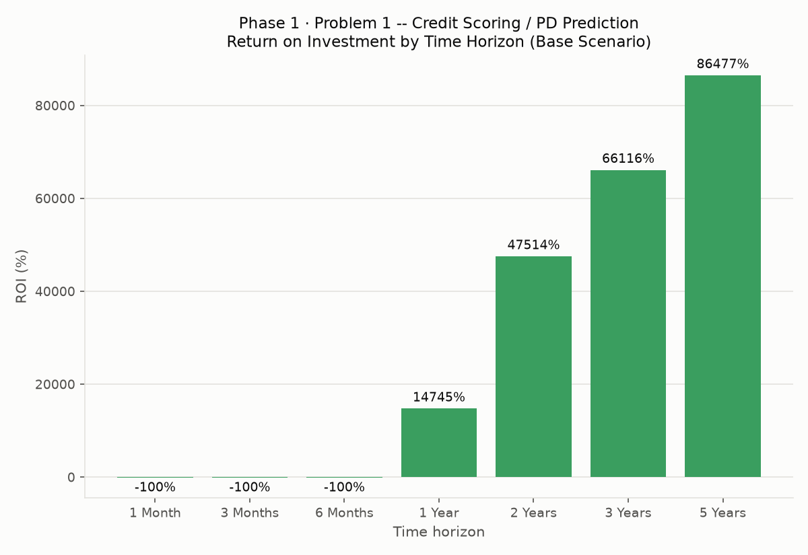
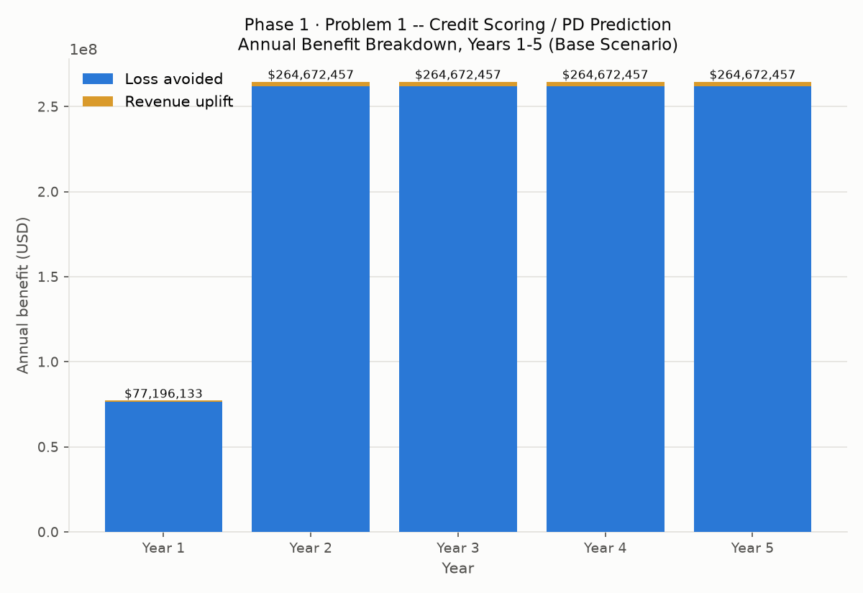

5. Scenario Comparison (Conservative / Base / Optimistic)
Scenarios scale the BENEFIT side only (conservative x0.7, base x1.0, optimistic x1.3) -- costs are held fixed across scenarios since they represent up-front staffing/infrastructure commitments, not outcomes that vary with deployment performance.
Scenario | 5-Year Net Benefit | 5-Year ROI % | Payback (months)
Conservative | $793,808,174 | 60504% | 7
Base | $1,134,573,962 | 86477% | 7
Optimistic | $1,475,339,751 | 112450% | 7

6. Model Performance Basis (Measured)
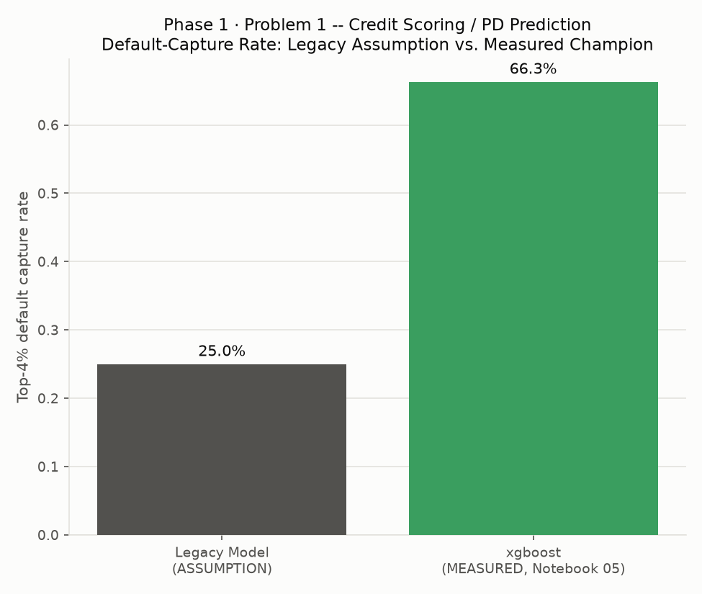
The financial case's loss-avoidance component depends on the measured improvement in Top-4% default capture over the assumed legacy baseline: +41.30% percentage points.

7. Implementation Timeline
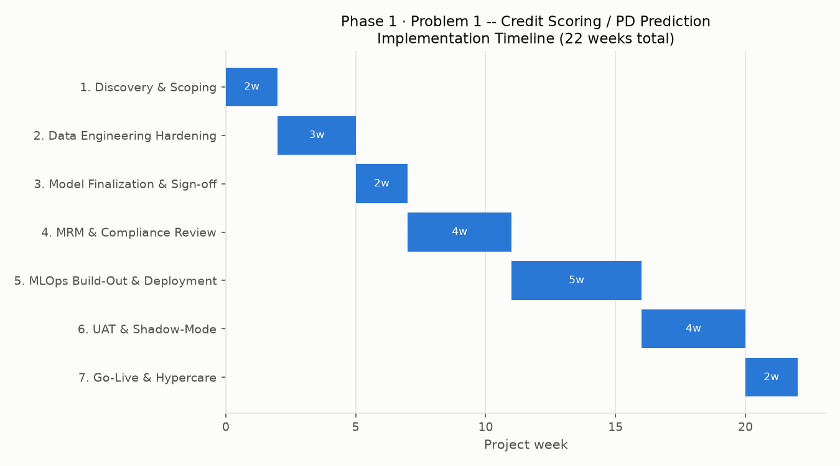
Phase | Start Week | Duration (weeks)
1. Discovery & Scoping | 0 | 2
2. Data Engineering Hardening (productionize Notebooks 02/04 pipelines) | 2 | 3
3. Model Finalization & Sign-off (Notebook 05) | 5 | 2
4. Model Risk Validation & Compliance Review (Notebooks 07/08) | 7 | 4
5. MLOps Build-Out & Deployment (Notebooks 09-11) | 11 | 5
6. UAT & Shadow-Mode Parallel Run | 16 | 4
7. Go-Live & Hypercare | 20 | 2
Total implementation duration: 22 weeks (~5.1 months)

8. Ongoing Monitoring Cost
$16,500/month post go-live, covering cloud hosting/inference, MRM oversight, and amortized quarterly retraining (breakdown in Section 5's monthly recurring cost table).

9. SMART Recommendations by Team

Executive Leadership / CRO
Specific | Approve production deployment funding based on the modeled 5-year net benefit.
Measurable | 5-year cumulative net benefit $1,134,573,962, ROI 86477%, payback in 7 months (base scenario).
Achievable | Champion model measured holdout AMEX metric 0.7936, a real, validated result from Notebook 05.
Relevant | Portfolio-wide default exposure and capital adequacy are the CRO's direct mandate.
Time Bound | Funding decision within 1 sprint of this report; re-review assumptions annually.

Head of Credit Risk / Underwriting
Specific | Replace the legacy scorecard's top-4% flagging logic with the new champion model's output.
Measurable | Measured Top-4% default capture improves from an assumed 25% (legacy) to 66.3% (new model, measured).
Achievable | No new data collection required -- Notebook 05's model scores directly on the existing feature store.
Relevant | Directly drives the loss-avoided component of the financial case.
Time Bound | Cutover during Phase 5-6 of the implementation plan (weeks 11-20).

Model Risk Management / Independent Validation
Specific | Complete (or re-confirm) SR 11-7-style independent validation before go-live.
Measurable | Notebook 07 assigned risk tier 'Tier 2 (Medium)'.
Achievable | Notebook 07 runs PSI, rank-ordering, sensitivity, and challenger-benchmark checks directly against Notebook 05's saved champion.
Relevant | Regulatory and internal governance prerequisite for any credit-decisioning model.
Time Bound | Must complete during Phase 4 (Model Risk Validation & Compliance Review) before Phase 5 begins.

Compliance / Regulatory Affairs
Specific | Complete Basel III / IFRS 9 capital-treatment mapping and fair-lending review.
Measurable | 0 feature(s) flagged with significant population shift (Notebook 07).
Achievable | Notebook 08 (Basel III / IFRS 9 Mapping) produces the required documentation trail.
Relevant | Deployment cannot proceed at a regulated card issuer without this sign-off.
Time Bound | Complete within Phase 4, in parallel with Model Risk Management.

Collections Operations
Specific | Build the intervention workflow (outreach, credit-line adjustment) for accounts newly flagged by the improved model.
Measurable | Assumed 35% intervention success rate drives $262,032,457/year in modeled loss avoidance -- track actual realized success rate against this assumption post go-live.
Achievable | Workflow changes only, no new systems required beyond the model's output feed.
Relevant | Realizing the loss-avoided benefit depends entirely on Collections actually acting on the model's flags.
Time Bound | Operational by end of Phase 6 (UAT & Shadow-Mode).

Data Engineering
Specific | Productionize the Notebook 02/04 Polars feature-store pipeline for daily/real-time scoring.
Measurable | Pipeline must reproduce the same feature set the champion model was trained on (see Notebook 04's engineered feature columns).
Achievable | Pipeline already exists and runs end-to-end in this platform; this is a hardening/scheduling task, not new development.
Relevant | Every downstream number in this report assumes the production feature set matches what Notebook 05 trained on.
Time Bound | Complete during Phase 2 (weeks 2-5).

MLOps / Platform Engineering
Specific | Stand up the FastAPI scoring service, Docker packaging, and monitoring pipeline (Notebooks 09-12).
Measurable | Monthly recurring cost budget: $16,500/month post go-live (assumption, Section 5).
Achievable | Architecture and monitoring triggers (PSI > 0.25) are already defined in this platform's governance docs.
Relevant | Deployment reliability and drift monitoring directly protect the modeled financial benefit from decaying silently.
Time Bound | Complete during Phase 5 (weeks 9-14).

Card Issuing / Product Business Unit
Specific | Adjust approval-policy thresholds to capture the modeled incremental-approval opportunity.
Measurable | $2,640,000/year modeled revenue uplift from a stated 3%-point increase in approvals among 400,000 assumed annual applicants.
Achievable | Requires only a policy-threshold change once the new model's calibration is validated (Notebook 07).
Relevant | New-business revenue is the second major component of the financial case, alongside loss avoidance.
Time Bound | Threshold change effective at go-live (Phase 7).

Finance / CFO Office
Specific | Track realized costs and benefits against this report's modeled figures on a monthly cadence.
Measurable | Total one-time investment $421,000; monthly recurring $16,500; base-scenario payback at month 7.
Achievable | monthly_financial_model.csv (this notebook's own output) gives a ready-made tracking template.
Relevant | Validates or corrects this report's assumptions with real realized figures as they become available.
Time Bound | First realized-vs-modeled variance review at month 3 post go-live, then quarterly.

External Regulator Engagement (e.g. Federal Reserve / OCC)
Specific | Maintain the full documentation trail (Notebooks 01, 05, 07, 08, 14) as supervisory evidence.
Measurable | 9 governance dimensions tracked in Notebook 07's checklist -- current tier: Tier 2 (Medium).
Achievable | Every document already exists as a notebook output; no new artifact type required.
Relevant | SR 11-7 / OCC 2011-12 examinations expect exactly this kind of end-to-end evidentiary trail.
Time Bound | Documentation package finalized before go-live (end of Phase 6).

10. Limitations & Disclaimers
- All dollar figures rest on the stated hypothetical scenario in Sections 4-5, not real AMEX financials -- the Kaggle dataset contains no revenue, cost, or investment data for any institution.
- This report is a worked methodology with editable assumption constants, not investment, accounting, tax, or regulatory advice. Consult your institution's finance, actuarial, and compliance functions before acting on any figure in this report.
- Benefit realization depends on operational execution (e.g. Collections actually acting on model flags) that this report cannot guarantee -- see the SMART recommendations above for the operational prerequisites.

