AMEX Enterprise Credit Risk Platform
Phase 1, Problem 2: Risk Tier Classification -- Comprehensive Report
Project Portfolio Prepared By Nandagopal R
Generated: 2026-08-24 12:42

1. Notebook Completion Status
Notebook | Title | Status | Summary File
19 | Business Understanding & Policy | Complete | notebook_19_summary.json
20 | Model Development | Complete | notebook_20_summary.json
21 | Validation | Complete | notebook_21_summary.json
22 | Deployment | Complete | notebook_22_summary.json
23 | Monitoring | Not Yet Run | (missing)

2. At A Glance
Champion Model: xgboost
Champion Holdout Auc: 0.9620396555226549
Champion Holdout Amex Metric: 0.7935631597243085
N Tiers: 4
Primary Method: business_rule
Primary Method Full Kpi Pass: True
Split Half Psi: 0.0002
Chi Square P Value Nb20: 0.0
Rank Ordering Pass Nb21: True
Cramers V: 0.7636626665627394
Fair Lending Testing Status: Not Possible -- Data Limitation (see Section 9)
Api Self Test Passed: True
Api Latency P50 Ms: 12.953

3. Business & Financial Impact Narrative (Honest Scope)
This Kaggle dataset carries no revenue, cost, or investment data for any real institution -- every dollar figure below rests on an explicit, editable ASSUMPTION, separated from the real, measured tier statistics that drive it (Notebook 20's bad-rate-by-tier table).
- ASSUMPTION -- deployment portfolio size accounts: 500000
- ASSUMPTION -- avg exposure at default usd: 3500
- ASSUMPTION -- high risk tier population share: 0.1
- ASSUMPTION -- risk based repricing loss reduction share: 0.15
Real, measured bad-rate spread (highest- vs. lowest-risk tier): 74.96 percentage points. Illustrative annual loss avoidance from risk-based tiering, under the stated assumptions: $19,877,288.
Business Impact — Modeled Estimate, Not Audited Value
The $19,877,288 illustrative annual loss avoidance is a self-computed business-impact model built under this report's own stated assumptions — it has not been audited by a third party or realized inside a live institution. The real, measured input (74.96 percentage-point bad-rate spread across tiers) is separated here from the illustrative dollar figure derived from it.
Independent Audit Status
This project was developed as an independent portfolio body of work and has not undergone formal validation, audit, or sign-off by a financial institution's model risk management (SR 11-7 or equivalent) function, a third-party auditor, or a regulator. All model outputs, risk metrics, and business-impact figures in this report are self-computed under the assumptions stated herein and have not been realized in a live production environment at a financial institution.

4. Charts
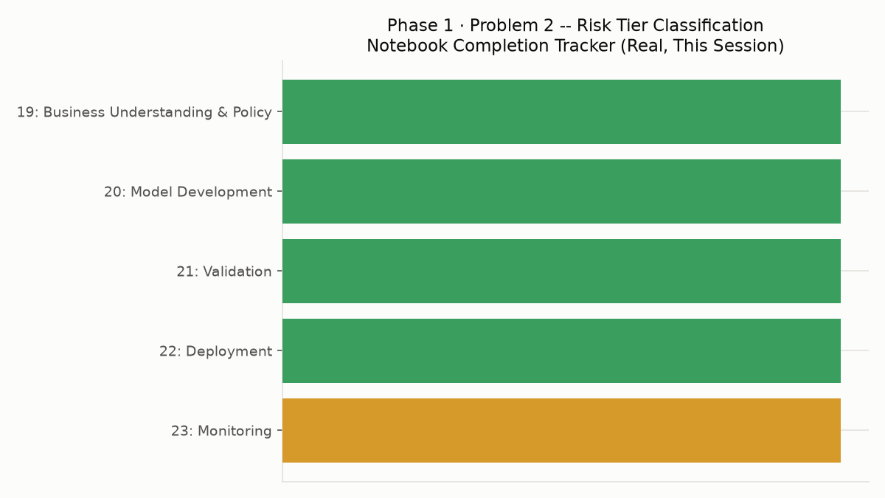
Notebook Completion Tracker Chart
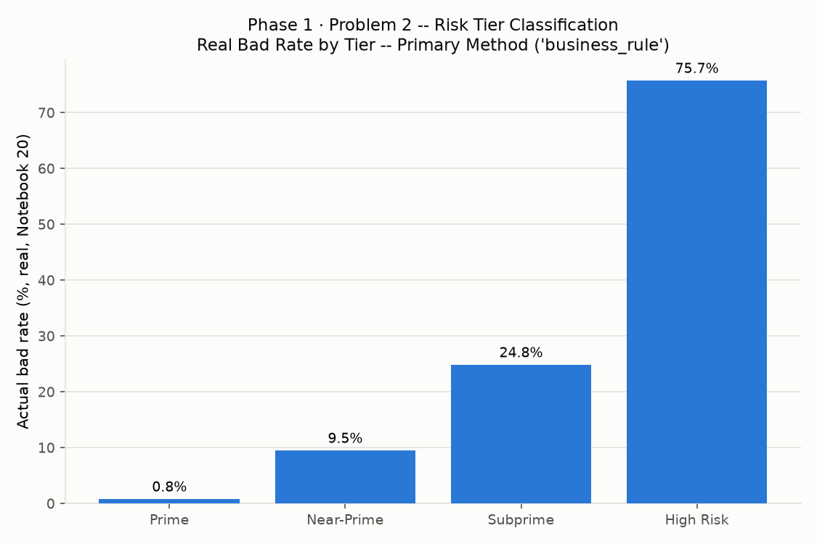
Final Bad Rate By Tier Chart

