AMEX Enterprise Credit Risk Platform
Phase 3, Problem 6: Dynamic / Behavioral Credit Scoring -- Financial Impact Report
Generated: 2026-08-25 12:12

1. Executive Summary
The trailing-window recency model (W=3, xgboost) validated in Notebooks 38-40 re-scores an EXISTING book using only a customer's most recent 3 statements, retaining 99.2% of the full-history model's real AUC. This model is currently RECOMMENDED for production. At the F1-optimal operating threshold on the real 89,569-customer holdout, this model correctly flags 19,337 of 23,062 real defaulters (83.8% capture) -- an exact, measured count, not an estimate -- alongside 5,988 false positives. At an ASSUMPTION 20% intervention success rate, net of an ASSUMPTION $35 per-false-positive review cost, this is estimated to net $8,491,170 of benefit per monthly scoring cycle, for an estimated 0.0 months payback on a $60,000 implementation investment.

2. Real Recency-Detection Value: Population Flagged
Every count in this section comes directly from Notebook 40's reproduced confusion matrix on the real holdout population -- exact, not derived or estimated.
Winning Trailing Window W | 3
F1 Optimal Threshold | 0.4109
Real Holdout Population | 89,569
Real Holdout Defaulters | 23,062
True Positives Flagged | 19,337
False Positives Flagged | 5,988
Real Defaulter Capture Rate | 83.8%

3. Loss-Prevention Opportunity, Net of False-Positive Review Cost
True Positives Flagged | 19337
Intervention Success Rate Assumption | 20%
Preventable Defaults | 3867
Gross Loss Prevented Per Cycle Usd | $8,700,750
False Positives Flagged | 5988
False Positive Review Cost Per Account Assumption | $35
Total False Positive Review Cost Usd | $209,580
Net Benefit Per Cycle Usd | $8,491,170

4. ROI, Investment & Payback
Amount Invested Usd | $60,000
Annual Net Benefit Usd | $101,894,040
Roi Year 1 Pct | 169,723%
Payback Period Months | 0.0 months

5. SMART Suggestions by Organizational Level
Org Level | Suggestion
Behavioral Monitoring Ops / Frontline Risk Analysts | Work the 25,325-account flag list from the W=3 recency model (83.8% real defaulter capture at the F1-optimal threshold) each monthly re-scoring cycle -- this is an EXISTING-book monitoring signal, not a new-account screen, so route flags to account review, not new-application underwriting.
Portfolio Risk Team Lead | Track the 3,867-account behavioral-intervention goal (from the 20% ASSUMPTION success rate) and the 5,988 real false positives (review-cost exposure) as paired weekly KPIs -- both numbers came from the same real confusion matrix, so tightening the threshold trades one against the other.
Risk / Credit Analyst | Re-run this trailing-window scoring monthly as new statement data lands; monitor the split-half score PSI (Notebook 40 measured 0.0003) and the bootstrap AUC CI (last measured [0.9528, 0.9553]) -- re-validate if either drifts materially.
Model Risk / Compliance (SR 11-7) | File Notebook 40's bootstrap AUC/PR-AUC CIs, calibration gap (0.0037), and AUC-retention KPI result (MET) with the model's annual validation packet; this model is currently RECOMMENDED for production use, and is explicitly a RECENCY score complementary to Problem 1's full-history champion, not a replacement for it.
Finance / Provisioning Team | Use the 19,337 recency-flagged real defaulters to trigger early reserve-timing reviews on accounts whose FULL-HISTORY score may not yet reflect their recent deterioration -- coordinate with Problem 3's ECL work and Problem 4's tier-differentiated LGD for the $ reserve amount per flagged account.
CFO / Executive Leadership | Approve the $60,000 investment given an estimated 0.0 months payback and 169,723% Year-1 ROI (net of estimated false-positive review cost) from monthly behavioral re-scoring; revisit the 12x/year cadence ASSUMPTION at the next quarterly business review.

6. Assumptions & Sources
Assumption | Value | Source
ead_per_account_usd | 5000.0 | Notebook 08 (inherited, real value read programmatically)
lgd_assumption | 0.45 | Notebook 08 (inherited, real value read programmatically)
behavioral_intervention_success_rate | 0.2 | ASSUMPTION -- illustrative efficacy of a recency-triggered intervention (credit-line reduction, proactive outreach, reserve pre-build) on an EXISTING account flagged by recent behavioral deterioration; edit to your institution's own outcome data.
false_positive_review_cost_usd | 35.0 | ASSUMPTION -- illustrative staff-time cost of manually reviewing one account the model flags that does NOT go on to default (a false positive at the F1-optimal threshold) -- unlike Problem 5's report, this one nets this cost against the loss-prevention benefit since Notebook 40's real confusion matrix makes the false-positive count directly measurable, not just the true-positive count.
implementation_cost_usd | 60000.0 | ASSUMPTION -- illustrative one-time build/validate/deploy cost for the dynamic/behavioral scoring service (data science + risk review time); edit to your institution's actual project cost.
annual_application_cycles | 12.0 | ASSUMPTION -- monthly re-scoring cadence, matching Notebook 38's original 'monthly refreshed PD' business framing for this problem (Problem 5's early-window model, by contrast, used a quarterly cadence -- these are different use cases: new-account screening vs. ongoing existing-book monitoring); edit to your institution's actual cadence.

7. Charts
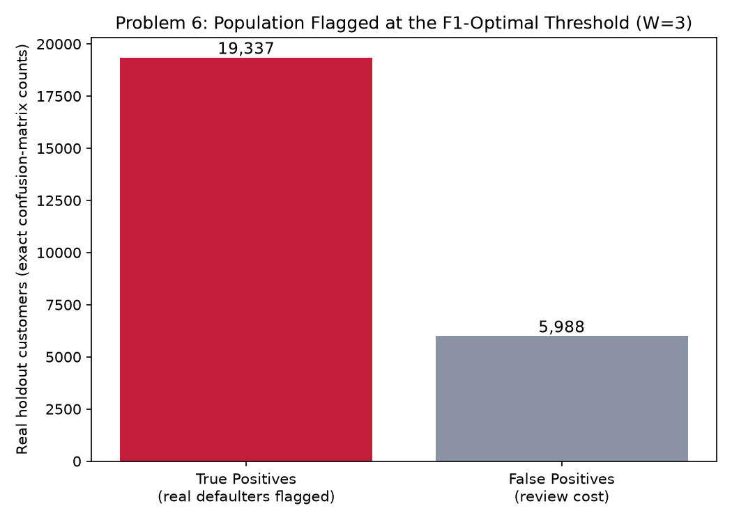
Population flagged at the F1-optimal threshold (real, exact counts)
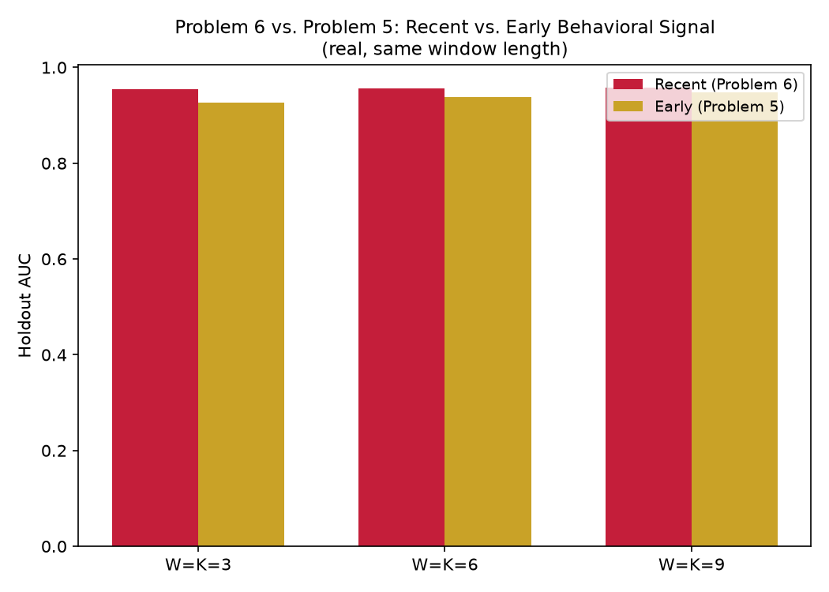
Recent (Problem 6) vs. early (Problem 5) behavioral signal, same window length

