AMEX Enterprise Credit Risk Platform
Phase 3, Problem 6: Dynamic / Behavioral Credit Scoring -- Validation & Deployment Report
Generated: 2026-08-25 11:56

1. Scope & Selected Window
Statistical validation and deployment packaging for the trailing-window model at W=3 most-recent statements, selected from Notebook 39's real AUC-retention curve across candidates [3, 6, 9]. This window meets Notebook 38's AUC-retention KPI target.

2. Full Classification Metrics-Suite Validation Summary
Per the platform's standing metrics-suite directive (effective Problem 6 onward): every metric below is a real, measured value reproduced independently in this notebook, cross-checked against Notebook 39's originally-reported numbers (see Section 6's reproduction check).
Test | Value | Target | Pass
Holdout AUC-ROC (reproduced) | 0.9541 | >0.5 | True
Holdout AUC-ROC 95% CI lower bound | 0.9528 | >0.5 | True
Holdout PR-AUC (reproduced) | 0.8796 | >0.2575 (no-skill) | True
Holdout PR-AUC 95% CI lower bound | 0.8759 | >0.2575 (no-skill) | True
Holdout Log Loss (reproduced) | 0.2367 | <0.6931 | True
Holdout AMEX competition metric (reproduced) | 0.7609 | >0 | True
Accuracy @ 0.50 threshold | 0.8937 | reported | True
Precision @ 0.50 threshold | 0.7991 | reported | True
Recall @ 0.50 threshold | 0.7843 | reported | True
F1 @ 0.50 threshold | 0.7916 | reported | True
Specificity @ 0.50 threshold | 0.9316 | reported | True
MCC @ 0.50 threshold | 0.7203 | >0 | True
Accuracy @ F1-optimal threshold (0.411) | 0.8916 | reported | True
Precision @ F1-optimal threshold (0.411) | 0.7636 | reported | True
Recall @ F1-optimal threshold (0.411) | 0.8385 | reported | True
F1 @ F1-optimal threshold (0.411) | 0.7993 | reported | True
Specificity @ F1-optimal threshold (0.411) | 0.91 | reported | True
MCC @ F1-optimal threshold (0.411) | 0.7267 | >0 | True
Mean calibration gap (deciles) | 0.0037 | <0.05 | True
Split-half score PSI | 0.0003 | <0.1 | True
AUC retention vs. full history (W=3) | 99.2 | >=80% | True

3. Honest Limitation -- Deployment Scope & Assumptions
Trailing Window Assumption: This model was trained and validated on customers' MOST RECENT 3 chronological statements ONLY. It is a RECENCY score, not a replacement for Problem 1's full-history champion -- both can coexist operationally: the full-history model for static book-wide PD, this model for re-scoring using a customer's latest observed behavior. It assumes exactly (or at least) 3 real statements are available at scoring time; customers with fewer are out of scope for this model.
Kpi Status: MEETS the 80% AUC-retention KPI set in Notebook 38.
Data Limitation: Same limitation Notebook 38 documented: this dataset has exactly one eventual-default label per customer, no month-by-month ground truth -- so this model still predicts the SAME real eventual-default outcome as Problem 1, only from a restricted (recent-only) feature snapshot, not a genuinely re-labeled 'default in the next N months' target.
Feature Space Leakage Note: Reuses Problem 4's real, correlation-filtered feature list, re-aggregated per window from ONLY the trailing statements (not Problem 4's precomputed severity tier, which would leak full-history information into a short-window snapshot) -- see Notebook 38 Section 8.
Single Architecture Scope: Only the champion architecture (xgboost) was evaluated (see Notebook 39's Section 7 scope note) -- windowed GBM only; the LSTM alternative the master plan also names was explicitly deferred as a future extension in Notebook 38 Section 9, not built in this pass.

4. Deployment Readiness Checklist
Dimension | Status
Model reproducibility | PASS
Full metrics-suite statistical validation (all checks) | PASS
AUC-retention KPI (Notebook 38 target) | MET
Model + preprocessing artifacts persisted | PASS
API self-test (live, generated service) | PASS
API p99 latency < 500ms | PASS
Overall recommendation | RECOMMENDED FOR PRODUCTION

5. API Performance
Latency over 150 real TestClient calls to /score: p50=15.702ms, p95=19.805ms, p99=22.527ms, max=23.389ms.

6. Charts
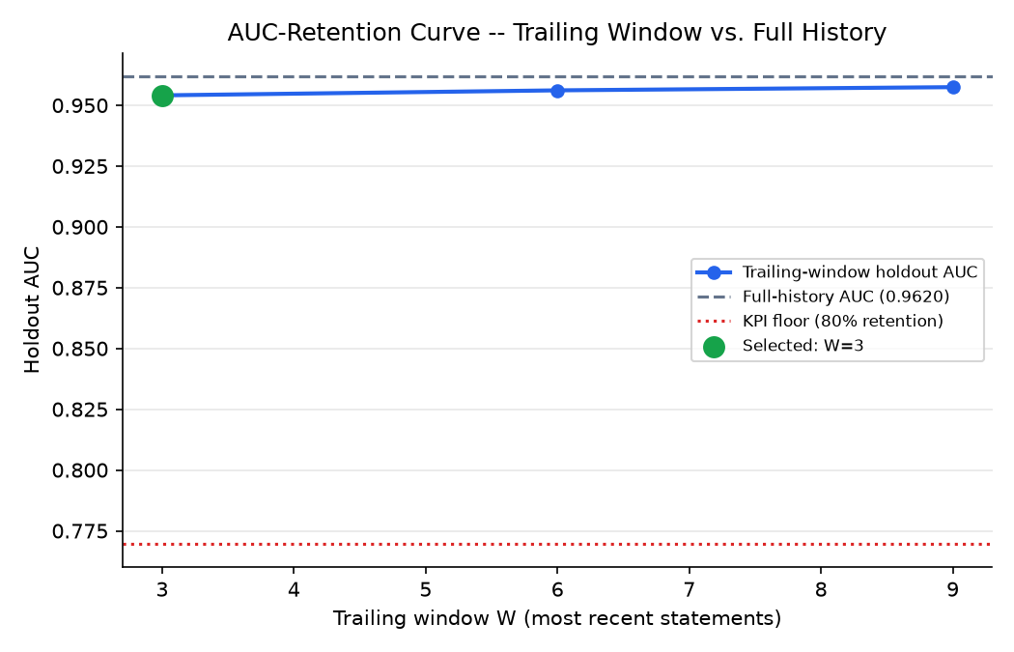
AUC-retention curve across candidate trailing windows
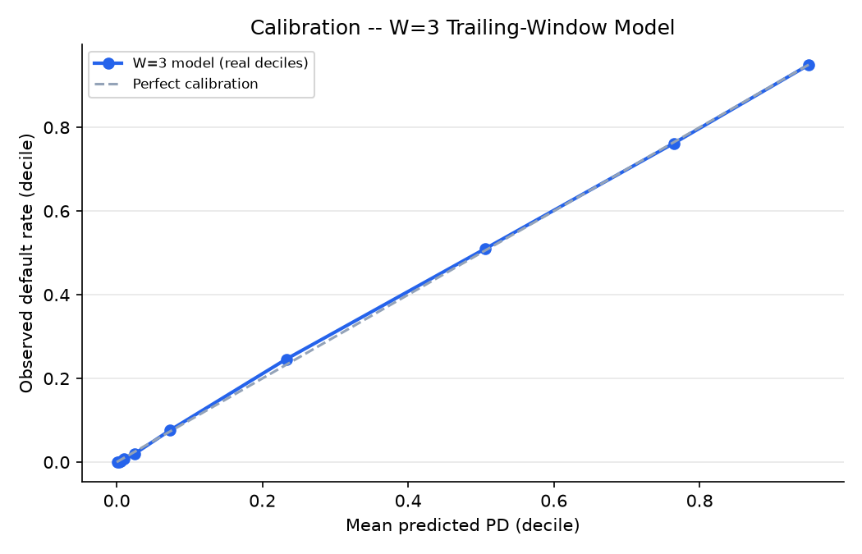
Calibration -- W=3 model, real holdout deciles
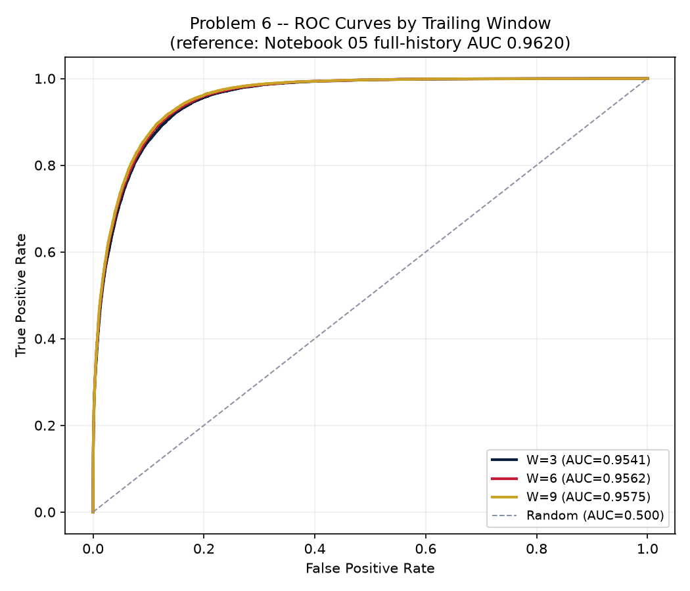
ROC curves by trailing window (from Notebook 39)
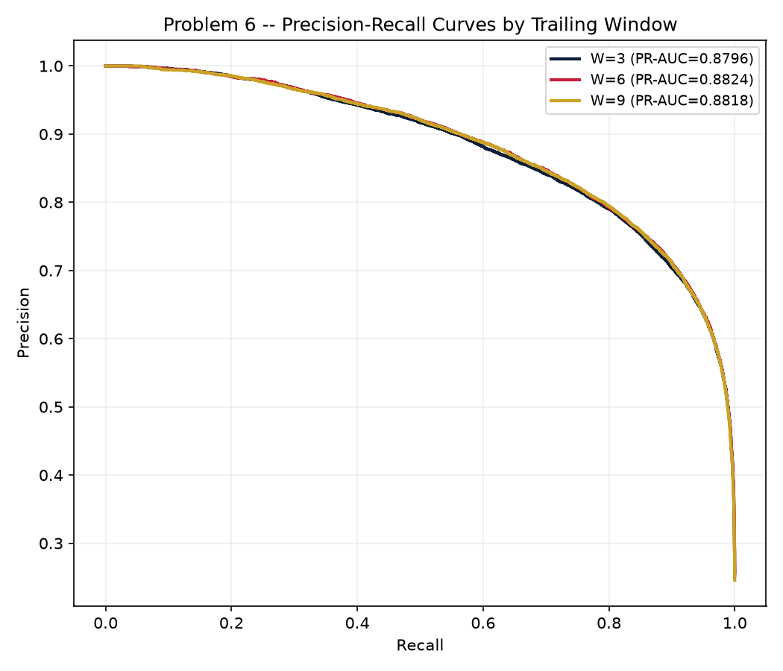
Precision-Recall curves by trailing window (from Notebook 39)

