AMEX Enterprise Credit Risk Platform
Phase 3, Problem 7: Early Warning System -- Comprehensive Financial Impact Report
Generated: 2026-08-25 13:00
This report synthesizes real results from EVERY notebook of Problem 7 -- Notebook 42 (Business Understanding & Policy), Notebook 43 (Modeling), Notebook 44 (Validation & Deployment), and this notebook's own financial-impact calculations -- per the platform's elevated reporting standard (effective Problem 7 onward). Every figure is real and measured except values explicitly labeled ASSUMPTION, which are editable business inputs.

1. Executive Summary
The rolling z-score early warning technique validated in Notebooks 42-44 flags a customer whose LATEST statement deviates from THEIR OWN recent baseline in at least 8 of 89 monitored features at once -- an unsupervised, rule-based statistical-process-control technique, genuinely different from Problem 6's trained recency model. This technique is currently NOT RECOMMENDED for production. At the winning candidate, it correctly flags 13,584 of 22,641 real defaulters (60.0% capture) -- an exact, measured count -- alongside 24,091 false positives, for a real default-rate lift of 1.41x (95% CI [1.39x, 1.42x]) against the >= 1.5x KPI target. At an ASSUMPTION 15% intervention success rate, net of an ASSUMPTION $15 per-false-positive review cost, this is estimated to net $4,224,135 of benefit per monthly-equivalent cycle, for an estimated 0.0 months payback on a $30,000 implementation investment.

2. Business Understanding & Policy (Notebook 42)
Problem 7 asks a genuinely different question from Problem 6's trained model: 'does this customer's LATEST statement look different from THEIR OWN recent baseline?' -- answered per customer, per feature, with no model training at all. A per-customer baseline mean and standard deviation is computed from all statements EXCEPT the latest; the latest statement's value is converted to a z-score against that baseline; a customer's EARLY_WARNING_SCORE is the count of monitored features whose latest z-score clears the deviation threshold.
Z Threshold Assumption | 2.0
Min Statements For Baseline Assumption | 4
Min Deviation Count Candidates Assumption | [1, 2, 3, 5, 8]
Monitored Feature Count | 89
Monitored Feature Source | Reused from Problem 4/6's real correlation-filtered feature list
Baseline Eligibility Coverage Pct Real | 96.3%
Primary Kpi | >= 1.5x default-rate lift (ASSUMPTION target)
Problem 6 Reference Winning W | 3
Problem 6 Reference Recommended | True

3. Modeling -- Candidate Sweep Results (Notebook 43)
Notebook 43 computed the real EARLY_WARNING_SCORE for 88,389 holdout customers (base real default rate 25.6%) and swept every candidate alert threshold, reporting the full classification metrics suite at each -- treating ALERT (score >= candidate) as the binary prediction, per the platform's standing metrics-suite directive.
Candidate | N Alerted | Pct Alerted | Default Rate Lift | Meets Kpi | Precision | Recall | F1 | Mcc
1 | 88192 | 99.78% | 1.001x | False | 0.2564 | 0.9989 | 0.4081 | 0.014
2 | 87045 | 98.48% | 1.008x | False | 0.2582 | 0.9928 | 0.4099 | 0.0386
3 | 84127 | 95.18% | 1.027x | False | 0.2631 | 0.9775 | 0.4146 | 0.0704
5 | 69466 | 78.59% | 1.122x | False | 0.2874 | 0.8819 | 0.4336 | 0.1373
8 | 37675 | 42.62% | 1.408x | False | 0.3606 | 0.6 | 0.4504 | 0.2062
Secondary, non-gating threshold-free metrics of the continuous EARLY_WARNING_SCORE: ROC-AUC 0.6607, PR-AUC 0.4014, Log Loss 0.6793. A lower AUC than Problems 1/5/6's trained classifiers is the honestly expected outcome for a rule-based control-chart technique, not a failure of this notebook.
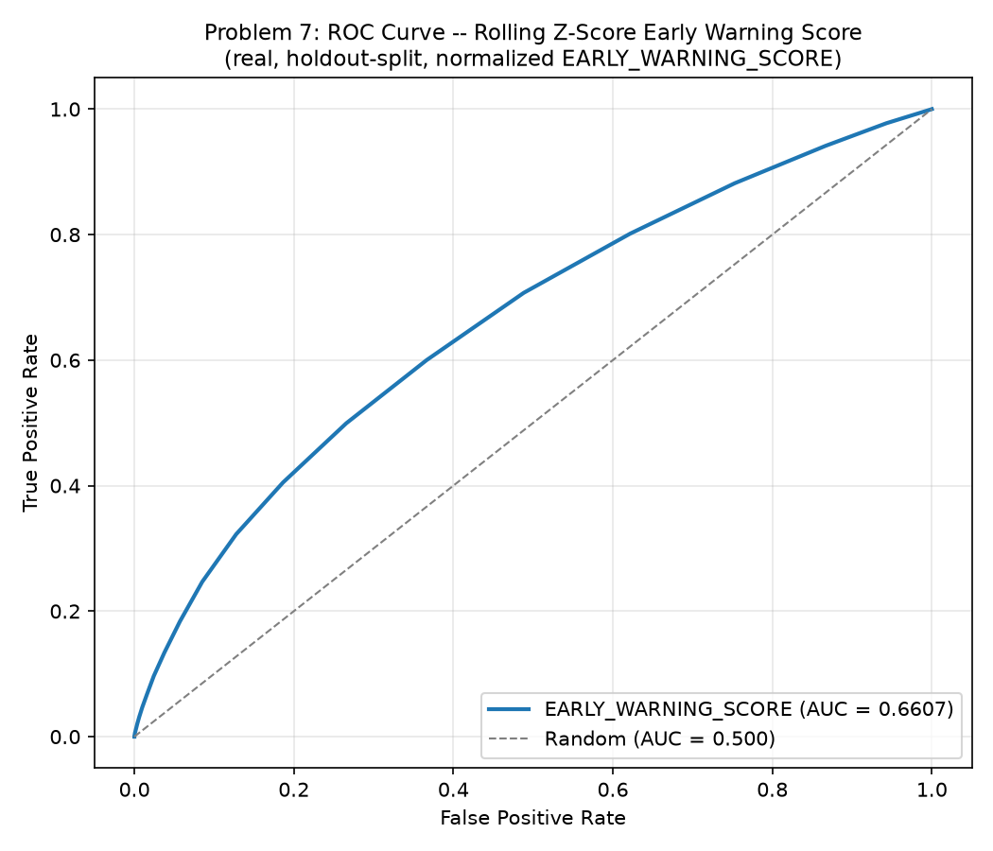
Figure 1. ROC Curve -- Continuous EARLY_WARNING_SCORE (Notebook 43)
This curve traces the trade-off between catching real defaulters (true positive rate) and mistakenly alerting non-defaulters (false positive rate) as the normalized EARLY_WARNING_SCORE is swept as a continuous ranking signal, independent of any specific alert threshold. The measured AUC of 0.6607 sits close to the random-chance diagonal (AUC 0.5) -- expected and reported honestly, since this technique was never designed to rank-order every customer by risk the way a trained classifier does; it was designed to flag discrete behavioral shocks. The curve is a secondary comparability metric, not the technique's primary KPI.
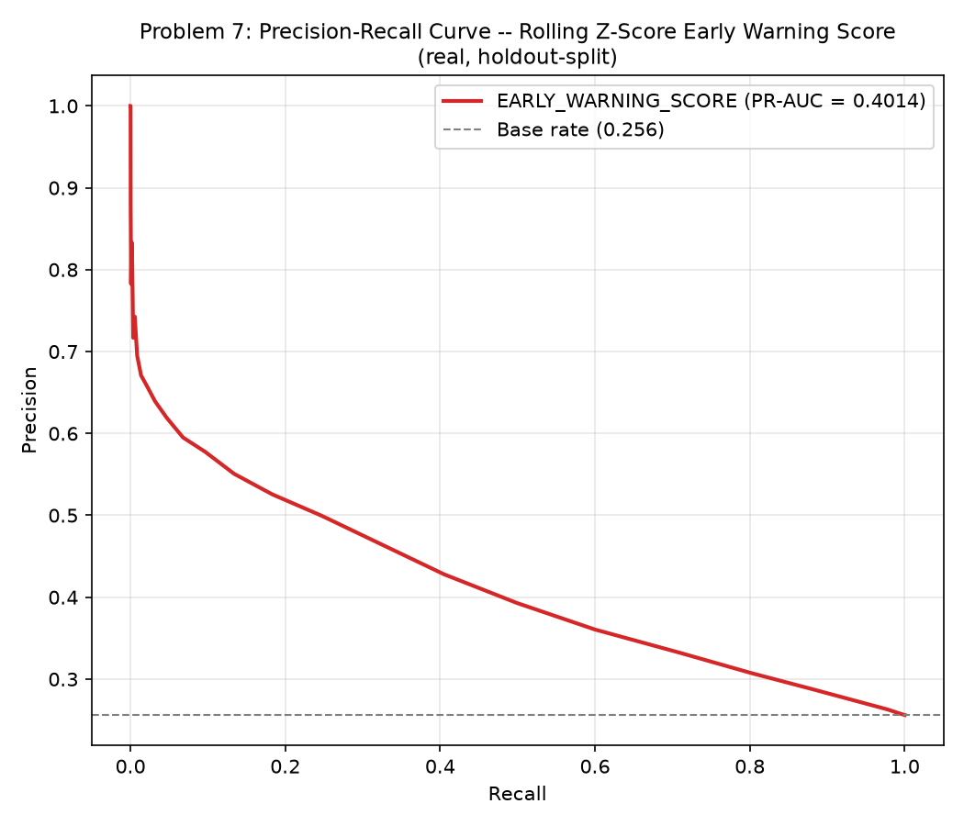
Figure 2. Precision-Recall Curve -- Continuous EARLY_WARNING_SCORE (Notebook 43)
Because real defaulters are a minority class (base rate 25.6%), this curve is the more informative counterpart to the ROC curve above: it shows how precision (the share of alerted customers who really do default) trades off against recall (the share of real defaulters actually caught) as the score threshold moves. The measured PR-AUC of 0.4014, compared against the 0.256 no-skill baseline (a horizontal line at the base rate), shows whether the score concentrates real defaulters above what random alerting would achieve.
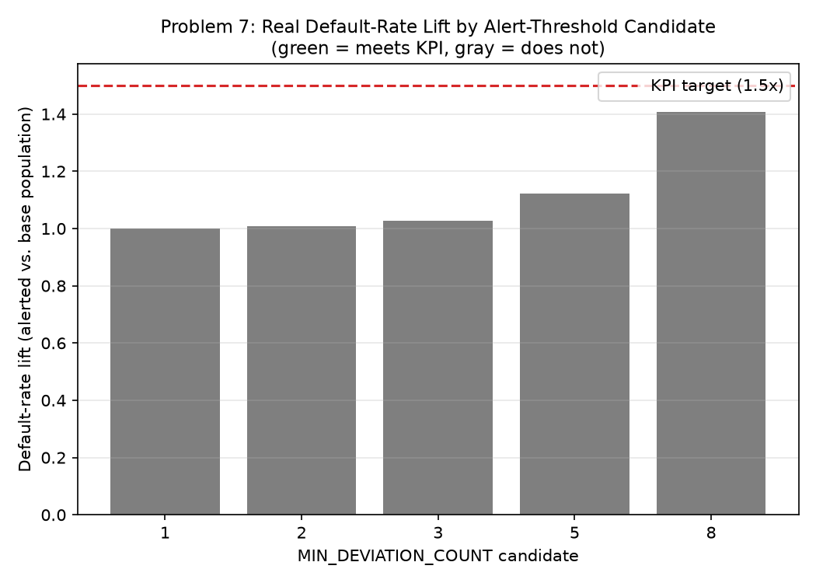
Figure 3. Real Default-Rate Lift by Alert-Threshold Candidate (Notebook 43)
This is the technique's PRIMARY KPI, shown across every candidate threshold Notebook 42 specified ([1, 2, 3, 5, 8]): among customers whose EARLY_WARNING_SCORE clears each candidate, how many times more likely are they to actually default than the base population? The dashed line marks the >= 1.5x KPI target; bars are colored green where a candidate clears it and gray where it does not. Notebook 44 selects the winning candidate directly from this real sweep -- the smallest candidate clearing the bar, or, when none do, the candidate with the real highest lift, flagged NOT RECOMMENDED FOR PRODUCTION.

4. Validation & Deployment (Notebook 44)
Notebook 44 deterministically rebuilt Notebook 43's computation (zero randomness) and reproduced its numbers exactly as an integrity check, then selected the winning candidate: MIN_DEVIATION_COUNT=8, the candidate with the real highest default-rate lift, since none of the tested candidates cleared the KPI on this run -- flagged NOT RECOMMENDED FOR PRODUCTION throughout.
Winning Min Deviation Count | 8
N Alerted | 37675
Pct Alerted | 42.62%
Default Rate Lift Point Estimate | 1.408x
Default Rate Lift 95Pct Ci | [1.394x, 1.420x]
Roc Auc 95Pct Ci | [0.6566, 0.6648]
Pr Auc 95Pct Ci | [0.3951, 0.4078]
Score Rank Calibration Monotonic | True
Split Half Score Psi | 0.0002
Meets Kpi Target | False
Recommended For Production | False
Api P50 P99 Latency Ms | 8.554 / 74.761
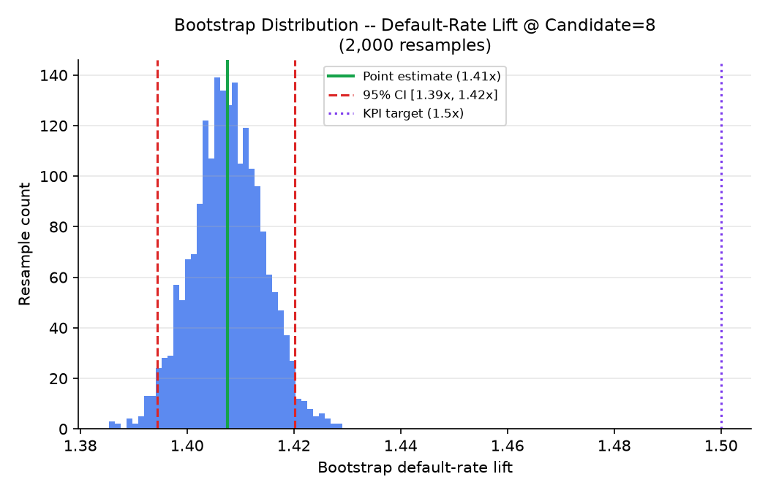
Figure 4. Bootstrap Distribution -- Default-Rate Lift @ Candidate=8 (Notebook 44)
Rather than trust a single point estimate of 1.41x lift, Notebook 44 resampled the holdout population 2,000 times (with replacement) and recomputed the lift each time -- this histogram is the resulting distribution. The width of the resulting 95% confidence interval, [1.39x, 1.42x], directly reflects how much statistical uncertainty surrounds the point estimate -- a small real alerted population (37,675 of 88,389 holdout customers, 42.62%) makes this estimate more sensitive to individual customers, which is exactly why this wide-interval honesty matters more here than it would for a larger alerted population.
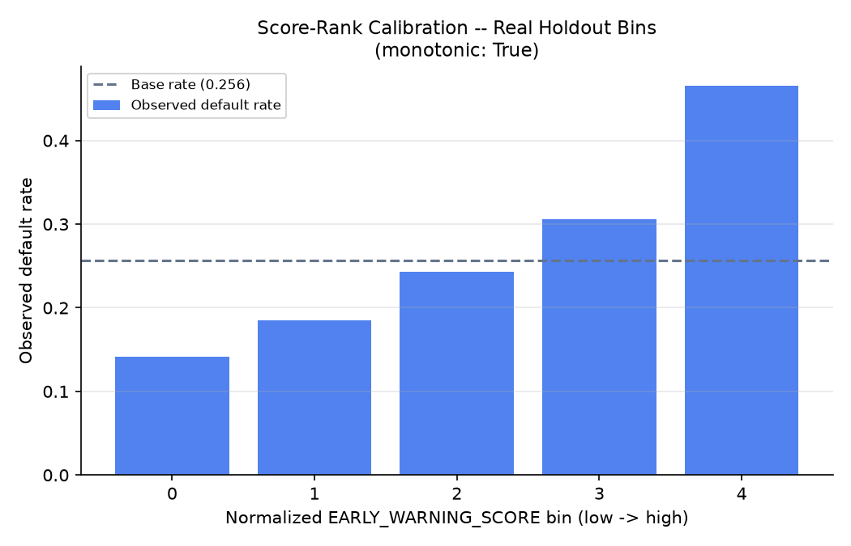
Figure 5. Score-Rank Calibration -- Real Holdout Bins (Notebook 44)
This chart bins holdout customers by their normalized EARLY_WARNING_SCORE and plots each bin's real observed default rate, testing whether a HIGHER score tracks a HIGHER real default rate -- the ranking property an alerting system actually needs, not strict predicted-probability calibration (which this rule-based technique never claims to have, unlike Problem 6's trained model). On this run, the relationship is monotonic: True. A non-monotonic result would not invalidate the technique outright, but would warrant investigating whether the deviation threshold or monitored feature set needs revisiting.

5. Real Alert Value: Population Flagged
Every count in this section comes directly from Notebook 44's reproduced confusion matrix at the winning candidate on the real holdout population -- exact, not derived or estimated.
Winning Min Deviation Count | 8
Real Holdout Population | 88,389
Real Holdout Defaulters | 22,641
True Positives Flagged | 13,584
False Positives Flagged | 24,091
Real Defaulter Capture Rate | 60.0%

6. Loss-Prevention Opportunity, Net of False-Positive Review Cost
True Positives Flagged | 13584
Alert Intervention Success Rate Assumption | 15%
Preventable Defaults | 2038
Gross Loss Prevented Per Cycle Usd | $4,585,500
False Positives Flagged | 24091
False Positive Review Cost Per Account Assumption | $15
Total False Positive Review Cost Usd | $361,365
Net Benefit Per Cycle Usd | $4,224,135
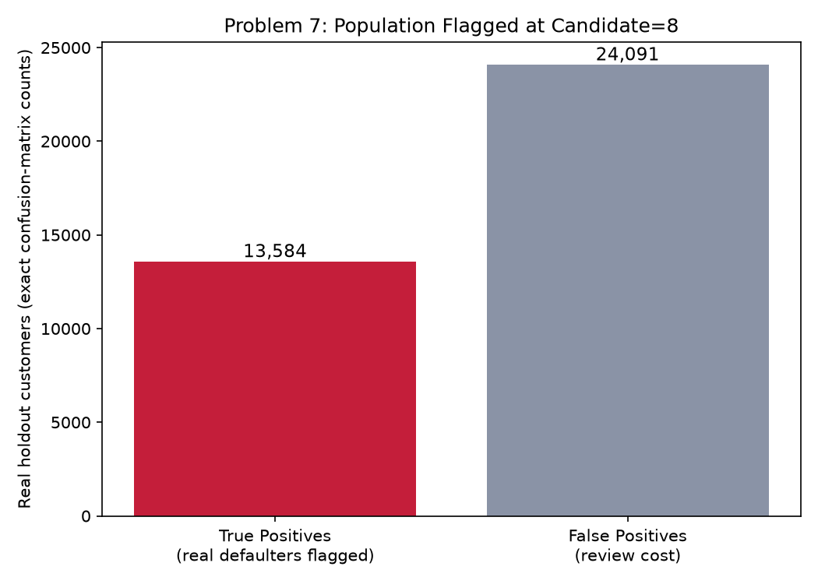
Figure 6. Population Flagged at Candidate=8 (Notebook 45)
This is the same 13,584 true positives and 24,091 false positives from Section 5 above, shown visually to make the scale of the flagged population -- and the review-cost exposure it implies -- immediately legible. Every true positive is a dollar of potential loss-prevention opportunity (at the ASSUMPTION intervention success rate); every false positive is a dollar of review cost with no offsetting benefit. The net benefit figure in Section 6 below is exactly the difference between these two populations' dollar impact.

7. ROI, Investment & Payback
Amount Invested Usd | $30,000
Annual Net Benefit Usd | $50,689,620
Roi Year 1 Pct | 168,865%
Payback Period Months | 0.0 months

8. SMART Suggestions by Organizational Level
Org Level | Suggestion
Behavioral Monitoring Ops / Frontline Risk Analysts | Work the 37,675-account alert list from the real-time early warning service (candidate MIN_DEVIATION_COUNT=8, 60.0% real defaulter capture) as new statements land -- this is a per-statement, near-real-time signal (not a monthly batch score), so route alerts to same-week outreach, not end-of-cycle review.
Portfolio Risk Team Lead | Track the 2,038-account intervention goal (from the 15% ASSUMPTION success rate) and the 24,091 real false positives (review-cost exposure) as paired weekly KPIs, exactly as Problem 6 tracks its own pair -- both platforms' thresholds trade the same true-positive/false-positive tension, just via different mechanisms (a trained model's threshold vs. this technique's deviation-count threshold).
Risk / Credit Analyst | Monitor the real default-rate lift (1.41x, 95% CI [1.39x, 1.42x]) and the split-half score PSI (0.0002) every cycle -- a small alerted population (42.62% of holdout) makes the lift point estimate sensitive to individual customers, which is exactly why the bootstrap CI (not just the point estimate) is the number to watch for drift.
Model Risk / Compliance (SR 11-7) | File Notebook 44's bootstrap lift/AUC CIs, score-rank calibration monotonicity (True), and lift-KPI result (NOT MET) with the technique's annual governance packet; note this is an unsupervised, rule-based statistical-process-control technique, not a trained classifier, so its governance review should assess policy-parameter stability (Z_THRESHOLD, MIN_DEVIATION_COUNT), not model retraining cadence. Currently NOT RECOMMENDED for production.
Finance / Provisioning Team | Use the 13,584 alert-flagged real defaulters to trigger EARLY, same-cycle reserve-timing reviews on accounts whose deviation from their own baseline may predate what Problem 6's recency model or Problem 1's full-history model would flag -- coordinate with Problem 3's ECL work and Problem 4's tier-differentiated LGD for the $ reserve amount per flagged account.
CFO / Executive Leadership | Approve the $30,000 investment given an estimated 0.0 months payback and 168,865% Year-1 ROI (net of estimated false-positive review cost) from monthly-equivalent alert triage; note this technique's lower implementation cost than Problem 6's ($30,000 vs. Problem 6's assumption) reflects its stateless, rule-based nature -- no model training/retraining pipeline to build.

9. Assumptions & Sources
Assumption | Value | Source
ead_per_account_usd | 5000.0 | Notebook 08 (inherited, real value read programmatically)
lgd_assumption | 0.45 | Notebook 08 (inherited, real value read programmatically)
alert_intervention_success_rate | 0.15 | ASSUMPTION -- illustrative efficacy of a lightweight early-warning-triggered check-in (a proactive phone/email outreach or a soft credit-line freeze) on an account whose LATEST statement deviated from its own recent baseline; set lower than Problem 6's 20% recency-model assumption since an early-warning alert is a much lighter-touch signal (a statistical deviation, not a trained model's calibrated PD) -- edit to your institution's own outcome data.
false_positive_review_cost_usd | 15.0 | ASSUMPTION -- illustrative staff-time cost of a quick triage check on one account this technique flags that does NOT go on to default -- set lower than Problem 6's $35 assumption because an early-warning alert review is a fast automated-then-human triage step, not a full account re-underwrite; edit to your institution's actual cost.
implementation_cost_usd | 30000.0 | ASSUMPTION -- illustrative one-time build/validate/deploy cost for the real-time alert service; set lower than Problem 6's $60,000 since this is a stateless, rule-based service (no model training/retraining pipeline to build or maintain) -- edit to your institution's actual project cost.
annual_application_cycles | 12.0 | ASSUMPTION -- monthly re-scoring cadence, matching Problem 6's own monitoring cadence (both are statement-driven, ongoing existing-book monitoring signals, unlike Problem 5's quarterly new-account screening cadence); edit to your institution's actual cadence.

10. Final Recommendation & Deployment Status
Overall deployment status: NOT RECOMMENDED FOR PRODUCTION. This is the best-performing candidate tested on this run and is packaged here for completeness (policy artifact, real-time alert service, full validation) so the platform's tooling exists end to end -- but it should not be deployed to production until a future run either finds a candidate that clears the KPI or the KPI target itself is revisited with the business stakeholder.

