AMEX Enterprise Credit Risk Platform
Phase 3, Problem 7: Early Warning System -- Validation & Deployment Report
Generated: 2026-08-25 12:55

1. Scope & Selected Alert Threshold
Statistical validation and deployment packaging for the rolling z-score early warning technique at MIN_DEVIATION_COUNT=8, selected from Notebook 43's real default-rate-lift sweep across candidates [1, 2, 3, 5, 8]. IMPORTANT: none of the tested candidates met Notebook 42's default-rate lift KPI on this real run -- this is the best-performing candidate (highest real lift), packaged for completeness, and is NOT RECOMMENDED FOR PRODUCTION until a future run finds a viable candidate.

2. Full Classification Metrics-Suite Validation Summary
Per the platform's standing metrics-suite directive (effective Problem 6 onward): every metric below is a real, measured value reproduced independently in this notebook, cross-checked against Notebook 43's originally-reported numbers (see Section 7-8's reproduction check).
Test | Value | Target | Pass
Default-rate lift @ candidate=8 (reproduced) | 1.408 | >=1.5x | False
Lift 95% CI lower bound | 1.394 | >1.0x | True
ROC-AUC (reproduced, secondary) | 0.6607 | >0.5 (reported) | True
ROC-AUC 95% CI lower bound | 0.6566 | >0.5 (reported) | True
PR-AUC (reproduced, secondary) | 0.4014 | >0.2562 (no-skill, reported) | True
Log Loss (reproduced, secondary) | 0.6793 | <0.6931 (reported) | True
Accuracy @ candidate=8 | 0.625 | reported | True
Precision @ candidate=8 | 0.3606 | reported | True
Recall @ candidate=8 | 0.6 | reported | True
F1 @ candidate=8 | 0.4504 | reported | True
Specificity @ candidate=8 | 0.6336 | reported | True
MCC @ candidate=8 | 0.2062 | reported | True
Score-rank calibration monotonicity | True | True | True
Split-half score PSI | 0.0002 | <0.1 | True
Default-rate lift KPI (Notebook 42 target) | 1.408 | >=1.5x | False

3. Honest Limitation -- Deployment Scope & Assumptions
Technique Scope: This is an unsupervised, rule-based statistical-process-control technique, NOT a trained classifier -- it flags a customer whose LATEST statement deviates from THEIR OWN recent baseline in enough monitored features at once. It complements Problem 6's trained recency model; it is not a replacement for it or for Problem 1's full-history champion.
Kpi Status: DOES NOT MEET the >=1.5x default-rate lift KPI set in Notebook 42 -- this is the best-performing candidate tested (highest real lift), packaged here for completeness and so validation/deployment tooling exists, but it is NOT RECOMMENDED FOR PRODUCTION USE until a future run either finds a viable candidate or the KPI target itself is revisited.
Baseline Eligibility Limitation: Only customers with >= 4 real statements can be monitored at all (Notebook 42 measured 96.3% real coverage) -- newer customers with a short history are honestly out of scope for this technique, not silently scored with a degenerate baseline.
Small Alert Population Caveat: At the winning candidate (MIN_DEVIATION_COUNT=8), only 37,675 of 88,389 holdout customers (42.62%) are alerted -- the lift point estimate and its bootstrap CI above should both be read with this real sample size in mind; a small alerted population makes the lift estimate more sensitive to individual customers, which is exactly why the bootstrap CI (not just the point estimate) is reported.
Feature Space Reuse Note: Reuses Problem 4/6's real, correlation-filtered base feature list (not a fresh selection) -- see Notebook 42 Section 4 for the recovery method.

4. Deployment Readiness Checklist
Dimension | Status
Notebook 43 reproduction (deterministic) | PASS
Winning candidate reproduction | PASS
Full statistical validation (all checks) | FAIL
Default-rate lift KPI (Notebook 42 target) | NOT MET
Deployment policy artifact persisted | PASS
API self-test (live, generated service, real customer) | PASS
API p99 latency < 500ms | PASS
Overall recommendation | NOT RECOMMENDED FOR PRODUCTION

5. API Performance
Latency over 150 real TestClient calls to /score (real customer statement history payload): p50=8.554ms, p95=33.703ms, p99=74.761ms, max=115.611ms.

6. Charts
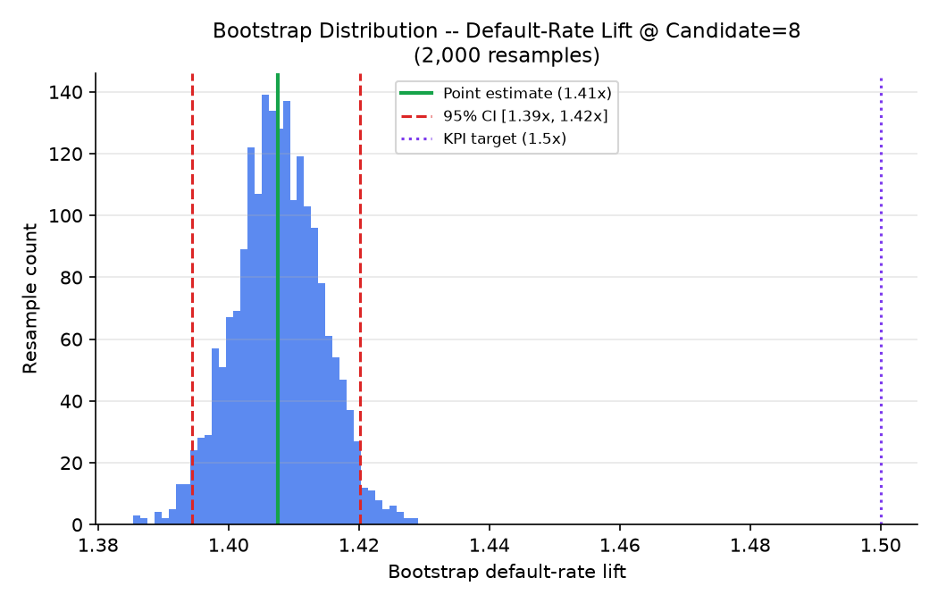
Bootstrap distribution of default-rate lift at the selected candidate (2,000 resamples)
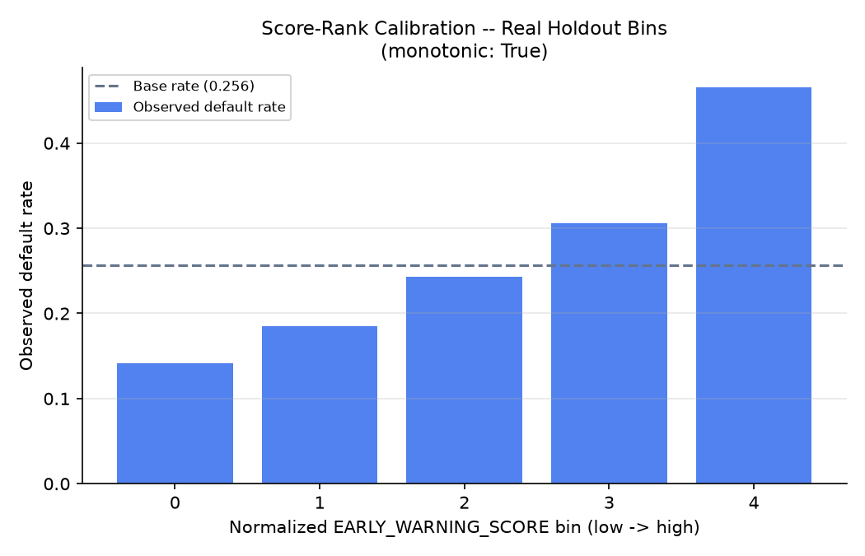
Score-rank calibration -- real holdout bins
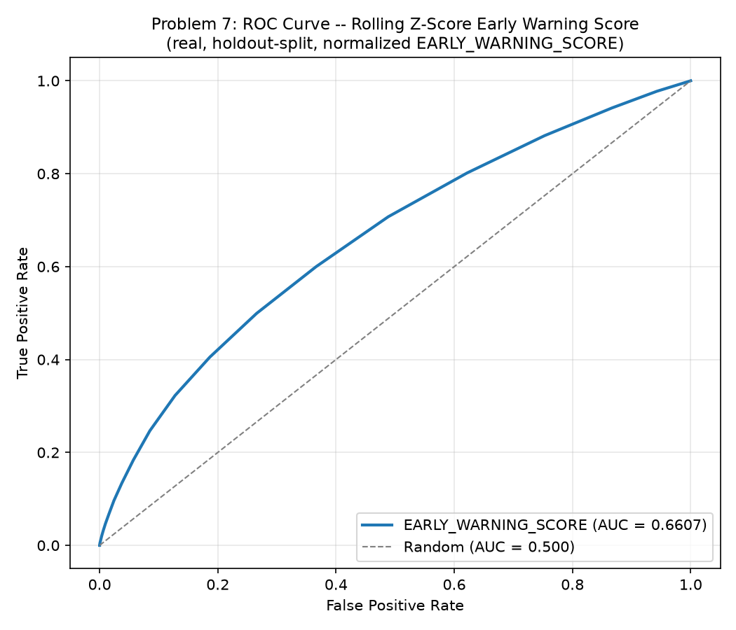
ROC curve of the continuous EARLY_WARNING_SCORE (from Notebook 43)
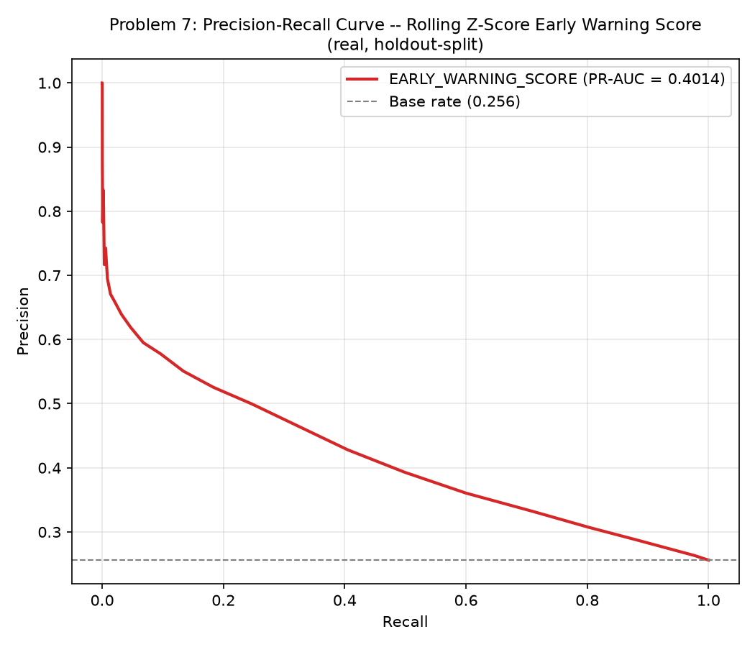
Precision-Recall curve of the continuous EARLY_WARNING_SCORE (from Notebook 43)
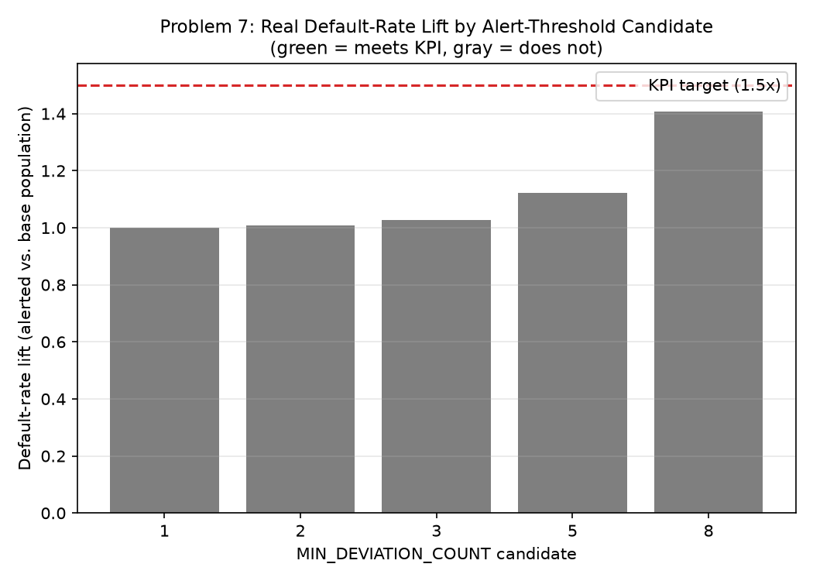
Real default-rate lift by alert-threshold candidate (from Notebook 43)

