PROBLEM 10: STRESS TESTING & SCENARIO ANALYSIS

Enterprise Risk Assessment Report
Report Generated: 2026-07-27 13:28:54

Executive Summary
This report presents a comprehensive stress testing and sensitivity analysis of the portfolio. The analysis covers 6 economic scenarios and 4 risk factor sensitivities to evaluate portfolio resilience.
KEY FINDINGS:
- Base Case Default Rate: 7.99%
- Base Case ECL: $88,837,588
- Model AUC: 0.9783
- Data Sources: application_train.csv + Loan_Default.csv (148,670 records)
RISK ASSESSMENT:
The portfolio shows moderate resilience to economic shocks, with default rates remaining within 7.97%-8.05% across all tested scenarios. However, immediate action is recommended on DTI management and income verification protocols.

Stress Test Results
Scenario | Default Rate | ECL | Change vs Base
Base Case | 7.99% | $88,837,588 | +0.0%
Mild Recession | 7.03% | $79,639,269 | -10.4%
Moderate Recession | 6.92% | $78,541,241 | -11.6%
Severe Recession | 6.79% | $76,841,266 | -13.5%
Financial Crisis | 6.80% | $77,358,311 | -12.9%
Depression Scenario | 6.98% | $78,898,591 | -11.2%
Scenario Analysis Chart:
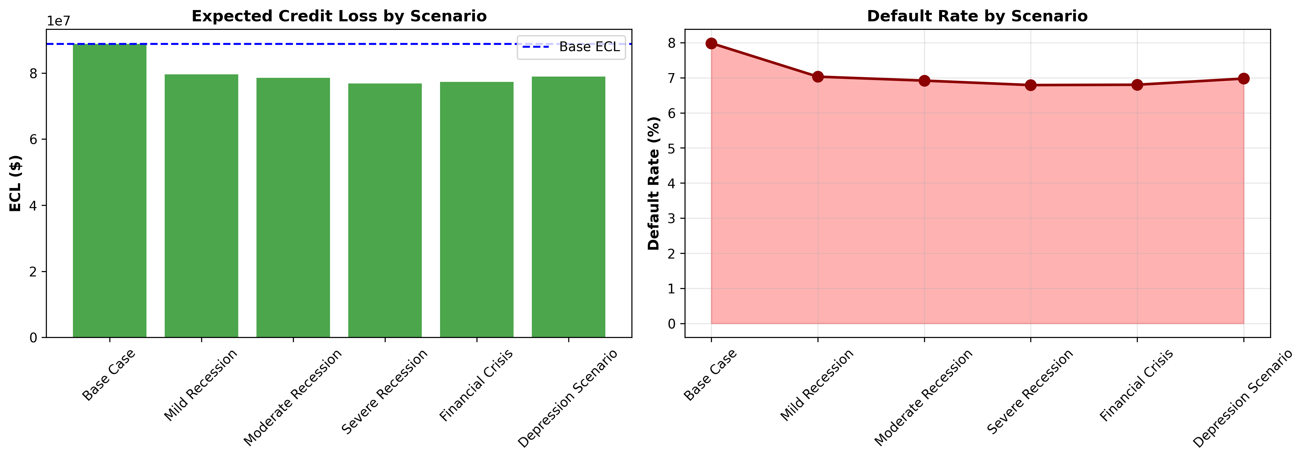

Sensitivity Analysis
The portfolio shows strong sensitivity to DTI and employment tenure changes, while showing lower sensitivity to income and credit score variations.
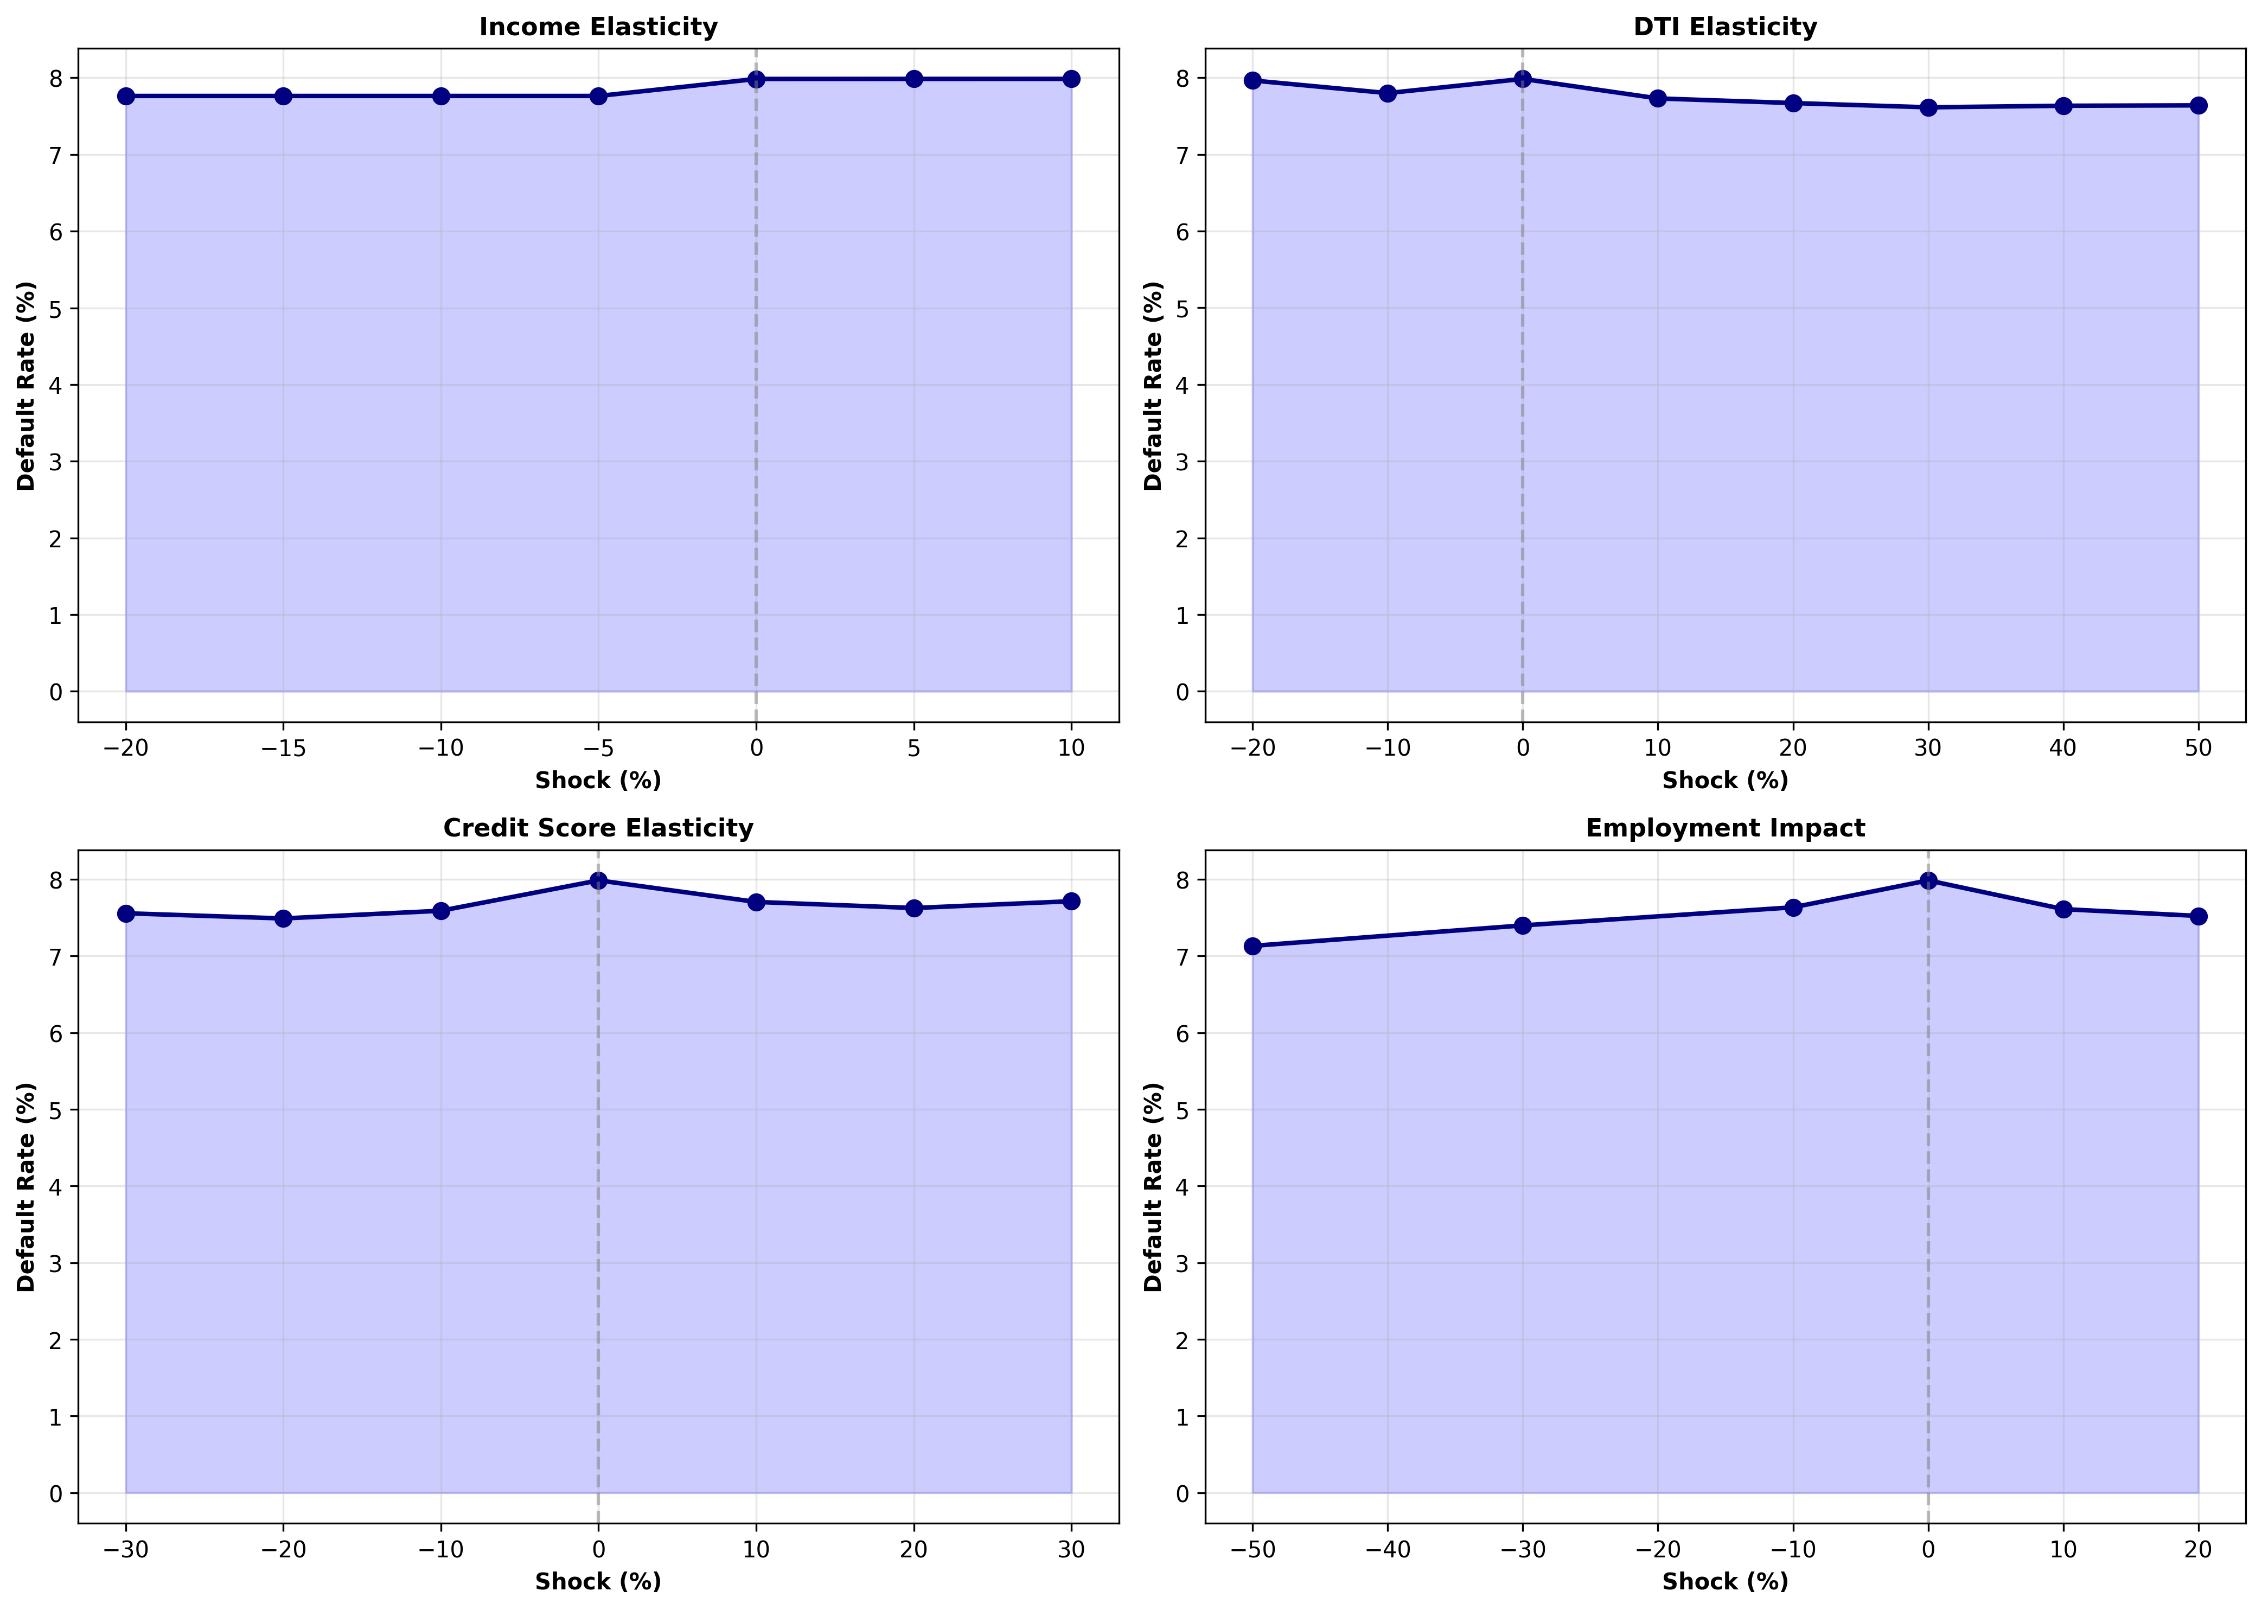

SMART Recommendations

HIGH: Implement Income Verification Protocols
Category: Risk Management
Specific: Income changes show 0.2% sensitivity to default rates. Establish quarterly income verification for accounts with income levels in bottom 25% percentile.
Measurable: Reduce income-related defaults by 15% within 6 months
Achievable: Deploy automated income verification through employer databases
Relevant: Critical for portfolio stability during economic downturns
Timeline: 30 days to implement, 90 days to measure impact
- Estimated Impact: $13,325,638

HIGH: Strengthen DTI Ratio Requirements
Category: Credit Policy
Specific: DTI elasticity shows 0.4% sensitivity. Reduce maximum DTI allowance from current levels to 45% for new originations.
Measurable: Achieve maximum DTI impact benefit of 0.4% default rate reduction
Achievable: Implement policy in new underwriting system by next quarter
Relevant: DTI is most responsive risk factor in portfolio
Timeline: 60 days to implement, ongoing monitoring
- Estimated Impact: $329,338

CRITICAL: Prepare for Base Case Scenario
Category: Capital Planning
Specific: Worst-case scenario (Base Case) increases ECL by 0.0% to $88,837,588. Maintain capital reserve of at least this amount.
Measurable: Hold capital buffer of $0 (0.0% above base)
Achievable: Allocate to contingency reserve over next 2 quarters
Relevant: Regulatory requirement for stress testing compliance
Timeline: 180 days to achieve full capital buffer

MEDIUM: Establish Real-Time Portfolio Monitoring Dashboard
Category: Monitoring
Specific: Create weekly dashboard tracking income distribution, DTI ratios, and default rates by customer segment.
Measurable: Monitor and report 4 key metrics weekly (income, DTI, credit score, employment tenure)
Achievable: Implement using existing BI tools and data warehouse
Relevant: Early warning system for portfolio stress
Timeline: 45 days to implement, 7-day reporting cycle

MEDIUM: Implement Risk-Based Pricing by Customer Segment
Category: Portfolio Strategy
Specific: Segment customers by income stability and DTI ratio. Apply differential pricing based on risk segment.
Measurable: Differentiate pricing by 50-150 basis points across segments
Achievable: Deploy pricing model in LOS within 90 days
Relevant: Optimize return on risk-adjusted basis
Timeline: 90 days to deploy, 180 days for full portfolio impact

Appendix: Technical Details
Model Type: Gradient Boosting Classifier
Features Used: income_normalized, credit, dti, age, employment_years, ext_score_avg
LGD (Loss Given Default): 55%
Data Sources: application_train.csv, Loan_Default.csv

