PROBLEM 11: CONCENTRATION RISK ANALYSIS

Portfolio Diversification Assessment Report
Report Generated: 2026-07-27 14:59:27

Executive Summary
This report analyzes portfolio concentration risk across multiple dimensions including income level, employment type, credit score, and age. Concentration risk measures how much of the portfolio is exposed to specific segments - excessive concentration creates systemic risk.
KEY FINDINGS:
- • Income Level: HHI=2012 (HIGH) - Top 5 segments control 100.0%
- • Employment Type: HHI=3334 (CRITICAL) - Top 5 segments control 100.0%
- • Credit Score Bucket: HHI=2002 (HIGH) - Top 5 segments control 100.0%
- • Age Group: HHI=2231 (HIGH) - Top 5 segments control 100.0%

Concentration Risk Metrics
Herfindahl-Hirschman Index (HHI): Measures market concentration. Range 0-10,000. >2500 is highly concentrated. <1500 is well-diversified.
Concentration Ratio (CR5/CR10): Percentage of total exposure held by top 5/10 segments. Higher values indicate more concentration.
Gini Coefficient: Measures inequality in distribution. 0=perfect equality, 1=perfect inequality.

Detailed Results
Dimension | HHI | Status | CR5 (%) | Top Segment | Top Share (%)
Income Level | 2012 | HIGH | 100.0 | Medium | 21.7
Employment Type | 3334 | CRITICAL | 100.0 | Working | 34.0
Credit Score Bucket | 2002 | HIGH | 100.0 | Fair | 20.9
Age Group | 2231 | HIGH | 100.0 | 45-55 | 26.6

Visual Analysis
01_HHI_Concentration_Analysis.png:
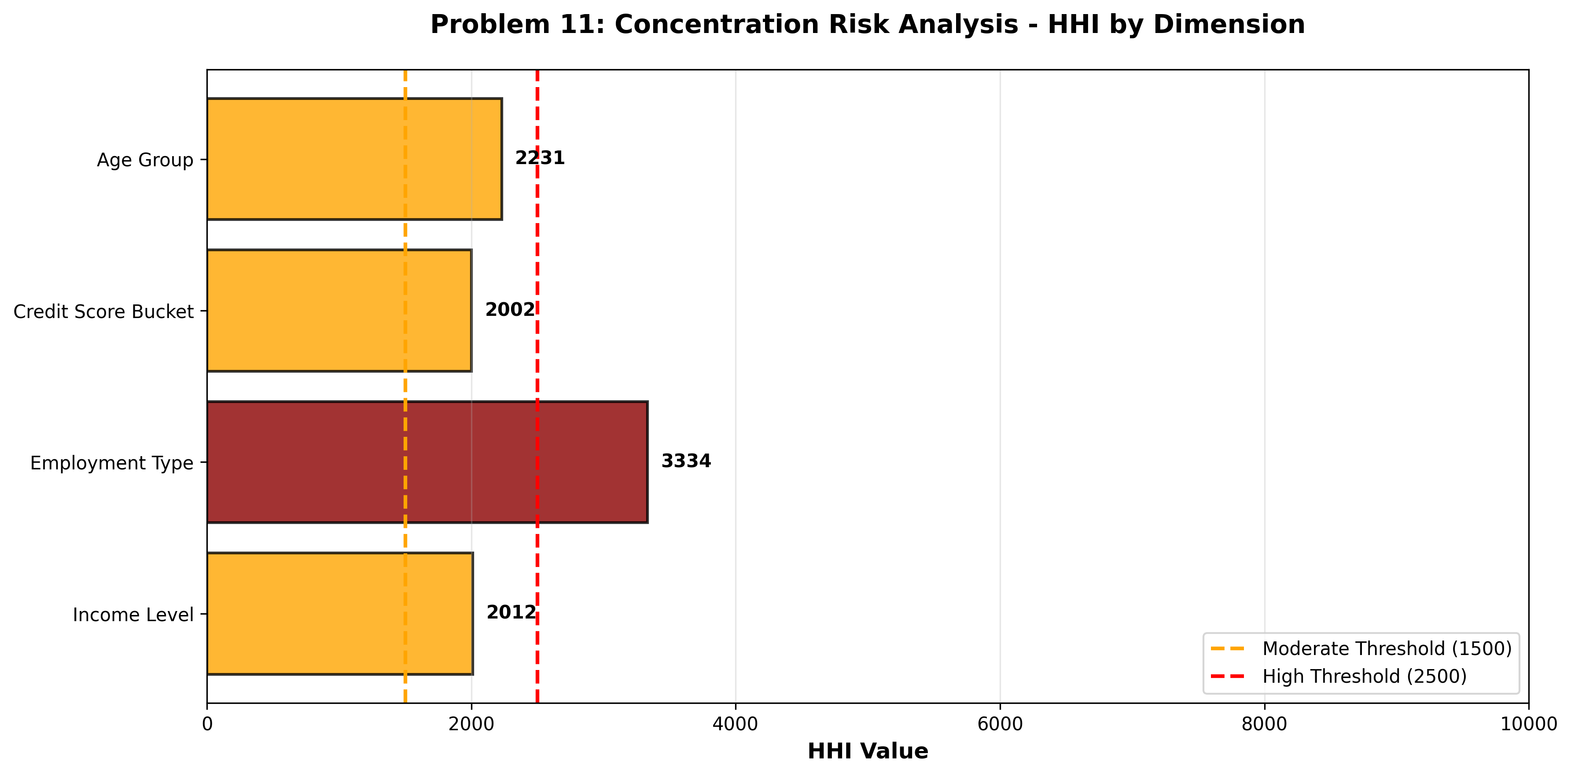
02_Concentration_Ratio_CR5_CR10.png:
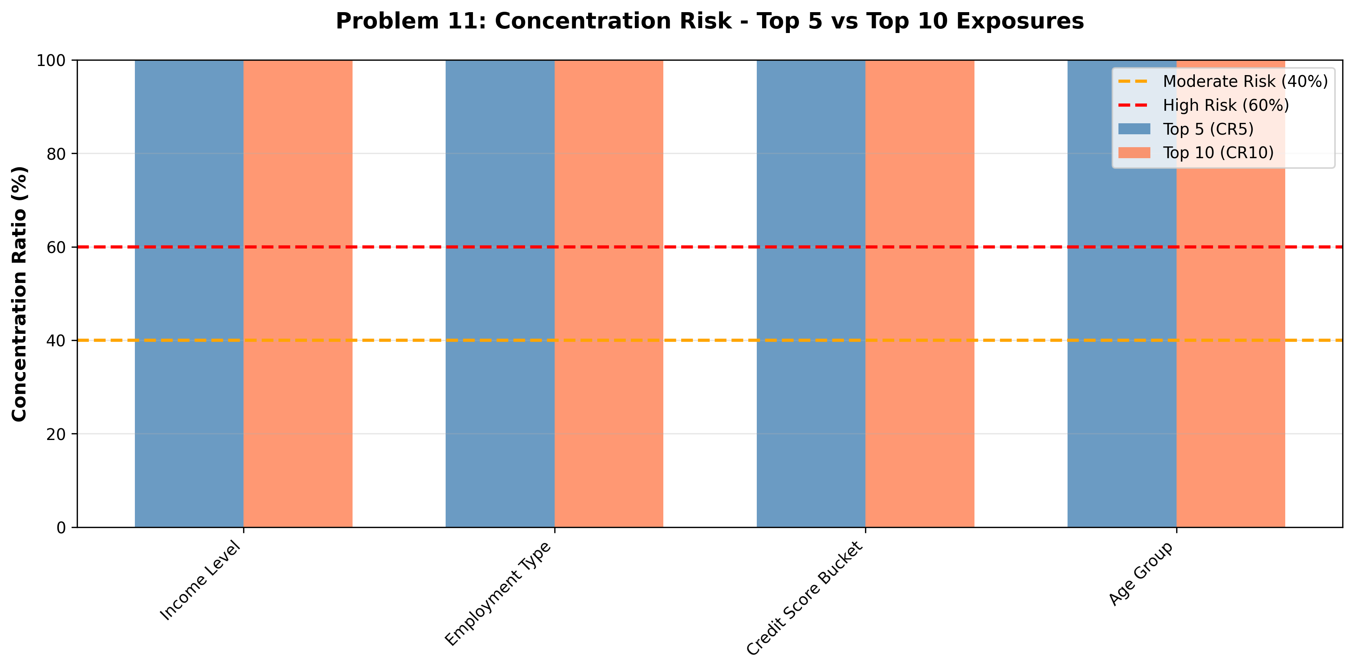
03_Top_Segments_Distribution.png:
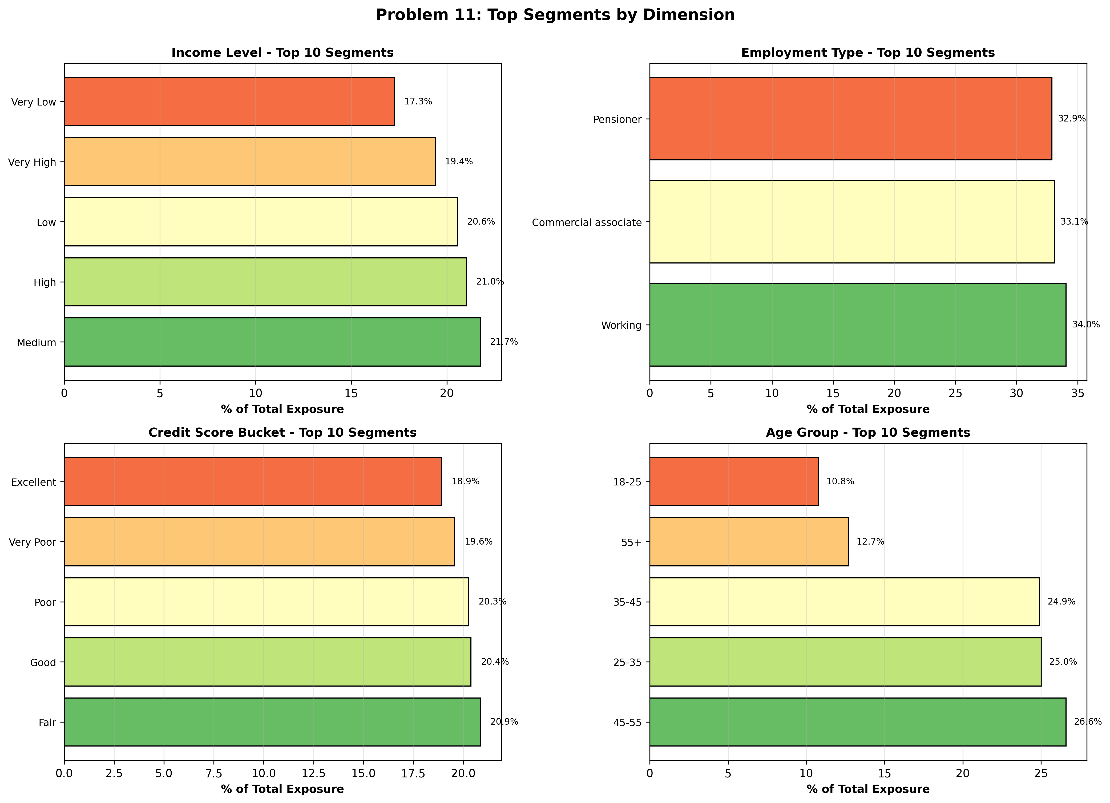
04_Risk_Matrix_Concentration.png:
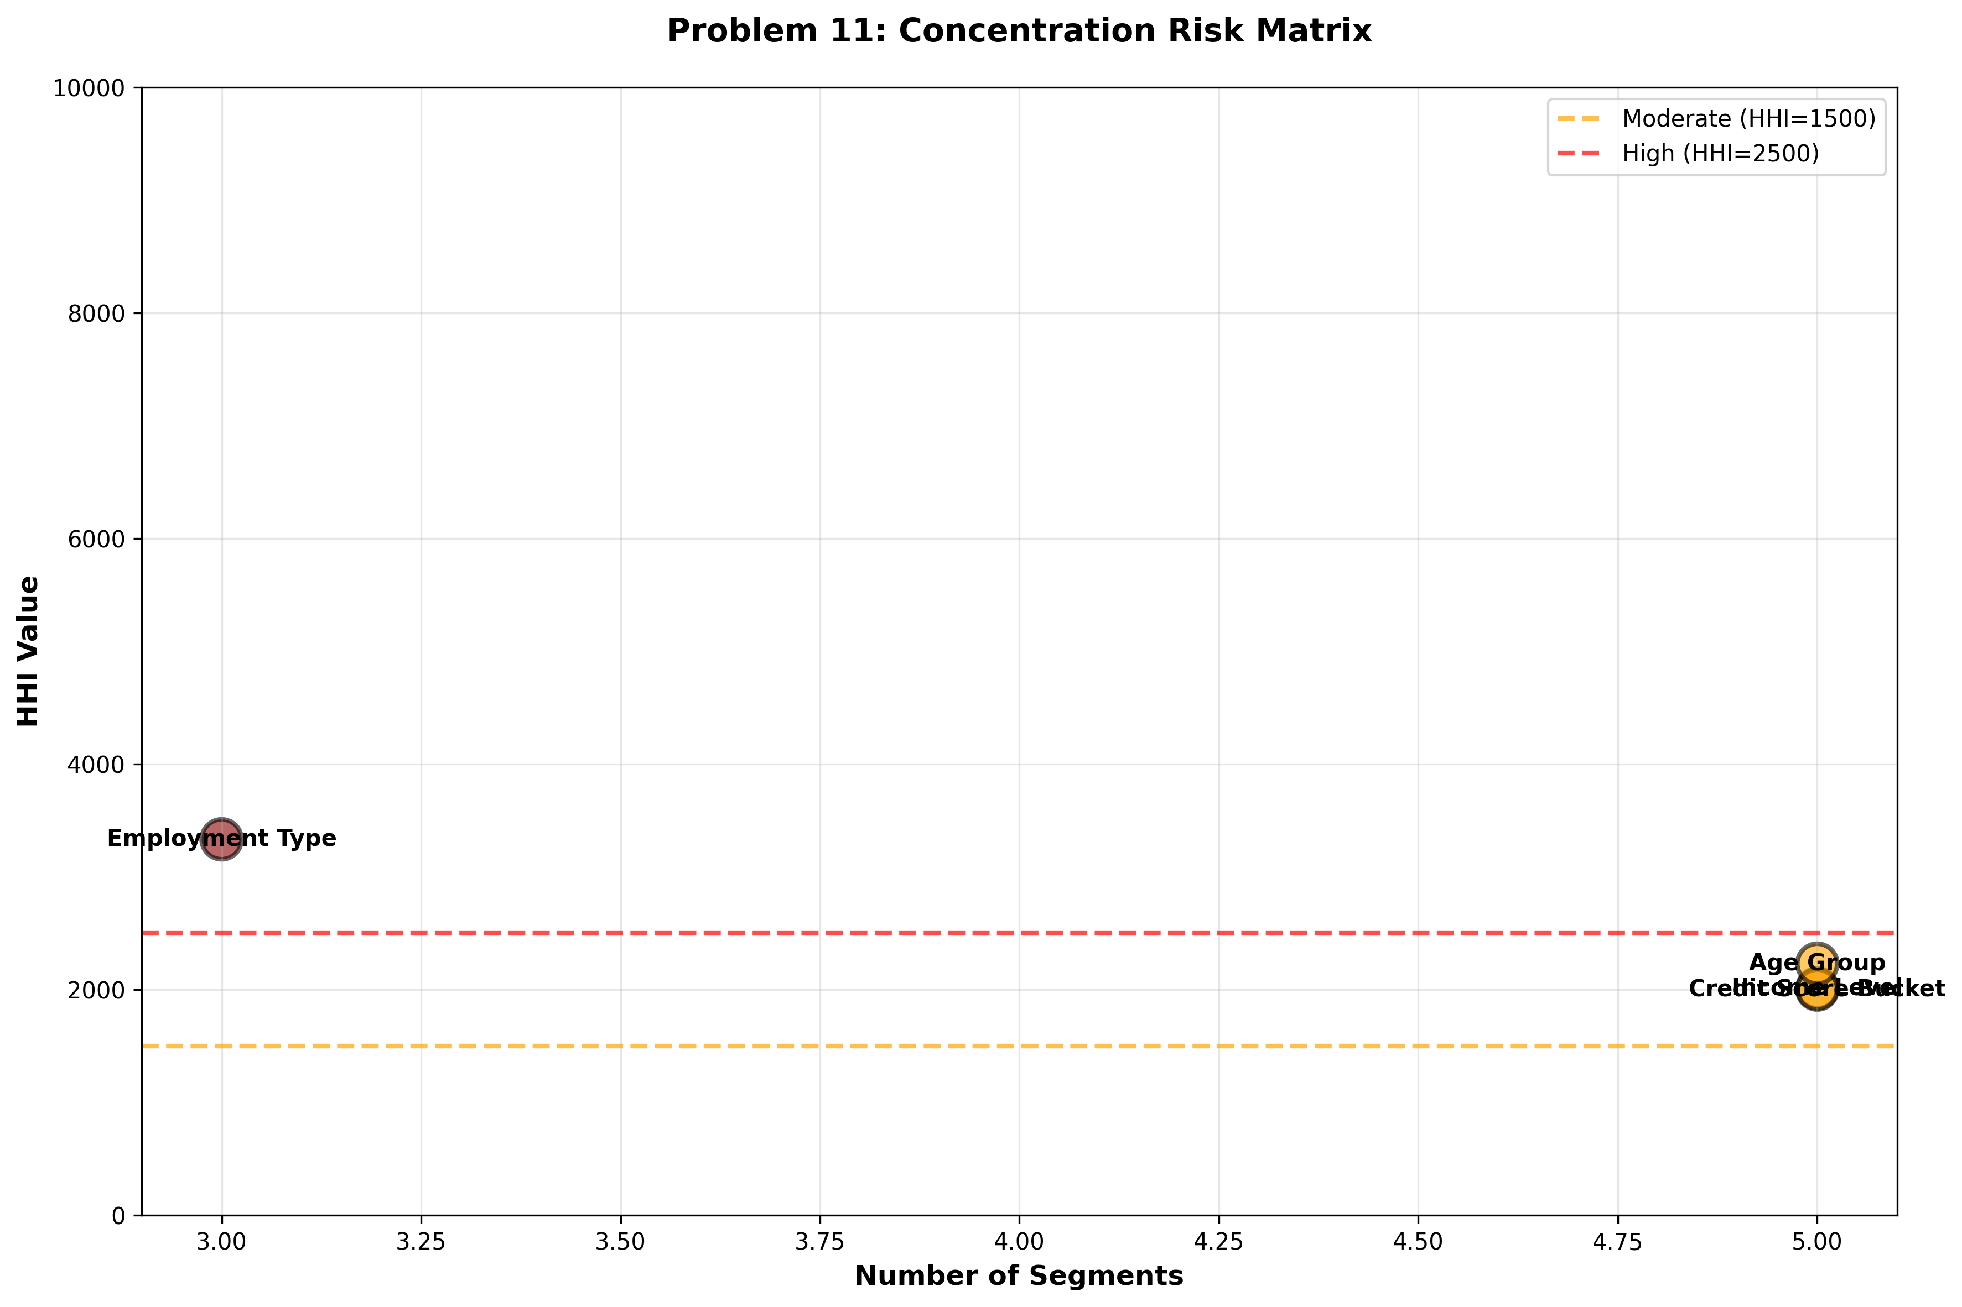

SMART Recommendations

HIGH: Income Level
Issue: Moderately Concentrated - HHI: 2012
Specific: Income Level shows moderate concentration risk with top 5 segments at 100.0%.
Measurable: Maintain HHI <1500 or reduce by 15% annually
Achievable: Implement targeted diversification strategy in underwriting
Relevant: Optimize risk-return profile
Timeline: 6-12 months

CRITICAL: Employment Type
Issue: Highly Concentrated - HHI: 3334
Specific: Employment Type shows critical concentration with top segment holding 34.0% and top 5 holding 100.0%.
Measurable: Reduce HHI from 3334 to <2500 within 12 months
Achievable: Diversify new originations across 4 segments
Relevant: Regulatory compliance and systemic risk reduction
Timeline: 12 months with quarterly milestones

HIGH: Credit Score Bucket
Issue: Moderately Concentrated - HHI: 2002
Specific: Credit Score Bucket shows moderate concentration risk with top 5 segments at 100.0%.
Measurable: Maintain HHI <1500 or reduce by 15% annually
Achievable: Implement targeted diversification strategy in underwriting
Relevant: Optimize risk-return profile
Timeline: 6-12 months

HIGH: Age Group
Issue: Moderately Concentrated - HHI: 2231
Specific: Age Group shows moderate concentration risk with top 5 segments at 100.0%.
Measurable: Maintain HHI <1500 or reduce by 15% annually
Achievable: Implement targeted diversification strategy in underwriting
Relevant: Optimize risk-return profile
Timeline: 6-12 months

Appendix: Technical Details
Analysis Date: 2026-07-27 14:59:27
Total Dimensions Analyzed: 4
Dimensions: Income Level, Employment Type, Credit Score, Age

