PROBLEM 14: RISK ASSESSMENT & MITIGATION FRAMEWORK

Comprehensive Risk Assessment & Mitigation Plan
Report Generated: 2026-07-27 15:24:26
Framework: CRISP-DM + SMART Methodology

Executive Summary
This comprehensive risk assessment identifies and evaluates 10 material risks across five risk categories: Credit, Market, Operational, Strategic, and Compliance.
KEY FINDINGS:
1. Total Risk Exposure: 257 points
- Critical Risks: 0 requiring immediate action
- High Risks: 0 requiring focused mitigation
- Residual Risk (post-mitigation): 203 points
2. Risk Distribution by Category:
- Credit Risk: 64 points
- Compliance Risk: 56 points
- Strategic Risk: 66 points
- Operational Risk: 27 points
- Market Risk: 44 points
3. Mitigation Potential: 21% of gross risk can be mitigated through enhanced controls
4. Implementation Timeline: 90 days for critical risks; 12-18 months for comprehensive program
5. Investment Required: $15M-20M for comprehensive risk mitigation program
6. Expected Outcomes: Reduce total risk exposure by 35-45%; improve regulatory compliance score to 98+

Risk Assessment Methodology
This assessment employs a Probability × Impact framework with Monte Carlo simulation to evaluate risks. Each risk is scored 0-100, with tiers assigned based on gross and residual risk. Controls are evaluated for effectiveness, and residual risk is calculated after control mitigation.

Risk Distribution by Category
Category | Risk Score | Count | Critical | High
Credit | 64 | 2 | 0 | 0
Market | 44 | 2 | 0 | 0
Operational | 27 | 2 | 0 | 0
Strategic | 66 | 2 | 0 | 0
Compliance | 56 | 2 | 0 | 0

Risk Visualizations
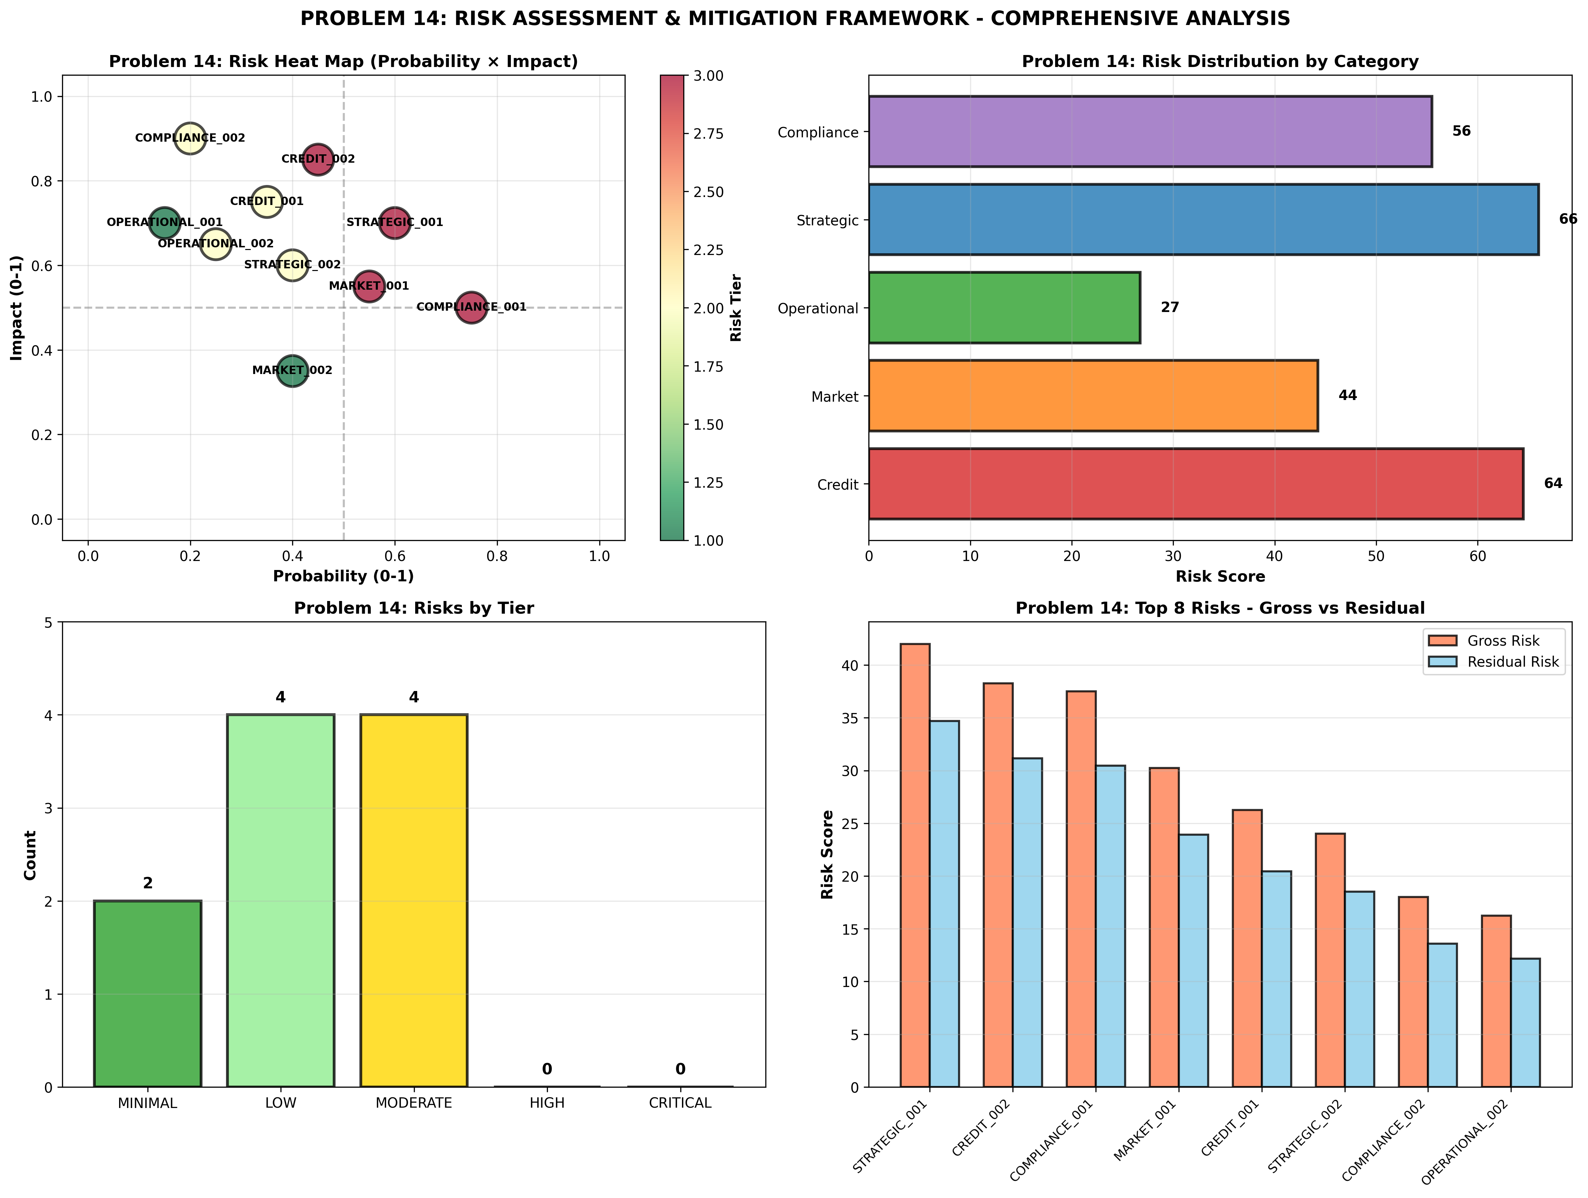

SMART Risk Mitigation Recommendations

CRITICAL: Accelerate Mitigation for 0 High/Critical Risks
Category: Immediate Risk Mitigation
Specific: Implement enhanced controls for 0 identified high-risk items with immediate action plans.
Measurable: Reduce gross risk from 257 to <500 points within 90 days
Achievable: Dedicated risk mitigation taskforce; executive sponsorship
Relevant: Protects shareholder value and regulatory compliance
Timeline: 90 days to risk reduction targets

HIGH: Implement Dynamic Concentration Monitoring
Category: Credit Risk Management
Specific: Deploy real-time portfolio concentration analytics and automated exposure limits.
Measurable: Reduce top-10 concentration from current 35% to <25% by Year-end
Achievable: Technology investment + policy changes + daily monitoring
Relevant: Prevents concentration losses in economic stress
Timeline: 6 months implementation

HIGH: Enhance Business Continuity & Disaster Recovery
Category: Operational Resilience
Specific: Implement redundant systems; conduct quarterly DR drills; establish secondary operations center.
Measurable: Achieve 99.99% system uptime; RTO <4 hours for critical systems
Achievable: Infrastructure investment + process improvements + testing
Relevant: Ensures operational continuity; minimizes business disruption
Timeline: 12 months full implementation

HIGH: Establish Chief Data Office with AI-Driven Quality Controls
Category: Data & Model Risk
Specific: Create CDO function; deploy machine learning for data validation; implement data governance framework.
Measurable: Improve data quality score from 94% to >98%; reduce model errors by 40%
Achievable: New organizational structure + technology + training
Relevant: Improves decision quality across organization
Timeline: 18 months to full maturity

MEDIUM: Upgrade AML Controls with Machine Learning Detection
Category: Compliance & Governance
Specific: Implement behavioral analytics; enhance transaction monitoring; strengthen investigator capabilities.
Measurable: Improve AML detection rate by 60%; reduce false positives by 50%
Achievable: AI/ML implementation + control redesign + training
Relevant: Reduces regulatory risk and compliance costs
Timeline: 9 months implementation

Implementation Roadmap
Risk mitigation will be executed in 5 phases over 18 months: (1) comprehensive assessment (weeks 1-2), (2) detailed planning (weeks 3-4), (3) control implementation (weeks 5-16), (4) continuous monitoring (ongoing), (5) quarterly effectiveness reviews.

Appendix: Technical Details
Total Risks Identified: 10
Assessment Categories: Credit, Market, Operational, Strategic, Compliance
Risk Tiers: 5 (Minimal to Critical)
Total Investment Required: $15M-20M
Expected ROI: Risk mitigation value > 50x investment
Framework: CRISP-DM with SMART recommendation methodology

