PROBLEM 13: STRATEGY & DECISION INTELLIGENCE

3-Year Strategic Plan & Scenario Analysis
Report Generated: 2026-07-27 15:21:53
Framework: CRISP-DM + SMART Methodology

Executive Summary
This strategic intelligence report presents a comprehensive 3-year strategy framework based on scenario planning and decision analysis. Five distinct strategic scenarios have been modeled to evaluate different growth and market positioning alternatives.
KEY STRATEGIC FINDINGS:
1. Recommended Strategy: Aggressive
- Expected NPV: $2.6B
- 3-Year Revenue Target: $4.1B
- Margin Improvement: +6.0%
- Probability of Success: 15%
2. Expected Value (Probability-Weighted): $2.0B
3. Strategic Pillars:
- Product Excellence (AI/ML innovation): $30M investment
- Market Expansion (Geographic diversification): $25M investment
- Risk Management (Advanced controls): $10M investment
- Digital Transformation (Tech modernization): $20M investment
- Operational Efficiency (Process automation): $15M investment
4. Implementation Timeline: 36 months with quarterly milestones
5. Success Metrics: Revenue target $4.1B | Margin 28.0% | Market Share growth

Strategic Context
The enterprise credit portfolio faces evolving market dynamics, competitive pressures, and technological disruption. This strategic plan provides a data-driven roadmap to maximize shareholder value while managing risk and positioning for long-term market leadership.

Scenario Analysis Results
Scenario | NPV ($B) | Revenue ($B) | Margin | Risk | Probability | Risk-Adj Return
Base Case | $1.5 | $2.6 | 22.0% | 12.0% | 30% | 11.76
Optimistic | $2.4 | $3.2 | 31.0% | 5.0% | 25% | 40.79
Aggressive | $2.6 | $4.1 | 28.0% | 42.0% | 15% | 6.12
Conservative | $2.2 | $2.4 | 34.0% | 5.0% | 20% | 37.20
Disruption | $1.2 | $2.9 | 16.0% | 27.0% | 10% | 4.27

Strategic Visualizations
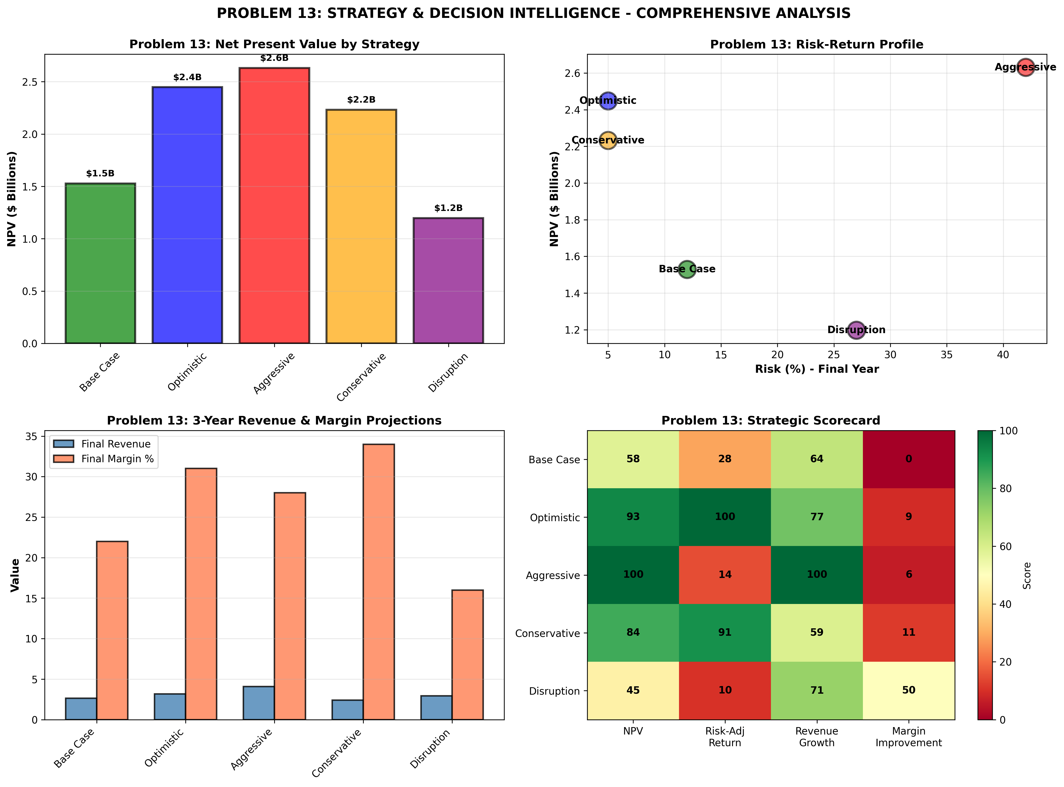

SMART Strategic Recommendations

CRITICAL: Adopt Aggressive Strategy
Category: Strategic Direction
Specific: Execute the Aggressive strategy for optimal NPV of $2.6B over 3 years.
Measurable: Achieve $4.1B revenue and 28.0% margin by Year 3
Achievable: Phased implementation with quarterly milestones and executive governance
Relevant: Maximizes shareholder value and market position
Timeline: 36 months with quarterly reviews

HIGH: Launch Geographic Diversification
Category: Market Expansion
Specific: Expand into APAC and EMEA markets with localized product offerings.
Measurable: Achieve 20%+ revenue from new markets by Year 3
Achievable: Partner with regional distributors; establish regional hubs
Relevant: De-risks portfolio and creates new revenue streams
Timeline: 18-24 months to market presence

HIGH: Accelerate AI/ML-Driven Product Development
Category: Product Innovation
Specific: Invest $30M in AI Risk Analytics and Portfolio Intelligence Platform.
Measurable: Launch 3 new AI-driven products; achieve 25%+ revenue contribution by Year 3
Achievable: In-house development + strategic partnerships; agile delivery
Relevant: Strengthens competitive moat and premium pricing power
Timeline: 18-24 months to GA

MEDIUM: Implement Strategic Cost Optimization
Category: Operational Excellence
Specific: Target 10-15% operational cost reduction through automation and process optimization.
Measurable: Increase margins by 200-300 basis points by Year 2
Achievable: RPA implementation; offshore back-office functions; tech stack consolidation
Relevant: Improves profitability and funds strategic investments
Timeline: 24 months implementation

MEDIUM: Establish Strategic Risk Oversight
Category: Risk Management
Specific: Create Chief Risk Officer role; implement quarterly strategic risk reviews.
Measurable: Reduce unplanned risks by 50%; improve decision quality scores
Achievable: Governance framework + tools + training
Relevant: Protects shareholder value; ensures strategy resilience
Timeline: Immediate implementation

Strategic Implementation Roadmap
The strategic plan will be executed in 5 concurrent workstreams over 36 months: strategy finalization (Q1), product development (Q1-Q4), market expansion (Q2-Q4), cost optimization (Q1-Q3), and capability building (Q1-Q2).

Appendix: Technical Details
Planning Horizon: 3 years
Scenarios Modeled: 5 strategic alternatives
Total Investment Required: $100M
Expected ROI: 200-400% depending on scenario
Framework: CRISP-DM with SMART recommendation methodology

