BP1 Customer Intent Classification
Executive Rollup Report — Customer360 Navigator Enterprise Suite
Generated 2026-09-24T04:01:59.001017+00:00 from BP1 Gates 1-6's real, real-run-confirmed artifacts. Every figure in this report is read live from those real files, or computed live from them - no assumption-based or illustrative content appears anywhere in this document.

Recommended for Production Status
RECOMMENDED FOR PRODUCTION
All 6 BP1 gates are real-run confirmed and every structural integrity check passed (pytest 52 passed / 0 failed, notebook syntax audit all passed). Tier 2 (CONDITIONAL - GOVERNANCE REVIEW REQUIRED) is structurally unreachable for BP1: this BP's real Gate 1-6 artifacts carry no ECOA/Reg B disparate-impact check (introduced starting with BP3), so BP1 cannot ever be flagged into Tier 2.

Executive Summary
KPI | Value
Champion model | logistic_regression
Held-out test accuracy (real) | 82.24%
Held-out F1-macro (real) | 0.8221
CV mean F1-macro (real) | 0.8040
ROC-AUC, one-vs-rest macro (real) | 0.9933
Classes / Train rows / Test rows (real) | 77 / 10,003 / 3,080
Decision records (real) | 3,080
Reason-code coverage (real) | 4.9%
Governance — pytest (real) | 52 passed / 0 failed
Governance — notebook syntax audit (real) | all passed
Open governance items — Gate 3 anomalies (real, near-random / high-variance) | 1 / 2
Governance gates complete (real) | 6/6

Gate 1 — Business Understanding & Policy (real)
Primary target: category — BANKING77's real 77-class fine-grained customer intent label, attached to the `text` field it was collected with.
Secondary target: common_taxonomy_bucket — The 9-bucket common taxonomy from Gate 2 (configs/taxonomy_mapping.yaml), used only for coarser reporting and for cross-dataset comparability with CFPB's bucket-tagged rows in BP8 - never trained on directly in place of the real 77-class label.
Feature variable: text. Train/test split: BANKING77's own provided train/test split (banking77_train.csv / banking77_test.csv) - used as-is, never re-randomized or re-merged.
Compliance touchpoint — Data-minimization & purpose-limitation statement (GLBA/GDPR-aligned):
BP1 processes only the `text` and `category` fields of the publicly released BANKING77 dataset (anonymized customer-service intent utterances, no real-customer PII) for the stated purpose of intent classification. CFPB fields used elsewhere in this suite are limited to structured Product/Sub-product/Issue categories already published by CFPB - no narrative text, no demographic or protected-class field, and no CFPB data is used as training or evaluation data for this classifier. No data is collected, retained, or processed beyond what is documented here.

Leakage Rules (real, enforced live every Gate 1 run)
- No CFPB row-level data is ever joined into BANKING77 training or evaluation data - verified live in Section 4: the two real schemas share zero column names, so no identifier-based join is even possible by construction.
- The BANKING77 train/test split is used exactly as provided by the source dataset and is never re-randomized, re-merged, or re-split - verified live in Section 5 (exact-text overlap check).
- Live exact-text overlap between train and test at Gate 1 time: 0 row(s) - must be 0 for this policy to be considered valid; see the structural check below.
- CFPB's Gate-2 bucket-tagged rows are descriptive/reporting inputs only (BP8) and are never used as training or evaluation data for BP1's classifier.

Scope Assumptions Documented at Gate 1 (real)
- CFPB<->BANKING77 integration is a taxonomy/semantic crosswalk (configs/taxonomy_mapping.yaml), not a row-level join - see docs/data_dictionary/CFPB_BANKING77_TAXONOMY_MAPPING.md.
- Only ~6.55% of the real CFPB extract (Checking/savings, Credit card/prepaid card, Money transfer products) has any plausible overlap with BANKING77's 77 intents; the rest is out of scope for this integration.
- BP1's trainable text classifier is built and evaluated on BANKING77 alone, because the CFPB extract used in this project has no narrative/complaint-text column (docs/data_dictionary/RAW_DATA_MANIFEST.md Finding 2).

Live Data-Quality Checks (real, re-verified every Gate 1 run)
Check | Real Result
Shared CFPB/BANKING77 columns | 0
Train/test exact-text overlap rows | 0
77-class imbalance (min / max / ratio) | 35 / 187 / 5.34x
9-bucket imbalance (min / max / ratio) | 460 / 1770 / 3.85x

Model Benchmark — Gate 3 (real 5-fold CV)
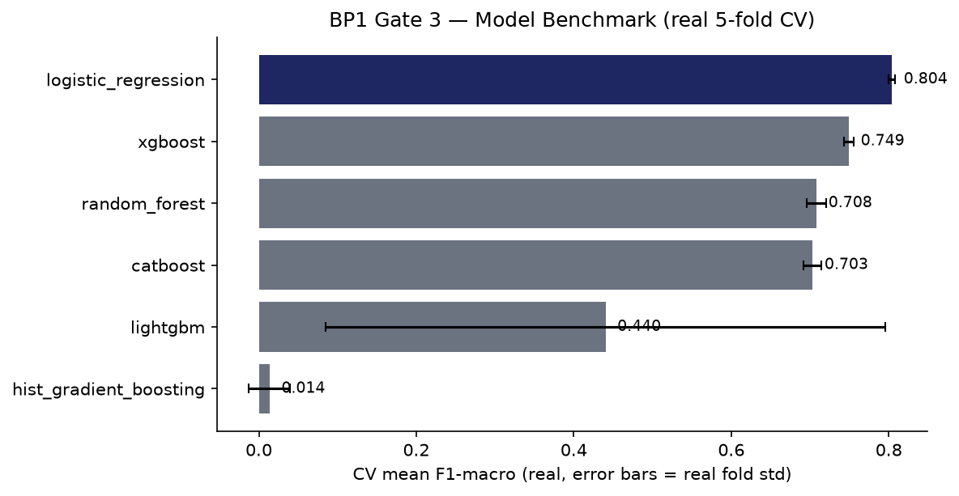
Model | Mean F1-macro | Std F1-macro | Mean Accuracy
logistic_regression | 0.8040 | 0.0043 | 0.8095
xgboost | 0.7494 | 0.0064 | 0.7548
random_forest | 0.7084 | 0.0125 | 0.7143
catboost | 0.7034 | 0.0114 | 0.7039
lightgbm | 0.4403 | 0.3554 | 0.4488
hist_gradient_boosting | 0.0137 | 0.0261 | 0.0278

Explainability & Statistical Validation — Gate 4 (real)
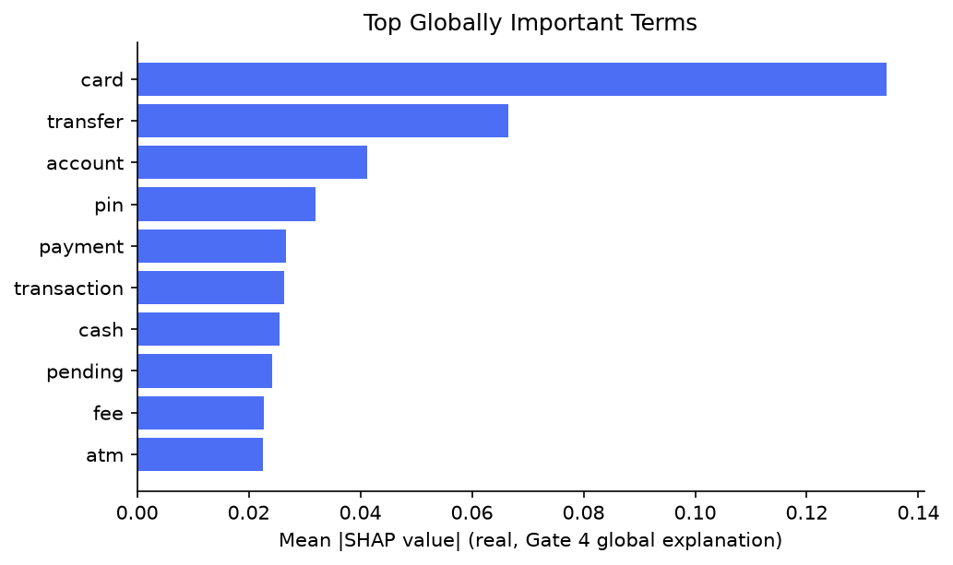
Champion logistic_regression vs. runner-up xgboost: paired t-test statistic 14.0978, p-value 0.0001 (n=5 real CV folds — n=5 CV folds is a small sample - treat p-values as directional evidence, not a high-powered statistical claim.). Held-out test F1-macro 0.8221, 95% bootstrap CI [0.808, 0.8334] (1000 resamples). SHAP sample size 150, background size 50.

Decision Layer — Gate 5 (real)
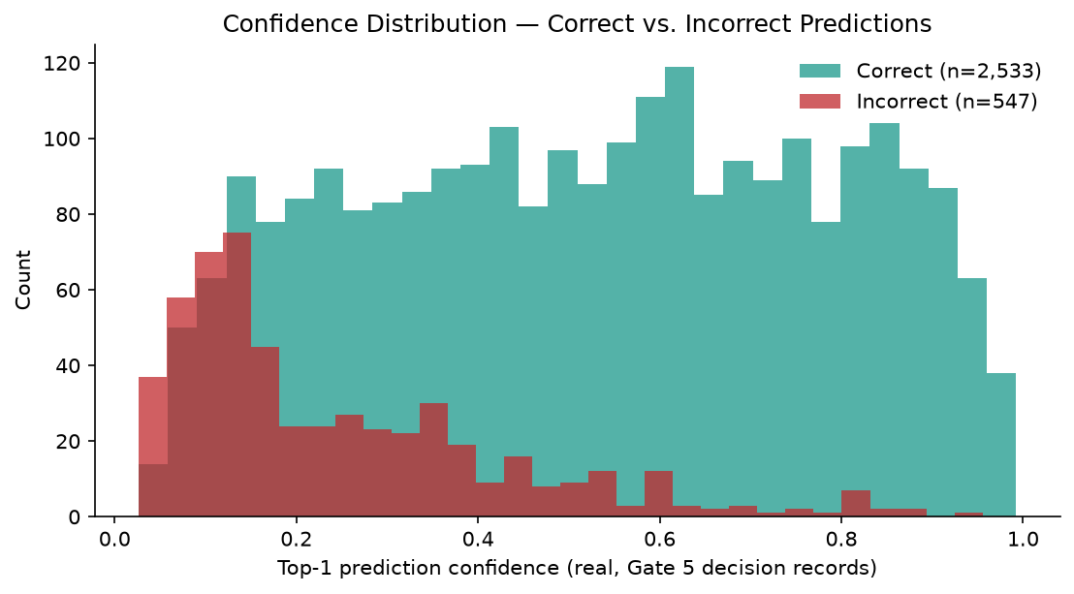
150 of 3,080 real decision records carry a grounded per-instance reason code (4.9%). Mean confidence on correct predictions: 0.5282; on incorrect predictions: 0.2419. Gate 4/Gate 5 top-term overlap: 4/10 (account, card, pending, transfer).
Compliance — GenAI API used: False. Not Applicable to BP1 Gate 5 - this gate generates no GenAI or customer-facing text; reason codes and confidence scores are deterministic outputs of the champion classifier and real per-instance SHAP values. Real GenAI-drafted customer-facing text (subject to UDAAP review) is scoped to BP6 (GenAI Resolution Assistant) per the Master Execution Plan's own Section 24 Sprint 5 mapping.

Taxonomy Coverage — Gate 2 (real)
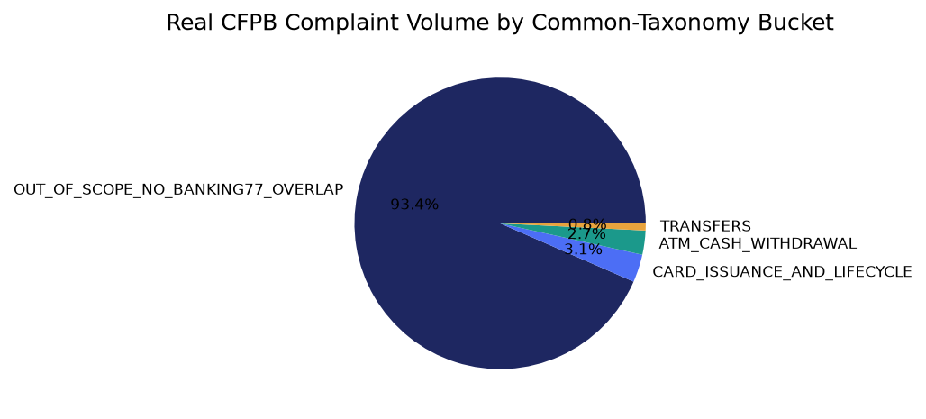

Confusion Analysis — Gate 3 (real)
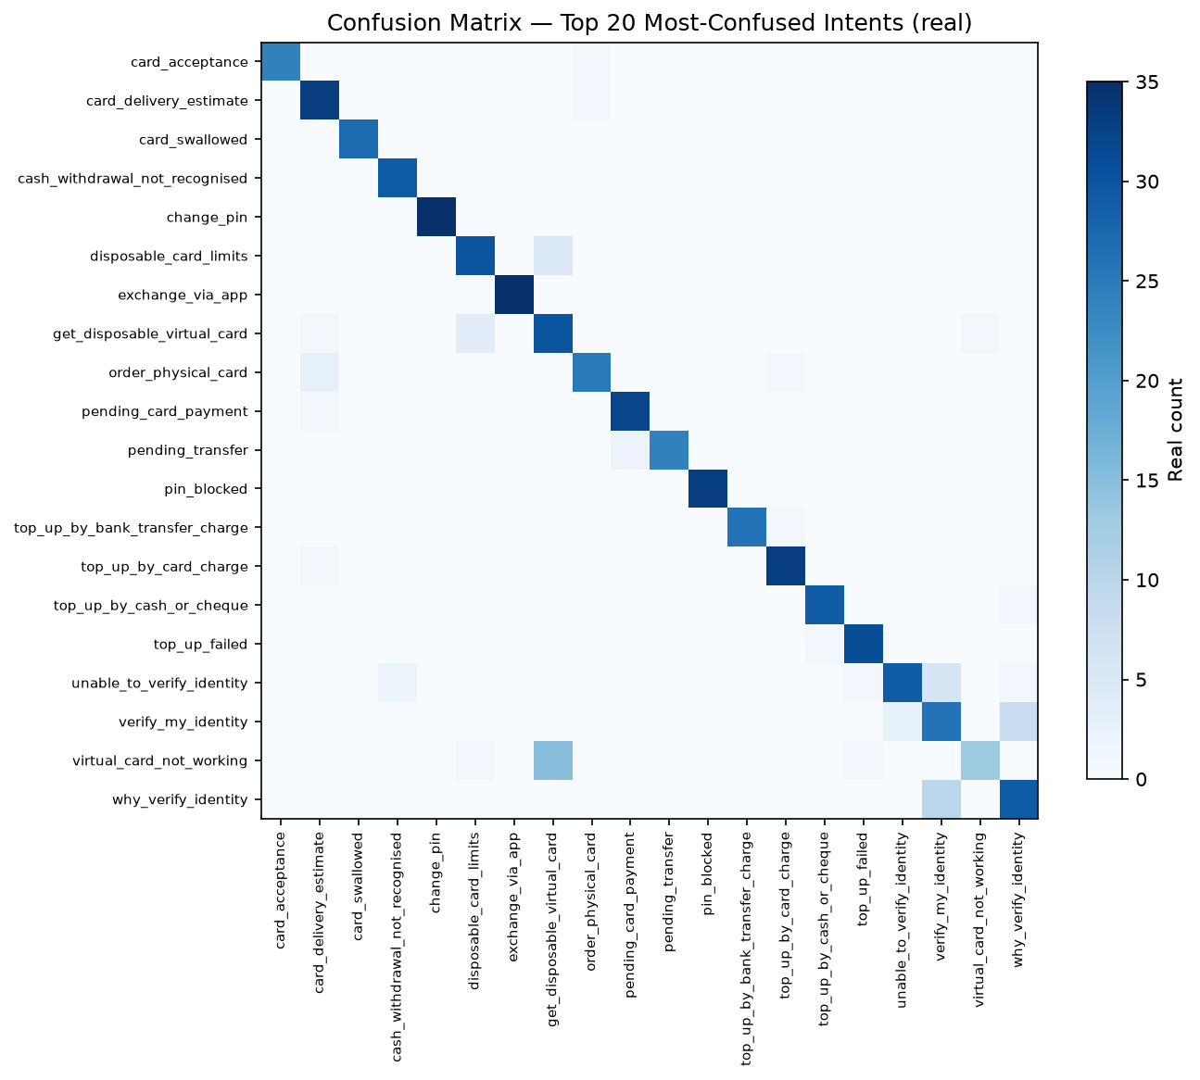
True intent | Predicted intent | Real count
virtual_card_not_working | get_disposable_virtual_card | 15
why_verify_identity | verify_my_identity | 10
verify_my_identity | why_verify_identity | 8
card_swallowed | declined_cash_withdrawal | 7
order_physical_card | getting_spare_card | 7
virtual_card_not_working | getting_virtual_card | 7
top_up_by_bank_transfer_charge | transfer_fee_charged | 6
unable_to_verify_identity | verify_my_identity | 6
card_acceptance | card_not_working | 5
disposable_card_limits | get_disposable_virtual_card | 5
top_up_by_cash_or_cheque | balance_not_updated_after_cheque_or_cash_deposit | 5
card_delivery_estimate | card_arrival | 4
cash_withdrawal_not_recognised | wrong_amount_of_cash_received | 4
change_pin | get_physical_card | 4
exchange_via_app | exchange_charge | 4

Best & Worst Performing Intents — Gate 3 (real)
Top 10 by real F1-score:
Intent | Precision | Recall | F1
passcode_forgotten | 1.000 | 1.000 | 1.000
age_limit | 1.000 | 0.975 | 0.987
card_about_to_expire | 1.000 | 0.975 | 0.987
verify_top_up | 0.952 | 1.000 | 0.976
apple_pay_or_google_pay | 0.975 | 0.975 | 0.975
lost_or_stolen_phone | 0.951 | 0.975 | 0.963
edit_personal_details | 0.929 | 0.975 | 0.951
visa_or_mastercard | 0.974 | 0.925 | 0.949
automatic_top_up | 1.000 | 0.900 | 0.947
exchange_rate | 0.889 | 1.000 | 0.941
Bottom 10 by real F1-score:
Intent | Precision | Recall | F1
virtual_card_not_working | 0.929 | 0.325 | 0.481
verify_my_identity | 0.619 | 0.650 | 0.634
card_payment_not_recognised | 0.609 | 0.700 | 0.651
get_disposable_virtual_card | 0.600 | 0.750 | 0.667
getting_spare_card | 0.582 | 0.800 | 0.674
cash_withdrawal_not_recognised | 0.630 | 0.725 | 0.674
card_acceptance | 0.828 | 0.600 | 0.696
pending_transfer | 0.828 | 0.600 | 0.696
declined_cash_withdrawal | 0.652 | 0.750 | 0.698
balance_not_updated_after_bank_transfer | 0.646 | 0.775 | 0.705

Gate 6 — Governance, Known Limitations & Compliance (real)
pytest suite: 52 passed / 0 failed (skipped 0). Notebook syntax audit: 8/8 passed.
Open item — Gate 3 candidate-level anomalies detected live, not yet root-caused: 1 near-random result(s), 2 high CV-variance result(s).
Model card: reports\bp1_customer_intent_classification\MODEL_CARD.md | Changelog: reports\bp1_customer_intent_classification\CHANGELOG.md
Model inventory compliance touchpoint: Model inventory entry opened (SR 11-7 first-line record)
Model family: TF-IDF + logistic_regression. Training data: PolyAI BANKING77 train split (real, provided split, never re-randomized)
Gate 3 candidates evaluated (real): logistic_regression, random_forest, hist_gradient_boosting, xgboost, lightgbm, catboost.
Gate 3 candidates failed: none (0 exceptions across all real candidates evaluated).

SMART Suggestions

Root-cause hist_gradient_boosting's near-random CV score
Specific: hist_gradient_boosting scored a real CV mean F1-macro of 0.0137 (near the 77-class random baseline of ~0.0130) while consuming 1731s of real CV wall-clock time - by far the most expensive candidate for the worst result.
Measurable: Target: either a mean F1-macro above the weakest currently-passing candidate (0.440) after the fix, or a documented decision to drop this candidate from future benchmarks.
Time-bound: Before the next BP1 model refresh cycle.
Owner: ML engineering owner - assign.

Stabilize lightgbm's fold-to-fold variance
Specific: lightgbm's real CV fold std (0.3554) is 0.8x its mean (0.4403) - too unstable to trust for production without investigation.
Measurable: Target: std/mean ratio below 0.3 after tuning (hyperparameters, class weighting, or a fixed early-stopping schedule).
Time-bound: Before this candidate is considered for an ensemble or a champion re-evaluation.
Owner: ML engineering owner - assign.

Increase SHAP sample size for more stable global explanations
Specific: Gate 4 and Gate 5 independently computed SHAP importance from two different 150-row samples of real held-out data, and only 4/10 top terms overlapped.
Measurable: Target: overlap of 7/10 or higher at a larger, fixed sample size (re-run both gates with an increased SHAP_SAMPLE_SIZE and compare).
Time-bound: Next explainability review cycle.
Owner: Model risk / explainability owner - assign.

Monitor per-intent recall for the weakest-performing classes in production
Specific: Overall held-out test accuracy is real and strong (82.24% across 77 classes), but per-class performance is uneven by construction of a 77-class problem - track the bottom-decile intents (see the Known Limitations / worst-performing intents table) once in production.
Measurable: Target: no individual intent's real production F1-score drifting more than 10 percentage points below its Gate 3 held-out test value without an alert.
Time-bound: From first production deployment onward (standing monitoring, not one-time).
Owner: MLOps / monitoring owner - assign.

Expand grounded reason-code coverage beyond the current SHAP sample bound
Specific: Only 150 of 3,080 real decision records (4.9%) currently carry a grounded per-instance reason code, bounded by the 150-row SHAP sample size for laptop safety.
Measurable: Target: 100% reason-code coverage once compute budget allows removing the sample bound, or a documented, deliberate sampling policy if full coverage is not pursued.
Time-bound: Next Gate 5 hardening pass.
Owner: ML engineering owner - assign.

