BP2 Customer Friction Classification
Executive Rollup Report — Customer360 Navigator Enterprise Suite
Generated 2026-09-24T04:04:01.346562+00:00 from BP2 Gates 1-6's real, real-run-confirmed artifacts. Every figure in this report is read live from those real files, or computed live from them - no assumption-based or illustrative content appears anywhere in this document.

Recommended for Production Status
RECOMMENDED FOR PRODUCTION
All 6 BP2 gates are real-run confirmed and every structural integrity check passed (pytest 105 passed / 0 failed, notebook syntax audit all passed, 0 Gate 3 failed candidates — CatBoost was removed from the real Gate 3 candidate set entirely, not left as a failed candidate). Tier 2 (CONDITIONAL - GOVERNANCE REVIEW REQUIRED) is structurally unreachable for BP2: this BP's real Gate 1-6 artifacts carry no ECOA/Reg B disparate-impact check (introduced starting with BP3), so BP2 cannot ever be flagged into Tier 2.

Executive Summary
KPI | Value
Champion model | xgboost
Held-out test accuracy (real) | 75.58%
Held-out F1-macro (real) | 0.4559
Held-out F1-weighted (real) | 0.7355
CV mean F1-macro (real) | 0.4584
ROC-AUC, one-vs-rest macro (real) | 0.8857
Classes / Train rows / Test rows (real) | 4 / 653,373 / 163,344
Class imbalance ratio, majority/minority (real) | 152.0:1
Decision records (real) | 163,344
Reason-code coverage (real) | 0.09%
Governance — pytest (real) | 105 passed / 0 failed
Governance — notebook syntax audit (real) | all passed
Open governance items — Gate 3 near-random / high-variance / failed (real) | 0 / 0 / 0
Governance gates complete (real) | 6/6

Gate 1 — Business Understanding & Policy (real)
Primary target: friction_severity_class — An ordinal friction-severity class derived from the real CFPB `Company response to consumer` and `Timely response?` fields. The concrete bucket-to-ordinal-class mapping (which of the real values in Section 5's live output map to which severity level) is deliberately deferred to Gate 2 (taxonomy engineering) - the same sequencing BP1 used for its CFPB<->BANKING77 crosswalk - because only the live-enumerated real label strings above, not an assumed set, may ground it.
Sentiment-proxy signal (Master Plan's 3-signal taxonomy) — scoped OUT: NOT built as literally named in the Master Plan - no narrative/complaint-text column exists in the real CFPB extract (RAW_DATA_MANIFEST.md Finding 2) and BANKING77 carries no sentiment annotation (schema verified live in Section 6: text, category only). `Company public response` is the nearest real structured substitute if wanted later; using it that way is a labeled substitution for Gate 2 human review, not asserted here.
Repeat-contact signal (Master Plan's 3-signal taxonomy) — scoped OUT: NOT built - the real CFPB schema (verified live in Section 4) has no persistent customer/consumer identifier, only `Complaint ID` (identifies the complaint, not the person). Scoped out entirely, applying the identical real-data resolution the Master Plan already uses for BP4 ('do not invent customer IDs... call this event/issue journey analytics explicitly').
Feature variable candidates: Structured CFPB fields only (Product, Sub-product, Issue, Sub-issue, State, Submitted via) plus the Gate-2/BP1 `common_taxonomy_bucket` (configs/taxonomy_mapping.yaml) as an optional categorical feature for the ~6.55% of CFPB rows already in scope for BANKING77 overlap (UNMAPPED_UNKNOWN_CATEGORY for the rest) - this is how BP2 satisfies the Master Plan's 'Integrates BANKING77: YES' requirement, since BANKING77 itself carries no friction signal to train on directly. Final feature set is a Gate 2/3 decision.
Train/test split source: CFPB ships no pre-defined train/test split (unlike BANKING77) - BP2 will use a fresh random split of the real CFPB extract, stratified by the derived target, random_state=42 (matching BP1's random_state for consistency, not a shared value).
Compliance touchpoint — UDAAP (Unfair, Deceptive, or Abusive Acts or Practices) framing:
Per Master Plan Section 9: friction findings from this classifier are framed as potential risk indicators only when statistically supported - never as a determination of unfair, deceptive, or abusive conduct by any named company. No demographic or protected-class field exists in the real CFPB extract in scope for this project (docs/data_dictionary/RAW_DATA_MANIFEST.md Finding 3), so ECOA/Regulation B disparate-impact testing is Not Applicable - No Protected-Class Field in Scope, stated honestly rather than skipped silently.

Leakage Rules (real, enforced live every Gate 1 run)
- `Company response to consumer` and `Timely response?` define the target and must NEVER also be used as input features - they are not traditional train/test leakage, they are the label itself. This is the single most important rule in this policy.
- `Company public response` is NOT pre-cleared as a safe feature - it is ~54% null (live-checked in Section 5) and its relationship to the target is unverified; Gate 2/3 must test it for suspiciously high predictive power before treating it as a legitimate feature rather than a leakage proxy.
- No CFPB row may appear in both the train and test split of BP2's fresh random split - verified structurally by construction (single stratified split call, not a manual/ad hoc merge) once Gate 3 builds it.
- BANKING77 is never a source of friction/severity training labels - verified live in Section 6 that its schema carries no such field. It contributes only the Gate-2/BP1 taxonomy-bucket feature described above.

Scope Assumptions Documented at Gate 1 (real)
- BP2's friction taxonomy is honestly narrowed to ONE of the Master Plan's three named signal types (severity) - sentiment proxy and repeat-contact signal are scoped out for the documented real-data reasons above, not silently substituted.
- The severity bucket-to-class mapping itself is NOT decided in this notebook - it is deferred to Gate 2, to be built as a documented judgment mapping (HIGH/MEDIUM/LOW confidence per bucket, same pattern as configs/taxonomy_mapping.yaml) against the real values live-enumerated in Section 5, with explicit human review before Gate 3 trains on it.
- `src/utils/bp1_config_sync.py` is reused unmodified for BP2's own config file (configs/bp2_customer_friction_classification.yaml) - its read/write functions are already fully parameterized by config_path and contain no BP1-specific logic.

Live Target-Field Distributions (real, re-verified every Gate 1 run)
Company response to consumer | Real count
Closed with explanation | 492,340
Closed with non-monetary relief | 312,602
In progress | 231,856
Closed with monetary relief | 10,511
Untimely response | 1,264
None | 2
Real CFPB row count at Gate 1: 1,048,575. Company public response null rows: 570,861.

Model Benchmark — Gate 3 (real 5-fold CV)
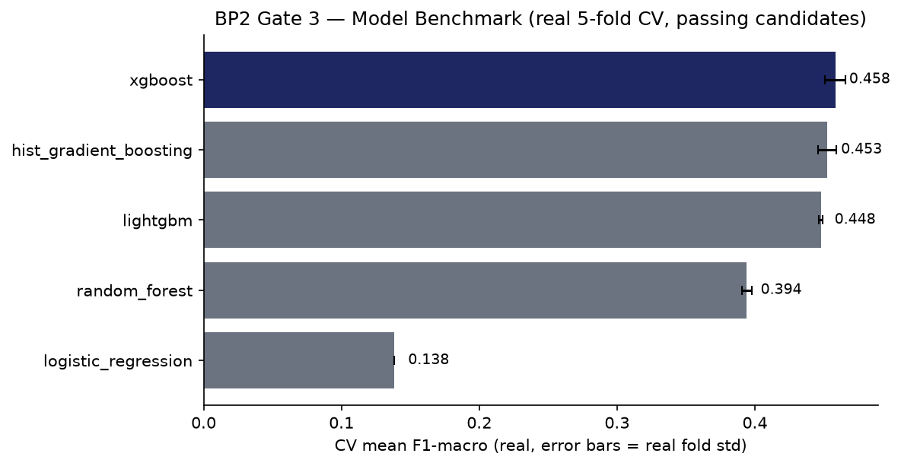
Model | Mean F1-macro | Std F1-macro | Mean Accuracy
xgboost | 0.4584 | 0.0075 | 0.7582
hist_gradient_boosting | 0.4525 | 0.0068 | 0.7570
lightgbm | 0.4478 | 0.0013 | 0.6642
random_forest | 0.3942 | 0.0037 | 0.5792
logistic_regression | 0.1384 | 0.0000 | 0.3827
Real Gate 3 candidate failure (not investigated further, per explicit user instruction): [].

Explainability & Statistical Validation — Gate 4 (real)
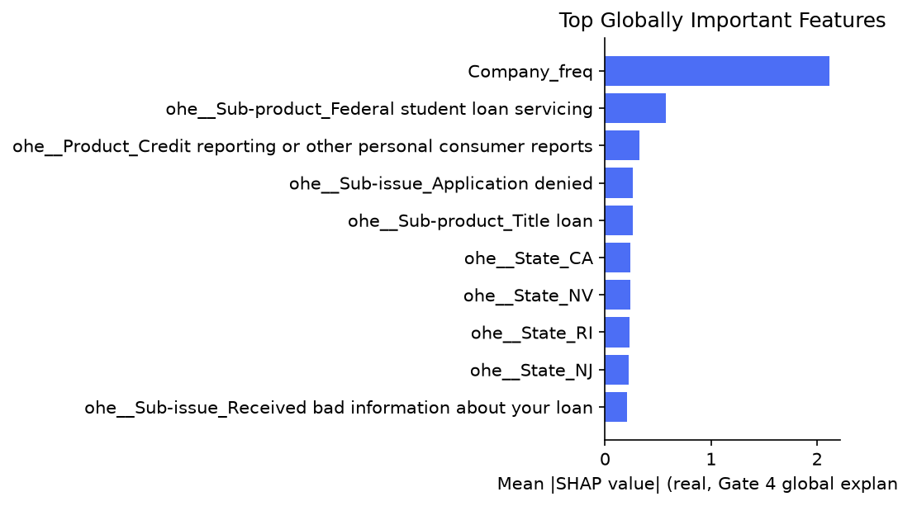
Champion xgboost vs. runner-up hist_gradient_boosting: paired t-test statistic 1.3893, p-value 0.2371 (n=5 real CV folds — n=5 CV folds is a small sample - treat p-values as directional evidence, not a high-powered statistical claim.). Held-out test F1-macro 0.4559, 95% bootstrap CI [0.4452, 0.4666] (1000 resamples). SHAP sample size 150, background size 50.

Per-Severity-Class Performance — Gate 3 (real, all 4 classes)
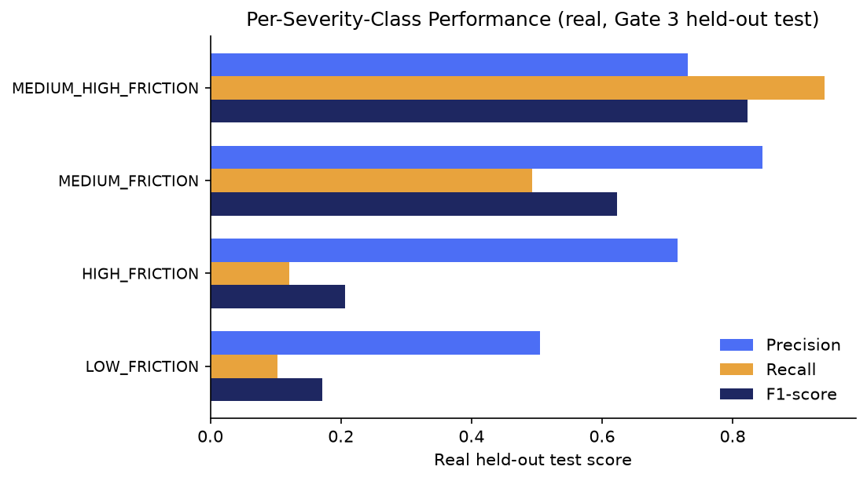
Severity class | Precision | Recall | F1 | Support
MEDIUM_HIGH_FRICTION | 0.731 | 0.941 | 0.823 | 98,108
MEDIUM_FRICTION | 0.846 | 0.493 | 0.623 | 62,506
HIGH_FRICTION | 0.716 | 0.121 | 0.207 | 645
LOW_FRICTION | 0.505 | 0.103 | 0.171 | 2,085

Decision Layer — Gate 5 (real)
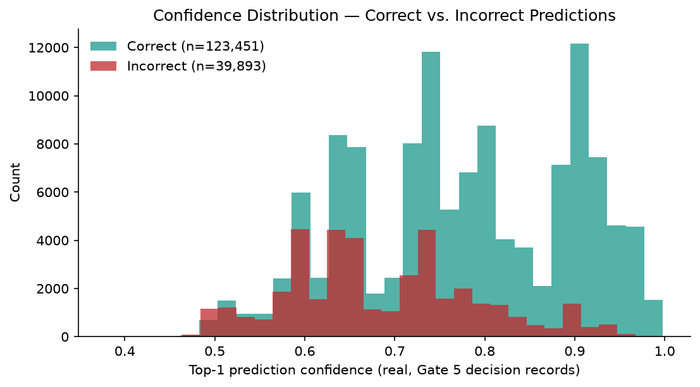
150 of 163,344 real decision records carry a grounded per-instance reason code (0.09%). Mean confidence on correct predictions: 0.7753; on incorrect predictions: 0.6845. Gate 4/Gate 5 top-term overlap: 2/10 (Company_freq, ohe__Product_Credit reporting or other personal consumer reports).
Compliance — GenAI API used: False. Not Applicable to BP2 Gate 5 - this gate generates no GenAI or customer-facing text; reason codes and confidence scores are deterministic outputs of the champion classifier and real per-instance SHAP values. Real GenAI-drafted customer-facing text (subject to UDAAP review) is scoped to BP6 (GenAI Resolution Assistant) per the Master Execution Plan, same standing scope decision as BP1 Gate 5.

Severity Distribution — Gate 2 (real)
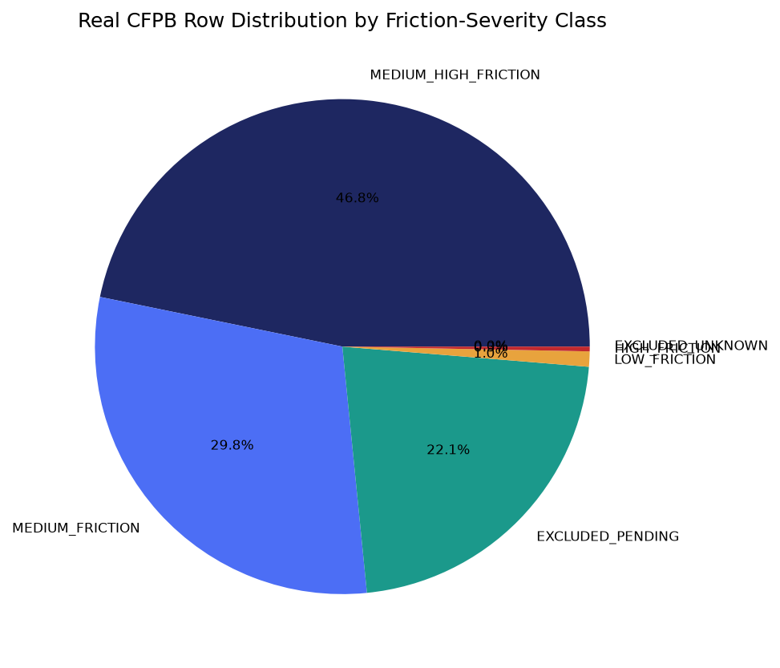

Confusion Analysis — Gate 3 (real, full 4×4 matrix)
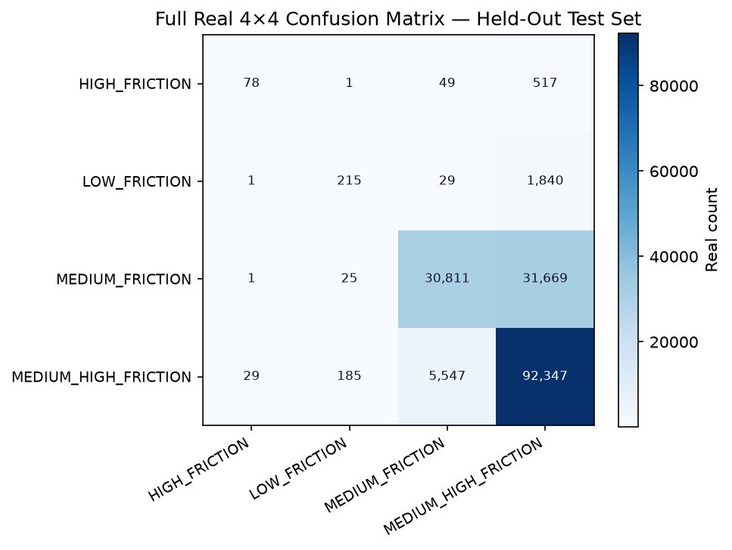
True class | Predicted class | Real count
MEDIUM_FRICTION | MEDIUM_HIGH_FRICTION | 31669
MEDIUM_HIGH_FRICTION | MEDIUM_FRICTION | 5547
LOW_FRICTION | MEDIUM_HIGH_FRICTION | 1840
HIGH_FRICTION | MEDIUM_HIGH_FRICTION | 517
MEDIUM_HIGH_FRICTION | LOW_FRICTION | 185
HIGH_FRICTION | MEDIUM_FRICTION | 49
LOW_FRICTION | MEDIUM_FRICTION | 29
MEDIUM_HIGH_FRICTION | HIGH_FRICTION | 29
MEDIUM_FRICTION | LOW_FRICTION | 25
HIGH_FRICTION | LOW_FRICTION | 1
LOW_FRICTION | HIGH_FRICTION | 1
MEDIUM_FRICTION | HIGH_FRICTION | 1

Gate 6 — Governance, Known Limitations & Compliance (real)
pytest suite: 105 passed / 0 failed (skipped 1). Notebook syntax audit: 19/19 passed.
Open items — Gate 3 candidate-level issues detected live: 0 near-random result(s), 0 high CV-variance result(s), 0 outright failure(s).
Model card: reports\bp2_customer_friction_classification\MODEL_CARD.md | Changelog: reports\bp2_customer_friction_classification\CHANGELOG.md
Model inventory compliance touchpoint: Model inventory entry opened (SR 11-7 first-line record)
Model family: one-hot/frequency-encoded structured features + xgboost. Training data: Real CFPB extract, fresh stratified 80/20 split (CFPB provides no split of its own), random_state=42
Gate 3 candidates evaluated (real): logistic_regression, random_forest, hist_gradient_boosting, xgboost, lightgbm.
Demographic-adjacent `Tags` values found live at Gate 3 (real; `Tags` itself is excluded from the feature set regardless): servicemember, older american, older american, servicemember.

SMART Suggestions

Close the minority-class recall gap on the two smallest severity classes
Specific: Despite reasonably strong real precision, the two lowest-support real severity classes show much weaker real recall on the held-out test set: HIGH_FRICTION (precision 71.6%, recall 12.1%, support 645); LOW_FRICTION (precision 50.5%, recall 10.3%, support 2,085). With a real 152:1 class-imbalance ratio (majority/minority), the champion under-predicts these classes far more than the headline 75.6% accuracy suggests.
Measurable: Target: real recall above 30% for both LOW_FRICTION and HIGH_FRICTION at the next Gate 3 re-benchmark (e.g. via class weighting adjustments, threshold tuning, or a resampling strategy), without materially reducing macro-F1 on the majority classes.
Time-bound: Next BP2 Gate 3 re-benchmark cycle.
Owner: ML engineering owner - assign.

Increase SHAP sample size for more stable global explanations
Specific: Gate 4 and Gate 5 independently computed SHAP importance from two different 150-row samples of real held-out data, and only 2/10 top terms overlapped — lower than BP1's equivalent 4/10 overlap, consistent with a structured-feature space having many more near-tied low-signal one-hot columns than BP1's TF-IDF vocabulary.
Measurable: Target: overlap of 6/10 or higher at a larger, fixed sample size (re-run both gates with an increased SHAP_SAMPLE_SIZE and compare).
Time-bound: Next explainability review cycle.
Owner: Model risk / explainability owner - assign.

Run the deferred Company public response leakage/predictive-value ablation
Specific: `Company public response` (~54% null, real, live-checked at Gate 1) was deliberately excluded from Gate 3's feature set as an open item, never tested for leakage against the target or for genuine predictive value.
Measurable: Target: a documented ablation run (with vs. without the field) reporting the real macro-F1 delta and a leakage-risk verdict, before it is ever added to the production feature set.
Time-bound: Before any production feature-set change is proposed.
Owner: ML engineering / compliance owner - assign.

Expand grounded reason-code coverage beyond the current SHAP sample bound
Specific: Only 150 of 163,344 real decision records (0.09%) currently carry a grounded per-instance reason code, bounded by the 150-row SHAP sample size for laptop safety — a much thinner relative real coverage than BP1's 150/3,080 (4.9%) on the same sample-size bound, simply because BP2's real held-out test set (163,344 rows) is ~53x larger.
Measurable: Target: 100% reason-code coverage once compute budget allows removing the sample bound, or a documented, deliberate sampling policy (e.g. stratified by severity class) if full coverage is not pursued.
Time-bound: Next Gate 5 hardening pass.
Owner: ML engineering owner - assign.

