BP3 Complaint Escalation / Intervention Prediction
Executive Rollup Report — Customer360 Navigator Enterprise Suite
Generated 2026-09-23T11:19:04.607858+00:00 from BP3 Gates 1-6's real, real-run-confirmed artifacts. Every figure in this report is read live from those real files, or computed live from them - no assumption-based or illustrative content appears anywhere in this document.

Recommended for Production Status
CONDITIONAL - GOVERNANCE REVIEW REQUIRED
All 6 BP3 gates are real-run confirmed and every structural integrity check passed (pytest 189 passed / 0 failed, notebook syntax audit all passed, 0 Gate 3 failed candidates). However, the real, independently-recomputed disparate-impact ratio on the `Tags` field is 0.139 — below the four-fifths-rule convention threshold of 0.8. This is a monitoring signal for a human reviewer, not a legal determination of ECOA/Reg B compliance, and is never treated as a hard block — but production use requires explicit governance sign-off first.

Executive Summary
KPI | Value
Champion model | xgboost
Held-out test PR-AUC / Average Precision (real, champion-selection metric) | 0.3496
Held-out test ROC-AUC (real) | 0.9762
Held-out test recall / precision / F1 at threshold 0.5 (real) | 94.24% / 15.10% / 0.2603
CV mean Average Precision (real) | 0.3467
Real positive-class ratio of trainable rows | 1.29%
Train rows / Test rows (real) | 652,362 / 163,091
Trainable / Excluded rows (real) | 815,453 / 233,122
Disparate-impact ratio, Tags field (real) | 0.139 (FLAGGED)
Brier score / paired t-test p-value vs runner-up (real) | 0.0533 / 0.6995
Decision records / reason-code coverage (real) | 163,091 / 0.092%
Governance — pytest (real) | 189 passed / 0 failed
Governance — notebook syntax audit (real) | all passed
Open governance items — near-random-PR-AUC / near-zero-recall / failed candidates (real) | 0 / 2 / 0
Governance gates complete (real) | 6/6

Gate 1 — Business Understanding & Policy (real)
Primary target: intervention_required — Binary: 1 if the real `Company response to consumer` value is 'Closed with monetary relief' (CFPB's own explicit observed intervention outcome, the Master Plan's own named example proxy); 0 if 'Closed with explanation' or 'Closed with non-monetary relief'. 'In progress', 'Untimely response', and null-response rows are excluded from the trainable set - see exclusion_reasons below and this notebook's markdown cell for the full reasoning.
Disputed-flag note: The Master Plan's other named example target ('a disputed flag') is not buildable: the real 15-column CFPB schema (re-verified live in Section 4) has no `Consumer disputed?` column or equivalent - CFPB dropped that field from its public dataset in 2017 and this extract post-dates that change. Not substituted with an invented proxy.
Feature variable candidates: Structured CFPB fields only: Product, Sub-product, Issue, Sub-issue, State, Submitted via, Company (frequency-encoded, HYPER-reusing BP2's own pattern in src/features/bp2_friction_features.py). Final feature set is a Gate 2/3 decision. No BANKING77 field (BP3 does not integrate BANKING77 per the Master Plan's BP table).
Train/test split source: CFPB ships no pre-defined train/test split - BP3 will use a fresh random split of the real, trainable-only CFPB rows, stratified by intervention_required, random_state=42.
Compliance touchpoint — ECOA / Regulation B - Fair Lending & Adverse Action (Master Plan Section 9; BP3 is one of the four BPs this section explicitly maps to ECOA/Reg B):
The real CFPB extract's 15 named columns carry no demographic or protected-class field by name. However, 'Tags' (one of those 15 columns) was found - live, in Section 5 above, re-confirming BP2 Gate 3's own real finding on the same data - to contain demographic-adjacent values. Per Master Plan Section 9's own rule ('if any demographic-adjacent field is present, disparate-impact-style testing runs before Gate 6'), BP3 excludes 'Tags' from its feature set outright at this Gate rather than deferring that compliance burden. With 'Tags' excluded, no remaining candidate feature is demographic-adjacent, so disparate-impact-style testing is not required for the feature set BP3 actually uses - stated as a scoping decision, not a claim that no protected-class-adjacent data exists anywhere in the source file.

Real Exclusion Reasons (why 233,122 rows are not in the trainable set)
- In progress: Unresolved - no real observed outcome to label yet (mirrors BP2's own EXCLUDED_PENDING class).
- Untimely response: Excluded deliberately, not for lack of a defensible outcome: this CFPB label is already BP2's own primary friction-severity signal on this same field. Including it in BP3's target too would define two BPs' targets from the same rows on the same field. Open design choice, flagged for Gate 3 review, not proven necessary.
- null Company response to consumer: Unknown outcome, 2 rows in the whole real extract per DATA_PROFILE_REPORT.md (mirrors BP2's own EXCLUDED_UNKNOWN class).

Leakage Rules (real, enforced live every Gate 1 run)
- 'Company response to consumer' defines the target and must NEVER also be used as an input feature - it is not traditional train/test leakage, it is the label itself.
- 'Timely response?' is NOT used to define this target (only 'Company response to consumer' is), but is barred from the feature set anyway as a conservative default - it is conceptually close to 'escalation' and BP2 Gate 2 already found real rows where it disagrees with 'Company response to consumer' (1,963 rows), so its true leakage risk for THIS target is unverified. Deferred to Gate 3 for an explicit test before any relaxation, the same pattern BP2 Gate 3 used for 'Company public response.'
- 'Date received' and 'Date sent to company' are barred from the feature set - a computed response-time duration was found to leak the timeliness-derived half of BP2's own target on this identical data (BP2 Gate 3 finding); the same risk is assumed to apply here until Gate 3 tests it directly, not assumed safe by default.
- 'Tags' is barred from the feature set - live-re-checked in Section 5 rather than trusting BP1/BP2 Gate 1's now-superseded 'no protected-class field' claim, and found (or re-confirmed found, matching BP2 Gate 3's real finding) to contain demographic-adjacent values. BP3 is ECOA/Reg B-mapped (Master Plan Section 9); excluding 'Tags' outright avoids needing disparate-impact-style testing before Gate 6.
- 'Complaint ID' and 'ZIP code' are barred as a pure identifier and a fine-grained quasi-identifier respectively - never used as model features, matching BP2's own BARRED_COLUMNS precedent (HYPER-consistent).
- No BANKING77 data is used for BP3 at all (Master Plan BP table: Integrates BANKING77? = NO) - not loaded in this notebook.
- No CFPB row may appear in both the train and test split of BP3's fresh random split - enforced structurally at Gate 3 (single stratified split call, not a manual/ad hoc merge).

Scope Assumptions Documented at Gate 1 (real)
- No 'disputed' flag exists in this real CFPB extract (re-verified live in Section 4); BP3's target therefore uses the Master Plan's other named example, 'company response = closed with monetary relief', not a disputed-flag proxy.
- 'Untimely response' rows are excluded from BP3's binary target as an explicit, disclosed design choice (not a data limitation) to keep BP2's and BP3's targets separable on the same source field - open to Gate 3 review if this makes the trainable class balance unworkable.
- 'In progress' and null-response rows are excluded as having no observed/resolved outcome yet, mirroring BP2's own EXCLUDED_PENDING / EXCLUDED_UNKNOWN precedent on the same field.
- 'Timely response?' and the two Date fields are barred from BP3's feature set at Gate 1 as a conservative default, not yet proven necessary - deferred to Gate 3 for an explicit leakage/ablation test before any relaxation, the same practice BP2 Gate 3 used for 'Company public response.'
- src/utils/bp1_config_sync.py is reused unmodified for BP3's own config file - already fully generic, parameterized by config_path, no BP1-specific logic (already reused unmodified by BP2 too).
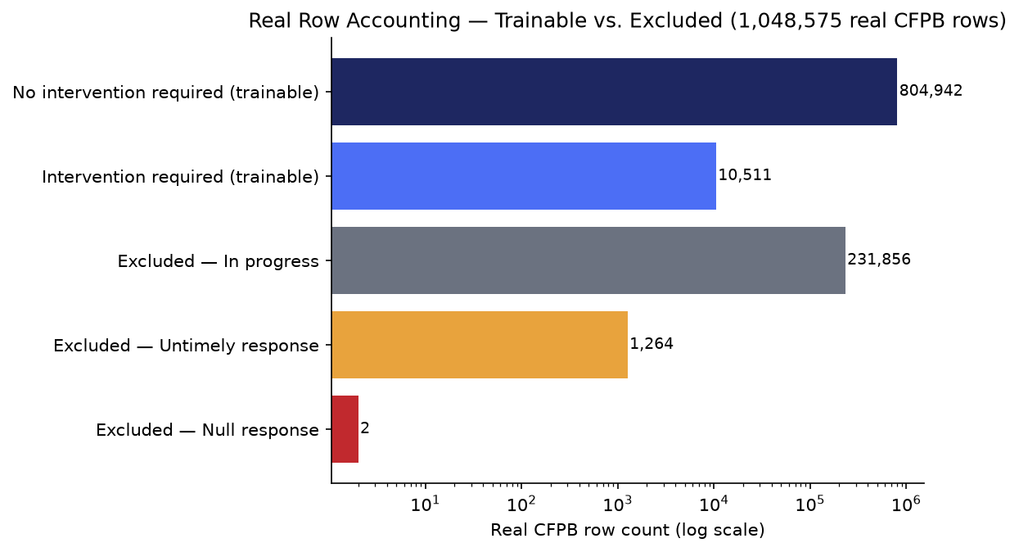

Model Benchmark — Gate 3 (real 5-fold CV, PR-AUC-selected)
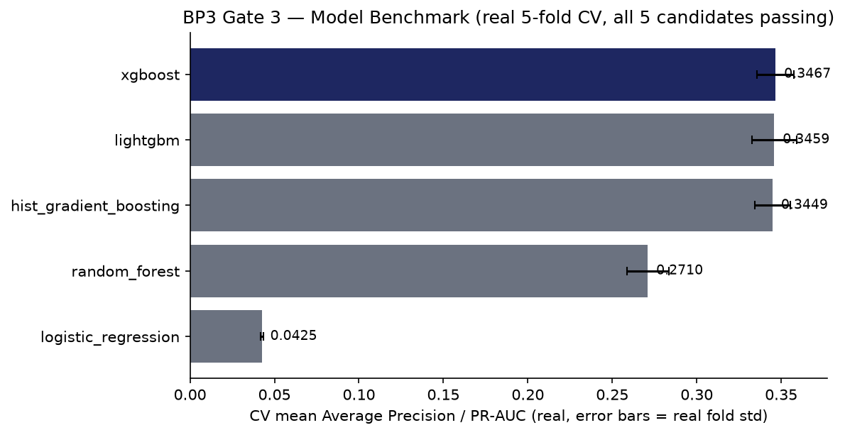
Model | Mean Avg. Precision | Mean ROC-AUC | Mean Recall | Mean Precision
xgboost | 0.3467 | 0.9774 | 0.9383 | 0.1517
lightgbm | 0.3459 | 0.9784 | 0.9623 | 0.1407
hist_gradient_boosting | 0.3449 | 0.9777 | 0.0734 | 0.5418
random_forest | 0.2710 | 0.9713 | 0.9453 | 0.1200
logistic_regression | 0.0425 | 0.8620 | 0.0000 | 0.0000

Explainability & Statistical Validation — Gate 4 (real)
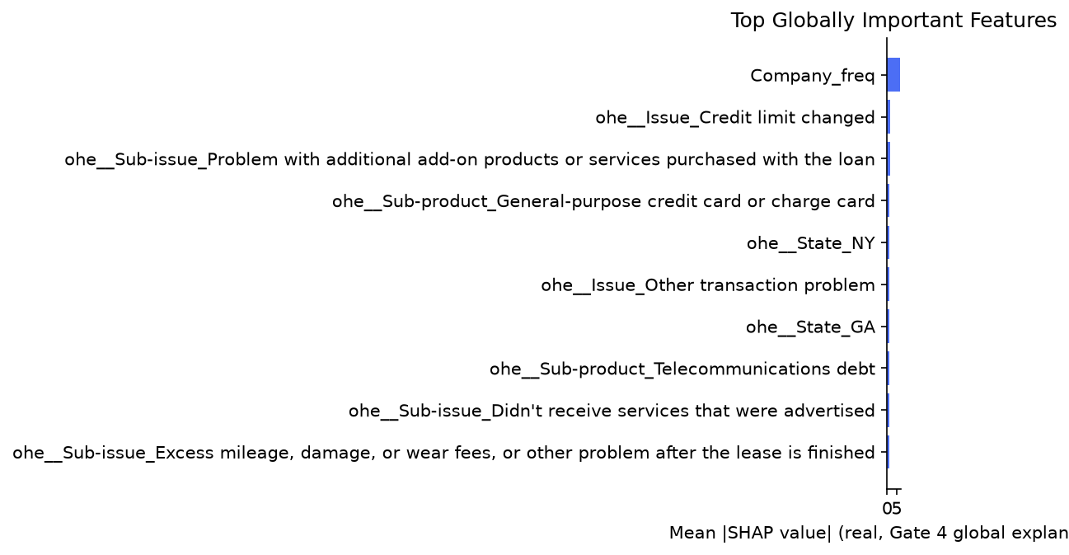
Champion xgboost vs. runner-up lightgbm: paired t-test statistic 0.4148, p-value 0.6995 (n=5 real CV folds — n=5 CV folds is a small sample - treat p-values as directional evidence, not a high-powered statistical claim.). Held-out test PR-AUC 0.3496, 95% bootstrap CI [0.3299, 0.3709] (1000 resamples). Brier score 0.0533.

Real Threshold Tradeoff — Gate 4's 9-Point Grid
Threshold | Precision | Recall | F1 | N predicted positive
0.1 | 0.0896 | 0.9895 | 0.1644 | 23,206
0.2 | 0.1080 | 0.9800 | 0.1945 | 19,082
0.3 | 0.1247 | 0.9681 | 0.2209 | 16,323
0.4 | 0.1382 | 0.9548 | 0.2414 | 14,523
0.5 | 0.1510 | 0.9424 | 0.2603 | 13,121
0.6 | 0.1647 | 0.9253 | 0.2797 | 11,808
0.7 | 0.1785 | 0.9001 | 0.2979 | 10,602
0.8 | 0.1998 | 0.8625 | 0.3244 | 9,075
0.9 | 0.2433 | 0.7750 | 0.3704 | 6,695

Per-Class Performance — Gate 3 (real, both binary classes)
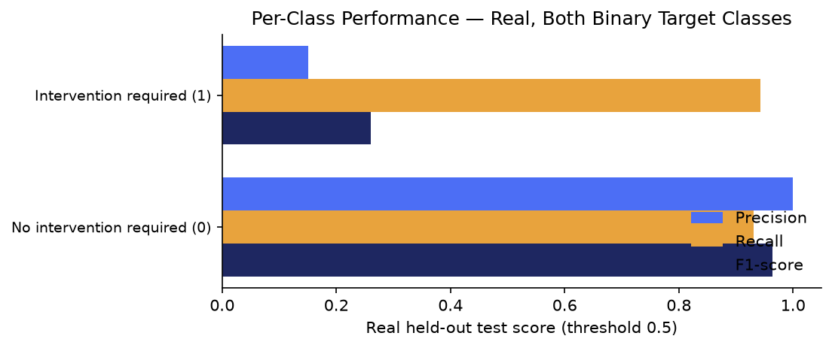
Target class | Precision | Recall | F1 | Support
No intervention required (0) | 0.9992 | 0.9308 | 0.9638 | 160,989
Intervention required (1) | 0.1510 | 0.9424 | 0.2603 | 2,102

Confusion Analysis — Gate 3 (real, full 2×2 matrix)
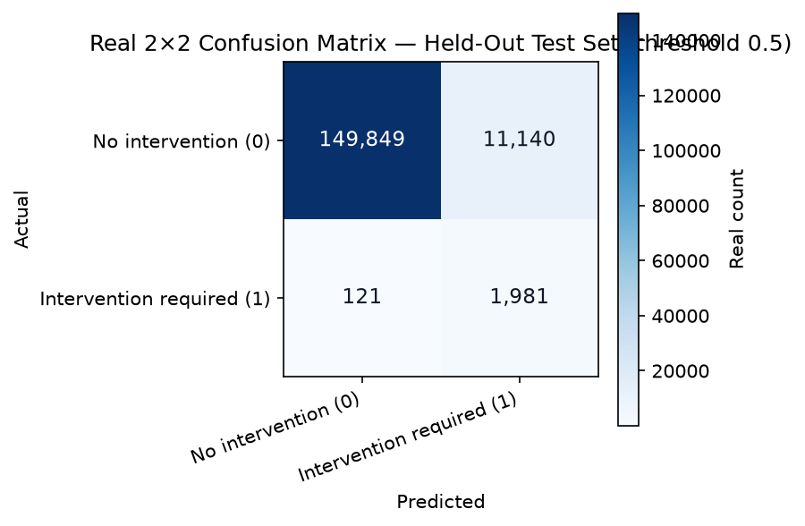
True class | Predicted class | Real count
No intervention required (0) | Intervention required (1) | 11140
Intervention required (1) | No intervention required (0) | 121

Decision Layer — Gate 5 (real)
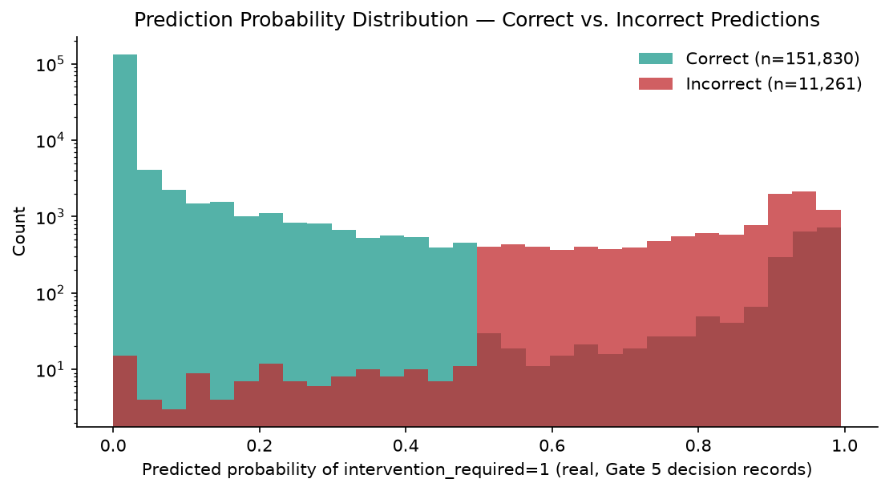
150 of 163,091 real decision records carry a grounded per-instance reason code (0.092%). Mean predicted probability on correct predictions: 0.0319; on incorrect predictions: 0.8195. Gate 4/Gate 5 top-term overlap: 1/10 (Company_freq).

Disparate-Impact Check — ECOA/Reg B (real, FLAGGED)
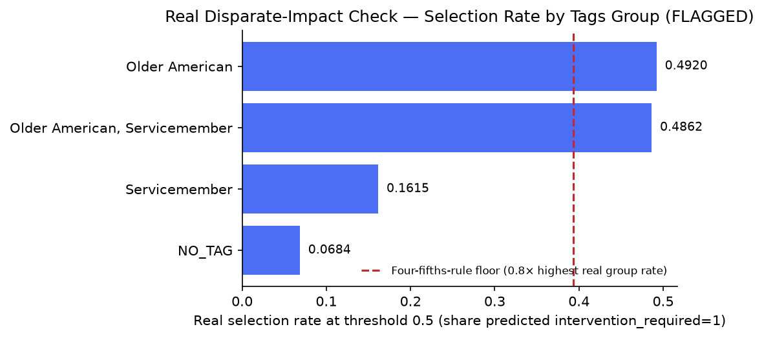
Compliance requirement: ECOA / Regulation B - Fair Lending & Adverse Action (Master Plan Section 9; BP3 is one of the four BPs this section explicitly maps to ECOA/Reg B)
The real CFPB extract's 15 named columns carry no demographic or protected-class field by name. However, 'Tags' (one of those 15 columns) was found - live, in Section 5 above, re-confirming BP2 Gate 3's own real finding on the same data - to contain demographic-adjacent values. Per Master Plan Section 9's own rule ('if any demographic-adjacent field is present, disparate-impact-style testing runs before Gate 6'), BP3 excludes 'Tags' from its feature set outright at this Gate rather than deferring that compliance burden. With 'Tags' excluded, no remaining candidate feature is demographic-adjacent, so disparate-impact-style testing is not required for the feature set BP3 actually uses - stated as a scoping decision, not a claim that no protected-class-adjacent data exists anywhere in the source file.
Tags group | N rows in test | Selection rate @0.5 | Recall @0.5
NO_TAG | 153,194 | 0.0684 | 0.9477
Servicemember | 6,726 | 0.1615 | 0.913
Older American | 2,447 | 0.492 | 0.9365
Older American, Servicemember | 724 | 0.4862 | 0.9062
Adverse-impact ratio (min/max group selection rate, real): 0.139 — FLAGGED (< 0.8, four-fifths-rule convention). Independently recomputed at Gate 5: 0.139 (diff=2.4e-05). Monitoring signal for a human reviewer, not a legal determination of ECOA/Reg B compliance.

Gate 6 — Governance, Known Limitations & Compliance (real)
pytest suite: 189 passed / 0 failed (skipped 4). Notebook syntax audit: 27/27 passed.
Open items — Gate 3 candidate-level issues detected live: 0 near-random-PR-AUC result(s), 2 near-zero-recall result(s), 0 outright failure(s).
Model card: reports\bp3_complaint_escalation_prediction\MODEL_CARD.md | Changelog: reports\bp3_complaint_escalation_prediction\CHANGELOG.md
Model inventory compliance touchpoint: Model inventory entry opened (SR 11-7 first-line record)
Model family: one-hot/frequency-encoded structured features + xgboost. Training data: Real CFPB extract, fresh stratified 80/20 split (CFPB provides no split of its own), random_state=42
Gate 3 candidates evaluated (real): logistic_regression, random_forest, hist_gradient_boosting, xgboost, lightgbm.
Barred columns (real, never used as features): Company response to consumer, Timely response?, Date received, Date sent to company, Tags, Complaint ID, ZIP code.

SMART Suggestions

Root-cause the 2 real near-zero-recall Gate 3 candidates
Specific: Despite passing PR-AUC and ROC-AUC, 2 of the 5 real Gate 3 candidates show near-zero real recall at the default 0.5 threshold: `logistic_regression` (recall 0.0000, PR-AUC 0.0425, ROC-AUC 0.8620) and `hist_gradient_boosting` (recall 0.0734, PR-AUC 0.3449, ROC-AUC 0.9777). Both rank real positives well above random but the default threshold yields almost no positive predictions on this real, 1.29%-positive data. Champion selection uses PR-AUC, not threshold-dependent recall, so neither had a path to silently becoming the champion — but this is undocumented behavior worth root-causing.
Measurable: Target: a documented root cause for both candidates' real threshold/recall behavior, or a documented decision that PR-AUC-based champion selection already makes this immaterial for production use.
Time-bound: Before the next BP3 model refresh cycle.
Owner: ML engineering owner - assign.

Governance sign-off required on the real FLAGGED disparate-impact finding
Specific: The real, independently-recomputed disparate-impact ratio on the `Tags` field is 0.139 (Gate 4) / 0.139 (Gate 5 recompute, diff=2.4e-05) — below the four-fifths-rule convention threshold of 0.8. Notably in the opposite direction naive intuition might expect: real selection rate is LOWEST for `NO_TAG` (0.0684) and HIGHEST for `Older American` (0.492) — the model flags intervention far more often, not less, for the tagged/protected groups.
Measurable: Target: a documented human governance review of this real finding (per Master Plan Section 9's ECOA/Reg B mapping) before any production use, resulting in either a documented risk acceptance or a mitigation plan.
Time-bound: Before this model is proposed for any production use.
Owner: Model risk / compliance owner - assign.

Increase SHAP sample size — real overlap is unusually low
Specific: Gate 4 and Gate 5 independently computed SHAP importance from two different 150-row samples of real held-out data, and only 1/10 top terms overlapped (`Company_freq`) — markedly lower than BP2's equivalent 4/10 overlap on the same sample-size bound, consistent with BP3's real, very high-cardinality one-hot feature space (many near-tied low-signal company/state/sub-issue columns).
Measurable: Target: overlap of 5/10 or higher at a larger, fixed sample size (re-run both gates with an increased SHAP_SAMPLE_SIZE and compare).
Time-bound: Next explainability review cycle.
Owner: Model risk / explainability owner - assign.

Decide the real production operating threshold — 0.5 vs. Gate 4's F1-maximizing 0.9
Specific: At the default 0.5 threshold, the real held-out recall is 94.24% but real precision is only 15.10% — roughly 85 real false positives for every 15 true positives flagged. Gate 4's own 9-point threshold grid found real F1 is maximized at threshold 0.9 (precision 24.33%, recall 77.50%, F1 0.3704, 6,695 real rows flagged vs. 13,121 at 0.5) — a real, data-grounded operational tradeoff never resolved by any gate to date.
Measurable: Target: a documented decision on the real production operating threshold, grounded in the real operational cost of a false positive (unnecessary intervention review) vs. a false negative (missed real escalation risk).
Time-bound: Before this model is proposed for any production use.
Owner: Product / ML engineering owner - assign.

Expand grounded reason-code coverage beyond the current SHAP sample bound
Specific: Only 150 of 163,091 real decision records (0.092%) currently carry a grounded per-instance reason code, bounded by the 150-row SHAP sample size for laptop safety — a much thinner relative real coverage than BP2's, simply because BP3's real held-out test set (163,091 rows) is far larger relative to the fixed 150-row sample bound.
Measurable: Target: 100% reason-code coverage once compute budget allows removing the sample bound, or a documented, deliberate sampling policy (e.g. stratified by predicted probability) if full coverage is not pursued.
Time-bound: Next Gate 5 hardening pass.
Owner: ML engineering owner - assign.

