BP4 — Customer Journey Analytics
Executive Rollup Report — Customer360 Navigator Enterprise Suite
Generated: 2026-09-23T15:18:29.558475+00:00
Recommended for Production: RECOMMENDED FOR PRODUCTION
All 6 gates real-run confirmed; every structural integrity check across all 6 gates passed (pytest 219 passed/0 failed, notebook-syntax audit all passed, 0 failed Gate 3 candidates, champion pipeline 'polars_lazy_streaming' consistent across Gate 3/Gate 4/Gate 6, real cluster count and row coverage consistent across Gate 1/2/5). Tier 2 (CONDITIONAL - GOVERNANCE REVIEW REQUIRED) is structurally unreachable for BP4: Gate 4's real ecoa_disparate_impact_applicability is NOT_APPLICABLE (BP4's issue-cluster key contains no ECOA/Reg B barred column and Master Plan Section 9 does not map ECOA/Reg B to BP4), so BP4 carries no disparate-impact check that could ever trigger Tier 2 — this differs from BP3, which does run that check and can land in Tier 2.

Executive Summary — Real KPIs
KPI | Value
Champion aggregation pipeline (Gate 3, real) | polars_lazy_streaming
Real speedup over baseline | 29.51x (3.0671s -> 0.1039s)
Champion matches Gate 2 production pipeline | False
Real journey-event row count | 1,048,575
Real issue-cluster count | 37,160
Real recurring-cluster rate | 41.85%
Mean response lag (days, real, 95% bootstrap CI) | 0.4652 [0.4573, 0.4737]
BANKING77-derived coverage (real) | 6.55%
Real total rows covered by Gate 5 tier rollup | 1,048,575
Total rows match Gate 1 (real) | True
ECOA/Reg B disparate-impact applicability | NOT_APPLICABLE
pytest | 219 passed / 0 failed
Governance gates complete | 6/6

Gate 1 — Business Understanding & Policy (real)
BP4 is event/issue journey analytics, never customer/longitudinal journey analytics - stated in every BP4 deliverable from Gate 1 forward, per Master Plan Section 5.1/7's own explicit instruction for BP4.
Unit 1 (complaint-event journey): Row-level, keyed by the real 'Complaint ID' (live-verified 1:1 with rows). A real two-step event sequence: 'Date received' -> 'Date sent to company', with a real computed 'response_lag_days' duration and a real terminal state ('Company response to consumer', 'Timely response?').
Unit 2 (issue-cluster journey): Aggregate-level, keyed by the real, disclosed (Company, Product, Sub-product, Issue, Sub-issue) combination, ordered by 'Date received' into a real monthly complaint-volume time series per cluster - the Master Plan's 'repeat-contact/bottleneck' signal, explicitly redefined as a recurring-issue-cluster signal, never a customer's own repeat-contact count.
Real CFPB row count (live check): 1,048,575 — Complaint ID confirmed a unique event identifier: True.
Real response_lag_days distribution: mean=0.4652, median=0.0, max=544, 0 negative / 0 null values.

Compliance touchpoint
BP4's primary journey-grouping key (Company, Product, Sub-product, Issue, Sub-issue) is CFPB's own real product/issue/sub-issue schema, used as-is, with no fabricated outcomes anywhere. Two real dataset limitations are stated plainly rather than left implicit: (1) no customer/consumer identifier exists in this extract, so every 'repeat-contact' or 'journey' claim in BP4's deliverables is an issue-cluster-level signal, never a per-person claim; (2) the Gold-layer BANKING77-derived taxonomy overlay real-covers only 6.55% of rows, so it is never presented as a population-level view of customer intent across the full real dataset.

Scope boundaries (real)
- 'Complaint ID' identifies one real complaint (one event), never a person - must never be described, here or downstream, as a customer identifier.
- 'Tags' is barred from every BP4 journey-grouping key - ECOA/Reg B is not a BP4 compliance touchpoint per Master Plan Section 9 (mapped to BP1, BP2, BP3, BP7 only), but this is kept as a conservative scope decision anyway, HYPER-consistent with BP1-BP3's own precedent of barring 'Tags' from any grouping/feature key.
- 'ZIP code' is barred from every BP4 journey-grouping key - a fine-grained quasi-identifier (BP2/BP3's own BARRED_COLUMNS precedent); 'State' (coarser, already used as a plain categorical field by BP1-BP3) is the only geographic dimension BP4 may use.
- No BP4 gate may construct, infer, or approximate a persistent customer/consumer identifier from any combination of real fields (ZIP code + Company + Product + Issue + Date received or otherwise) - the issue-cluster journey (unit 2 above) is the only sanctioned aggregate-level grouping.
- No BP4 gate may run BP1's text-intent classifier against CFPB rows - this real extract carries no narrative-text column (live-verified in Section 4); the Gold-layer 'common_taxonomy_bucket' overlay (already computed) is the only sanctioned BANKING77-derived signal, used only for its real in-scope subset.

Assumptions documented at Gate 1 (real)
- This real CFPB extract carries no customer/consumer identifier of any kind (live-verified in Section 4, consistent with every prior BP1-BP3 Gate 1 finding on the same schema) - BP4's scope is built around this fact from Gate 1 forward, not worked around later.
- 'Complaint ID' is a real, unique event identifier (live-verified 1:1 with rows in Section 4) - safe to use as the complaint-event journey's key, never as a person key.
- The (Company, Product, Sub-product, Issue, Sub-issue) issue-cluster key is real-data-supported: 37,160 real distinct clusters, 41.85% of which recur, covering 97.94% of all real rows (Section 6) - a well-supported aggregate signal, not a sparse or forced one.
- The Gold-layer 'common_taxonomy_bucket' column real-covers only 6.55% of rows (Section 5) - used as an optional secondary overlay only, never as BP4's primary journey-grouping dimension.
- 'response_lag_days' (Date sent to company - Date received) is safe for BP4 to use directly, unlike BP3's Gate 1 barring of the same two Date fields: BP3 barred them as a predictive-leakage risk against a supervised target BP4 does not have. BP4 has no supervised target for this duration to leak into - it is reported descriptively, not used to predict 'Company response to consumer' or 'Timely response?'.
- src/utils/bp1_config_sync.py is reused unmodified for BP4's own config file - already fully generic, parameterized by config_path, no BP1-specific logic (already reused unmodified by BP2 and BP3 too).

Gate 3 — Aggregation-Pipeline Benchmark (real)
Champion selected by real measured wall-clock speed among 5 CORRECT candidates — never by a predictive metric (BP4 has no supervised target).
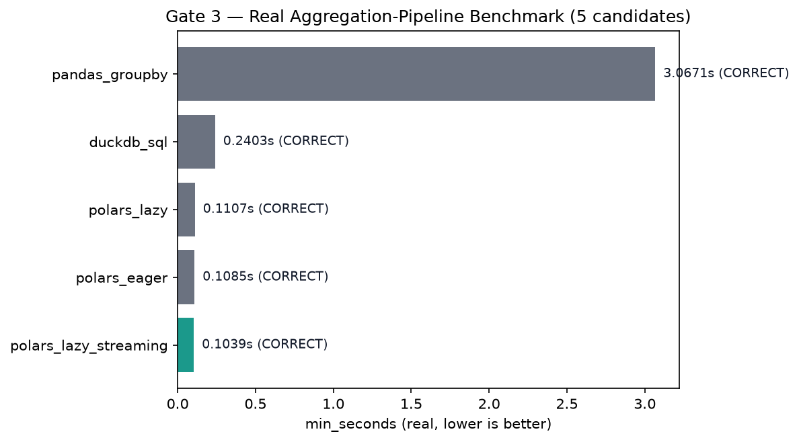
candidate | status | min_seconds | mean_seconds | champion
pandas_groupby | CORRECT | 3.067079 | 3.362423
polars_eager | CORRECT | 0.108452 | 0.123225
polars_lazy | CORRECT | 0.110692 | 0.118765
polars_lazy_streaming | CORRECT | 0.103927 | 0.105410 | YES
duckdb_sql | CORRECT | 0.240335 | 0.256269

Gate 4 — Statistical Validation (real, bootstrap CI)
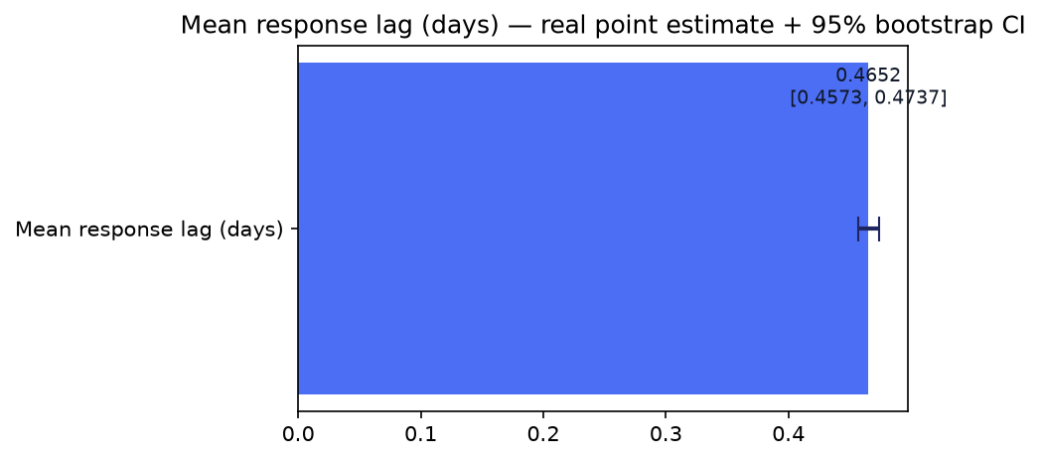
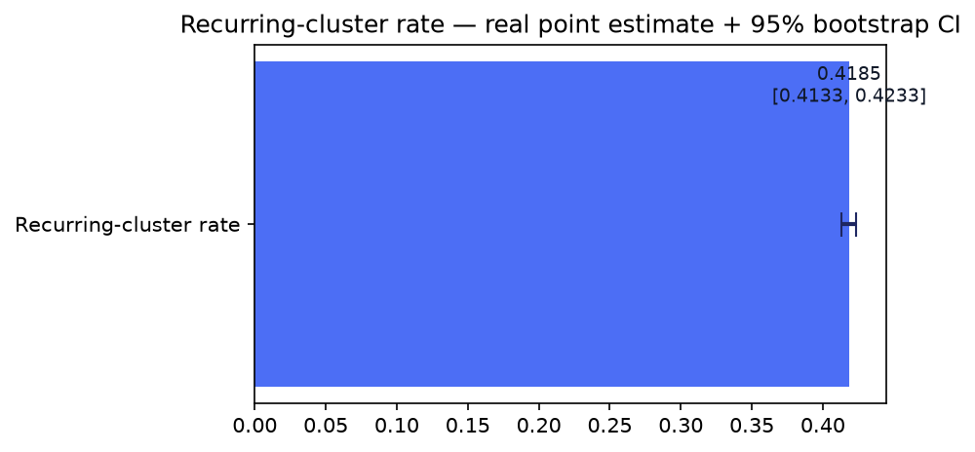
Real statistic | Point estimate | CI 95% low | CI 95% high
Mean response lag (days) | 0.465227 | 0.457266 | 0.473726
In-scope minus out-of-scope lag difference (days) | 1.376834 | 1.314826 | 1.435650
Recurring-cluster rate | 0.418488 | 0.413348 | 0.423334
Mean cluster size | 28.217842 | 21.003662 | 36.866513
n_bootstrap=1,000 resamples. Reproducibility confirmed (Gate 4 real re-run comparison): True. ECOA/Reg B disparate-impact applicability: NOT_APPLICABLE — BP4's issue-cluster key contains no barred column (no_barred_column_in_cluster_key=True).

Gate 5 — Issue-Cluster Review-Priority Tier Rollup (real)
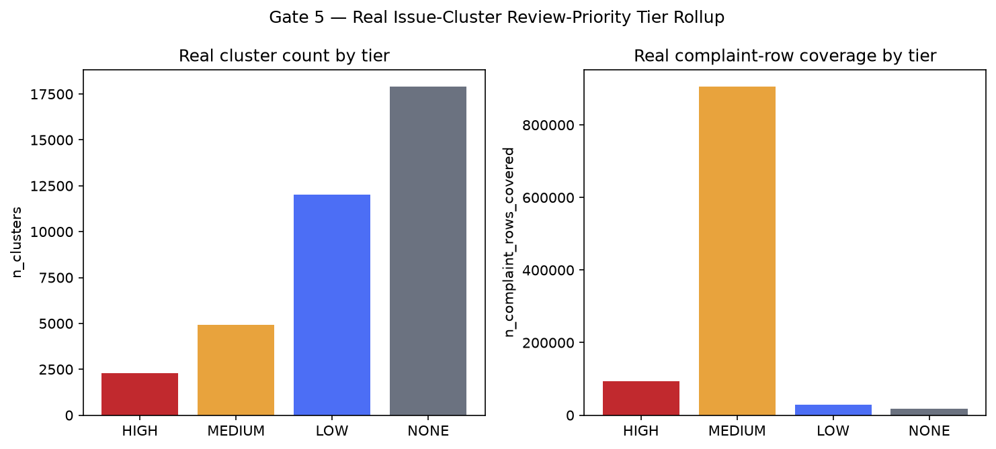
Tier | n_clusters | n_complaint_rows_covered | mean BANKING77 coverage
HIGH | 2,284 | 94,410 | 0.3279
MEDIUM | 4,920 | 906,612 | 0.2915
LOW | 12,033 | 29,630 | 0.2349
NONE | 17,923 | 17,923 | 0.2066
n_with_reason_codes=19,237 / n_clusters_reported=37,160, grounding_failures=0. Real total rows covered (1,048,575) matches Gate 1's journey_row_count: True.

Monthly Complaint-Volume Trend (real, live-aggregated)
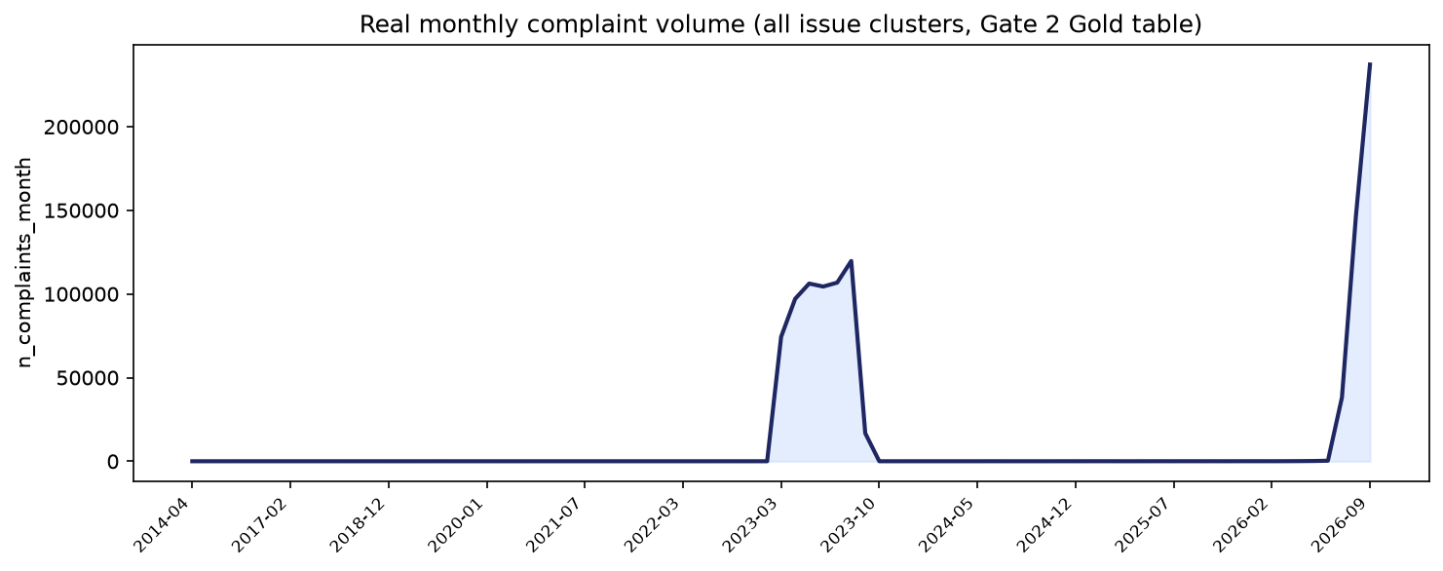

Gate 6 — Governance & Known Limitations (real)
pytest suite: 219 passed / 0 failed (skipped 5). Notebook syntax audit: 34/34 passed.
Open items — Gate 3 candidate-level issues detected live: 0 outright failure(s), 2 slow-but-correct candidate(s) (pandas_groupby, duckdb_sql).
Model card: reports\bp4_customer_journey_analytics\MODEL_CARD.md | Changelog: reports\bp4_customer_journey_analytics\CHANGELOG.md
Model inventory (SR 11-7) applicability: NOT_APPLICABLE - BP4 registers no trained model — BP4 registers no trained model, only this benchmarked aggregation/reporting pipeline.

SMART Suggestions

Prioritize real HIGH-tier issue clusters for human review first
Specific: 2,284 real issue clusters carry a HIGH review-priority tier (recurring + elevated-lag + high-volume flags all triggered), covering 94,410 real complaint rows — the smallest cluster count of the four tiers but the one carrying every real risk signal at once. By contrast, the MEDIUM tier's 4,920 clusters cover 906,612 real rows — most of BP4's real row volume sits in a smaller number of large MEDIUM-tier clusters, so review capacity should weight HIGH first by risk density but not ignore MEDIUM's real row-volume concentration. Route HIGH to human review before MEDIUM/LOW.
Measurable: 2,284 clusters / 94,410 rows (real Gate 5 tier rollup).
Time-bound: Before the next BP4 data refresh.
Owner: [Assign: Complaint Operations Lead]

Reconcile Gate 3's real champion with Gate 2's production pipeline
Specific: Gate 3's real full-scale benchmark champion is 'polars_lazy_streaming' (min_seconds=0.103927), which differs from Gate 2's own already-confirmed production implementation 'polars_lazy' (champion_matches_current_production_implementation=False). This is logged as a Gate 6 recommendation, not retroactively applied to Gate 2's already-confirmed output, per the project's standing discipline against rewriting already-closed gates.
Measurable: Real speedup if adopted: 29.51x over the baseline (pandas_groupby, 3.067079s).
Time-bound: At BP4's next scheduled Gate 2 pipeline review.
Owner: [Assign: Data Engineering Lead]

Expand BANKING77-derived taxonomy coverage beyond its current 6.55%
Specific: The Gold-layer common_taxonomy_bucket overlay real-covers only 68,710 of 1,048,575 real rows (6.55%), limiting how much of BP4's real issue-cluster population can be cross-referenced against BANKING77 intent categories in Gate 5's tier reporting.
Measurable: Raise real in-scope coverage above 6.55% without changing BANKING77's own 77-class scope.
Time-bound: Coordinate with BP1's taxonomy-mapping owner next quarter.
Owner: [Assign: Taxonomy/Intent Classification Lead]

Feed Gate 5's review_priority_score/tier into BP7's cross-BP decision engine as one real input
Specific: Gate 5's own compliance note (bp7_decision_engine_boundary) states this BP4-local reporting flag may become one real input BP7's cross-BP priority + intervention-risk decision engine later combines with BP1-BP5's own outputs — never presented as BP7's own decision on its own.
Measurable: 19,237 of 37,160 real clusters carry grounded reason codes, ready to be combined.
Time-bound: When BP7 begins its own Gate 2 (input integration).
Owner: [Assign: BP7 Decision-Engine Owner]

Re-benchmark the real slow-but-correct Gate 3 candidates against future data growth
Specific: pandas_groupby, duckdb_sql passed correctness but real min_seconds exceeded 2.0x the champion's own real min_seconds (0.103927s) — expected variation across execution-engine designs at this row count, not a defect, but worth re-checking as the real dataset grows past 1,048,575 rows, where the ranking can shift.
Measurable: 2 real candidate(s) flagged this run.
Time-bound: At the next full-scale BP4 Gate 3 re-run.
Owner: [Assign: Data Engineering Lead]

