BP5 — Root-Cause & Driver Analytics: Executive Rollup Report
Recommendation: Recommended for Decision-Support Use, With Monitoring
All structural checks passed. 3 real open item(s) were live-detected by Gate 6 (2 negligible-association candidate field(s), 0 near-random PR-AUC outcome(s), 1 near-zero-precision-at-0.5 outcome(s)) - none of these block use, but each is a real, disclosed monitoring item a human reviewer should be aware of before acting on this report's findings. This is a monitoring signal, never a legal or compliance determination.
Generated: 2026-09-24T11:23:26.431529+00:00 | ECOA/Reg B disparate-impact applicability: NOT_APPLICABLE
This report trains and evaluates nothing itself - every number, table, and chart it produces was already computed and recorded by Gates 1-6's own real runs, most directly via Gate 5's own synthesized, citation-backed prioritized root-cause report per outcome. Every finding is a statistical ASSOCIATION, never a causal claim. There is no financial-impact or illustrative-projection section anywhere in this report - only original notebook output results are reported.

Executive KPIs
Metric | Value
Top field — Outcome 1 | Sub-issue (Cramer's V=0.4156)
Top field — Outcome 2 | Sub-product (Cramer's V=0.1645)
Top SHAP feature — Outcome 1 | Company_freq_zscored (1.6236)
Top SHAP feature — Outcome 2 | Company_freq_zscored (2.0926)
Held-out ROC-AUC — Outcome 1 | 0.9705
Held-out ROC-AUC — Outcome 2 | 0.9526
Brier score — Outcome 1 | 0.0727
Brier score — Outcome 2 | 0.0992
UDAAP language check | PASSED
Barred-fields bar relaxed | False
Gate 6 pytest | 325 passed / 0 failed
Negligible-strength fields detected | 2
Near-zero-precision outcomes detected | 1

Gate 3/5 — Root-Cause Findings (Outcome 1 — Intervention Required)
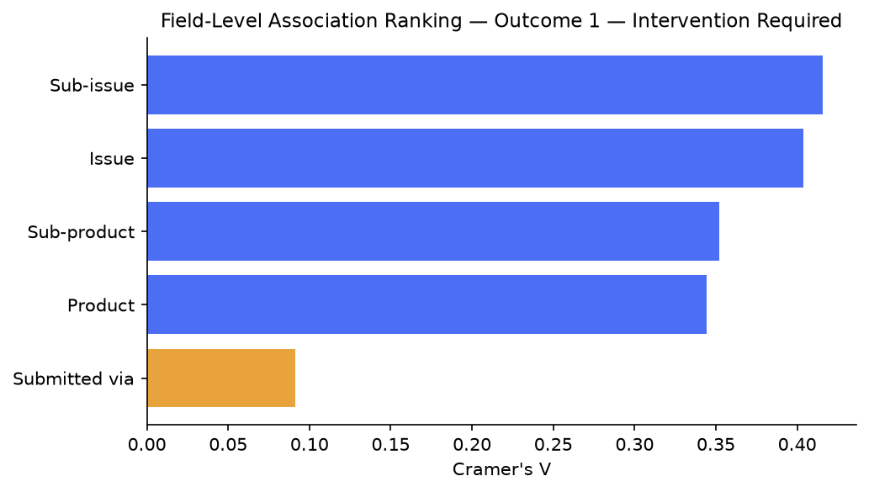
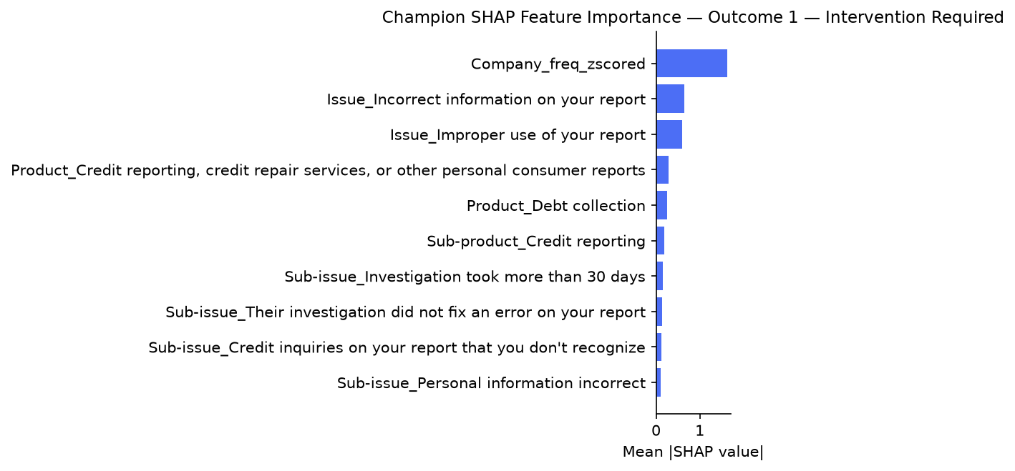

Top Category-Level Findings (Outcome 1 — Intervention Required)
Field | Category | n_rows | Odds Ratio vs Ref. | p-value
Sub-issue | Problem with fees | 1656 | 2038.03 | 0.00e+00
Sub-issue | Add-on products and services | 88 | 1475.82 | 0.00e+00
Sub-issue | Charged too much interest | 657 | 1257.68 | 0.00e+00
Sub-issue | Didn't receive terms that were advertised | 639 | 1234.70 | 0.00e+00
Sub-issue | Credit card company isn't resolving a dispute about a purchase on your statement | 4886 | 1166.64 | 0.00e+00
Issue | Fees or interest | 2555 | 740.61 | 0.00e+00
Issue | Problem with a purchase shown on your statement | 7090 | 526.84 | 0.00e+00
Issue | Problem caused by your funds being low | 1325 | 338.68 | 0.00e+00
Issue | Problem with a purchase or transfer | 810 | 301.48 | 0.00e+00
Issue | Problem with a lender or other company charging your account | 3284 | 289.96 | 0.00e+00

Gate 4 — Statistical Validation (Outcome 1 — Intervention Required)
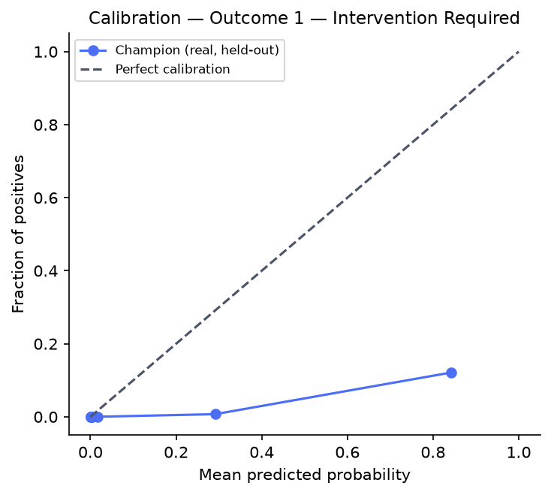
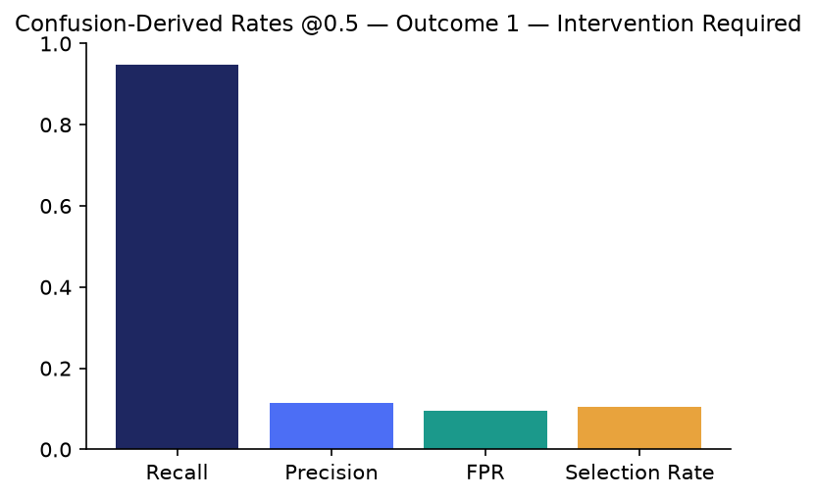

Gate 3/5 — Root-Cause Findings (Outcome 2 — Timely-Response Failure)
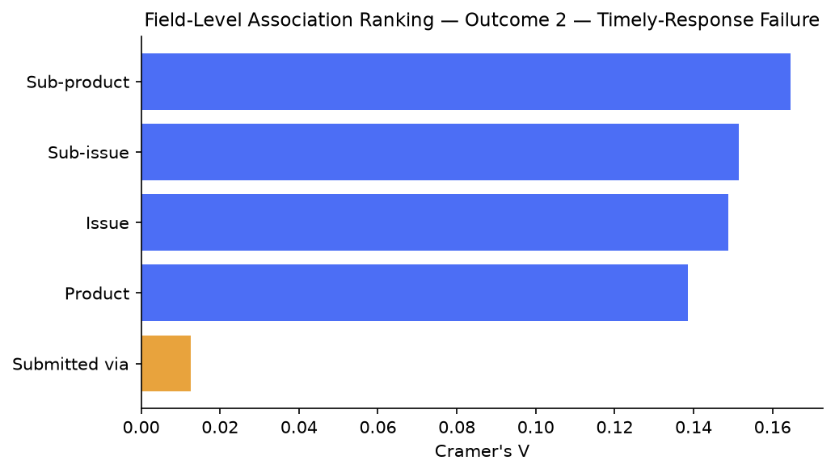
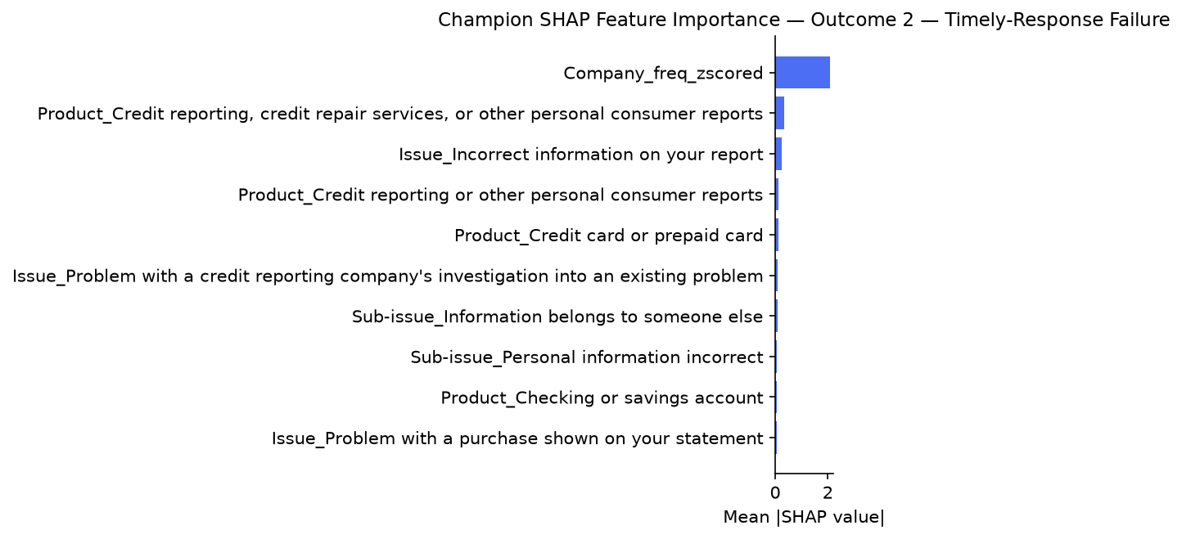

Top Category-Level Findings (Outcome 2 — Timely-Response Failure)
Field | Category | n_rows | Odds Ratio vs Ref. | p-value
Sub-product | Title loan | 421 | 296.92 | 0.00e+00
Sub-product | Government benefit card | 767 | 137.08 | 0.00e+00
Sub-product | Debt settlement | 260 | 115.21 | 0.00e+00
Sub-product | Federal student loan servicing | 2957 | 109.09 | 0.00e+00
Sub-product | Payday loan debt | 824 | 99.64 | 0.00e+00
Sub-issue | Problem with forgiveness, cancellation, or discharge | 116 | 924.31 | 0.00e+00
Sub-issue | Changes in loan terms during or after closing | 38 | 287.47 | 0.00e+00
Sub-issue | Problem with your payment plan | 40 | 210.81 | 0.00e+00
Sub-issue | Trouble with how payments are being handled | 796 | 185.80 | 0.00e+00
Sub-issue | Paying off the loan | 58 | 140.54 | 0.00e+00

Gate 4 — Statistical Validation (Outcome 2 — Timely-Response Failure)
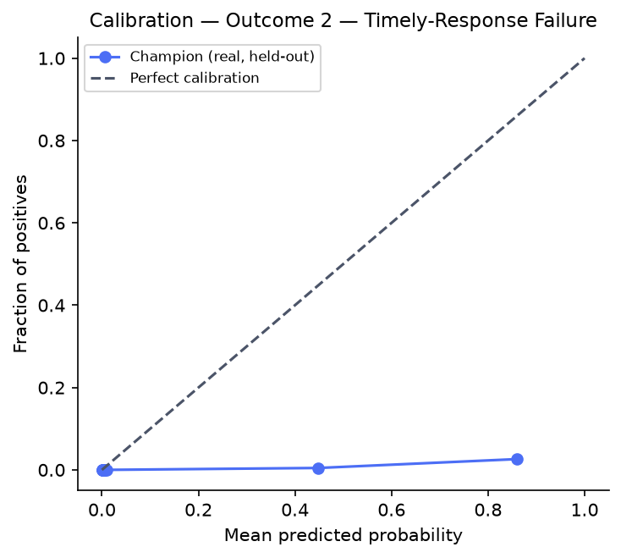
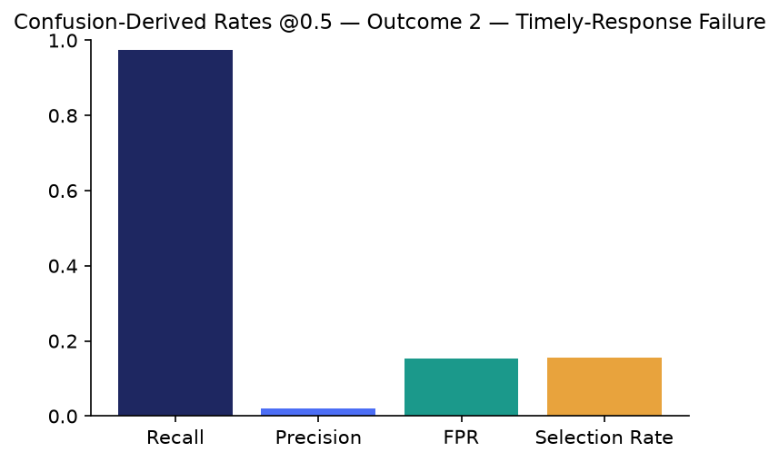

Gate 1 — Business Understanding & Policy
Master Plan Section 6 (Integration Architecture) names 'CFPB outcome fields' (plural) feeding BP3/BP5 - BP5 draws on that same real CFPB outcome-field family BP3's Gate 1 already defined and used, not a different data source. BP5 tests real product/issue/process fields for statistical association against TWO real, distinct outcome fields (below), not one - grounded live in Section 6's outcome-field overlap check, not assumed redundant or assumed independent.

Gate 6 — Governance & Known Limitations
pytest: ================ 325 passed, 3 skipped, 182 warnings in 9.51s ================= | notebook syntax: 51 passed / 0 failed

SMART Suggestions

Review the two real negligible-association candidate fields
Specific: 'Submitted via' shows negligible Cramer's V association with BOTH real outcomes (outcome_1: 0.091, outcome_2: 0.013, per Gate 3's own chi_square_cramers_v.csv) - the weakest of the 5 non-control candidate fields for both outcomes.
Measurable: 2 real negligible-strength field/outcome combinations, as live-detected by Gate 6 (n_negligible_strength_fields_detected=2).
Time-bound: Before the next scheduled Gate 3 re-run.
Owner: BP5 analytics lead (name TBD by the user's team)

Review outcome_2's near-zero precision at the default 0.5 threshold
Specific: outcome_2_timely_response_failure's champion shows real precision=0.0191 at threshold 0.5 (real recall=0.9752) - high recall / very low precision, consistent with class_weight='balanced' under outcome_2's own extreme real class imbalance.
Measurable: 1 outcome(s) live-flagged by Gate 6's own PRECISION_ANOMALY_THRESHOLD=0.05 check.
Time-bound: Before this report's findings are used to prioritize any real review queue.
Owner: BP5 analytics lead (name TBD by the user's team)

Maintain the mechanical UDAAP language review cadence
Specific: Gate 5's own real UDAAP check scanned 76 narrative sentences and found 0 unquoted banned-pattern matches on this real run.
Measurable: 0 of 0 narrative sentences failing, maintained on every future real re-run.
Time-bound: Every time Gate 5 or Gate 7 is re-run.
Owner: BP5 compliance reviewer (name TBD by the user's team)

Formal governance review of the 3 barred candidate fields' real diagnostics
Specific: Gate 3's own barred-field diagnostics show real, non-trivial associations for all 3 barred fields ('Timely response?' log-odds-ratio=1.24 vs outcome_1; '_response_duration_days' odds-ratio-per-1sd≈1.13-1.17 vs both outcomes; 'Company response to consumer' Cramer's V=0.63 (strong) vs outcome_2) - Gate 1's conservative bar was never relaxed automatically.
Measurable: 3 real barred-field diagnostic findings, all disclosure-only per Gate 3's own design.
Time-bound: As a standing governance agenda item, no fixed deadline.
Owner: BP5 governance owner (name TBD by the user's team)

Deep-dive the Company (frequency-encoded) driver - the strongest SHAP feature for both outcomes
Specific: 'Company_freq_zscored' ranks #1 by real mean |SHAP| for BOTH outcomes (outcome_1: 1.6236, outcome_2: 2.0926).
Measurable: 1 real, consistently top-ranked driver across both outcomes.
Time-bound: As input to the next Gate 3 re-run's candidate-field review.
Owner: BP5 analytics lead (name TBD by the user's team)

