BP6 — GenAI Resolution Assistant: Executive Rollup Report
Recommendation: RECOMMENDED FOR PRODUCTION
All 6 gates real-run confirmed (each gate's own config marker block present with a real generated_at_utc timestamp); every real structural/governance check passed (pytest 363 passed/0 failed, notebook-syntax audit all passed, retrieval champion 'taxonomy_bucket_match' agrees across Gate 3/Gate 4, coverage independently reproduces exactly, leakage reconfirmed, citation/UDAAP checks passed, finish_reason='FinishReason.STOP' (never truncated), NIST AI RMF risk category 'MEDIUM' (never LOW), human-in-the-loop enforced (approval_status=PENDING_HUMAN_REVIEW, auto_applied=False), and Gate 6's own real FastAPI self-test reported identical=True). Tier 2 (CONDITIONAL - GOVERNANCE REVIEW REQUIRED) is structurally unreachable for BP6: Gate 4's real ecoa_reg_b_status is NOT_APPLICABLE (BP6's real inputs - BANKING77's text/category columns and the real common_taxonomy_bucket join field - carry no ECOA/Reg B protected-class or demographic-adjacent field), so BP6 carries no disparate-impact check that could ever trigger Tier 2 - this differs from BP3, which does run that check and can land in Tier 2, and matches BP4's own precedent exactly.
Generated: 2026-09-24T17:09:51.901460+00:00 | ECOA/Reg B disparate-impact applicability: NOT_APPLICABLE | Tier 2 reachable for this BP: False
This report trains and evaluates nothing itself - every number, table, and chart it produces was already computed and recorded by Gates 1-6's own real runs. BP6 is a retrieval + human-in-the-loop grounded-generation governance layer over BP1-BP5's own real Gate 7 outputs, never a trained classifier - it has no champion model, no SHAP importance, and no confusion matrix. Every recommendation remains PENDING_HUMAN_REVIEW and is never auto-applied. There is no financial-impact or illustrative-projection section anywhere in this report - only original notebook output results are reported.

Executive KPIs
Metric | Value
Champion retrieval strategy | taxonomy_bucket_match (coverage=0.3333)
Runner-up retrieval strategy | raw_string_match (coverage=0.0000)
Bootstrap 95% CI on champion coverage | [0.0000, 0.6667] (n=1000)
Bucket-availability crosstab | both=3, BANKING77-only=6, CFPB-only=0
PII rows screened / flagged | 13,083 / 0
Gemini model used (Gate 5) | gemini-3.5-flash
finish_reason (Gate 5) | FinishReason.STOP
Citations used / available | 4 / 28
Citation check passed | True
UDAAP check passed | True
NIST AI RMF risk category | MEDIUM
Approval status | PENDING_HUMAN_REVIEW (auto_applied=False)
Gate 6 pytest | 363 passed / 0 failed
Gate 6 FastAPI self-test identical | True
ECOA/Reg B disparate-impact applicability | NOT_APPLICABLE

Gate 3/4 — Retrieval Strategy Benchmark & Validation
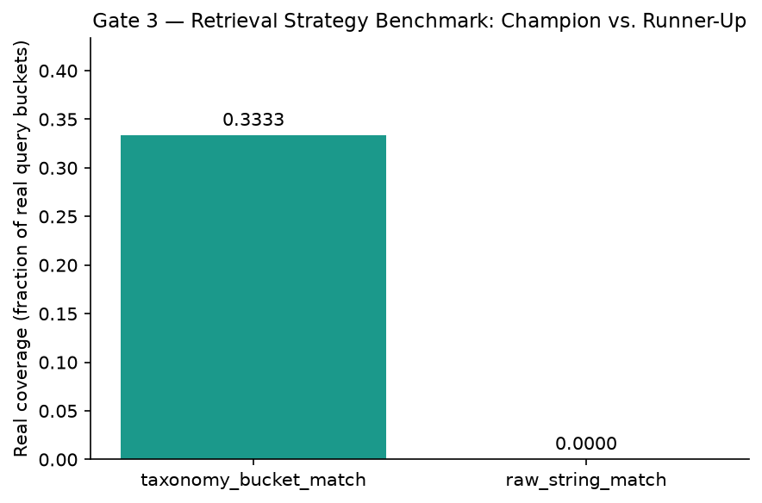
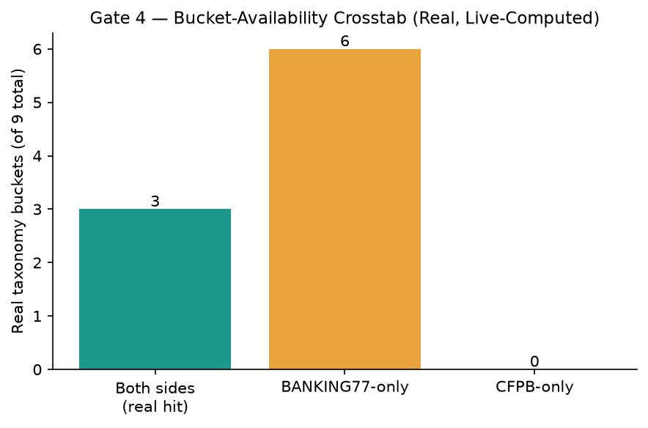
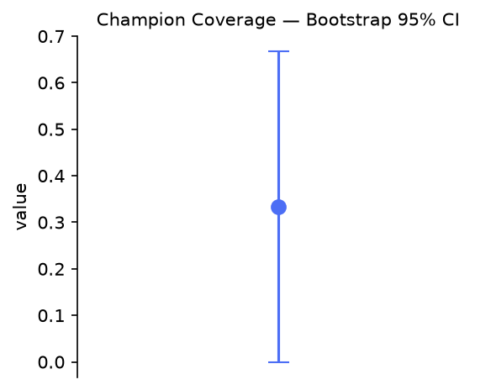

Gate 4 — Taxonomy-Bucket Crosswalk (Explainability Trace)
BP6 fits no black-box model, so there is no SHAP feature-importance chart. This explainability trace is BP6's fully transparent, by-design equivalent: the real real crosswalk rationale for every real taxonomy bucket with a cross-corpus hit.
Bucket | Crosswalk Confidence | n BANKING77 Categories Mapped
ATM_CASH_WITHDRAWAL | LOW | 7
CARD_ISSUANCE_AND_LIFECYCLE | MEDIUM | 15
TRANSFERS | HIGH | 11

Gate 5 — GenAI Recommendation & Grounding
The real, GenAI-generated recommendation text below is quoted verbatim from Gate 5's own saved artifact - never paraphrased or re-generated by this report:
“To address this unrecognized withdrawal report, we should review BP4, which utilizes a polars_lazy_streaming champion pipeline [EV-BP4-1] and is currently recommended for the production tier [EV-BP4-2]. Additionally, we should note that BP4 represents two slow but correct candidates from gate 3 [EV-BP4-5] and embeds 7,204 high and medium tier clusters [EV-BP4-6]. Please verify these system specifications before initiating the standard investigation process for the customer's transaction.”
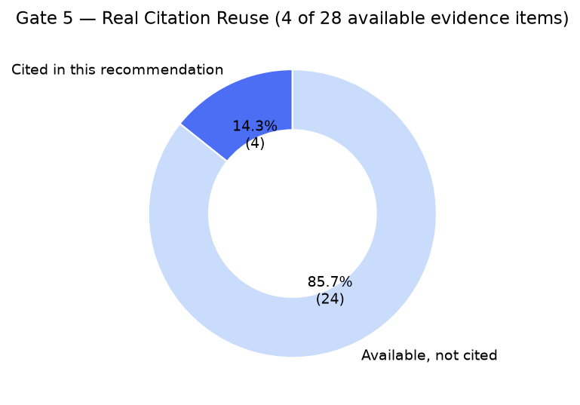
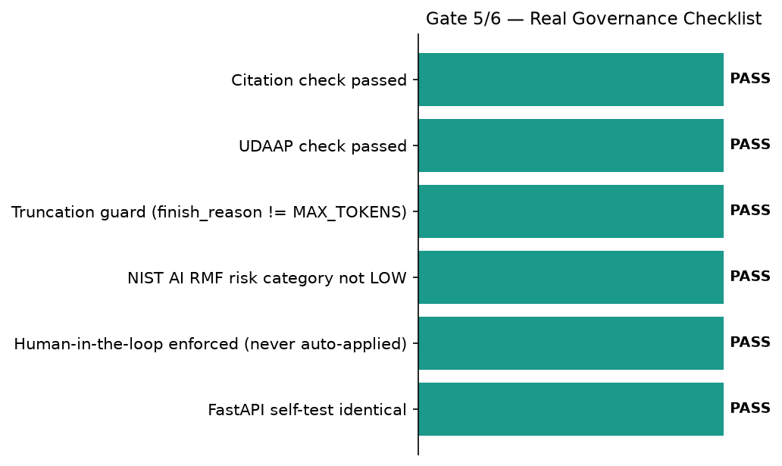

Gate 1 — Business Understanding & Policy
Retrieve structured evidence from BP1-BP5's real outputs, summarize it, and recommend a next action with a citation/evidence field on every claim, per Master Plan Section 5.1/7 - human-in-the-loop approval required before any recommendation is treated as final.

Gate 6 — Governance & Known Limitations
pytest: ================ 363 passed, 6 skipped, 182 warnings in 21.06s ================ | notebook syntax audit returncode: 0
Open items (informational, non-blocking): low_citation_reuse_ratio_detected=True, model_drift_vs_gate5_saved_artifact=True

SMART Suggestions

Expand taxonomy-bucket coverage beyond the 3 real cross-corpus hits
Specific: Only 3 of 9 real taxonomy buckets have a real cross-corpus hit on both BANKING77 and CFPB (champion strategy 'taxonomy_bucket_match', real coverage 0.3333); 6 buckets are BANKING77-only today, with zero real CFPB-side evidence to retrieve against.
Measurable: Real coverage of 0.3333 (95% bootstrap CI [0.0000, 0.6667]) — target: raise both_sides_n above 3/9 on a future real re-run of Gate 3's crosswalk.
Time-bound: Before the next scheduled Gate 3 crosswalk re-run.
Owner: BP6 retrieval-strategy owner (name TBD by the user's team)

Review the low real citation-reuse ratio as a governance signal
Specific: Gate 5's real recommendation cited 4 of 28 real evidence items available (reuse ratio 0.1429) — live-flagged by Gate 6 as a real, disclosed open item, not an error.
Measurable: low_citation_reuse_ratio_detected=True at threshold 0.25, as live-computed by Gate 6.
Time-bound: Reviewed at every future real Gate 5/Gate 6 re-run.
Owner: BP6 governance reviewer (name TBD by the user's team)

Monitor the real Gemini model-drift disclosure between Gate 5 and Gate 6
Specific: Gate 5's saved recommendation used model 'gemini-3.5-flash'; Gate 6's own real runtime environment override recorded 'gemini-3.6-flash' (model_drift_vs_gate5_saved_artifact=True) — an informational disclosure only, since Gate 6's self-test still reported identical=True on its own real call.
Measurable: 0 further undisclosed model substitutions on the next real re-run.
Time-bound: Every time Gate 5 or Gate 6 is re-run.
Owner: BP6 MLOps owner (name TBD by the user's team)

Maintain the mechanical UDAAP + citation-grounding review cadence
Specific: Gate 5's own real UDAAP check scanned 3 narrative sentences and found 0 failing on this real run; the citation check confirmed 4 real, non-phantom evidence IDs referenced.
Measurable: 0 of 0 sentences failing, maintained on every future real re-run.
Time-bound: Every time Gate 5 or Gate 7 is re-run.
Owner: BP6 compliance reviewer (name TBD by the user's team)

Keep the human-in-the-loop approval gate mandatory as BP6 scales
Specific: Every real recommendation remains approval_status='PENDING_HUMAN_REVIEW' with auto_applied=False - a governance feature, not a current limitation, per Master Plan Section 5.1's own human-in-the-loop requirement.
Measurable: auto_applied=False on 100% of real recommendations, every real run.
Time-bound: Standing requirement — no fixed deadline, re-verified at every Gate 6 run.
Owner: BP6 governance owner (name TBD by the user's team)

