BP7 — Customer Navigator Decision Engine: Executive Rollup Report
Recommendation: RECOMMENDED FOR PRODUCTION
All 6 gates real-run confirmed (each gate's own config marker block present, combined with a real confirming generated_at_utc timestamp - Gates 2-4 checked against their own artifact JSON's timestamp per this BP's real flat-config shape, Gates 5-6 checked against the config's own gate5_generated_at_utc/gate6_generated_at_utc fields); every real structural/governance check passed (pytest 410 passed/0 failed, notebook-syntax audit all passed, Gate 3/Gate 5 champion rule scheme 'correlation_aware_plus_lr_diagnostic' agrees, Gate 4's independent reproduction of Gate 3's entire champion-selection pipeline is bit-exact, leakage reconfirmed clean, the exact contribution decomposition reconstructs priority_score exactly (max_abs_reconstruction_error=0.0), Gate 5's weight rederivation matches the config and all 4 Gate 3/Gate 4 cross-checks passed, and Gate 6's own real FastAPI self-test reported all_checks_passed=True); and the real, independently re-derived-at-Gate-5 four-fifths-rule disparate-impact check is NOT flagged (adverse_impact_ratio=0.908127, above the 0.8 four-fifths-rule convention threshold). Tier 2 (CONDITIONAL - GOVERNANCE REVIEW REQUIRED) is genuinely reachable for BP7 - unlike BP4's/BP6's own NOT_APPLICABLE ECOA/Reg B finding, BP7 DOES run a real disparate-impact check (resolved at Gate 4 after an honest Gate 3 deferral) - it is simply not triggered on this real run's own numbers.
Generated: 2026-09-25T07:45:22.492499+00:00 | Four-fifths-rule flagged: False | Tier 2 reachable for this BP: True
This report trains and evaluates nothing itself - every number, table, and chart it produces was already computed and recorded by Gates 1-6's own real runs. BP7 fits no model and makes no GenAI/external API call ever - it is a transparent, auditable, deterministic weighted decision-rule layer combining BP2's/BP3's/BP4's own real prediction fields into priority_score, intervention_flag, and recommended_action. There is no SHAP, no confusion matrix, and no calibration curve anywhere in this report; the exact contribution decomposition below is BP7's own transparent, by-design equivalent. UDAAP applicability: "Not Applicable to BP7 Gate 5 - recommended_action is Gate 1's own named deterministic, reason-code-keyed lookup, never GenAI-generated text. Real GenAI-drafted customer-facing text (subject to UDAAP review) is scoped to BP6 per the Master Plan, the identical standing scope decision confirmed at every upstream BP's own Gate 5.". NIST AI RMF applicability: 'Not Applicable to BP7 Gate 5 for the same reason - no GenAI output is produced here. Applies at BP6.'. There is no financial-impact or illustrative-projection section anywhere in this report - only original notebook output results are reported.

Executive KPIs
Metric | Value
Champion rule scheme (Gate 3) | correlation_aware_plus_lr_diagnostic
Champion weights (BP2 / BP3 / BP4, normalized) | 0.222714 / 0.170774 / 0.606512
Intervention threshold | 0.5
Real intervention_flag rate (point estimate, 95% bootstrap CI) | 0.7684 [0.7676, 0.7692] (n=1000)
Champion BP3-agreement rate (reference, not ground truth) | 28.5865%
BP2/BP3 Cramér's V (association strength) | 0.2144 (weak)
BP4 join coverage (Gate 3) | 97.5368%
Gate 4 reproduction bit-exact | True
Exact contribution decomposition (BP2 / BP3 / BP4 mean) | 0.1393 / 0.0152 / 0.3996 (max_abs_reconstruction_error=0.0)
ECOA/Reg B disparate-impact ratio (real, four-fifths-rule) | 0.908127 (flagged=False)
Real decision records scored | 1,048,575 (100.0% coverage)
Gate 6 pytest | 410 passed / 0 failed
Gate 6 FastAPI self-test all checks passed | True
GenAI API used (any gate) | False

Gate 3 — Decision-Rule-Scheme Benchmark & Champion Selection
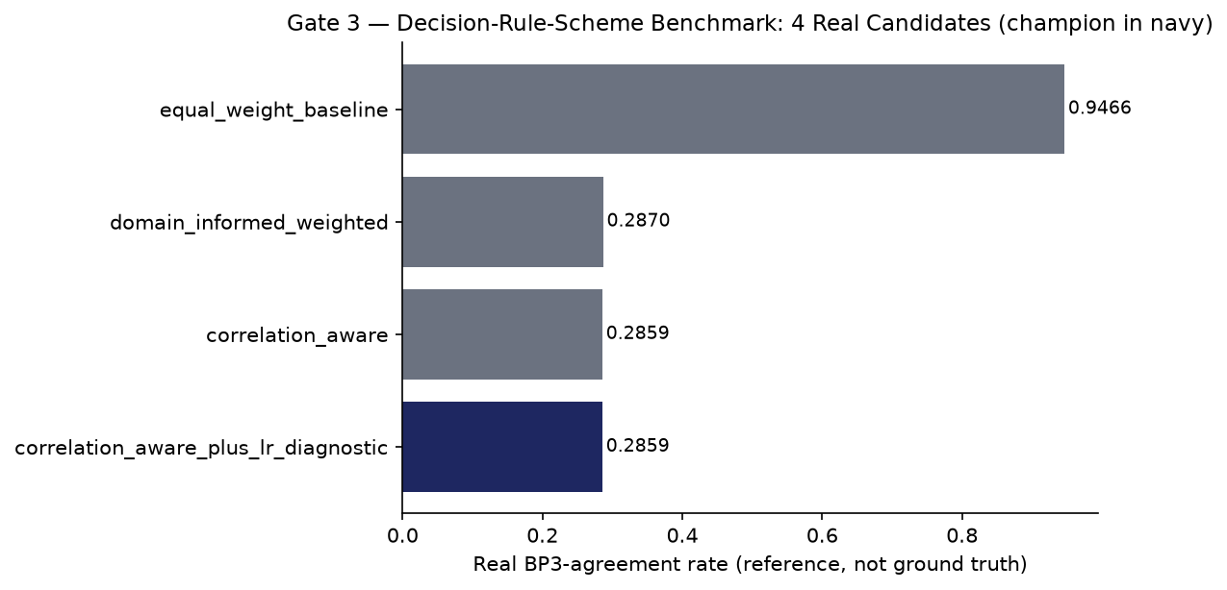
Candidate | Champion | Weight BP2 | Weight BP3 | Weight BP4 | Intervention Flag Rate
equal_weight_baseline | False | 0.3333 | 0.3333 | 0.3333 | 0.1159
domain_informed_weighted | False | 0.2560 | 0.1963 | 0.5477 | 0.7694
correlation_aware | False | 0.2227 | 0.1708 | 0.6065 | 0.7684
correlation_aware_plus_lr_diagnostic | True | 0.2227 | 0.1708 | 0.6065 | 0.7684

Gate 4 — Statistical Validation & Explainability
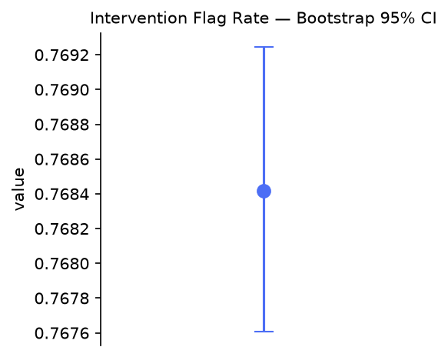
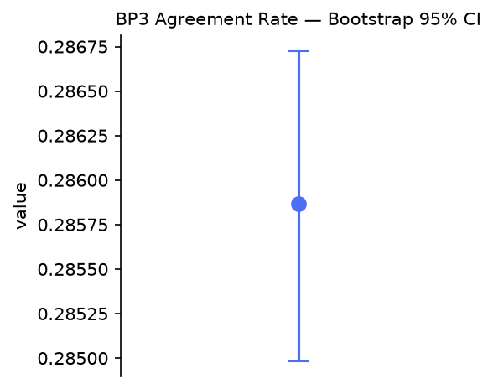
BP7 fits no black-box model, so there is no SHAP feature-importance chart. The exact contribution decomposition below is BP7's fully transparent, by-design equivalent: the rule already IS a linear combination, so its own arithmetic is its explanation, not an estimate of one.
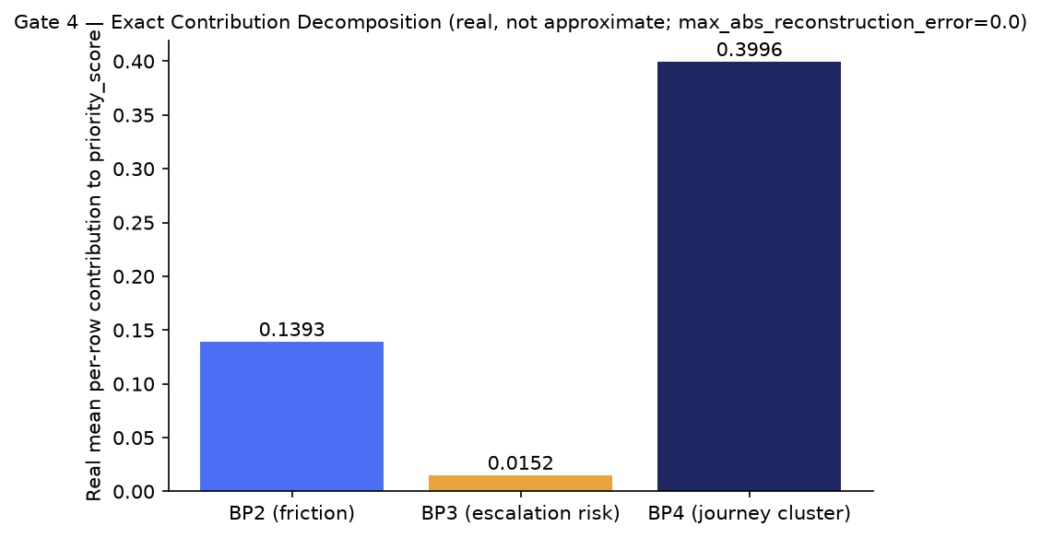

Gate 4/5 — ECOA/Reg B Disparate-Impact Audit (real, applicable)
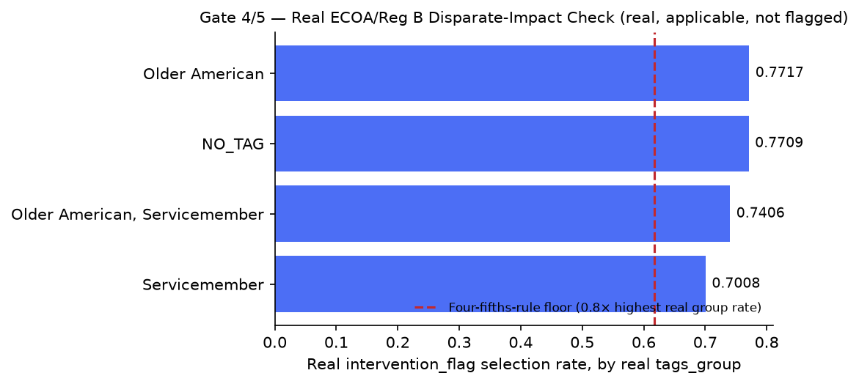
Tags Group | N Rows | N Intervention Flagged | Selection Rate
NO_TAG | 995,094 | 767,144 | 0.7709
Servicemember | 36,094 | 25,294 | 0.7008
Older American | 13,713 | 10,582 | 0.7717
Older American, Servicemember | 3,674 | 2,721 | 0.7406

Gate 5 — Decision Outputs
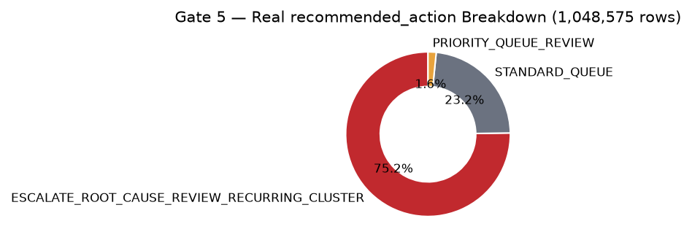
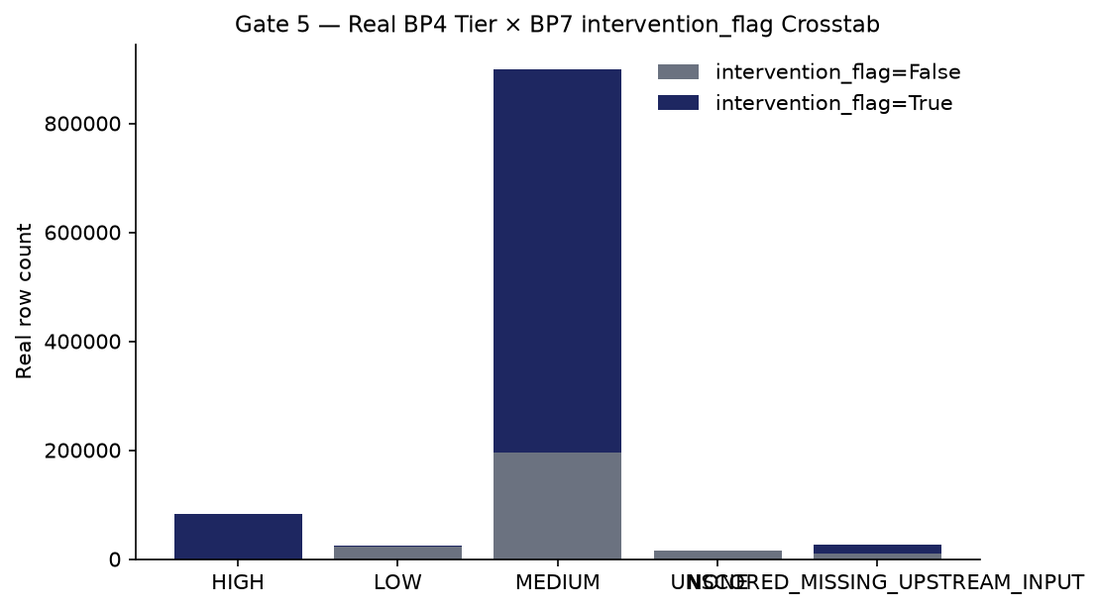

Gate 1 — Business Understanding & Policy
NOT a single trained ML target. Per Master Plan Section 5.1/7, BP7 is a transparent, auditable decision-rule layer that combines BP1-BP5's own already-computed prediction fields into three output fields per in-scope complaint: priority_score, intervention_flag, and recommended_action - every row also carrying reason_codes and the exact thresholds applied. See this notebook's markdown cell 'The transparent-scoring-vs-model tension, resolved' for the full reasoning.

Gate 6 — Governance & Known Limitations
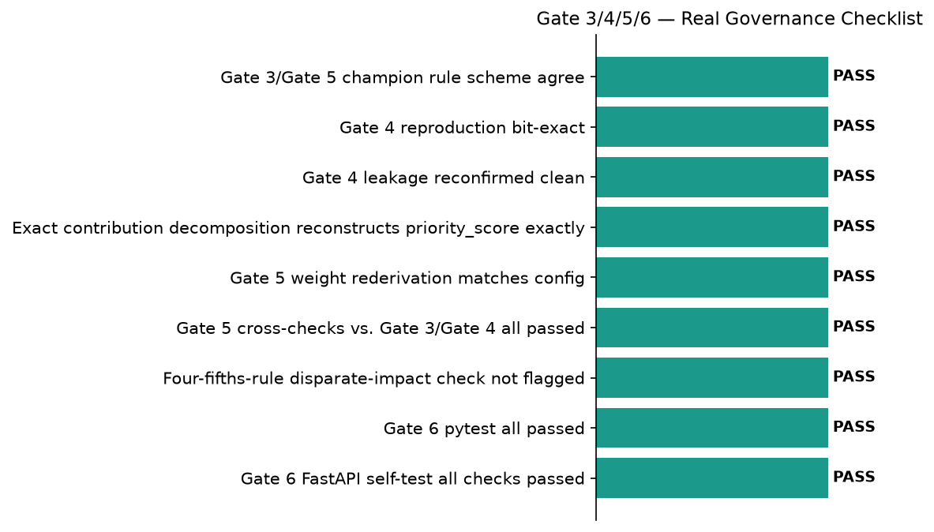
pytest: ================ 410 passed, 3 skipped, 182 warnings in 13.74s ================ | notebook syntax audit returncode: 0
Open items (informational, non-blocking): bp4_unscored_rate_detected=True, low_bp3_agreement_rate_detected=True

SMART Suggestions

Resolve the real 2.46% BP4-unscored rate before wider rollout
Specific: 25,829 of 1,048,575 real complaint rows could not be joined to a real BP4 issue-cluster tier at Gate 2 (real unscored rate=0.024632, live-flagged by Gate 6 as a real, disclosed open item) - these rows are reported UNSCORED_MISSING_UPSTREAM_INPUT for the BP4 field only, per Gate 1's own leakage_rules, never silently defaulted.
Measurable: bp4_unscored_rate_detected=True at real rate 0.024632 - target: reduce the real unjoinable-cluster-key rate on the next real Gate 2 re-run.
Time-bound: Before the next scheduled Gate 2 re-scoring re-run.
Owner: BP7 data engineering owner (name TBD by the user's team)

Review the real, low BP3-agreement rate as a governance/interpretability signal
Specific: BP7's own champion intervention_flag agrees with BP3's own independently-validated bp3_predicted_label on only 28.5865% of the real, full 1,048,575-row population (95% bootstrap CI [0.2850, 0.2867], n=1,000 bootstrap draws) - expected, since bp3_predicted_label is a disclosed reference point, not ground truth for BP7's own decision (Gate 4's own bp3_agreement_crosstab disclosure), but live-flagged by Gate 6 as a real, disclosed open item worth a human governance review.
Measurable: low_bp3_agreement_rate_detected=True at real rate 0.285865 - target: a documented governance review of whether this real gap is expected (different objectives: BP3 predicts intervention risk alone, BP7 combines 3 real signals) or worth further investigation.
Time-bound: Reviewed at every future real Gate 5/Gate 6 re-run.
Owner: BP7 governance reviewer (name TBD by the user's team)

Expand real BP1 optional-context coverage beyond the current 6.55%
Specific: BP1's real BANKING77-derived intent/taxonomy context is available for only 6.5527% of the real CFPB population (per BP4 Gate 1's own live-verified figure, carried forward unmodified into BP7's own policy.json) - used as optional context only, never a required weighted input, so this does not block scoring, but it does limit how often BP1's real signal can inform recommended_action's reason codes.
Measurable: bp1_optional_context_coverage_pct=6.5527% today - target: a documented decision on whether wider real BP1 taxonomy coverage is worth pursuing, or whether 6.55% is an accepted structural ceiling of BANKING77's own real text-classification scope on CFPB's non-narrative rows.
Time-bound: Reviewed at BP1's next real model refresh cycle.
Owner: BP7/BP1 data engineering owner (name TBD by the user's team)

Maintain the real four-fifths-rule disparate-impact monitoring cadence
Specific: The real, independently-recomputed-at-Gate-5 adverse-impact ratio is 0.908127 (not flagged, above the 0.8 four-fifths-rule convention threshold) - real selection rate is lowest for `Servicemember` and highest for `Older American`. Per policy.json's own compliance_touchpoint.ecoa_reg_b commitment, this is a monitoring signal for a human reviewer, not a legal determination of ECOA/Reg B compliance - re-run and re-reviewed every time, not a one-time check.
Measurable: flagged_four_fifths_rule=False maintained on every future real re-run (threshold=0.8); Tier 2 (CONDITIONAL - GOVERNANCE REVIEW REQUIRED) is genuinely reachable for BP7 if this ever flips to True - monitored, not assumed impossible.
Time-bound: Every time Gate 4 or Gate 5 is re-run.
Owner: BP7 compliance / model-risk owner (name TBD by the user's team)

Integrate BP5's real driver-association output once it clears its own Gate 1
Specific: BP5 (Root-Cause Driver Analytics) was still `PENDING_NOT_YET_DELIVERED` at BP7's own real Gate 1 time (policy.json upstream_input_contract.bp5) and was never used as a scoring input - Gate 2's real coverage numbers (PENDING_NOT_YET_DELIVERED) confirm no BP5 field name was ever hardcoded or assumed.
Measurable: 0 hardcoded BP5 field names anywhere in BP7's own config/policy today (real, live-verified) - target: a documented Gate 1 policy amendment via write_front_matter (non-destructive to Gates 2+) once BP5 delivers its own real Gate 1, adding BP5's real qualitative driver-association context as a disclosed, non-numeric reason-code input, never a silently-added weight.
Time-bound: Once BP5 delivers its own real Gate 1 (no fixed date - dependency-gated).
Owner: BP7/BP5 product owner (name TBD by the user's team)

