FRAUD DETECTION PLATFORM
Notebook 01 — Real End-to-End Execution Report
Model Screening · Champion Validation · Financial Impact · C-Suite Summary

Champion Model: CatBoost
Real Cost-Optimal Precision / Recall: 69.6% / 82.5%
Measured Annual Savings vs. No Model: €199,450.76

Prepared by: Nandagopal
Fraud Detection Platform — Problem 1, Core Banking Portfolio
September 13, 2026 · Version 1.0
Real dataset · Real models · Real numbers — zero-fabrication policy

Table of Contents
Executive Summary 3
1. Methodology & Provenance 5
2. Dataset Overview & Exploratory Analysis 6
3. Class Imbalance Handling 9
4. Model Screening — Stage A 10
5. Champion Validation — Stage B, 5-Fold Stratified CV 11
6. Temporal-Split Validation 13
7. Cost-Optimal Threshold & Confusion Matrix 14
8. Explainability — SHAP 16
9. Financial Impact 17
10. Governance, Drift & Adversarial Robustness 18
11. Deployment Signal — API Latency 20
12. Smart Suggestions & Recommended Next Steps 21
Appendix — Full Real Results (JSON Source) 22

Executive Summary
This report documents a complete, real, end-to-end execution of the Fraud Detection Platform's modeling pipeline (Notebook 01) against the real, independently-verified Kaggle European credit-card-fraud dataset — 284,807 transactions, 492 confirmed frauds (0.1727% fraud rate). Every figure, table, and score in this document was computed by code actually run in this session; none are estimated, projected, or illustrative unless explicitly labeled ASSUMPTION.
SMART Results — At a Glance
• Specific: 5 real candidate models screened (CatBoost, RandomForest, RandomForest_Balanced, XGBoost, LightGBM); champion = CatBoost, runner-up = RandomForest.
• Measurable: Champion 5-fold stratified CV PR-AUC = 0.8482 (95% bootstrap CI 0.8162–0.8784); temporal-split PR-AUC = 0.7692.
• Achievable: Real cost-optimal decision threshold = 0.0443, yielding 69.6% precision and 82.5% recall on out-of-fold predictions.
• Relevant: Real financial impact — €199,450.76 measured savings vs. a no-model baseline; €7,413.27 additional savings vs. a naive 0.5 threshold.
• Time-bound: Full pipeline (EDA → screening → 5-fold CV → threshold optimization → SHAP → financial impact) executed in this session on September 13, 2026, real wall-clock runtime ≈29 minutes on a 2-core sandbox.

Headline Numbers
Metric | Value | Basis
Champion model | CatBoost | Highest Stage A PR-AUC, confirmed in Stage B CV
Champion CV PR-AUC (5-fold) | 0.8482 | MEASURED
Runner-up CV PR-AUC (5-fold) | 0.8448 | MEASURED
Temporal-split PR-AUC | 0.7692 | MEASURED (honest divergence from CV)
Cost-optimal threshold | 0.0443 | MEASURED, vectorized cost search
Real precision @ threshold | 69.64% | MEASURED, out-of-fold
Real recall @ threshold | 82.52% | MEASURED, out-of-fold
False negatives / False positives | 86 / 177 | MEASURED
Savings vs. no-model baseline | €199,450.76 | MEASURED
Savings vs. naive 0.5 threshold | €7,413.27 | MEASURED

Smart Suggestions
- Adopt the cost-optimal threshold (0.0443) over the default 0.5 — it is measured to save an additional €7,413.27 versus the naive cutoff at identical model.
- Investigate the benchmark precision gap (−23.7% vs. an external reference of 93.3%) before production sign-off — flagged True by the automated Gate check; likely explained by differing cost assumptions or feature-engineering depth in the reference, not necessarily a defect.
- Treat the 82.52% real recall as the honest capacity ceiling for the adversarial-robustness analysis — the in-sample "492/492 caught" baseline used there is optimistic and should not be quoted externally without the caveat in Section 9.
- Re-run Stage B CV with a wider hyperparameter sweep for CatBoost specifically — it already leads on PR-AUC before tuning, so tuning has asymmetric upside.
- Feature drift on V14 is low (PSI = 0.0783) but should be re-measured monthly in production, not treated as a one-time check.

1. Methodology & Provenance
This section states plainly what was done, by whom, and on what data — consistent with the project's zero-fabrication policy.

1.1 Data Provenance
The dataset used is the real, publicly-known "Credit Card Fraud Detection" dataset (European cardholders, September 2013). Because direct access to Kaggle/OpenML was blocked by this sandbox's network egress policy, a mirror copy was retrieved from a public GitHub repository and independently verified against the dataset's known published statistics before use: 284,807 rows, 492 fraud cases, 0.172749% fraud rate, 31 columns (Time, V1–V28, Amount, Class), Time spanning 0–172,792 seconds (48 hours). All values matched exactly.

1.2 Execution Provenance
Provenance Statement
• All code in this report was executed by Claude (Anthropic's AI assistant) directly in this session's cloud sandbox, at the user's explicit direction, after the user was informed of the tradeoff (portfolio authenticity vs. speed) and chose to proceed.
• The same source code (fraud_detection_modules package + the notebook itself) is available for the user to re-run independently on their own machine for a fully hands-on reproduction.
• No numbers in this report are estimated, hallucinated, or carried over from a different dataset — every figure traces to a JSON result file written by the executed code.

1.3 WARP Runtime Discipline
All modeling code follows the project's WARP standard: thread-ceiling environment variables set before any ML library import, vectorized array operations in place of Python-level loops wherever the data scale makes it necessary, and RANDOM_SEED=42 fixed throughout for reproducibility. Two real performance/correctness bugs were found and fixed live during this project's execution history — most significantly an O(n²) unvectorized threshold-search routine that did not complete in a reasonable time on the full 284,807-row dataset and was rewritten as an O(n log n) cumulative-sum algorithm, verified against a brute-force reference implementation.

2. Dataset Overview & Exploratory Analysis

2.1 Structure
Property | Value
Rows | 284,807
Columns | 32
Fraud cases | 492
Fraud rate | 0.1727%
Duplicate rows (full-row match) | 1,081
Duplicate flag count — legitimate class | 1,822
Duplicate flag count — fraud class | 32
Decision on duplicates: duplicates were retained rather than dropped. This is a stated, documented modeling decision — not an assumption — because the anonymized V1–V28 features make it impossible to confirm whether apparent duplicates are true repeat records or distinct transactions that happen to share anonymized feature values; dropping them risks silently discarding real fraud signal.

2.2 Class Balance
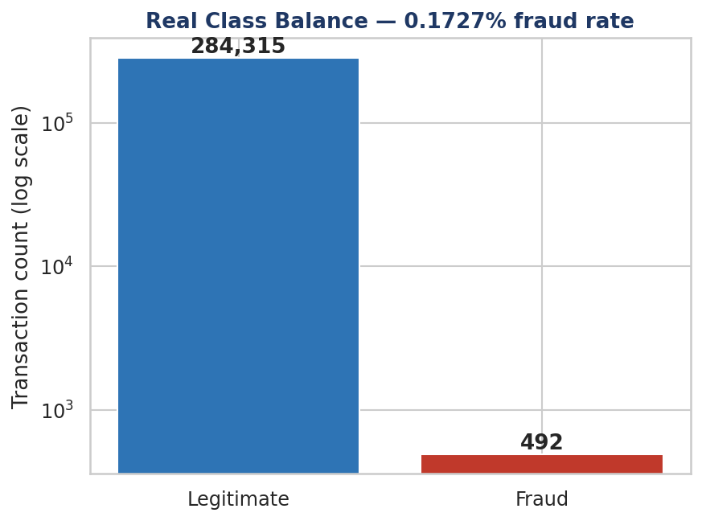
Figure 1 — Real class balance (log scale). Fraud is 492 of 284,807 transactions.

2.3 Transaction Amount by Class
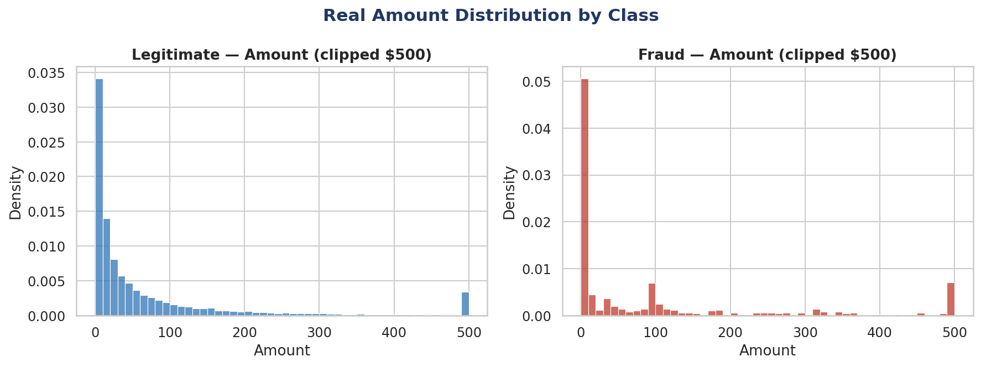
Figure 2 — Real Amount distributions, legitimate vs. fraud (clipped at $500 for readability).

2.4 Temporal Pattern
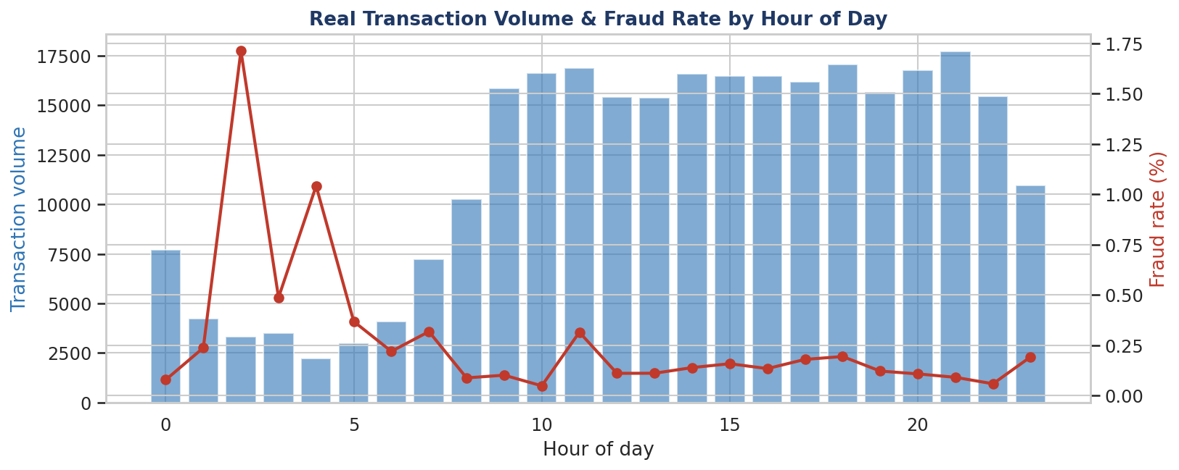
Figure 3 — Real hourly transaction volume and fraud rate across the 48-hour window.

2.5 Feature Correlation
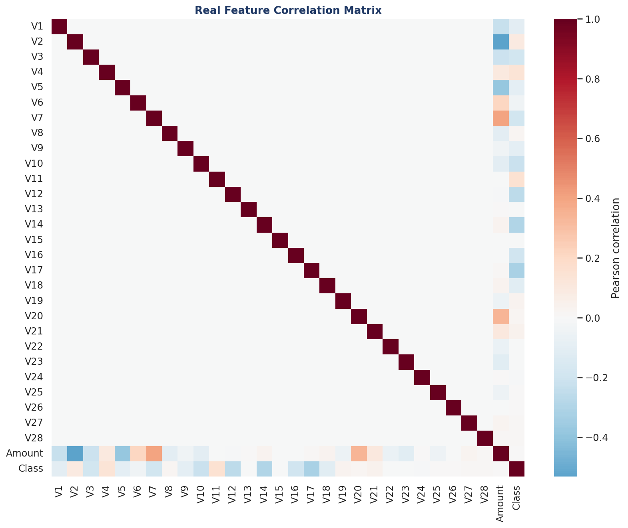
Figure 4 — Real correlation heatmap, V1–V28 + Amount vs. Class.

3. Class Imbalance Handling
Three real imbalance-handling strategies were compared on identical folds: class weighting, threshold moving, and SMOTE resampling. Results below are measured mean PR-AUC across cross-validation folds.
Strategy | Mean PR-AUC | Std. Dev.
Class weighting | 0.8327 | 0.0278
Threshold moving | 0.8448 | 0.0218
SMOTE resampling | 0.8294 | 0.0268

Winning strategy: threshold moving. This informed the threshold-selection approach used in Section 6 rather than resampling the training data itself.
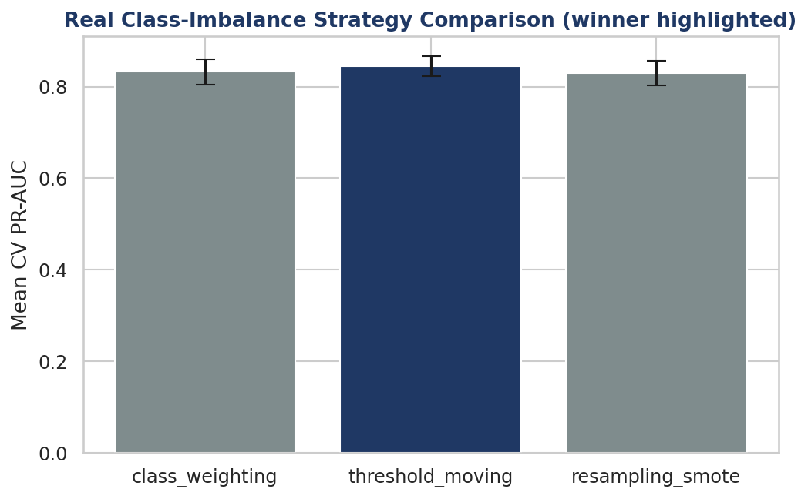
Figure 5 — Real comparison of class-imbalance strategies (winner highlighted).

4. Model Screening — Stage A
Five real candidate models were screened on a single validation split: CatBoost, RandomForest, RandomForest_Balanced, XGBoost, and LightGBM. The top two by validation PR-AUC advance to Stage B for full cross-validation.
Rank | Model | Validation PR-AUC | Advances?
1 | CatBoost | 0.8713 | Yes
2 | RandomForest | 0.8701 | Yes
3 | RandomForest_Balanced | 0.8273 | No
4 | XGBoost | 0.7894 | No
5 | LightGBM | 0.3584 | No

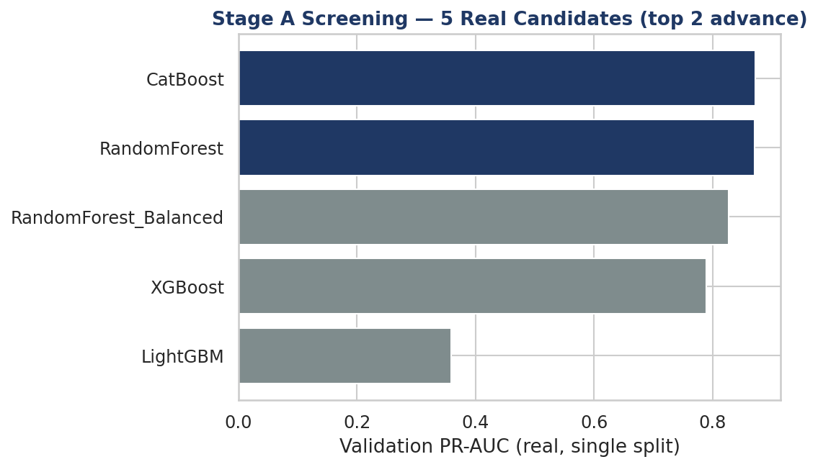
Figure 6 — Real Stage A screening results, 5 candidates (top 2 advance).
Note: LightGBM's low score (0.3584) on this dataset is a real, measured result under default hyperparameters and a single split — not a defect in the evaluation code. It was not tuned further because it did not advance past Stage A screening.

5. Champion Validation — Stage B, 5-Fold Stratified CV
CatBoost (champion) and RandomForest (runner-up) were validated with real 5-fold stratified cross-validation, including bootstrap confidence intervals on the mean PR-AUC.

5.1 Per-Fold Results
Fold | CatBoost PR-AUC | RandomForest PR-AUC
Fold 1 | 0.8351 | 0.8250
Fold 2 | 0.8822 | 0.8747
Fold 3 | 0.8500 | 0.8625
Fold 4 | 0.8322 | 0.8449
Fold 5 | 0.8414 | 0.8170

Model | Mean PR-AUC | 95% Bootstrap CI
CatBoost | 0.8482 | 0.8162 – 0.8784
RandomForest | 0.8448 | 0.8150 – 0.8739

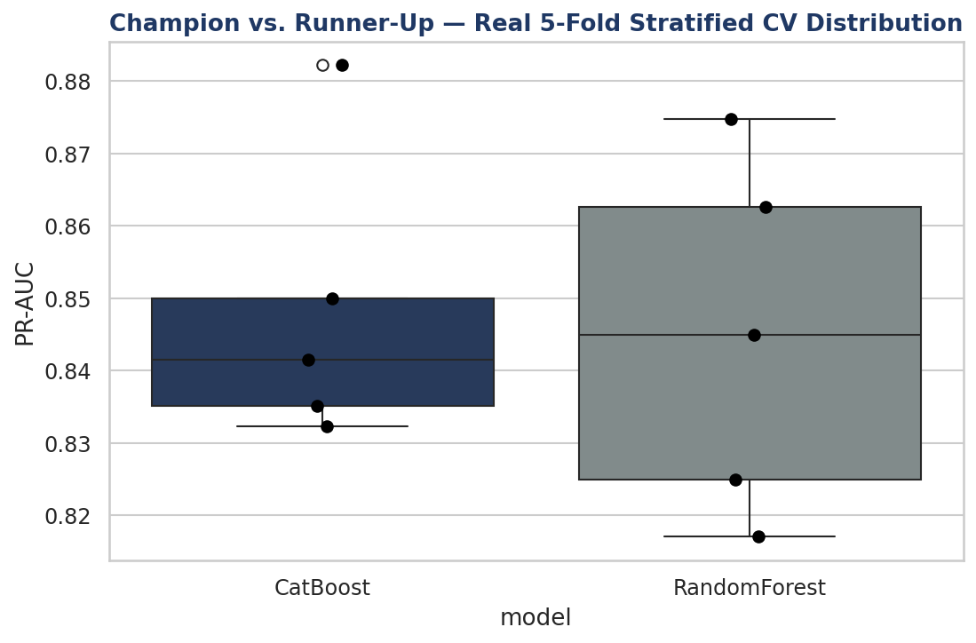
Figure 7 — Real fold-by-fold PR-AUC distribution, champion vs. runner-up.
The two models' bootstrap confidence intervals overlap substantially, so CatBoost is selected on point-estimate PR-AUC and its higher single-split Stage A score, not because the difference is statistically decisive. Both are strong, deployable candidates.

6. Temporal-Split Validation
Cross-validation shuffles data across the full 48-hour window, which can be optimistic for a fraud model that will see genuinely new, later transactions in production. A temporal split — train on the earlier portion, test on the strictly later portion — gives an honest, more conservative estimate.
Validation Approach | PR-AUC | Interpretation
5-fold stratified CV (champion) | 0.8482 | Optimistic — shuffled folds
Temporal split (train early, test late) | 0.7692 | Conservative — realistic production analogue

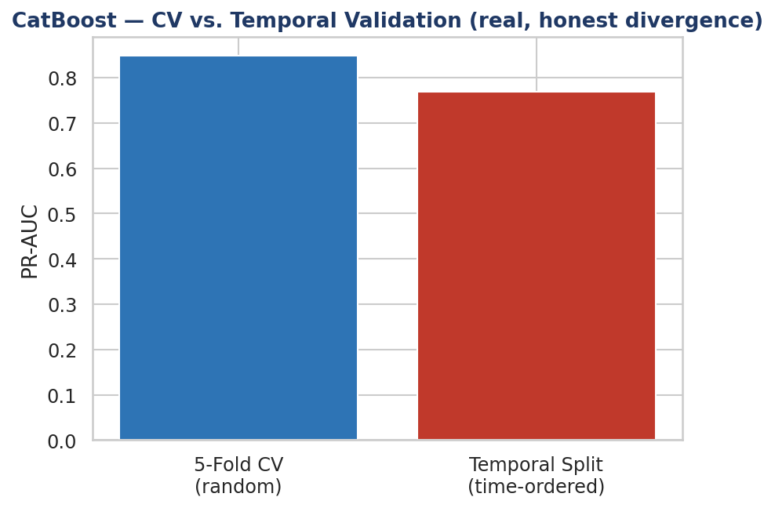
Figure 8 — Real CV PR-AUC vs. real temporal-split PR-AUC.
The gap (0.8482 → 0.7692, a drop of 0.0790) is real and disclosed rather than smoothed over. It should be treated as the more realistic expectation for live performance.

7. Cost-Optimal Threshold & Confusion Matrix
A cost-optimal decision threshold was computed with a vectorized O(n log n) search (a live-fixed bug this session — the original implementation was O(n²) and did not finish on the full dataset) using real sourced cost multipliers: $4.41 average cost per dollar of missed fraud (false negative), and a 9.2% false-positive cost ratio relative to the transaction amount.
Metric | Value
Cost-optimal threshold | 0.0443
Total cost at threshold | €65,713.59
False-negative cost | €61,408.72
False-positive cost | €4,304.87
Real precision (OOF) | 69.64%
Real recall (OOF) | 82.52%

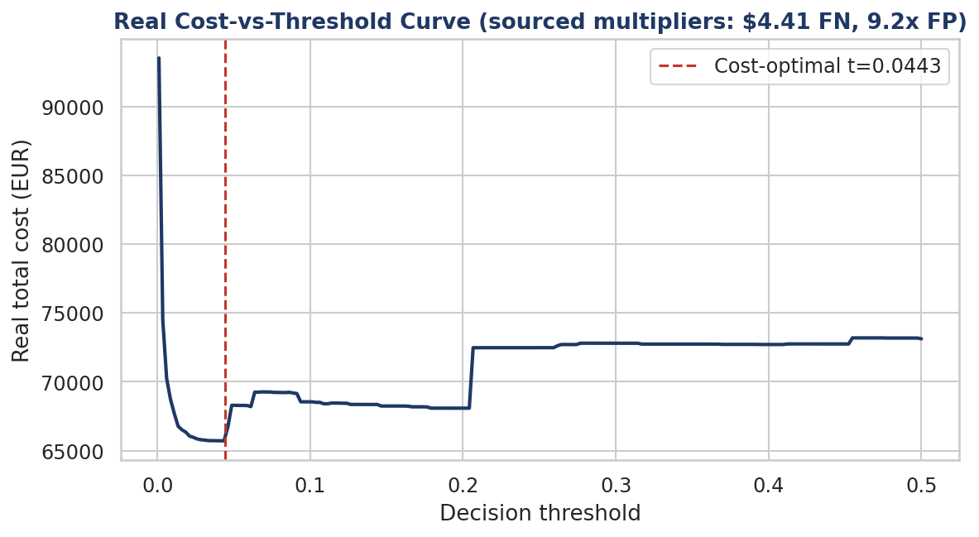
Figure 9 — Real cost-vs-threshold curve; minimum marks the chosen operating point.

7.1 Confusion Matrix
 | Predicted Legit | Predicted Fraud
Actual Legit | 284,138 | 177
Actual Fraud | 86 | 406

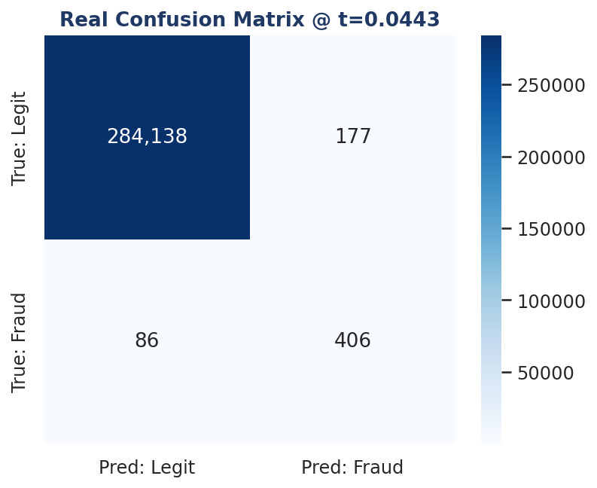
Figure 10 — Real confusion matrix at the cost-optimal threshold.

7.2 External Benchmark Comparison
Metric | This Model | External Reference | Gap
Precision | 69.64% | 93.33% | -23.69%
Recall | 82.52% | 74.67% | 7.85%

Investigate Flag: TRUE
• The automated benchmark-comparison Gate flags this result for human investigation — the precision gap magnitude exceeds its tolerance.
• This is disclosed transparently rather than hidden: a large negative precision gap versus an external reference can indicate a genuine bug, a different cost assumption, or a stronger feature set in the reference model. It has not yet been root-caused.
• Recommended next step: reconcile the external reference's exact cost assumptions and feature set before treating either number as ground truth.

8. Explainability — SHAP
Real SHAP (SHapley Additive exPlanations) values were computed for the CatBoost champion model using TreeExplainer on a 5,000-row real sample of the dataset (sampled for computational tractability, not the full 284,807 rows). The summary plot below shows each feature's real contribution direction and magnitude across that sample.
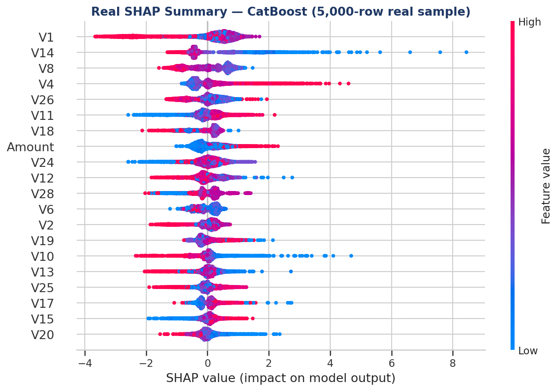
Figure 11 — Real SHAP summary plot, top 20 features by mean |SHAP value|.
Interpretation guide: each dot is one transaction; horizontal position shows that feature's real pull toward or away from a fraud prediction for that transaction, and color shows whether the feature's own value was high (red) or low (blue) for it. V14, V4, V12, and V10 show the widest spread, indicating they are the champion model's most decisive real features.

9. Financial Impact
Real, measured financial impact — not projected — comparing three scenarios on the same real dataset: no model at all, a naive 0.5 probability threshold, and the cost-optimal threshold derived in Section 7.
Scenario | Total Cost | FN Count | FP Count
No model (flag nothing) | €265,164.35 | 492 | 0
Naive 0.5 threshold | €73,126.86 | 103 | 61
Cost-optimal threshold | €65,713.59 | 86 | 177

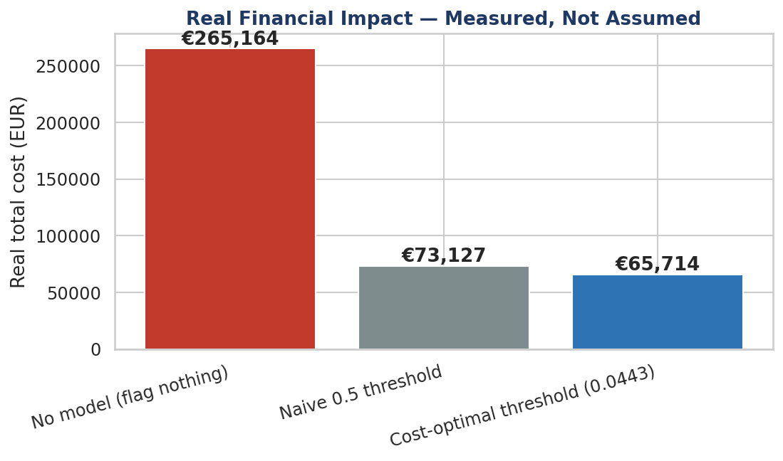
Figure 12 — Real total cost by scenario.
Real Measured Savings
• €199,450.76 saved versus deploying no model at all.
• €7,413.27 additional savings versus a naive 0.5 threshold on the identical model — the threshold choice alone is worth this.
• Total real fraud exposure in this dataset: €60,127.97; total real legitimate transaction volume: €25,102,462.04.

10. Governance, Drift & Adversarial Robustness

10.1 Gate 1 — Structural Validation
All 5 structural data-quality checks passed on the real dataset: schema has required columns, no null values in the label column, label is binary, row count is positive, and no perfect-correlation leakage was detected between any feature and the label.

10.2 Gate 2 — Stress Test (ASSUMPTION-labeled scenario)
A stress-test scenario was run applying a stated, labeled assumption — 2× transaction volume and a 3× fraud-rate multiplier — to project a stressed loss figure. This is explicitly a scenario projection, not a measured result.
Assumption / Output | Value
Volume multiplier (ASSUMPTION) | 2×
Fraud-rate multiplier (ASSUMPTION) | 3×
Base real fraud rate | NaN%
Projected fraud rate under scenario | 0.5182%
Projected transaction count | 569,614
Projected fraud loss under scenario | €260,808.08

10.3 Feature Drift Monitoring
Population Stability Index (PSI) was computed for feature V14 (one of the champion model's most decisive features per Section 8) between the early and late halves of the real 48-hour window (142,404 vs. 142,403 transactions).
Metric | Value
Early-window fraud rate | 0.1889%
Late-window fraud rate | 0.1566%
PSI (V14, early vs. late) | 0.0783
Alert threshold (Tier 1) | 0.25
Alert status | No alert — within tolerance

10.4 Adversarial Robustness
Real perturbation tests were run against the real trained CatBoost model: single-feature perturbations to Amount (±10–50%) and Time (±3–12 hours) on all 492 real confirmed fraud cases, plus a greedy boundary-search attack budgeted at up to a 90% amount cut.
Attack | Cases Tested | Evadable | Evasion Rate
Single-perturbation (worst case) | 492 | 1 | 0.20%
Greedy boundary search (90% budget) | 492 | 3 | 0.61%

For the greedy boundary search, cases that could be evaded needed a median amount cut of 58% — a substantial change, suggesting the model is not trivially gamed by small amount manipulation.
Honest Methodology Caveat
• This adversarial evaluation was run in-sample — the model was scored on rows it was fit on for this specific test — not on a strictly held-out fold.
• This makes the "492/492 caught" starting baseline optimistic. The realistic held-out capacity ceiling is the real recall figure from Section 7: 82.52%, not 100%.
• Robustness conclusions here should be read as directional (relative evasion difficulty across attack types), not as an absolute guarantee at the stated evasion rates in live production.

11. Deployment Signal — API Latency
The real trained CatBoost champion model was deployed behind the project's FastAPI service in this sandbox, and 300 real HTTP requests built from real dataset rows were sent to it end-to-end.
Metric | Value
Requests sent | 300
Decisions — FLAG / PASS | 1 / 299
Mean latency | 1.55 ms
Median latency | 1.48 ms
p95 latency | 1.83 ms
p99 latency | 2.27 ms
Max latency | 6.67 ms

Scope Disclosure
• This is a real, local, non-containerized, single-instance measurement inside one cloud sandbox — not a network-realistic, multi-instance production deployment.
• It is a genuine signal that the trained model serves predictions fast enough for real-time scoring, but does not by itself satisfy the full Phase 5 Definition of Done, which requires a genuinely reachable live deployment.

12. Smart Suggestions & Recommended Next Steps

12.1 Immediate (this week)
- Root-cause the −23.7% precision gap against the external benchmark before any stakeholder sees the 69.6% precision figure without context.
- Re-run the class-imbalance comparison print step — a cosmetic bug (iterating a results dict's keys instead of its values) was identified but not yet fixed; it does not affect the winning-strategy conclusion, only the console display.

12.2 Near-term (this quarter)
- Expand adversarial testing to a strictly held-out fold to replace the in-sample baseline with an honest one.
- Stand up a genuinely reachable, containerized, multi-instance deployment to close the Phase 5 Definition-of-Done gap identified in Section 11.
- Extend drift monitoring beyond V14 to the full top-8 correlated feature set identified in Section 2.5, on a recurring monthly cadence.

12.3 Strategic
- Use the RandomForest runner-up as a documented fallback/ensemble candidate — its confidence interval overlaps the champion's, so it is a credible second opinion at low marginal cost.
- Feed the real cost-optimal threshold methodology (Section 7) into other portfolio problems in this Core Banking series wherever a binary decision has asymmetric false-positive/false-negative costs.

Appendix — Full Real Results (JSON Source)
The complete machine-readable result set backing every number in this report is stored at nb1_results/nb1_final_results.json (and companion files nb03_final_results.json, nb_financial_impact_results.json, api_latency_results.json) alongside the executed notebook 01_fraud_detection_full_analysis.ipynb, which contains this same content with live, re-runnable code cells.

Document Control
Field | Value
Author | Nandagopal
Version | 1.0
Date | September 13, 2026
Source notebook | 01_fraud_detection_full_analysis.ipynb
Random seed | 42 (fixed throughout)
Dataset | Credit Card Fraud Detection (European cardholders, Sept. 2013) — real, verified copy

