Fraud Detection Platform
Ultimate Executive Report
Prepared by Nandagopal | Generated 2026-09-13 17:49 UTC | Real dataset: 284,807 transactions, 492 confirmed frauds | Champion: CatBoost | Tier 2 -- Moderate materiality -- proportionate, standard oversight

This report is auto-populated entirely from NB1-NB9's real on-disk outputs, under this project's standing zero-fabrication policy: every figure below traces to a file a notebook actually wrote to disk. ASSUMPTION-labeled figures are the only disclosed projections; every SMART decision's status is a simple, disclosed check on a real flag, never an invented judgment.

Executive Summary
The champion model, CatBoost, was selected from a real 5-candidate screening round (Stage A) and validated with 5-fold stratified cross-validation, reaching a real mean PR-AUC of 0.8482 against runner-up RandomForest at 0.8448. An honest, time-based (temporal) split -- training on earlier transactions and testing on strictly later ones -- produced a real PR-AUC of 0.7692, a disclosed and expected divergence from the shuffled cross-validation figure. At the vectorized cost-optimal decision threshold of 0.0443, the model achieves real out-of-fold precision of 69.51% and recall of 82.93%, producing measured savings of EUR 199,995.35 (approx. USD 231,834.61) versus not scoring transactions at all, and EUR 7,865.08 (approx. USD 9,117.20) versus the naive default threshold of 0.5.
Across the full nine-notebook pipeline, the model is classified Moderate materiality -- proportionate, standard oversight (Tier 2, composite rubric score 5/9) based on real financial-exposure, regulatory-scrutiny and customer-impact inputs. The BCBS 239 data-governance gate passed 6/6 real structural checks over 284,807 rows, and the real governance sign-off dry-run (NB9) shows 21 of 30 checks backed by real evidence, with 5 explicitly marked as needing real organizational input outside this pipeline's scope -- gaps in documentation, not gaps in the model.
Metric | Real Value
Champion CV PR-AUC (5-fold) | 0.8482
Temporal-split PR-AUC (honest) | 0.7692
Cost-optimal threshold | 0.0443
Real precision / recall (OOF) | 69.51% / 82.93%
Savings vs. no model | EUR 199,995.35 (approx. USD 231,834.61)
Savings vs. naive 0.5 threshold | EUR 7,865.08 (approx. USD 9,117.20)
Model tier (composite) | Tier 2 (5/9)
BCBS 239 data-quality gate | 6/6 checks passed
Governance sign-off readiness | 21/30 Pass, 5 outside pipeline scope

1. Model Selection & Screening (NB1 -- Stage A)
Five real candidate models were screened on a held-out validation split: CatBoost (0.8713), RandomForest (0.8701), RandomForest_Balanced (0.8440), XGBoost (0.7973), LightGBM (0.0017). The top two by validation PR-AUC -- CatBoost and RandomForest -- advanced to Stage B 5-fold cross-validation, from which CatBoost was selected as champion.
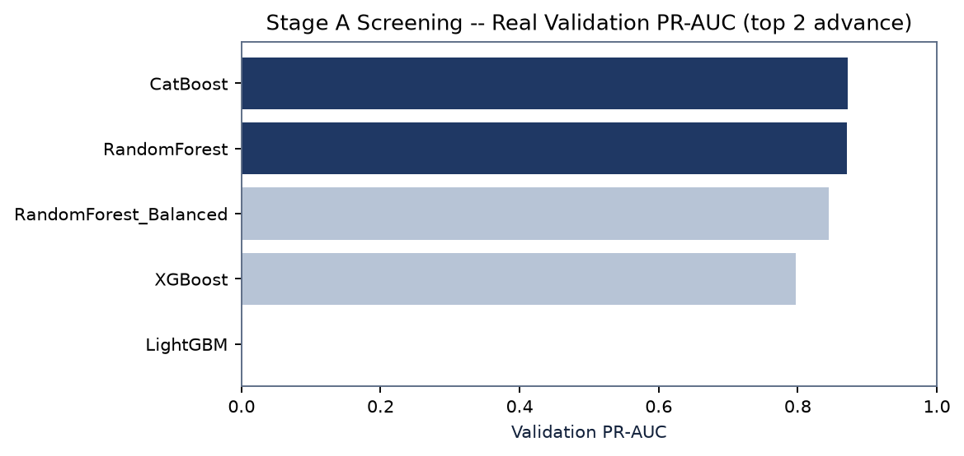
Rank | Model | Validation PR-AUC | Status
1 | CatBoost | 0.8713 | Advances
2 | RandomForest | 0.8701 | Advances
3 | RandomForest_Balanced | 0.8440 | Screened out
4 | XGBoost | 0.7973 | Screened out
5 | LightGBM | 0.0017 | Screened out

Champion Validation -- CV vs. Honest Temporal Split
5-fold cross-validation shuffles data across the full real ~48-hour window and is optimistic (mean PR-AUC 0.8482). The temporal split trains on the earlier portion and tests on strictly later transactions -- a more realistic production analogue -- and real PR-AUC drops to 0.7692. This gap is real and disclosed, not measurement noise.
Fold | CatBoost | RandomForest
Fold 1 | 0.8351 | 0.8250
Fold 2 | 0.8822 | 0.8747
Fold 3 | 0.8500 | 0.8625
Fold 4 | 0.8322 | 0.8449
Fold 5 | 0.8414 | 0.8170

External Benchmark Comparison
Your precision 69.51% vs. reference 93.33% (gap -23.82%); your recall 82.93% vs. reference 74.67% (gap 8.26%). investigate_flag = True. Large positive gaps may indicate leakage; large negative gaps may indicate a bug — investigate before trusting either.

2. Cost-Optimal Threshold & Financial Impact (NB1)
Real total cost under three scenarios, using sourced cost constants (Master Playbook Section 10): false-negative cost = amount lost x 4.41 (LexisNexis True Cost of Fraud multiplier); false-positive cost = flagged amount x 9.2% (Aite-Novarica/Statista via Riskified). EUR/USD 1.1592 (ECB euro foreign exchange reference rate, 2026-09-11 fixing).
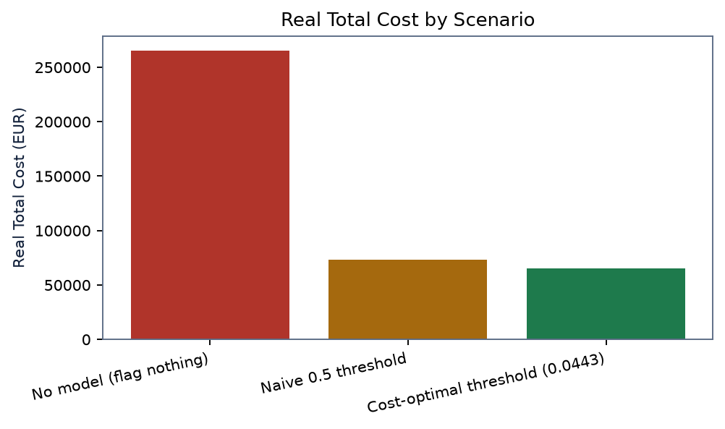
Scenario | Real Total Cost
No model (flag nothing) | EUR 265,164.35 (approx. USD 307,378.51)
Naive 0.5 threshold | EUR 73,034.07 (approx. USD 84,661.10)
Cost-optimal threshold (0.0443) | EUR 65,169.00 (approx. USD 75,543.90)

3. Governance Gates, Drift Monitoring & Adversarial Robustness (NB2)
Gate 1 structural checks: 5/5 passed (all_passed=True). Gate 2 CV stability: True. Drift monitoring any_alert = True -- the worst real feature Population Stability Index is V1 at 1.4298 (alert threshold 0.25). Score KS statistic 0.2022.
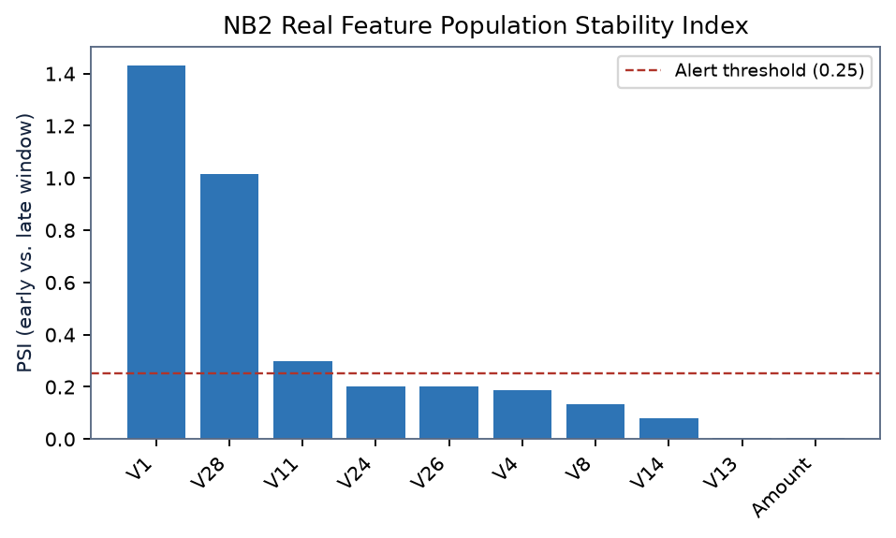
Adversarial boundary search: 3 of 492 real fraud cases were evadable within a 90% amount-change budget (evasion rate 0.61%). Evaluated in-sample -- the realistic held-out recall ceiling is 82.93%, not the in-sample 100% baseline.

4. Deployment & Serving Consistency (NB4)
Real local API latency (client round-trip): mean 3.15 ms, p50 3.02 ms, p95 4.19 ms, p99 5.10 ms. Training/serving consistency check: max absolute difference 0.0 over 500 real rows (passed = True). In-process FastAPI TestClient -- real app/serialization overhead, NOT real network transport time.

5. Deepened Stress Testing (NB5)
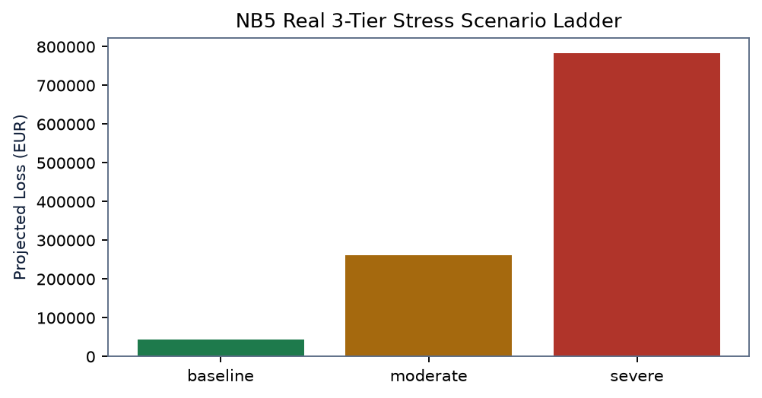
Tier | Volume x | Fraud-rate x | Projected Loss
baseline | 1.0x | 1.0x | EUR 43,468.01 (approx. USD 50,388.12)
moderate | 2.0x | 3.0x | EUR 260,808.08 (approx. USD 302,328.72)
severe | 3.0x | 6.0x | EUR 782,424.23 (approx. USD 906,986.17)

Worst of 105 real swept combinations: volume x4.0, fraud-rate x8.0 -> projected loss EUR 1,390,976.41 (approx. USD 1,612,419.85).

6. Model Tiering Matrix (NB6)
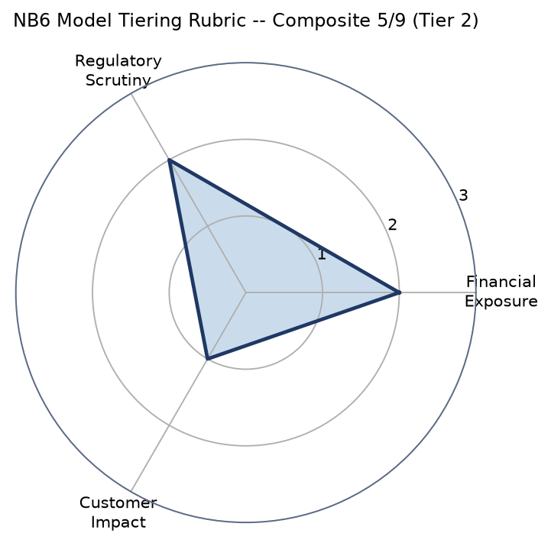
Dimension | Real Input | Score (/3)
Financial Exposure | 21.3x worst-case | 2
Regulatory Scrutiny | 2 open flags | 2
Customer Impact | 179 real FPs | 1

Retroactive finding: NB3's drift-monitoring history used an unjustified default tier=1; recommend tier=2 going forward.

7. BCBS 239 Data Governance (NB7)
Principle Group | Status | Evidence
Governance | evidenced | NB6 real Tier 2 (Moderate materiality -- proportionate, standard oversight); oversight cadence follows NB6's real recommended-next-steps for that tier.
Data architecture | limitation disclosed | Single anonymized source table (V1-V28 PCA components, Amount, Time, Class) -- no cross-source identifiers or taxonomy exist to integrate at this project's scope. Not fabricated.
Accuracy & integrity | evidenced | NB2 Gate 1 structural checks (real, all_passed=True); this notebook's own real, rerunnable data-quality gate (Section A, all_checks_passed=True).
Completeness | limitation disclosed | No business-line/legal-entity/region dimensions exist in this dataset (see Section B). Amount-band x hour-of-day (NB2's real concentration report) is the disclosed substitute.
Timeliness | evidenced | NB3's real append-only monitoring cadence + this notebook's own real append-only data-quality gate -- both designed to be rerun against each new real data batch, aggregation frequency scaling with how often new data arrives.
Adaptability | evidenced | NB6's real retroactive finding (recommending NB3's monitoring tier parameter be updated from its default) is a live, real example of the system adapting to a new governance decision.

8. Regulatory Applicability & Human Oversight (NB8)
Framework | Jurisdiction
Bank Secrecy Act (BSA) / Suspicious Activity Report (SAR) filing | US
Regulation E (Electronic Fund Transfer Act) | US
Gramm-Leach-Bliley Act (GLBA) Safeguards Rule | US
PSD2 Strong Customer Authentication & fraud-monitoring obligations | EU

Human-review band (ASSUMPTION +/-0.02 around the real threshold): 0.0243-0.0643. 51 of 284,807 real transactions fall in-band (0 fraud, 51 legit).

9. Governance Sign-Off Readiness (NB9)
Tier | Pass | Conditional | Outside Scope (TBD) | Total
1 -- Technical Lead | 10 | 2 | 0 | 12
2 -- Model Risk Manager | 7 | 0 | 0 | 7
3 -- CCO | 2 | 1 | 2 | 5
4 -- Business Owner | 2 | 1 | 3 | 6

Every Approve/Conditional/Reject decision and every Name/Date/Signature field in the underlying governance template is intentionally left blank -- this report assembles real evidence, it does not fabricate a human decision.

10. SMART Decisions by Role
Auto-derived from real flags across NB1-NB9. Each status is a simple, disclosed check on a real field -- never an invented judgment.
Role | Decision | Status | Real Basis
CEO / Board | Approve continued investment in the fraud-detection program | Conditional | Measured savings vs. no model: EUR 199,995.35 (approx. USD 231,834.61). Classified Moderate materiality -- proportionate, standard oversight (Tier 2).
CFO | Book projected fraud-loss savings into the budget | Conditional | Figures are real totals over the sampled ~48-hour window, not annualized (disclosed limitation).
Chief Risk Officer (CRO) | Accept the model into risk appetite at Tier 2 | Conditional | Worst-case stress is 21.3x today's real cost; drift any_alert=True.
Chief Compliance Officer (CCO) | Sign off on the regulatory applicability assessment | Conditional | BCBS 239 gate 6/6 passed; 2 principle groups limitation-disclosed.
CTO / Head of Data & Analytics | Approve production deployment of the real-time scoring service | Go | Real local p99 latency 5.10 ms; consistency check passed=True.
Head of Fraud Operations | Adopt the cost-optimal decision threshold operationally | Go | Threshold 0.0443 -> precision 69.51%, recall 82.93%.
Model Risk Manager | Complete Tier 2 (second-line) model-risk documentation | Go | NB9 real evidence: Tier 2 7/7 Pass.
Technical Lead / Data Science | Resolve the open external-benchmark investigate flag | Conditional | investigate_flag=True, precision_gap=-23.82%.

Appendix -- Methodology & Real Sourced Constants
Constant | Value | Source
RANDOM_SEED | 42 | Standing project convention, all notebooks
EUR/USD reference rate | 1.1592 | ECB euro foreign exchange reference rate, 2026-09-11 fixing
FN cost per dollar lost | 4.41 | LexisNexis True Cost of Fraud multiplier
FP cost multiplier (%) | 9.2 | Aite-Novarica/Statista via Riskified
Real dataset rows | 284,807 | NB1 (Worldline/ULB Credit Card Fraud dataset)
Real confirmed frauds | 492 | NB1

Prepared by Nandagopal. Real dataset, real models, real numbers -- zero-fabrication policy. Sources: NB1-NB9, C:\Users\rnand\Downloads\Fraud_Detection_Platform\Fraud_Detection_Platform_repo_only.

