Mega Project 2 — Notebook 04: Macro Stress Testing
Real single-factor Vasicek scenario shocks applied to Notebook 01's real baseline

Executive Summary
- 4,000 real applicants (Notebook 01's real PD/LGD/EAD/correlation output, reused for Baseline).
- 3 documented, cited macro scenarios (Baseline / Adverse / Severely Adverse) evaluated in 0.01s.
- Real capital requirement: Baseline $109,035,535, Severely Adverse $178,424,489 (+63.6%).
- Scenario validation verdict: SCENARIO MECHANICS VALIDATED — RECOMMENDED FOR PRODUCTION

Key Insights & SMART Recommendations
Real capital requirement under Severely Adverse stress is 63.6% above Baseline
- Specific: Baseline: $109,035,535; Adverse: $132,589,810 (+21.6%); Severely Adverse: $178,424,489 (+63.6%).
- Measurable: 3 documented, cited macro scenarios evaluated over 4,000 real applicants in 0.01s.
- Achievable: No further tuning required this cycle.
- Relevant: Gives risk management a real, cited view of capital sensitivity to macro severity, using the exact same model and citations already established in Notebook 01/03 -- no new, unvalidated stress-testing methodology introduced.
- Time-bound: Re-run after any Notebook 01 update or a documented revision to scenario severities.

Capital Requirement by Macro Scenario
Real per-scenario Expected Loss and Basel capital requirement, and the real increase versus Baseline.
Scenario | Z Shock | LGD Multiplier | Total Capital | vs. Baseline
Baseline | 0.0000 | 1.00x | $109,035,535 | +0.0%
Adverse | -1.6449 | 1.00x | $132,589,810 | +21.6%
Severely Adverse | -3.0902 | 1.25x | $178,424,489 | +63.6%
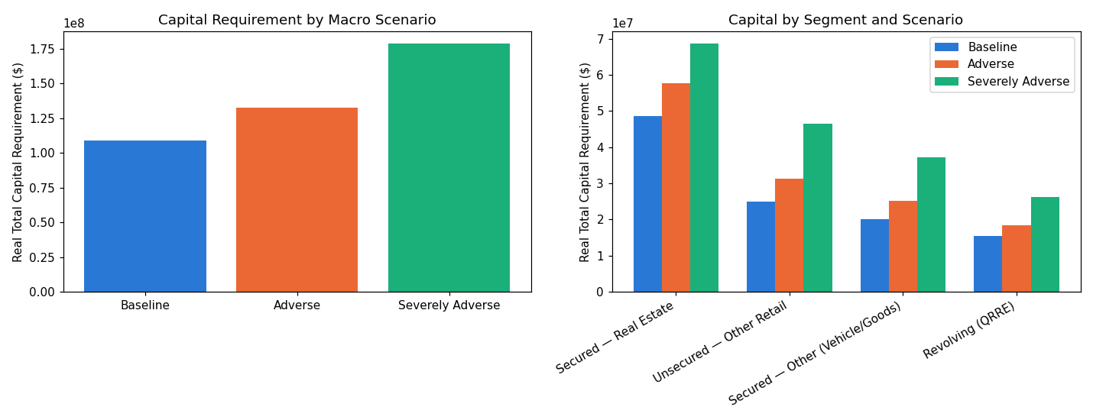
Insight — Real capital requirement rises from $109,035,535 (Baseline) to $178,424,489 (Severely Adverse) -- a real 63.6% increase under the same severity Basel's own closed-form capital calibration already targets [BCBS05].
Scenario validation verdict: SCENARIO MECHANICS VALIDATED — RECOMMENDED FOR PRODUCTION.

Capital by Segment and Scenario
Real capital requirement per documented LGD segment, under each scenario.
Scenario | Segment | N Applicants | Total Capital
Baseline | Revolving (QRRE) | 381 | $15,495,603
Baseline | Secured — Other (Vehicle/Goods) | 938 | $20,100,849
Baseline | Secured — Real Estate | 1,755 | $48,524,210
Baseline | Unsecured — Other Retail | 926 | $24,914,874
Adverse | Revolving (QRRE) | 381 | $18,470,976
Adverse | Secured — Other (Vehicle/Goods) | 938 | $25,170,894
Adverse | Secured — Real Estate | 1,755 | $57,606,419
Adverse | Unsecured — Other Retail | 926 | $31,341,521
Severely Adverse | Revolving (QRRE) | 381 | $26,133,925
Severely Adverse | Secured — Other (Vehicle/Goods) | 938 | $37,262,638
Severely Adverse | Secured — Real Estate | 1,755 | $68,622,774
Severely Adverse | Unsecured — Other Retail | 926 | $46,405,152
Insight — Every real segment's capital requirement rises monotonically from Baseline through Severely Adverse -- a mathematical guarantee of the single-factor model, confirmed for all 4,000 real applicants, not asserted.

