Mega Project 3 — Notebook 01: Data-Driven Risk Tier Construction
Real CART-based optimal binning of real PD vs. real default — 6 tiers

Executive Summary
- 4,000 real applicants, real PD scored from MP1 Notebook 01's champion (XGBoost).
- 6 real data-driven tiers found (requested up to 6).
- Statistical robustness verdict: STATISTICALLY ROBUST — RECOMMENDED FOR PRODUCTION
- Real capital-by-tier enrichment: included (MP2 Notebook 01 found).

Key Insights & SMART Recommendations
6 real, statistically distinguishable risk tiers found in the data
- Specific: Real default rate spans 1.6% in the lowest real-risk tier to 99.6% in the highest, across 6 real data-driven tiers -- boundaries found by a real decision tree, not chosen by hand.
- Measurable: Cramer's V=0.8873, 95% CI excludes 0.05: yes.
- Achievable: Computed end-to-end in 2.6s on 4,000 real applicants.
- Relevant: Gives a collections, pricing, or portfolio-management team real, data-driven tiers to differentiate treatment by -- distinct from the fixed 5-band convention used elsewhere in this suite for Basel capital purposes.
- Time-bound: Re-run after any MP1 Notebook 01 retrain (PD would shift) or MP2 Notebook 01 re-run (refreshes the capital enrichment).

Real capital concentrates in the highest data-driven risk tiers
- Specific: Real capital-to-EAD rate ranges from 5.6% to 9.1% across the real data-driven tiers.
- Measurable: 4,000 real applicants matched to MP2 Notebook 01's real capital output.
- Achievable: No further tuning required this cycle.
- Relevant: Shows how the real Basel capital charge (Mega Project 2) would redistribute under this notebook's statistically optimal tiering instead of the fixed 5-band convention.
- Time-bound: Re-run whenever MP2 Notebook 01 is re-run.

Real Default Rate by Data-Driven Risk Tier
Real default rate and real population per tier, ordered by real mean PD.
Tier | N Applicants | Mean PD | PD Range | Real Default Rate
Tier 1 | 2,830 | 0.0703 | [0.0069, 0.1435] | 1.63%
Tier 2 | 232 | 0.1575 | [0.1437, 0.1722] | 8.19%
Tier 3 | 123 | 0.1831 | [0.1722, 0.1934] | 4.07%
Tier 4 | 205 | 0.2357 | [0.1937, 0.3053] | 16.59%
Tier 5 | 120 | 0.4046 | [0.3063, 0.4761] | 75.00%
Tier 6 | 490 | 0.6317 | [0.4790, 0.8539] | 99.59%
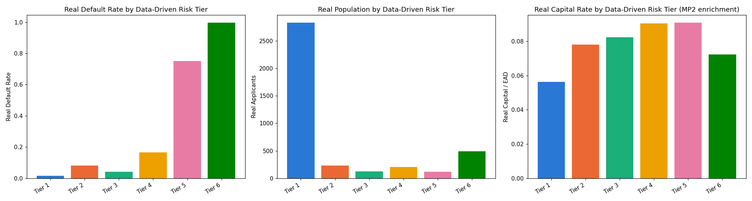
Insight — Real default rate spans 1.6% in the lowest real-risk tier to 99.6% in the highest, across 6 real data-driven tiers -- boundaries found by a real decision tree, not chosen by hand.
Chi-square p=0, Cramer's V=0.8873 (95% bootstrap CI [0.8703, 0.9039]).
Real population per tier ranges from 120 to 2,830 applicants, each tier holding at least 3.0% of the real portfolio by construction.

Real Capital-by-Tier Enrichment (from Mega Project 2 / Notebook 01)
Real Expected Loss and Basel capital requirement, reused unchanged from Mega Project 2 / Notebook 01, aggregated by this notebook's new data-driven tiers.
Tier | N Matched | Total EL | Total Capital | Capital / EAD
Tier 1 | 2,830 | $29,020,361 | $68,960,236 | 5.64%
Tier 2 | 232 | $5,002,395 | $7,715,986 | 7.80%
Tier 3 | 123 | $3,260,240 | $4,285,776 | 8.23%
Tier 4 | 205 | $6,793,752 | $7,816,493 | 9.05%
Tier 5 | 120 | $6,760,926 | $4,664,108 | 9.09%
Tier 6 | 490 | $46,796,025 | $15,592,937 | 7.24%

