Mega Project 3 — Notebook 03: Repayment Behavior Segmentation
Real K-Means clustering, k=7 (data-driven) — independent of PD level and bureau behavior

Executive Summary
- 4,000 real applicants; 2,691 (67.3%) have real previous-loan repayment history.
- 7 real data-driven repayment behavior segments found (silhouette=0.161).
- Statistical robustness verdict: NOT YET STATISTICALLY ROBUST — failed: chi_square_significant, cramers_v_ci_excludes_zero (a separate, stricter statistical-significance gate, distinct from the structural pipeline integrity checks reported elsewhere in this notebook's output)
- Cross-axis independence from Problem 1's Risk Tier: Cramer's V=0.0719. From Problem 2's Bureau Segment: Cramer's V=0.0465.

Key Insights & SMART Recommendations
7 real, data-driven repayment behavior segments found (silhouette=0.161)
- Specific: Real default rate spans 12.6% to 20.4% across 8 real repayment behavior segments (chi-square p=0.4594, Cramer's V=0.0410, 95% bootstrap CI [0.0331, 0.0836]).
- Measurable: 2,691 of 4,000 real applicants (67.3%) clustered; 1,309 real applicants with no previous-loan repayment history reported as their own explicit segment.
- Achievable: Computed end-to-end in 3.6s.
- Relevant: Gives a collections or portfolio-management team a real repayment-discipline axis, built from the applicant's own conduct on previous Home Credit loans, independent of PD level and external bureau behavior, to differentiate treatment by.
- Time-bound: Re-run after any Notebook 01 re-run (refreshes PD/TARGET/RISK_TIER) or when new real instalment/POS-cash data becomes available.

Real Default Rate by Repayment Behavior Segment
Real default rate and real population per segment, including applicants with no real previous-loan repayment history as their own explicit segment.
Segment | N Applicants | Real Default Rate | Mean % Instalments Late
Repayment Segment A | 459 | 15.25% | 36.1%
Repayment Segment B | 470 | 15.53% | 37.5%
Repayment Segment C | 730 | 17.26% | 39.2%
Repayment Segment D | 420 | 16.67% | 38.5%
Repayment Segment E | 142 | 20.42% | 37.3%
Repayment Segment F | 311 | 17.68% | 24.1%
Repayment Segment G | 159 | 12.58% | 32.7%
No Repayment History | 1,309 | 18.26% | 0.0%
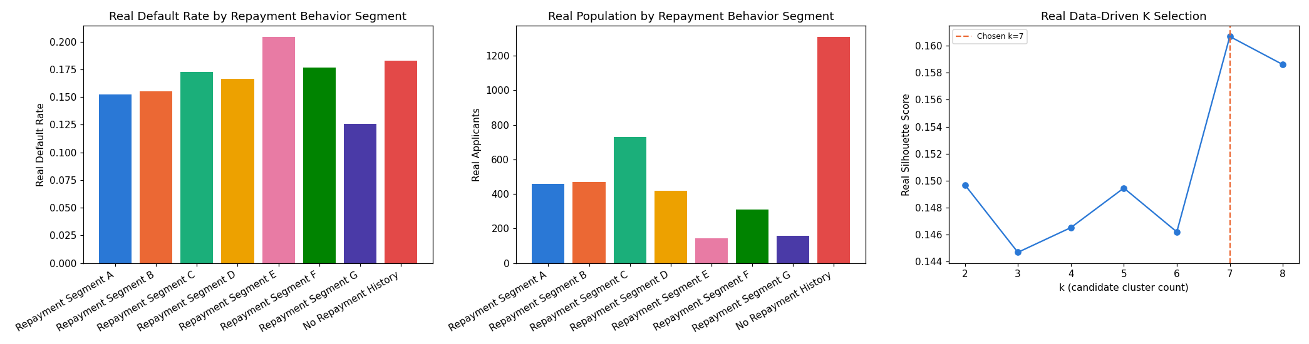
Insight — Real default rate spans 12.6% to 20.4% across 8 real repayment behavior segments (chi-square p=0.4594, Cramer's V=0.0410, 95% bootstrap CI [0.0331, 0.0836]).
Cross-check against Problem 1's Risk Tier: Cramer's V=0.0719; against Problem 2's Bureau Segment: Cramer's V=0.0465.

