Mega Project 3 — Notebook 04: Revolving Credit Utilization Segmentation
Real K-Means clustering, k=7 (data-driven) — independent of PD level, bureau behavior, and repayment conduct

Executive Summary
- 4,000 real applicants; 1,034 (25.9%) have real previous-loan revolving-credit history.
- 7 real data-driven utilization segments found (silhouette=0.184).
- Statistical robustness verdict: NOT YET STATISTICALLY ROBUST — failed: chi_square_significant, cramers_v_ci_excludes_zero (a separate, stricter statistical-significance gate, distinct from the structural pipeline integrity checks reported elsewhere in this notebook's output)
- Cross-axis independence from Problem 1's Risk Tier: Cramer's V=0.0505. From Problem 2's Bureau Segment: Cramer's V=0.0433. From Problem 3's Repayment Segment: Cramer's V=0.1300.

Key Insights & SMART Recommendations
7 real, data-driven revolving-credit utilization segments found (silhouette=0.184)
- Specific: Real default rate spans 12.5% to 18.5% across 8 real revolving-credit utilization segments (chi-square p=0.9492, Cramer's V=0.0233, 95% bootstrap CI [0.0225, 0.0697]).
- Measurable: 1,034 of 4,000 real applicants (25.9%) clustered; 2,966 real applicants with no previous-loan revolving-credit history reported as their own explicit segment.
- Achievable: Computed end-to-end in 1.6s.
- Relevant: Gives a collections or portfolio-management team a real revolving-credit-usage axis, built from the applicant's own conduct on previous Home Credit credit-card loans, independent of PD level, external bureau behavior, and instalment-loan repayment conduct, to differentiate treatment by.
- Time-bound: Re-run after any Notebook 01 re-run (refreshes PD/TARGET/RISK_TIER) or when new real credit-card data becomes available.

Real Default Rate by Utilization Segment
Real default rate and real population per segment, including applicants with no real previous-loan revolving-credit history as their own explicit segment.
Segment | N Applicants | Real Default Rate | Mean Utilization | % Months Any Cash Advance
Utilization Segment A | 130 | 18.46% | 50.2% | 21.2%
Utilization Segment B | 179 | 16.76% | 51.1% | 42.3%
Utilization Segment C | 343 | 16.03% | 53.2% | 13.0%
Utilization Segment D | 32 | 12.50% | 41.6% | 18.7%
Utilization Segment E | 37 | 16.22% | 48.9% | 27.7%
Utilization Segment F | 86 | 12.79% | 32.1% | 7.0%
Utilization Segment G | 227 | 17.62% | 51.5% | 19.2%
No Revolving Credit History | 2,966 | 17.26% | 0.0% | 0.0%
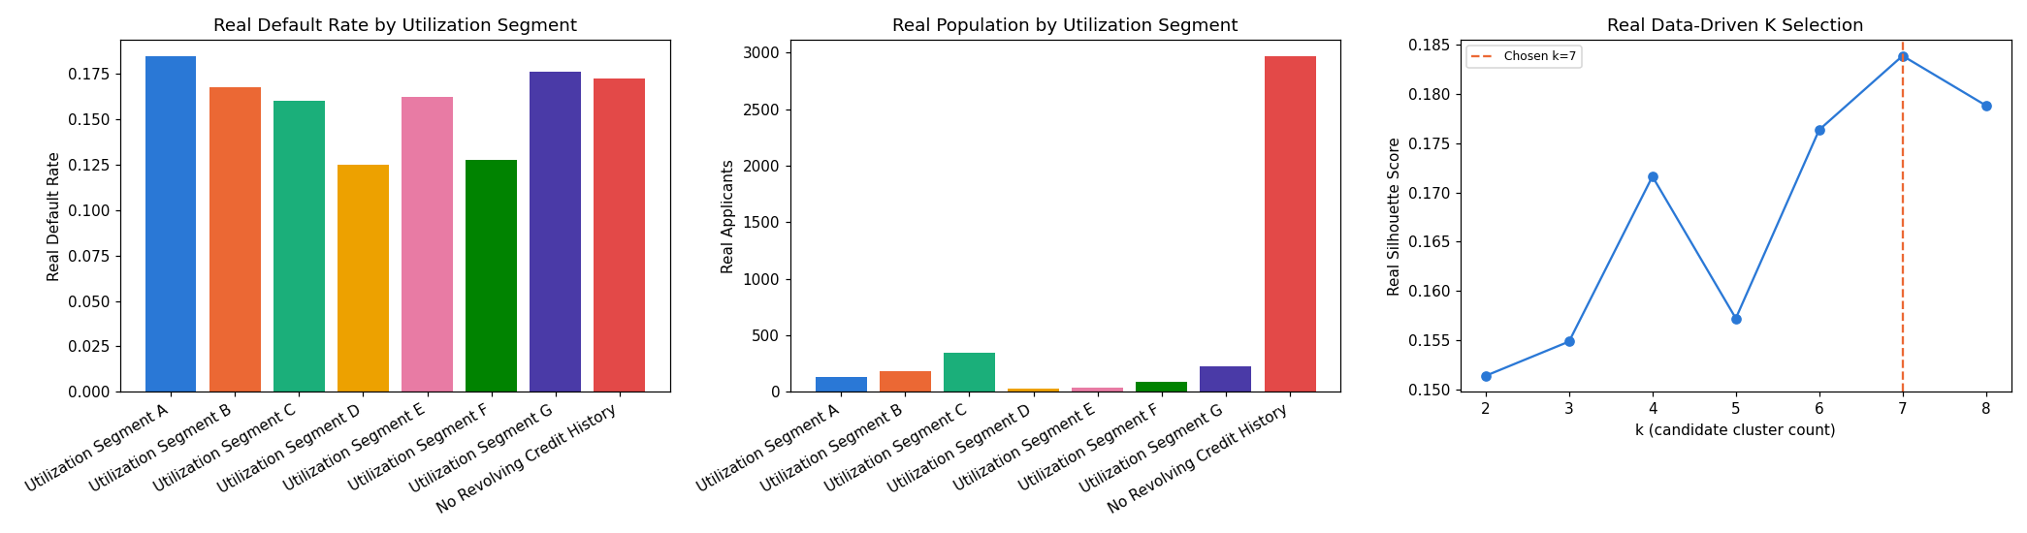
Insight — Real default rate spans 12.5% to 18.5% across 8 real revolving-credit utilization segments (chi-square p=0.9492, Cramer's V=0.0233, 95% bootstrap CI [0.0225, 0.0697]).
Cross-check against Problem 1's Risk Tier: Cramer's V=0.0505; against Problem 2's Bureau Segment: Cramer's V=0.0433; against Problem 3's Repayment Segment: Cramer's V=0.1300.

