Mega Project 3 — Notebook 05: Cross-Axis Risk-Return Synthesis
4 real segmentation axis(es), no new modeling

Executive Summary
- 4,000 real applicants synthesized across 4 real segmentation axis(es): Risk Tier, Bureau Segment, Repayment Segment, Utilization Segment.
- Widest real risk differentiation: Risk Tier (97.97% spread).
- Synthesis verdict: SYNTHESIS VALIDATED — CAPITAL TRACKS RISK AS EXPECTED

Key Insights & SMART Recommendations
Risk Tier differentiates real risk most sharply (97.97% default-rate spread across 6 real segments)
- Specific: Real default-rate spread by axis (widest to narrowest): Risk Tier=97.97%, Repayment Segment=7.84%, Bureau Segment=6.68%, Utilization Segment=5.96%.
- Measurable: 4 real segmentation axis(es) synthesized across 4,000 real applicants; real capital enrichment included.
- Achievable: Computed end-to-end in 0.9s from already-produced real outputs -- no new modeling, no raw data re-read.
- Relevant: Gives a collections or portfolio-management team a single, honest cross-axis view of which real segmentation (risk level, external bureau behavior, instalment repayment conduct, or revolving-credit usage) most sharply separates real risk and real capital consumption, to prioritize which axis to act on.
- Time-bound: Re-run after any upstream notebook (Notebook 01, MP2 Notebook 01, or this project's Notebooks 02-04) re-run refreshes its real output.

Real Cross-Axis Risk-Return Summary
Real default-rate (and, when available, real capital-rate) spread per real segmentation axis -- the wider the spread, the more sharply that axis differentiates real risk.
axis | n_segments | default_rate_min | default_rate_max | default_rate_spread | capital_rate_min | capital_rate_max | capital_rate_spread
Risk Tier | 6 | 0.01625441696113074 | 0.9959183673469387 | 0.979663950385808 | 0.056420238174608346 | 0.09085477622222823 | 0.03443453804761989
Repayment Segment | 8 | 0.12578616352201258 | 0.20422535211267606 | 0.07843918859066348 | 0.057068551805491315 | 0.0663046893909398 | 0.00923613758544848
Bureau Segment | 8 | 0.13225806451612904 | 0.19910514541387025 | 0.06684708089774122 | 0.06155513282048014 | 0.0649373749671537 | 0.003382242146673556
Utilization Segment | 8 | 0.125 | 0.18461538461538463 | 0.059615384615384626 | 0.05856794961583377 | 0.06821350457636971 | 0.009645554960535943
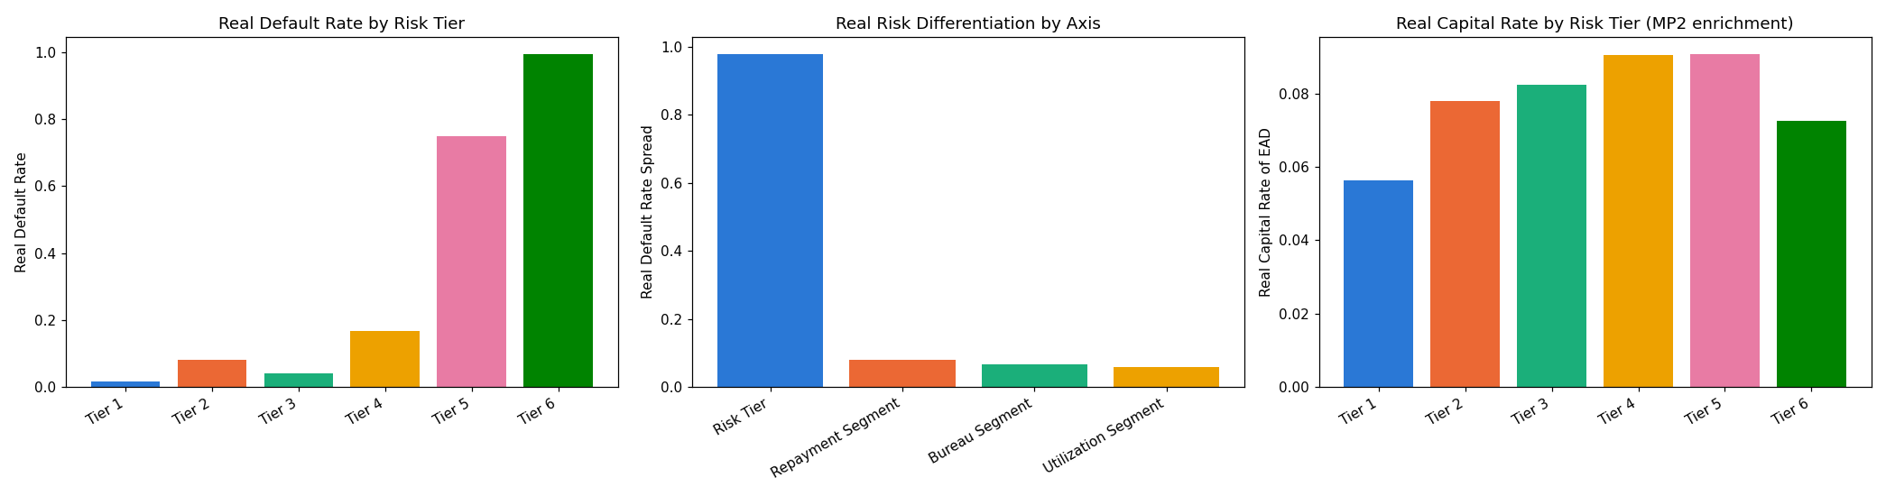
Insight — Real default-rate spread by axis (widest to narrowest): Risk Tier=97.97%, Repayment Segment=7.84%, Bureau Segment=6.68%, Utilization Segment=5.96%.
Synthesis verdict: SYNTHESIS VALIDATED — CAPITAL TRACKS RISK AS EXPECTED

