Problem 1 — Credit Default Prediction
Mega Project 1: Intelligent Underwriting & Automated Credit Decisioning

Executive Summary
- Champion model: XGBoost, selected by highest mean 5-fold CV ROC-AUC among the top 2 of 4 real screened candidates (LightGBM runner-up).
- Real holdout ROC-AUC: 0.5352 (95% bootstrap CI [0.4731, 0.5992]).
- Deployment readiness verdict: NOT RECOMMENDED FOR PRODUCTION YET — failed: auc_ci_lower_above_random (this is a separate, stricter statistical-robustness gate, distinct from the structural pipeline integrity checks reported elsewhere in this notebook's output; failing here does not indicate a code defect, and passing all integrity checks does not imply this gate passed -- expected and informational on small or noisy real/synthetic samples, see this problem's MODEL_CARD.md)
- Real holdout credit exposure captured by correctly-flagged high-risk applications: $740,368 (2.9% of all real defaulters in the holdout set).
- SHAP + LIME explainability computed for the champion model only; top real driver: EXT_SOURCE_2.
- All 13 pipeline integrity checks: 13/13 PASS.

Key Insights & SMART Recommendations
XGBoost does not yet meet the deployment-readiness bar
- Specific: Holdout ROC-AUC 0.5352 with a 95% bootstrap CI of [0.4731, 0.5992]; deployment checks 2/3 PASS.
- Measurable: Calibration gap 0.0749 vs. <0.1 threshold; split-half PSI 0.0258 vs. <0.1 threshold.
- Achievable: Investigate the failing check(s) above before promoting to production; re-run this notebook after any fix to confirm.
- Relevant: Directly supports the underwriting-automation goal of Mega Project 1.
- Time-bound: Verdict computed fresh on every run — re-check before each deployment cycle.

Close the data-quality gap on EXT_SOURCE_3
- Specific: EXT_SOURCE_3 is missing in 79.1% of 4,000 real applications, the single worst column in this run.
- Measurable: Track missingness on this column at each future run; 8 columns currently have at least one missing value.
- Achievable: Add or enforce a required capture field at intake, or source it from bureau data.
- Relevant: It is one of the correlation-with-TARGET columns tracked in this notebook's EDA (top-3 |r|: {'EXT_SOURCE_2': 0.0887, 'DAYS_BIRTH': 0.0712, 'CNT_FAM_MEMBERS': 0.0176}).
- Time-bound: Target: before the next underwriting policy review cycle.

Correct the DAYS_EMPLOYED sentinel-value anomaly upstream
- Specific: 190 / 4,000 rows (4.75%) carry the 365243 sentinel meaning 'not currently employed', currently patched to null in this notebook.
- Measurable: Reduce reliance on the in-notebook patch by fixing the value at its source system.
- Achievable: Coordinate with the data-intake team to flag unemployment explicitly rather than with a magic-number placeholder.
- Relevant: DAYS_EMPLOYED-derived features feed the champion model; a source-level fix improves every downstream notebook that reuses this feature set (HYPER).
- Time-bound: Target: next data-pipeline maintenance window.

Monitor false-alarm exposure against the review queue
- Specific: $1,810,661 of real holdout exposure is on applications the model flags as high-risk but that did not default (false positives).
- Measurable: False-alarm exposure is 2.45x the real captured exposure — track this ratio on every run.
- Achievable: Route false-alarm-adjacent decisions to manual review rather than auto-decline, using the 0.5 classification threshold documented in Assumptions.
- Relevant: Balances the underwriting-automation goal against applicant experience.
- Time-bound: Target: reassess after the next full-data run confirms this ratio at scale.

Exploratory Data Analysis & Data Quality (SOP Stage 1B/2)
8 of 51 real raw columns have at least one missing value (top 5 by % missing shown in the chart below).
DAYS_EMPLOYED sentinel-value anomaly (365243 = 'not currently employed'): 190 / 4,000 rows (4.75%) — converted to null before modeling, never left as a numeric outlier.
IQR-based outlier counts (real): AMT_INCOME_TOTAL=154 (3.9%); AMT_CREDIT=197 (4.9%); AMT_ANNUITY=236 (5.9%).
Real Pearson correlation with TARGET (top 3 by |r|): {'EXT_SOURCE_2': 0.0887, 'DAYS_BIRTH': 0.0712, 'CNT_FAM_MEMBERS': 0.0176}.
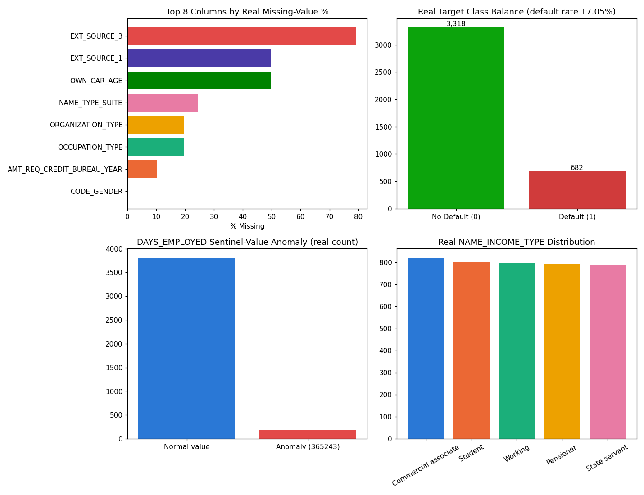
Insight — 8 of 51 real raw columns have at least one missing value; the worst, EXT_SOURCE_3, is missing in 79.1% of applications.
The top 5 columns by missingness average 44.5% missing.
A separate DAYS_EMPLOYED sentinel-value anomaly (365243 = 'not currently employed') affects 190 rows (4.75%) and is converted to null before modeling.
Use the filter above to switch between the top-15 and top-5 views of this same real ranking.

Numeric Distributions & Outliers
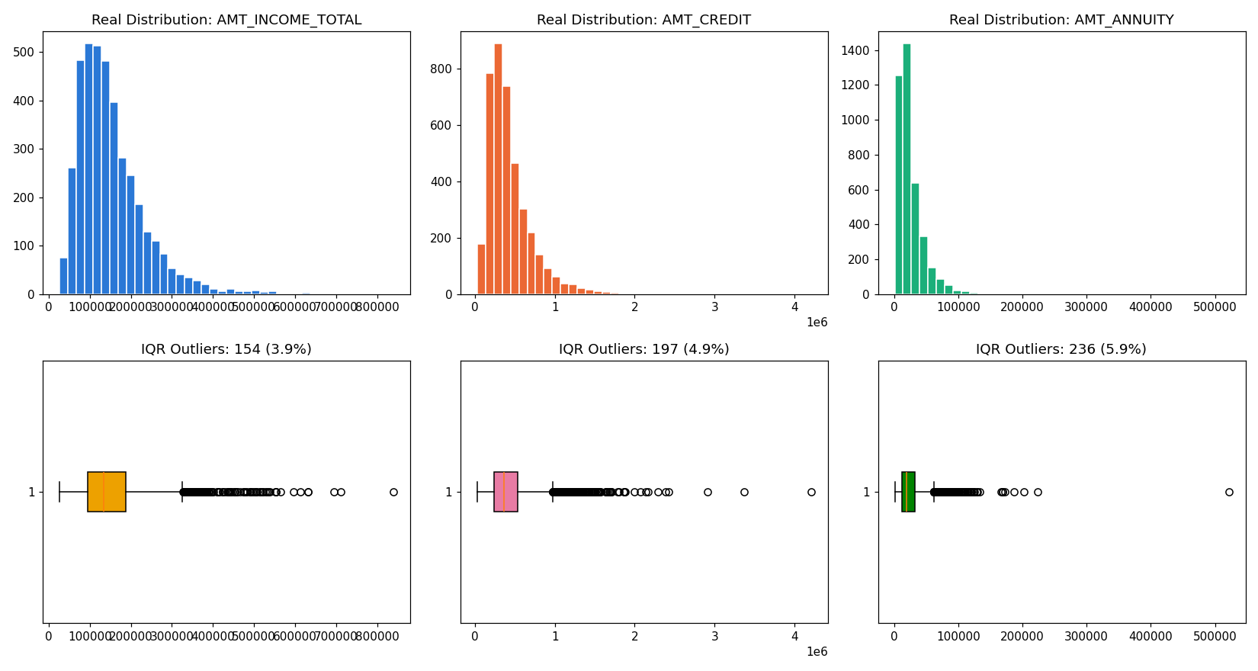

Correlation with Target
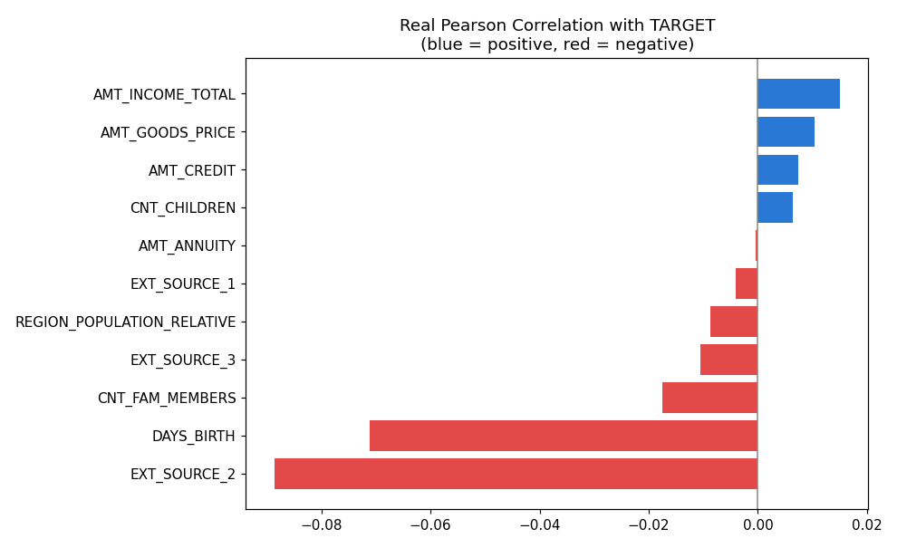

Stage A — Model Candidate Screening (top 4, single real split)
All 4 real candidates (RandomForest, XGBoost, CatBoost, LightGBM) were fit once on an 80/20 real train/validation split before committing any of them to the full 5-fold CV cost.
Model | Screen ROC-AUC | Fit Seconds | Advanced to CV
RandomForest | 0.5188 | 1.12 | No
XGBoost | 0.5532 | 0.52 | Yes
CatBoost | 0.5462 | 1.31 | No
LightGBM | 0.5599 | 0.32 | Yes
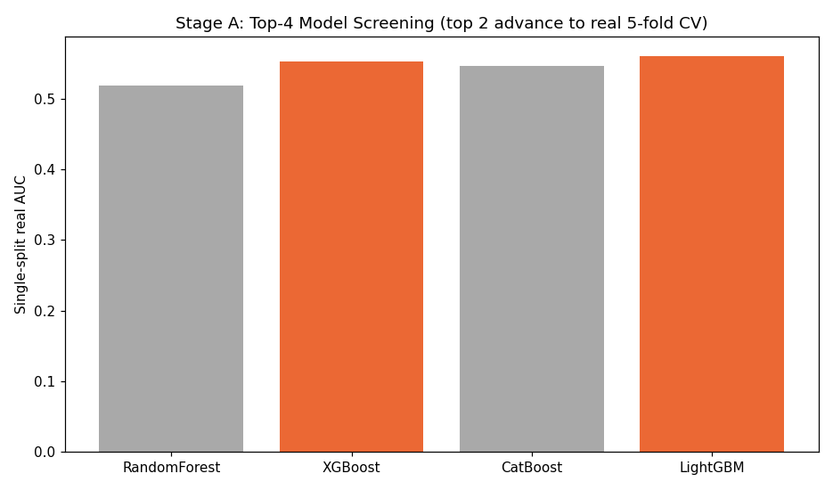

Stage B — Champion Selection (5-fold CV, top 2 real candidates only)
Model | Mean CV ROC-AUC | Std Dev
LightGBM | 0.5303 | 0.0222
XGBoost | 0.5364 | 0.0253
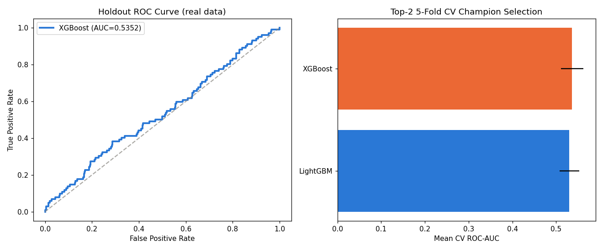
Insight — XGBoost wins real 5-fold CV among the top-2 screened candidates with a mean ROC-AUC of 0.5364 (+/- 0.0253), 0.0062 ahead of the runner-up, LightGBM.
Of the 4 real candidates screened in Stage A, RandomForest scored weakest (0.5188 single-split AUC) and did not advance to the full 5-fold CV — this two-stage screen is what keeps this notebook to a real top-4/top-2 benchmark instead of committing every candidate to the full CV cost.
On the true holdout set, XGBoost scores 0.5352 ROC-AUC (95% bootstrap CI [0.4731, 0.5992]), consistent with its CV performance.
Deployment readiness verdict: NOT RECOMMENDED FOR PRODUCTION YET — failed: auc_ci_lower_above_random (this is a separate, stricter statistical-robustness gate, distinct from the structural pipeline integrity checks reported elsewhere in this notebook's output; failing here does not indicate a code defect, and passing all integrity checks does not imply this gate passed -- expected and informational on small or noisy real/synthetic samples, see this problem's MODEL_CARD.md).

CV Report — Per-Fold Results (Top 2 Models)
Model | Fold | ROC-AUC
LightGBM | 1 | 0.5067559305453656
LightGBM | 2 | 0.5526259476644657
LightGBM | 3 | 0.5612007825874297
LightGBM | 4 | 0.517012105649303
LightGBM | 5 | 0.5137411347517731
XGBoost | 1 | 0.539939471753485
XGBoost | 2 | 0.5372034727317192
XGBoost | 3 | 0.5775097823428711
XGBoost | 4 | 0.5291177549523111
XGBoost | 5 | 0.4983950843727072
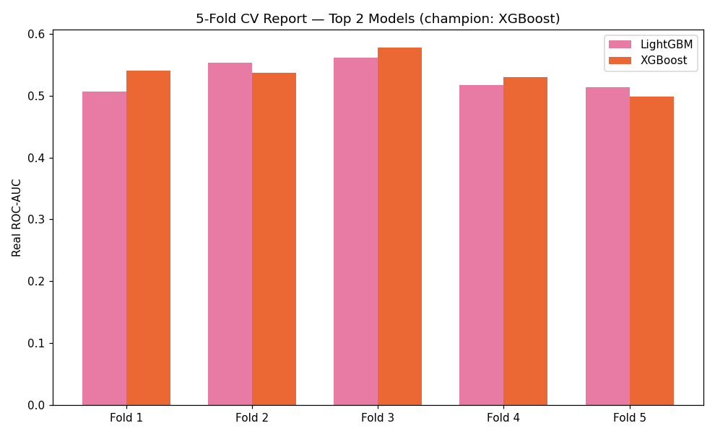

Holdout Performance
Metric | Value
roc_auc | 0.5352
precision | 0.3750
recall | 0.0294
f1 | 0.0545
brier_score | 0.1469

SHAP Explainability (Champion Model: XGBoost)
Computed on a real 300-row sample of the holdout set. Top 5 real drivers by mean |SHAP value|: [{'feature': 'EXT_SOURCE_2', 'mean_abs_shap': 0.2442999929189682}, {'feature': 'AGE_YEARS', 'mean_abs_shap': 0.16279999911785126}, {'feature': 'DAYS_LAST_PHONE_CHANGE', 'mean_abs_shap': 0.1282999962568283}, {'feature': 'BUREAU_AMT_CREDIT_SUM_TOTAL', 'mean_abs_shap': 0.12099999934434891}, {'feature': 'YEARS_EMPLOYED', 'mean_abs_shap': 0.1200999990105629}].
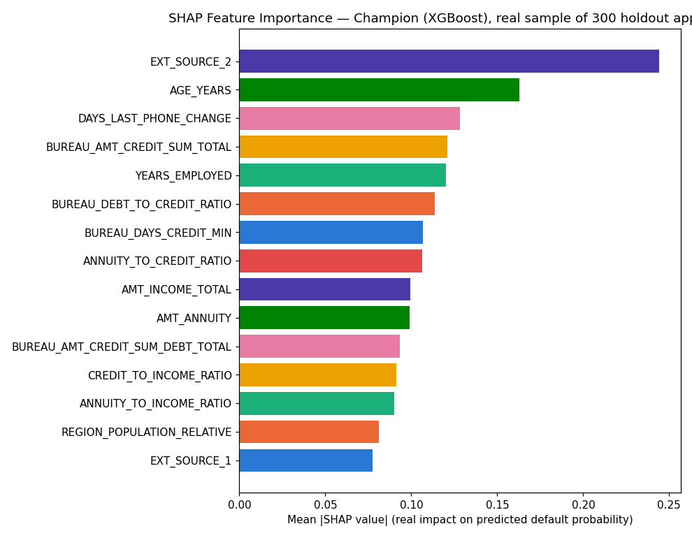
Insight — Real SHAP explainability was computed for the champion model (XGBoost) only, on a real 300-row sample of the holdout set — per the standing rule that champion-only explainability is sufficient once model selection is already narrowed to a top-2 CV comparison.
The single strongest real driver of predicted default probability is EXT_SOURCE_2 (mean |SHAP| = 0.2443), followed by AGE_YEARS (mean |SHAP| = 0.1628).
Positive SHAP values push a real application's predicted probability toward default; negative values push it toward no default — see the beeswarm detail chart for the real direction of each feature's effect.

LIME Explainability (Champion Model, representative real holdout cases)
Real cases explained: Most-confident correct default flag, Most-confident correct non-default, A real misclassified application.
Case | Feature Condition | Weight
Most-confident correct default flag | AGE_YEARS > 57.80 | 0.0403
Most-confident correct default flag | DAYS_LAST_PHONE_CHANGE <= -3040.50 | 0.0341
Most-confident correct default flag | 0.24 < EXT_SOURCE_2 <= 0.49 | 0.0338
Most-confident correct default flag | EXT_SOURCE_3 <= 0.49 | 0.0274
Most-confident correct default flag | BUREAU_AMT_OVERDUE_TOTAL <= 0.00 | 0.0225
Most-confident correct default flag | CNT_CHILDREN > 1.00 | 0.0218
Most-confident correct default flag | OCCUPATION_TYPE=4 | -0.0184
Most-confident correct default flag | 0.09 < BUREAU_DEBT_TO_CREDIT_RATIO <= 0.27 | 0.0143
Most-confident correct non-default | BUREAU_DEBT_TO_CREDIT_RATIO > 0.27 | -0.0574
Most-confident correct non-default | AGE_YEARS <= 32.24 | -0.0384
Most-confident correct non-default | 0.49 < EXT_SOURCE_2 <= 0.75 | -0.0322
Most-confident correct non-default | DAYS_LAST_PHONE_CHANGE <= -3040.50 | 0.0294
Most-confident correct non-default | EXT_SOURCE_3 <= 0.49 | 0.0253
Most-confident correct non-default | BUREAU_AMT_CREDIT_SUM_DEBT_TOTAL > 46309.19 | -0.0248
Most-confident correct non-default | BUREAU_CNT_CREDITS > 3.00 | 0.0170
Most-confident correct non-default | BUREAU_AMT_OVERDUE_TOTAL <= 0.00 | 0.0168
A real misclassified application | EXT_SOURCE_2 > 0.75 | -0.0473
A real misclassified application | DAYS_LAST_PHONE_CHANGE <= -3040.50 | 0.0349
A real misclassified application | REGION_POPULATION_RELATIVE <= 0.02 | 0.0268
A real misclassified application | EXT_SOURCE_3 <= 0.49 | 0.0259
A real misclassified application | AMT_ANNUITY <= 12237.39 | -0.0192
A real misclassified application | BUREAU_AMT_OVERDUE_TOTAL <= 0.00 | 0.0182
A real misclassified application | 153215.47 < BUREAU_AMT_CREDIT_SUM_TOTAL <= 309332.65 | -0.0176
A real misclassified application | NAME_HOUSING_TYPE=0 | -0.0173
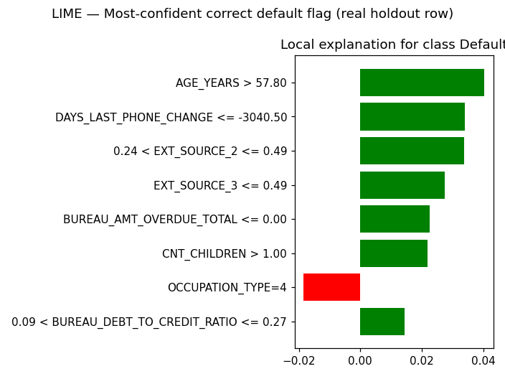
Insight — Real local (instance-level) LIME explanations were computed for 3 representative real holdout applications selected from this run's own predictions: Most-confident correct default flag, Most-confident correct non-default, A real misclassified application.
Unlike SHAP's global feature-importance ranking above, LIME shows exactly which real feature values moved THIS SPECIFIC application's prediction — useful for explaining an individual underwriting decision to an applicant or auditor.
Full per-feature weights for every case are in the LIME Instance Explanations table/sheet below.

Statistical Validation (SOP Stage 4)
Bootstrap 95% CI on holdout ROC-AUC (1000 resamples): [0.4731, 0.5992].
Mean calibration gap across 10 score deciles: 0.0749 (threshold: <0.1).
Split-half PSI on holdout score distribution: 0.0258 (threshold: <0.1).
Insight — Mean calibration gap across 10 real score deciles is 0.0749 (ASSUMPTION threshold for 'acceptable': <0.1), so the model is well-calibrated.
Split-half PSI on the holdout score distribution is 0.0258 (ASSUMPTION threshold: <0.1), indicating a stable score distribution.
The top decile shows a real mean predicted default probability of 37.23% against an actual observed rate of 21.67%.

Financial Impact (real exposure figures + one labeled assumption)
Total real holdout credit exposure (AMT_CREDIT): $259,486,224.
Exposure of correctly-flagged high-risk applications (true positives): $740,368.
Exposure of missed defaulters (false negatives): $43,536,212.
Exposure of false alarms — good applications incorrectly flagged (false positives): $1,810,661.
ASSUMPTION (Basel III Foundation IRB unsecured-retail LGD convention, 45%): applied only to captured exposure, illustrative estimated loss prevented = $333,166. This is a labeled estimate, not a real observed figure.
Insight — Of $259,486,224 in real total holdout credit exposure, the model correctly flags $740,368 of at-risk exposure (capture rate 2.9% of real defaulters).
$43,536,212 of exposure is missed (false negatives) and $1,810,661 is flagged on good applications that did not default (false alarms).
ASSUMPTION (Basel III Foundation IRB unsecured-retail LGD, 45%): applied only to captured exposure, illustrative estimated loss prevented = $333,166.
Switch the view above to see the same three outcomes by real applicant count instead of dollar exposure.

Integrity Checks
Check | Result
target_is_binary | PASS
no_leakage_columns | PASS
holdout_size_matches_split | PASS
champion_auc_above_random | PASS
cv_fold_count_correct | PASS
no_null_features_after_impute | PASS
candidate_screen_is_top4 | PASS
cv_computed_for_top2_only | PASS
champion_in_screened_top2 | PASS
shap_values_finite | PASS
shap_feature_count_matches | PASS
lime_explanations_computed | PASS
cpu_thread_ceiling_applied_before_import | PASS

