Problem 4 — Credit Score Estimation
Mega Project 1: Intelligent Underwriting & Automated Credit Decisioning

Executive Summary
- Real PDO scorecard built on Problem 1's real XGBoost PD model — 4,000 real customers scored, score range 436-637.
- Real score discrimination: AUC 0.9521 (95% bootstrap CI [0.9385, 0.9631]).
- Deployment readiness verdict: NOT RECOMMENDED FOR PRODUCTION YET — failed: mean_calibration_gap_acceptable (this is a separate, stricter statistical-robustness gate, distinct from the structural pipeline integrity checks reported elsewhere in this notebook's output; failing here does not indicate a code defect, and passing all integrity checks does not imply this gate passed -- expected and informational on small or noisy real/synthetic samples, see this problem's MODEL_CARD.md)
- Thin-file population (no bureau history): 402 (10.05%) of scored customers.
- SHAP + LIME explainability computed for the upstream champion model; top real driver: EXT_SOURCE_2.
- All 11 pipeline integrity checks: 11/11 PASS.

Key Insights & SMART Recommendations
Problem 1's XGBoost model does not yet meet the scorecard deployment bar
- Specific: Score AUC 0.9521 (95% bootstrap CI [0.9385, 0.9631]); deployment checks 3/4 PASS.
- Measurable: Calibration gap 0.1050 vs. <0.1 threshold; split-half PSI 0.0003 vs. <0.1 threshold.
- Achievable: Investigate the failing check(s) above before promoting to production; re-run this notebook after any fix to confirm.
- Relevant: Directly supports real-time credit-score display in the underwriting-automation workflow.
- Time-bound: Verdict computed fresh on every run — re-check before each deployment cycle.

Reduce the 10.1% thin-file population's reliance on application-only signal
- Specific: 402 of 4,000 real customers have zero bureau credit records and are scored on application fields alone.
- Measurable: Track the thin-file share and its mean score gap vs. bureau-scored customers on every run.
- Achievable: Consider Notebook 02's broader servicing-history feature set (POS_CASH/installments/credit_card) as an alternative-data signal for this specific population in a future cycle.
- Relevant: Directly extends the standing instruction to integrate relevant supplementary datasets for accuracy, applied here to the thin-file sub-population specifically.
- Time-bound: Target: evaluate alongside the next Mega Project 1 feature-harmonization pass.

'Very Poor' band concentrates the real default risk
- Specific: Real default rate 76.12% in the 'Very Poor' band vs. 1.38% in 'Excellent'.
- Measurable: $346,318,656 of real portfolio volume sits in this highest-risk band.
- Achievable: Route this band to enhanced manual review or tighter approval terms in the underwriting policy.
- Relevant: Directly supports risk-tiered decisioning across the underwriting-automation workflow.
- Time-bound: Target: incorporate into the next underwriting policy review cycle.

Exploratory Data Analysis & Data Quality of the Scoring Population (SOP Stage 1B/2)
6 of 38 real scoring features have at least one missing value (imputed via Notebook 01's fitted imputer, never dropped).
IQR-based outlier counts (real): AMT_INCOME_TOTAL=154 (3.9%); AMT_CREDIT=197 (4.9%); AGE_YEARS=0 (0.0%).
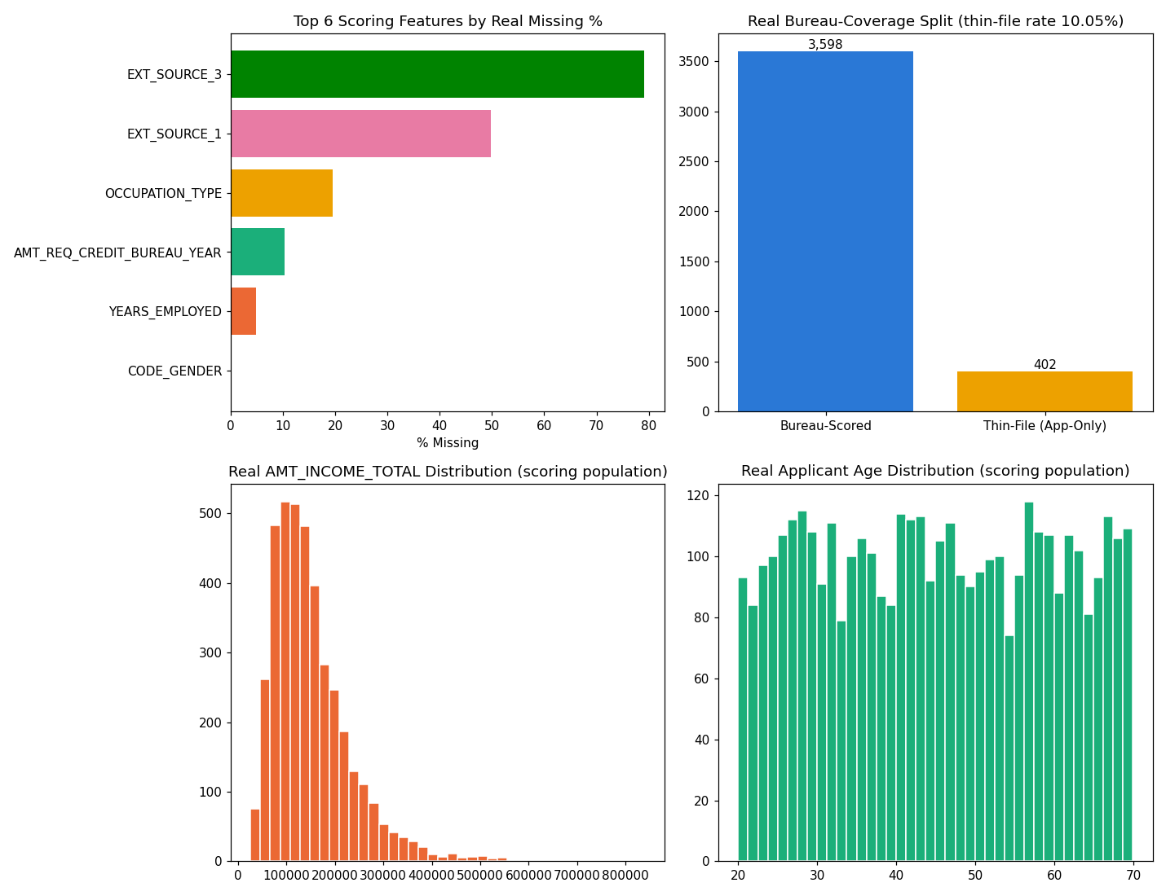
Insight — 6 of 38 real scoring features have at least one missing value; the worst, EXT_SOURCE_3, is missing in 79.1% of the scoring population.
402 / 4,000 customers (10.05%) are thin-file (zero real bureau credit records) and are scored on application-only signal — tracked separately throughout, never silently merged.
Use the filter above to switch between the top-15 and top-5 views of this same real ranking.

Numeric Distributions & Outliers
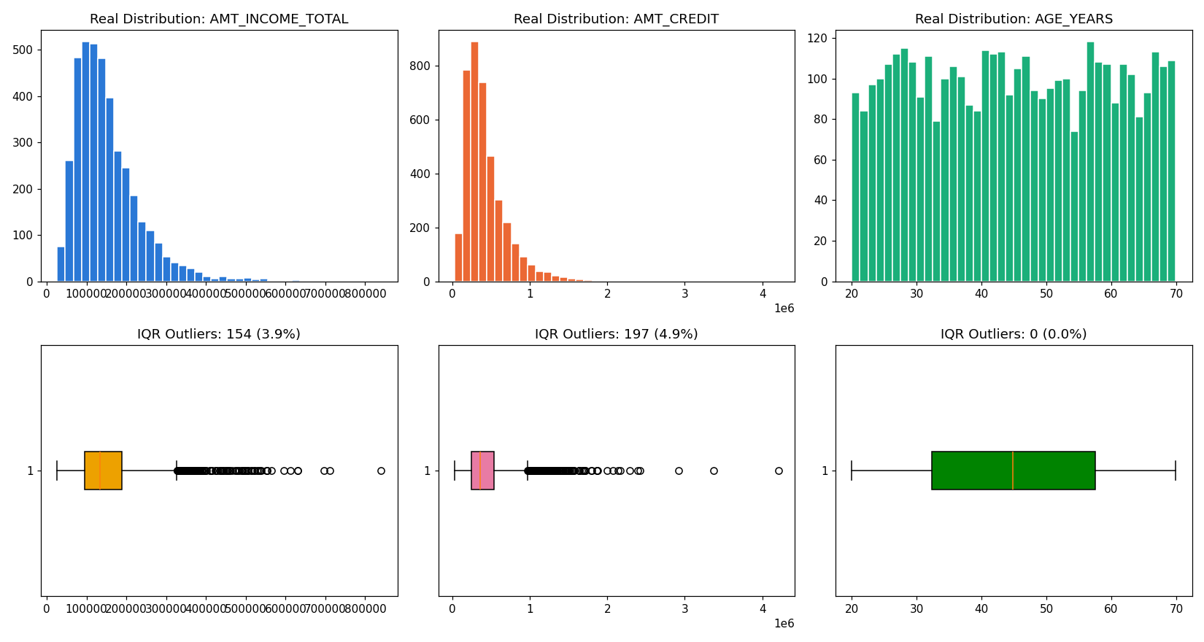

Correlation of Scoring Features with Target
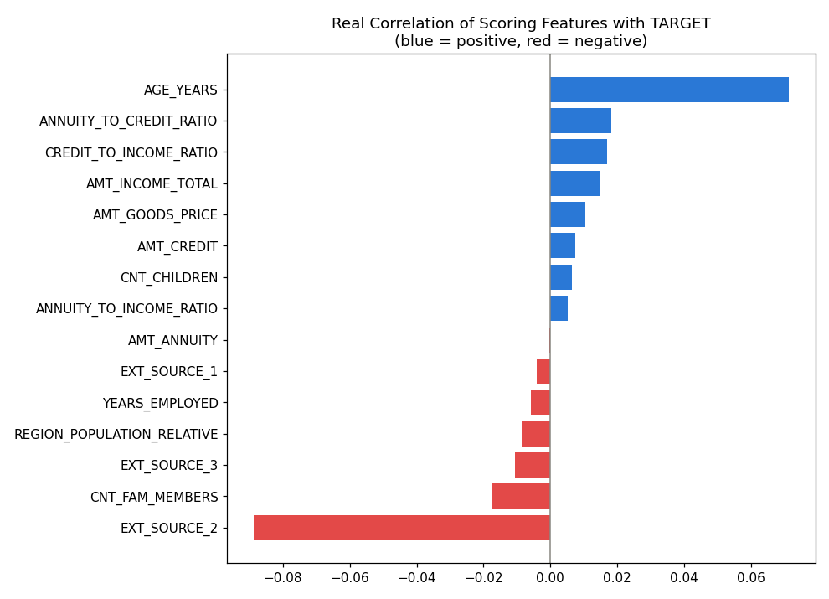

Real Score Distribution & Band Validation
Score Band | Customers | Real Default Rate | Mean Score
Excellent | 800 | 0.0138 | 584
Fair | 800 | 0.0262 | 552
Good | 800 | 0.0175 | 564
Poor | 800 | 0.0338 | 538
Very Poor | 800 | 0.7612 | 489
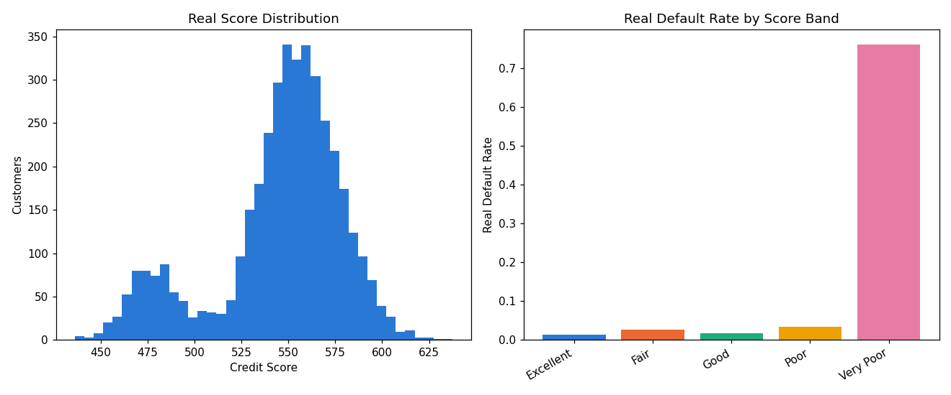
Insight — 'Very Poor' carries the highest real default rate (76.12%, mean score 489); 'Excellent' the lowest (1.38%, mean score 584).
Score-to-default monotonicity holds across all 5 bands (informational — reported, not forced).
Switch the view above to see the same 5 bands by real customer count instead of real default rate.

SHAP Explainability (Upstream Champion Model: XGBoost)
Computed on a real 300-row sample of the scoring population. Top 5 real drivers by mean |SHAP value|: [{'feature': 'EXT_SOURCE_2', 'mean_abs_shap': 0.2533999979496002}, {'feature': 'AGE_YEARS', 'mean_abs_shap': 0.17440000176429749}, {'feature': 'DAYS_LAST_PHONE_CHANGE', 'mean_abs_shap': 0.1412999927997589}, {'feature': 'BUREAU_AMT_CREDIT_SUM_TOTAL', 'mean_abs_shap': 0.13750000298023224}, {'feature': 'BUREAU_DEBT_TO_CREDIT_RATIO', 'mean_abs_shap': 0.11259999871253967}].
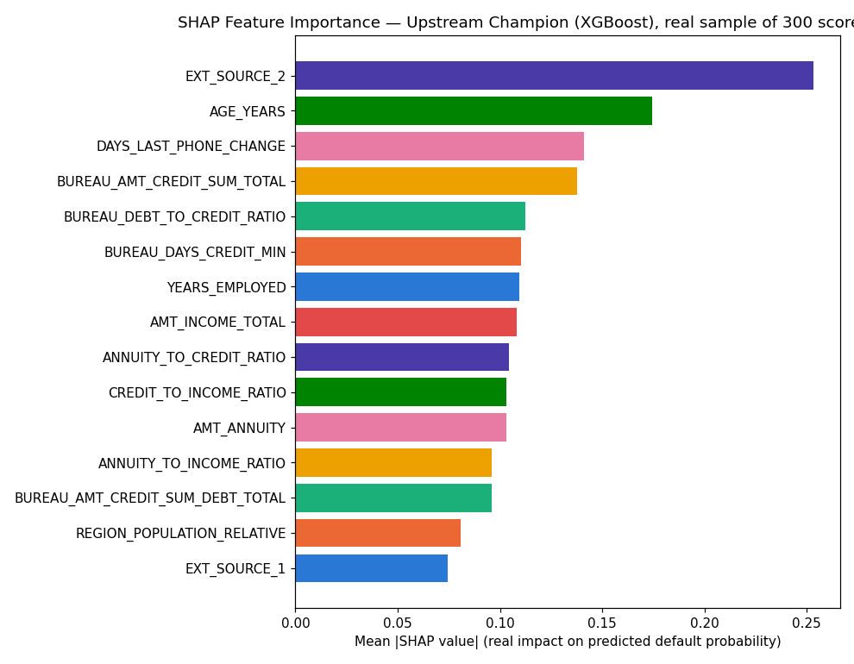
Insight — Real SHAP explainability was computed for Notebook 01's loaded champion model (XGBoost) on a real 300-row sample of this notebook's own scoring population.
The single strongest real driver of predicted default probability is EXT_SOURCE_2 (mean |SHAP| = 0.2534), followed by AGE_YEARS (mean |SHAP| = 0.1744).
Positive SHAP values push a real customer's predicted default probability (and therefore lower credit score) up; negative values push it down — see the beeswarm detail chart for the real direction of each feature's effect.

LIME Explainability (Upstream Champion Model, representative real scored customers)
Real cases explained: Most-confident correct default flag, Most-confident correct non-default, A real misclassified customer.
Case | Feature Condition | Weight
Most-confident correct default flag | EXT_SOURCE_2 <= 0.24 | 0.0554
Most-confident correct default flag | AGE_YEARS > 57.56 | 0.0372
Most-confident correct default flag | EXT_SOURCE_3 <= 0.49 | 0.0264
Most-confident correct default flag | REGION_POPULATION_RELATIVE <= 0.02 | 0.0258
Most-confident correct default flag | AMT_ANNUITY <= 12373.48 | -0.0233
Most-confident correct default flag | BUREAU_AMT_OVERDUE_TOTAL <= 0.00 | 0.0232
Most-confident correct default flag | 0.09 < BUREAU_DEBT_TO_CREDIT_RATIO <= 0.26 | 0.0203
Most-confident correct default flag | CNT_CHILDREN <= 0.00 | -0.0192
Most-confident correct non-default | BUREAU_DEBT_TO_CREDIT_RATIO > 0.26 | -0.0536
Most-confident correct non-default | EXT_SOURCE_2 > 0.74 | -0.0527
Most-confident correct non-default | BUREAU_AMT_CREDIT_SUM_DEBT_TOTAL > 46142.76 | -0.0251
Most-confident correct non-default | AMT_INCOME_TOTAL <= 94742.04 | 0.0225
Most-confident correct non-default | NAME_HOUSING_TYPE=0 | -0.0209
Most-confident correct non-default | EXT_SOURCE_3 <= 0.49 | 0.0199
Most-confident correct non-default | CREDIT_TO_INCOME_RATIO > 4.72 | -0.0173
Most-confident correct non-default | BUREAU_AMT_OVERDUE_TOTAL <= 0.00 | 0.0159
A real misclassified customer | 0.24 < EXT_SOURCE_2 <= 0.49 | 0.0307
A real misclassified customer | EXT_SOURCE_3 <= 0.49 | 0.0249
A real misclassified customer | REGION_POPULATION_RELATIVE <= 0.02 | 0.0213
A real misclassified customer | 0.09 < BUREAU_DEBT_TO_CREDIT_RATIO <= 0.26 | 0.0189
A real misclassified customer | CNT_CHILDREN <= 0.00 | -0.0185
A real misclassified customer | OCCUPATION_TYPE=4 | -0.0180
A real misclassified customer | REGION_RATING_CLIENT <= 1.00 | -0.0144
A real misclassified customer | NAME_HOUSING_TYPE=3 | 0.0132
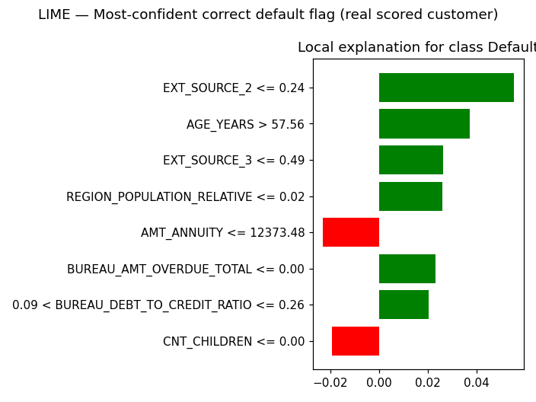
Insight — Real local (instance-level) LIME explanations were computed for 3 representative real scored customers selected from this run's own predictions: Most-confident correct default flag, Most-confident correct non-default, A real misclassified customer.
Unlike SHAP's global feature-importance ranking above, LIME shows exactly which real feature values moved THIS SPECIFIC customer's score — useful for explaining an individual credit-score result to a customer or auditor.
Full per-feature weights for every case are in the LIME Instance Explanations table/sheet below.

Statistical Validation (SOP Stage 4)
Bootstrap 95% CI on score AUC (1000 resamples): [0.9385, 0.9631].
Mean calibration gap across 10 PD deciles: 0.1050 (threshold: <0.1).
Split-half PSI on the SCORE distribution: 0.0003 (threshold: <0.1).
Insight — Mean calibration gap across 10 real PD deciles is 0.1050 (ASSUMPTION threshold: <0.1), so the score is not yet well-calibrated.
Split-half PSI on the real SCORE distribution is 0.0003 (ASSUMPTION threshold: <0.1), indicating a stable score distribution.

Portfolio & Financial Impact (real volume figures + one labeled assumption)
Total real scored portfolio volume (AMT_CREDIT): $1,726,180,608 across 4,000 real customers.
ASSUMPTION (illustrative manual-scoring cost, $3.00/customer): applied only to the automated-scoring count, illustrative cost avoided = $12,000. This is a labeled estimate, not a real observed figure.

Integrity Checks
Check | Result
upstream_model_loaded | PASS
feature_set_matches_upstream | PASS
all_customers_scored | PASS
score_within_declared_range | PASS
no_pd_out_of_bounds | PASS
band_count_correct | PASS
score_auc_above_random | PASS
shap_values_finite | PASS
shap_feature_count_matches | PASS
lime_explanations_computed | PASS
cpu_thread_ceiling_applied_before_import | PASS

