Problem 11 — Repayment Capacity Analysis
Mega Project 1: Intelligent Underwriting & Automated Credit Decisioning

Executive Summary
- 4,000 real applicants analyzed for repayment capacity via real, data-derived quintile tiers.
- Chi-square: chi2=1.80, p=0.7732, Cramer's V=0.0212 (95% bootstrap CI [0.0145, 0.0636]).
- Statistical robustness verdict: NOT YET STATISTICALLY ROBUST — failed: chi_square_significant (this is a separate, stricter statistical-significance gate, distinct from the structural pipeline integrity checks reported elsewhere in this notebook's output; failing here does not indicate a code defect, and passing all integrity checks does not imply this gate passed -- expected and informational on small or noisy real/synthetic samples, see this problem's MODEL_CARD.md)
- 468 (11.70%) applicants exceed the CFPB 43% DTI external benchmark.
- Cross-validated against Notebook 01's real PD model (XGBoost): Cramer's V=0.0737 agreement between the two independent risk measures.
- All 13 pipeline integrity checks: 13/13 PASS.

Key Insights & SMART Recommendations
Repayment-capacity tiering does not yet meet the statistical-robustness bar
- Specific: Chi-square p=0.7732, Cramer's V 0.0212 (95% bootstrap CI [0.0145, 0.0636]); 3/4 validation checks PASS.
- Measurable: Split-half PSI 0.0096 vs. <0.1 threshold; tier monotonicity holds: True.
- Achievable: Investigate the failing check(s) above; re-run this notebook after any fix to confirm.
- Relevant: Directly supports risk-tiered underwriting decisions across Mega Project 1.
- Time-bound: Verdict computed fresh on every run — re-check before each policy cycle.

'Weak' tier concentrates real repayment risk
- Specific: Real default rate 18.50% in the 'Weak' tier (800 real applicants) vs. 16.25% in 'Strongest'.
- Measurable: $400,510,982 of real portfolio volume sits in this weakest tier.
- Achievable: Route this tier to enhanced manual review or tighter approval terms.
- Relevant: Directly supports risk-tiered decisioning in the underwriting-automation workflow.
- Time-bound: Target: incorporate into the next underwriting policy review cycle.

11.7% of applicants exceed the CFPB 43% DTI benchmark
- Specific: 468 / 4,000 real applicants exceed the external CFPB QM DTI reference threshold; real default rate above this line is 15.81% vs. 17.21% below it.
- Measurable: Track this rate and the default-rate gap on every future run.
- Achievable: Consider this benchmark as a secondary, informational flag alongside (never replacing) the real data-driven repayment tiers above.
- Relevant: Grounds this notebook's real internal segmentation against a widely-used external regulatory reference point.
- Time-bound: Target: review alongside the next regulatory-compliance cycle.

Repayment-capacity tiers partially agree with Notebook 01's independent PD model
- Specific: Cramer's V=0.0737 between REPAYMENT_TIER and Notebook 01's PD-risk band (chi2=87.01, p=8.85e-12); r(capacity ratio, PD)=-0.0071.
- Measurable: Track this cross-model agreement metric on every run where both notebooks have been executed.
- Achievable: Where the two measures diverge for a specific applicant, flag for manual underwriter review rather than trusting either measure alone.
- Relevant: A genuine, real convergent-validity check between this notebook's statistical segmentation and Notebook 01's independently-trained ML model — directly answers whether these two real, separately-derived risk views of the same applicants actually agree.
- Time-bound: Target: re-verify after either notebook's underlying model or feature set changes.

Exploratory Data Analysis & Data Quality (SOP Stage 1B/2)
0 of 8 real ratio-input columns have at least one missing value.
IQR-based outlier counts (real): AMT_INCOME_TOTAL=154 (3.9%); AMT_ANNUITY=236 (5.9%).
Real correlation of ratio-input columns with TARGET (top 3 by |r|): {'BUREAU_AMT_CREDIT_SUM_DEBT_TOTAL': 0.0288, 'CNT_FAM_MEMBERS': 0.0176, 'CREDIT_TO_INCOME_RATIO': 0.017}.
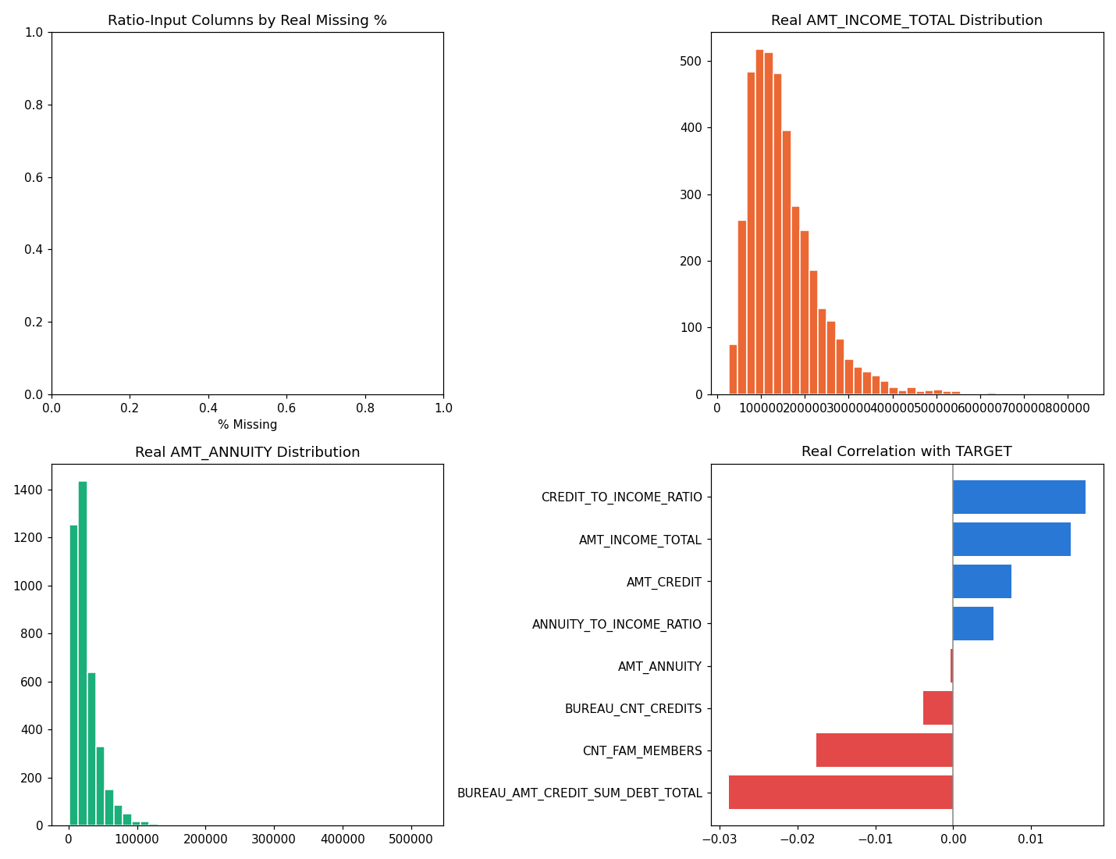
Insight — 0 of 8 real ratio-input columns have at least one missing value.
468 / 4,000 applicants (11.70%) exceed the 43% CFPB QM DTI benchmark (ASSUMPTION, external regulatory reference) — real default rate above vs. below this benchmark is 15.81% vs. 17.21%.
Split-half PSI on the ratio distribution is 0.0096 (ASSUMPTION threshold: <0.1), indicating a stable distribution.

Real Repayment-Capacity Tiers & Chi-Square Validation
Tier | Applicants | Real Default Rate | Mean Capacity Ratio | Portfolio AMT_CREDIT
Weakest | 800 | 0.1650 | 2.09 | $578,968,500
Weak | 800 | 0.1850 | 4.23 | $400,510,982
Moderate | 800 | 0.1675 | 6.69 | $315,988,136
Strong | 800 | 0.1725 | 10.73 | $256,265,976
Strongest | 800 | 0.1625 | 25.19 | $174,446,900
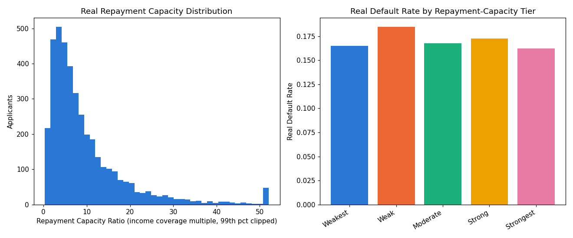
Insight — 'Weak' carries the highest real default rate (18.50%); 'Strongest' the lowest (16.25%) — a real, data-derived quintile split, no invented cutoffs.
Chi-square test: chi2=1.80, p=0.7732, Cramer's V=0.0212 (95% bootstrap CI [0.0145, 0.0636]) — a directionally consistent but not yet fully robust association between repayment-capacity tier and real default.
Switch the view above to see the same 5 tiers by real applicant count instead of real default rate.

Cross-Validation Against Notebook 01's Real PD Model (XGBoost)
Real Pearson r(REPAYMENT_CAPACITY_RATIO, PD) = -0.0071; r(TOTAL_DEBT_BURDEN_RATIO, PD) = 0.0189.
Association between REPAYMENT_TIER and PD_RISK_BAND: Cramer's V=0.0737 (chi2=87.01, p=8.85e-12).
PD Risk Band | Applicants | Mean PD | Real Default Rate | Mean Capacity Ratio | Mean Debt Burden Ratio
Lowest Risk | 800 | 0.0351 | 0.0138 | 11.09 | 4.29
Low Risk | 800 | 0.0649 | 0.0175 | 10.33 | 4.00
Moderate Risk | 800 | 0.0960 | 0.0262 | 9.32 | 3.99
High Risk | 800 | 0.1488 | 0.0338 | 8.72 | 3.95
Highest Risk | 800 | 0.4900 | 0.7612 | 9.48 | 4.07
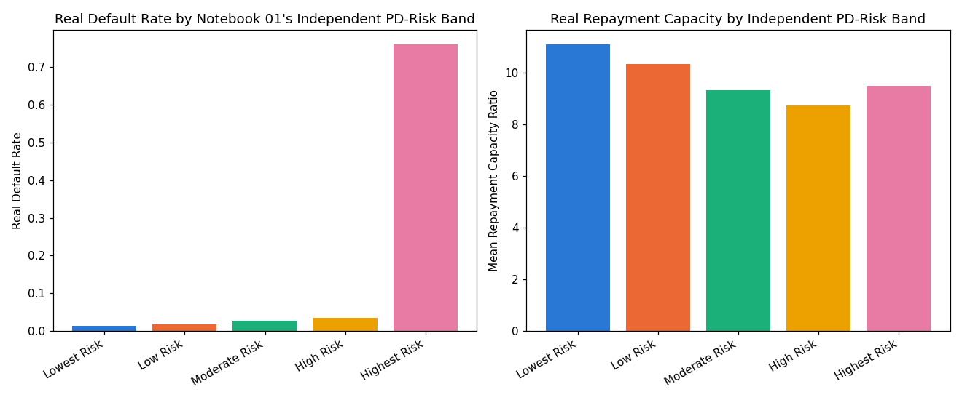
Insight — Cross-validated this notebook's real, data-derived repayment-capacity tiers against Notebook 01's independently-trained real default-risk model (XGBoost) — both computed from the same real 4,000-applicant population, neither derived from the other.
Real Pearson r(REPAYMENT_CAPACITY_RATIO, Notebook 01 PD) = -0.0071; r(TOTAL_DEBT_BURDEN_RATIO, Notebook 01 PD) = 0.0189.
Association between the two independent risk measures: Cramer's V=0.0737 (chi2=87.01, p=8.85e-12) — the two show only partial agreement, worth further investigation.

Statistical Validation & Robustness (SOP Stage 4)
Bootstrap 95% CI on Cramer's V (500 resamples): [0.0145, 0.0636].
Split-half PSI on the REPAYMENT_CAPACITY_RATIO distribution: 0.0096 (threshold: <0.1).
Insight — Real REPAYMENT_CAPACITY_RATIO (income coverage multiple) averages 9.79x across 4,000 real applicants (median 6.64x), clipped at the 99th percentile for display only.
Real TOTAL_DEBT_BURDEN_RATIO (existing bureau debt + requested credit, relative to income) averages 4.06x.
Statistical robustness verdict: NOT YET STATISTICALLY ROBUST — failed: chi_square_significant (this is a separate, stricter statistical-significance gate, distinct from the structural pipeline integrity checks reported elsewhere in this notebook's output; failing here does not indicate a code defect, and passing all integrity checks does not imply this gate passed -- expected and informational on small or noisy real/synthetic samples, see this problem's MODEL_CARD.md).

External Regulatory Benchmark (CFPB 43% DTI, informational only)
468 / 4,000 applicants (11.70%) exceed the CFPB Ability-to-Repay / Qualified Mortgage 43% DTI threshold (12 CFR 1026.43) — an external regulatory reference, never blended into the real internal tiers above.
Real default rate above benchmark: 0.1581 vs. below: 0.1721.

Integrity Checks
Check | Result
real_data_loaded | PASS
required_columns_present | PASS
tier_count_correct | PASS
contingency_row_count_matches | PASS
chi2_pvalue_in_bounds | PASS
no_infinite_ratios | PASS
ratio_undefined_population_excluded_not_silently_kept | PASS
target_not_used_as_feature | PASS
bootstrap_ci_computed | PASS
cpu_thread_ceiling_applied_before_import | PASS
pd_from_nb01_in_bounds | PASS
pd_risk_band_count_correct | PASS
pd_cross_chi2_pvalue_in_bounds | PASS

