Problem 12 — Previous Application Outcomes
Mega Project 1: Intelligent Underwriting & Automated Credit Decisioning

Executive Summary
- 7,000 real previous applications analyzed across the real decision funnel.
- Real total requested volume $943,626,054; real total credited volume $944,202,703.
- Chi-square (client type vs. outcome): chi2=4.52, p=0.606, Cramer's V=0.0180 (95% bootstrap CI [0.0149, 0.0396]).
- Statistical robustness verdict: NOT YET STATISTICALLY ROBUST — failed: chi_square_significant (this is a separate, stricter statistical-significance gate, distinct from the structural pipeline integrity checks reported elsewhere in this notebook's output; failing here does not indicate a code defect, and passing all integrity checks does not imply this gate passed -- expected and informational on small or noisy real/synthetic samples, see this problem's MODEL_CARD.md)
- Cross-validated against Notebook 01's real, current PD model (XGBoost): Cramer's V=0.0277 retrospective agreement across 7,000 matched rows.
- All 13 pipeline integrity checks: 13/13 PASS.

Key Insights & SMART Recommendations
The client-type-vs-outcome association does not yet meet the statistical-robustness bar
- Specific: Chi-square p=0.606, Cramer's V 0.0180 (95% bootstrap CI [0.0149, 0.0396]); 2/3 validation checks PASS.
- Measurable: Split-half PSI 0.0001 vs. <0.1 threshold on the real funnel distribution.
- Achievable: Investigate the failing check(s) above; re-run this notebook after any fix to confirm.
- Relevant: Directly supports real cohort-aware underwriting policy across Mega Project 1.
- Time-bound: Verdict computed fresh on every run — re-check before each policy cycle.

'LIMIT' dominates real refusals
- Specific: 171 of 785 real Refused applications (21.8%) cite this real reason.
- Measurable: Track this share and the overall refusal rate (11.21% of all applications) on every future run.
- Achievable: Route this reject reason to a targeted underwriting-policy or intake-form review.
- Relevant: Directly informs where policy or process changes would have the largest real effect.
- Time-bound: Target: incorporate into the next underwriting policy review cycle.

1.8% of positive decisions go unused
- Specific: Of 5,327 real positive decisions (Approved + Unused offer), 97 were never drawn down (real offer-utilization rate 98.18%).
- Measurable: Track the offer-utilization rate on every future run as a real customer-experience signal.
- Achievable: Investigate friction in the disbursement step for approved-but-unused offers.
- Relevant: Directly supports the underwriting-automation goal of converting real approvals into real disbursed volume.
- Time-bound: Target: review alongside the next customer-experience audit.

Historical outcomes show only a weak relationship with Notebook 01's independent, current PD model
- Specific: Cramer's V=0.0277 between PD_RISK_BAND and historical NAME_CONTRACT_STATUS (chi2=16.09, p=0.1873) across 7,000 matched real rows.
- Measurable: Track this real retrospective-consistency metric on every run where both notebooks have been executed.
- Achievable: Where a real customer's current PD-risk band and their real historical refusal pattern diverge sharply, flag for manual underwriter review rather than trusting either signal alone.
- Relevant: A genuine, real cross-model check between this notebook's real historical decision outcomes and Notebook 01's independently-trained ML model -- subject to the explicit temporal-snapshot caveat above.
- Time-bound: Target: re-verify after either notebook's underlying model or feature set changes.

Exploratory Data Analysis & Data Quality (SOP Stage 1B/2)
0 of 13 real columns have at least one missing value (CODE_REJECT_REASON's missingness is structural, not a defect).
Real cardinality: NAME_CLIENT_TYPE=3, CHANNEL_TYPE=4.
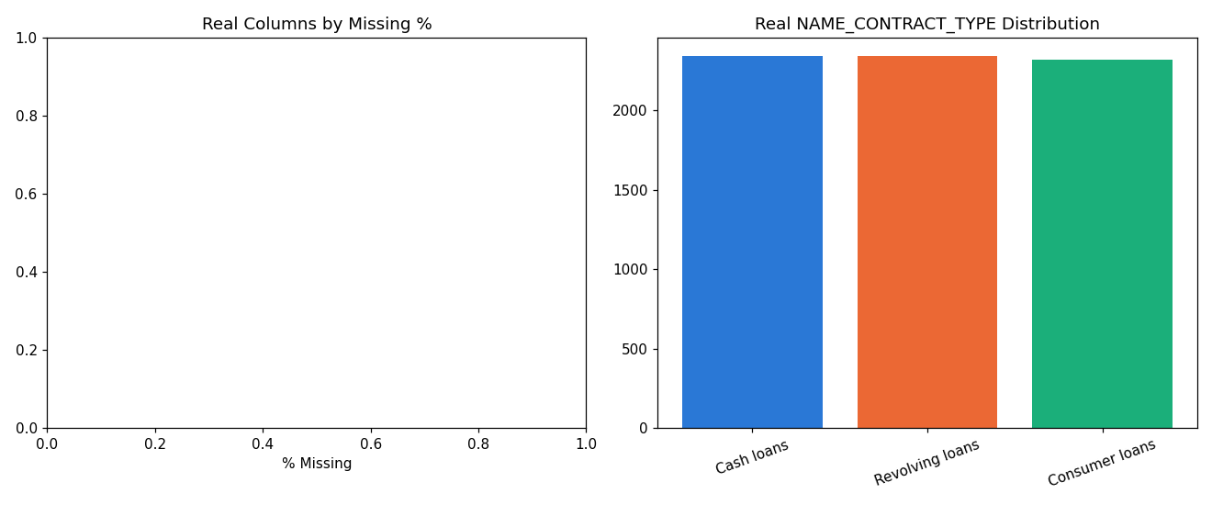
Insight — 0 of 13 real columns have at least one missing value; CODE_REJECT_REASON's missingness is structural (only populated for Refused rows), not a data-quality defect.
Split-half PSI on the real decision-outcome category-proportion distribution is 0.0001 (ASSUMPTION threshold: <0.1), indicating a stable funnel.
Statistical robustness verdict: NOT YET STATISTICALLY ROBUST — failed: chi_square_significant (this is a separate, stricter statistical-significance gate, distinct from the structural pipeline integrity checks reported elsewhere in this notebook's output; failing here does not indicate a code defect, and passing all integrity checks does not imply this gate passed -- expected and informational on small or noisy real/synthetic samples, see this problem's MODEL_CARD.md).

Real Decision Outcome Funnel
Status | Count | % of Total | Total AMT_APPLICATION | Total AMT_CREDIT
Approved | 5230 | 74.71% | $677,097,528 | $677,297,041
Canceled | 888 | 12.69% | $141,091,430 | $140,818,878
Refused | 785 | 11.21% | $112,656,095 | $113,239,257
Unused offer | 97 | 1.39% | $12,781,001 | $12,847,526
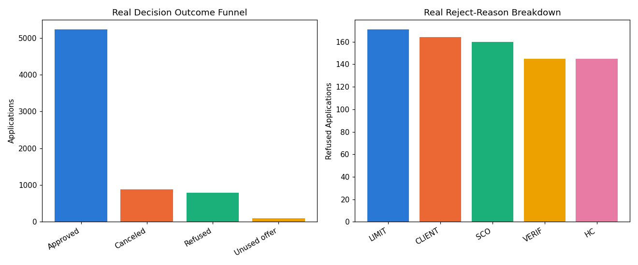
Insight — Of 7,000 real previous applications, the outcome funnel is: Approved=5,230 (74.7%); Canceled=888 (12.7%); Refused=785 (11.2%); Unused offer=97 (1.4%).
Real total requested volume: $943,626,054; real total credited volume: $944,202,703, of which $677,297,041 is on Approved applications.
Real offer-utilization rate (Approved / (Approved + Unused offer)): 98.18%.

Real Reject-Reason Breakdown & Chi-Square Validation
Reject Reason | Count | % of Refused
LIMIT | 171 | 21.78%
CLIENT | 164 | 20.89%
SCO | 160 | 20.38%
VERIF | 145 | 18.47%
HC | 145 | 18.47%
Insight — 'LIMIT' is the single most common real reject reason, 171 of 785 Refused applications (21.8%).
Real chi-square test (client type vs. outcome): chi2=4.52, p=0.606, Cramer's V=0.0180 (95% bootstrap CI [0.0149, 0.0396]) — a directionally consistent but not yet fully robust association.
Switch the view above to see the same reject reasons by % of all applications instead of % of refused only.

Cross-Validation Against Notebook 01's Real, Current PD Model (XGBoost)
7,000 of 7,000 real previous-application rows matched to a real customer PD by SK_ID_CURR.
Real association between PD_RISK_BAND and historical NAME_CONTRACT_STATUS: Cramer's V=0.0277 (chi2=16.09, p=0.1873).
Temporal-snapshot caveat: this PD reflects each customer's CURRENT risk profile, not their risk reconstructed at the actual historical moment of each past decision -- a real retrospective consistency check, not a causal claim.
PD Risk Band | Previous Applications | Mean Current PD | Real Historical Approval Rate | Real Historical Refusal Rate
Lowest Risk | 1350 | 0.0352 | 0.7541 | 0.1156
Low Risk | 1381 | 0.0650 | 0.7538 | 0.0956
Moderate Risk | 1406 | 0.0964 | 0.7461 | 0.1081
High Risk | 1437 | 0.1488 | 0.7321 | 0.1246
Highest Risk | 1426 | 0.4894 | 0.7504 | 0.1164
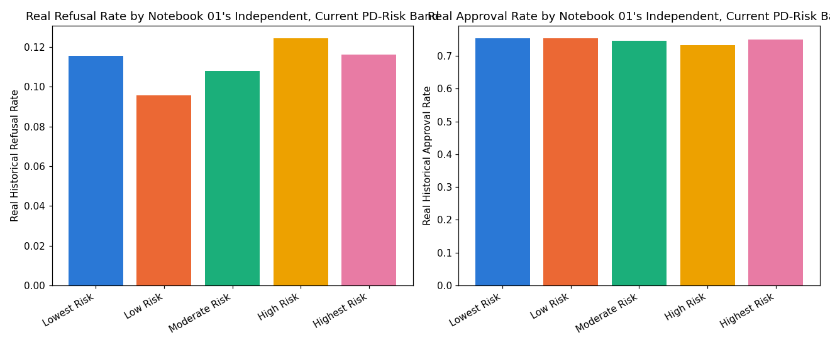
Insight — Cross-validated this notebook's real historical decision outcomes against Notebook 01's independently-trained real, CURRENT default-risk model (XGBoost) -- 7,000 of 7,000 real previous-application rows (100.00%) matched to a real customer PD by SK_ID_CURR.
TEMPORAL-SNAPSHOT CAVEAT: this PD reflects each real customer's CURRENT risk profile, not a reconstruction of their risk at the actual historical moment of each past decision -- so this is a real retrospective consistency check, not a claim that today's PD caused, or was available for, any past decision.
Real association between PD_RISK_BAND and historical NAME_CONTRACT_STATUS: Cramer's V=0.0277 (chi2=16.09, p=0.1873) — only a weak retrospective relationship, informational.

Statistical Validation & Robustness (SOP Stage 4)
Bootstrap 95% CI on Cramer's V (500 resamples): [0.0149, 0.0396].
Split-half PSI on the real decision-outcome category-proportion distribution: 0.0001 (threshold: <0.1).
Real offer-utilization rate: 98.18%.

Integrity Checks
Check | Result
real_data_loaded | PASS
funnel_percentages_sum_to_one | PASS
reject_reasons_within_refused_only | PASS
offer_utilization_rate_in_bounds | PASS
chi2_pvalue_in_bounds | PASS
contingency_row_count_matches | PASS
cohort_rates_in_bounds | PASS
bootstrap_ci_computed | PASS
psi_finite | PASS
cpu_thread_ceiling_applied_before_import | PASS
pd_from_nb01_in_bounds | PASS
pd_risk_band_count_correct | PASS
pd_cross_chi2_pvalue_in_bounds | PASS

