Mega Project 2 — Notebook 01: Expected Loss & Capital Requirement
Real PD (Mega Project 1 champion model) x Documented Basel Retail-IRB LGD/EAD/Correlation Assumptions

Executive Summary
- 4,000 real applicants scored for real probability of default via Mega Project 1's trained champion model (XGBoost).
- Real total EAD proxy (AMT_CREDIT): $1,726,180,495.
- Real-PD x documented-LGD Expected Loss: $97,633,699 (5.66% of EAD).
- Basel retail-IRB capital requirement: $109,035,535 (6.32% of EAD).
- Statistical robustness verdict: NOT YET STATISTICALLY ROBUST — failed: default_rate_monotonic_by_pd_band (this is a separate, stricter statistical-significance gate, distinct from the structural pipeline integrity checks reported elsewhere in this notebook's output; failing here does not indicate a code defect, and passing all integrity checks does not imply this gate passed -- expected and informational on small or noisy real/synthetic samples, see this problem's MODEL_CARD.md)

Key Insights & SMART Recommendations
Real-PD-based capital estimate does not yet meet the statistical-robustness bar
- Specific: Chi-square p=0, Cramer's V 0.8799 (95% bootstrap CI [0.8622, 0.8999]); 4/5 validation checks PASS.
- Measurable: Total real EAD proxy $1,726,180,495; Expected Loss $97,633,699 (5.66%); Basel retail-IRB capital requirement $109,035,535 (6.32%).
- Achievable: Investigate the failing check(s) above; re-run this notebook after any fix to confirm.
- Relevant: Directly informs Mega Project 2's downstream RWA analytics, economic-capital, stress-testing, and concentration notebooks, which all reuse this notebook's real per-applicant PD/EL/capital output rather than recomputing it.
- Time-bound: Re-run after any Notebook 01 (MP1) retrain, or any LGD/correlation assumption update.

Expected Loss by PD Risk Band
Real Expected Loss rate and real default rate, both computed per PD risk band (5-band convention shared across this suite).
PD Risk Band | N Applicants | Real Default Rate | EL Rate of EAD | Capital Rate of EAD
Lowest Risk | 904 | 1.11% | 1.15% | 4.36%
Low Risk | 1,296 | 1.77% | 2.45% | 5.81%
Moderate Risk | 1,012 | 4.05% | 4.61% | 7.48%
High Risk | 205 | 22.44% | 8.34% | 9.20%
Highest Risk | 583 | 96.40% | 20.52% | 7.53%
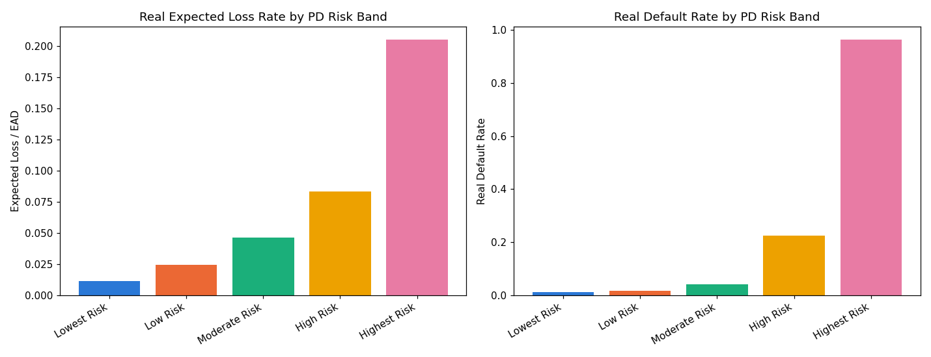
Insight — Real Expected Loss rate rises from 1.15% of EAD in 'Lowest Risk' to 20.52% in 'Highest Risk' — tracking the real PD input the assumption layer is applied to.
Real default rate is highest in 'Highest Risk' at 96.40% across 583 real applicants.
Statistical robustness verdict: NOT YET STATISTICALLY ROBUST — failed: default_rate_monotonic_by_pd_band (this is a separate, stricter statistical-significance gate, distinct from the structural pipeline integrity checks reported elsewhere in this notebook's output; failing here does not indicate a code defect, and passing all integrity checks does not imply this gate passed -- expected and informational on small or noisy real/synthetic samples, see this problem's MODEL_CARD.md).

Capital Requirement by Documented LGD Segment
Every segment's LGD and Basel asset-correlation value is a cited, published reference point (see the Assumptions sheet in the accompanying Excel workbook) -- never fitted to Home Credit's own real outcomes.
Segment | N Applicants | LGD Assumed | Real Default Rate | Total Capital Requirement
Secured — Real Estate | 1,755 | 20% | 16.87% | $48,524,210
Secured — Other (Vehicle/Goods) | 938 | 35% | 18.23% | $20,100,849
Unsecured — Other Retail | 926 | 45% | 15.98% | $24,914,874
Revolving (QRRE) | 381 | 65% | 17.59% | $15,495,603
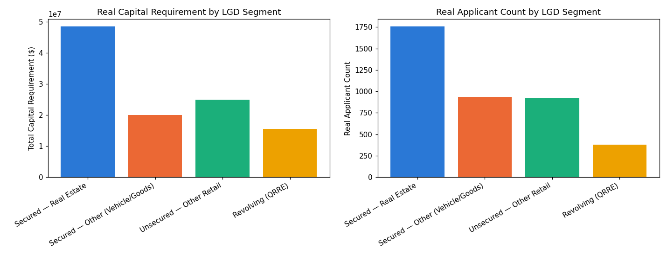
Insight — 'Secured — Real Estate' carries the largest real total capital requirement ($48,524,210, LGD assumption 20%) across 1,755 real applicants.
Chi-square (PD-band vs. real default): chi2=3096.78, p=0, Cramer's V=0.8799 (95% bootstrap CI [0.8622, 0.8999]).
Every LGD/correlation value driving this chart is a cited Basel retail-IRB reference point -- see the Assumptions sheet in the Excel workbook for full sourcing.

