Mega Project 2 — Notebook 02: Basel RWA Portfolio Analytics
Real per-applicant RWA (Notebook 01), analyzed across real portfolio segment cuts

Executive Summary
- 4,000 real applicants (Notebook 01's output, reused not recomputed).
- Real portfolio RWA density: 78.96%.
- Highest real RWA density segment: NAME_CONTRACT_TYPE=Revolving loans (113.65%).
- Statistical robustness verdict: NOT YET STATISTICALLY ROBUST — failed: default_rate_monotonic_by_pd_band (a separate, stricter statistical-significance gate, distinct from the structural pipeline integrity checks reported elsewhere in this notebook's output -- expected and informational on small or noisy real/synthetic samples)

Key Insights & SMART Recommendations
Portfolio RWA density does not yet meet the statistical-robustness bar
- Specific: Chi-square p=0, Cramer's V 0.8799 (95% bootstrap CI [0.8622, 0.8999]); 2/3 validation checks PASS.
- Measurable: Portfolio RWA density 78.96%; highest-density segment NAME_CONTRACT_TYPE=Revolving loans (113.65%).
- Achievable: Investigate the failing check(s) above; re-run after any Notebook 01 update.
- Relevant: Identifies which real portfolio segments concentrate capital demand -- informs Problem 5 (Capital Concentration by Segment).
- Time-bound: Re-run after any Notebook 01 (MP2) re-run or LGD/correlation assumption update.

RWA Density by PD Risk Band
Real RWA density and real default rate per PD risk band.
PD Risk Band | N Applicants | Real Default Rate | RWA Density
Lowest Risk | 904 | 1.11% | 54.44%
Low Risk | 1,296 | 1.77% | 72.59%
Moderate Risk | 1,012 | 4.05% | 93.49%
High Risk | 205 | 22.44% | 114.96%
Highest Risk | 583 | 96.40% | 94.11%
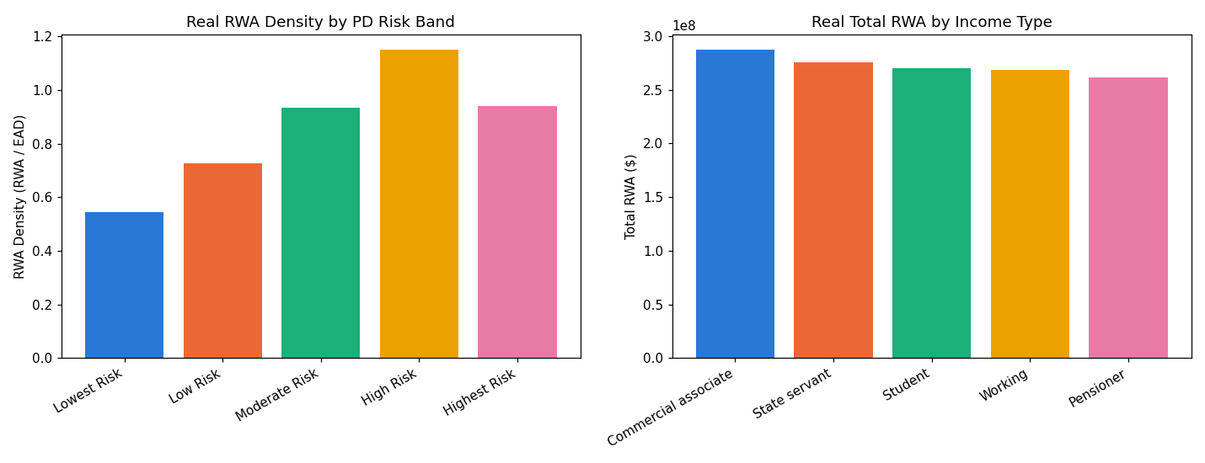
Insight — Real RWA density rises from 54.44% in 'Lowest Risk' to 94.11% in 'Highest Risk' -- higher-PD bands carry a higher capital charge by construction of the Basel K() formula (Notebook 01).
Portfolio-wide real RWA density: 78.96% ($1,362,944,191 RWA / $1,726,180,495 EAD).
Statistical robustness verdict: NOT YET STATISTICALLY ROBUST — failed: default_rate_monotonic_by_pd_band (a separate, stricter statistical-significance gate, distinct from the structural pipeline integrity checks reported elsewhere in this notebook's output -- expected and informational on small or noisy real/synthetic samples).

Top Segments by Total RWA
Real total RWA, RWA density, and default rate across every segment cut (income type, education, contract type, region rating).
Dimension | Segment | N Applicants | Total RWA | RWA Density
NAME_CONTRACT_TYPE | Cash loans | 3,619 | $1,169,249,160 | 75.16%
REGION_RATING_CLIENT | 3 | 1,373 | $471,221,030 | 78.88%
REGION_RATING_CLIENT | 2 | 1,319 | $449,799,181 | 79.29%
REGION_RATING_CLIENT | 1 | 1,308 | $441,923,980 | 78.70%
NAME_EDUCATION_TYPE | Incomplete higher | 1,035 | $365,435,613 | 80.21%
NAME_EDUCATION_TYPE | Lower secondary | 987 | $343,928,545 | 78.54%
NAME_EDUCATION_TYPE | Secondary / secondary special | 1,001 | $330,354,969 | 77.87%
NAME_EDUCATION_TYPE | Higher education | 977 | $323,225,065 | 79.13%
NAME_INCOME_TYPE | Commercial associate | 821 | $287,031,273 | 79.32%
NAME_INCOME_TYPE | State servant | 788 | $275,868,017 | 77.31%
Insight — 'Cash loans' (NAME_CONTRACT_TYPE) carries the largest real total RWA ($1,169,249,160) across 3,619 real applicants.
'Revolving loans' (NAME_CONTRACT_TYPE) shows the highest real RWA density (113.65%) -- a capital-efficiency signal, not necessarily the largest dollar exposure.

