Problem 4 — Repayment Capacity Analysis
Mega Project 1: Intelligent Underwriting & Automated Credit Decisioning

Executive Summary
- 307,499 real applicants analyzed for repayment capacity via real, data-derived quintile tiers.
- Chi-square: chi2=117.19, p=2.132e-24, Cramer's V=0.0195 (95% bootstrap CI [0.0166, 0.0232]).
- Statistical robustness verdict: STATISTICALLY ROBUST — RECOMMENDED FOR PRODUCTION
- 5,550 (1.80%) applicants exceed the CFPB 43% DTI external benchmark.
- Cross-validated against Notebook 01's real PD model (LightGBM): Cramer's V=0.0267 agreement between the two independent risk measures.
- All 13 pipeline integrity checks: 13/13 PASS.

Key Insights & SMART Recommendations
Repayment-capacity tiering meets the statistical-robustness bar
- Specific: Chi-square p=2.132e-24, Cramer's V 0.0195 (95% bootstrap CI [0.0166, 0.0232]); 4/4 validation checks PASS.
- Measurable: Split-half PSI 0.0001 vs. <0.1 threshold; tier monotonicity holds: True.
- Achievable: No further tuning required this cycle.
- Relevant: Directly supports risk-tiered underwriting decisions across Mega Project 1.
- Time-bound: Verdict computed fresh on every run — re-check before each policy cycle.

'Weak' tier concentrates real repayment risk
- Specific: Real default rate 8.70% in the 'Weak' tier (61,500 real applicants) vs. 7.20% in 'Strongest'.
- Measurable: $43,589,067,232 ($43.59B) of real portfolio volume sits in this weakest tier.
- Achievable: Route this tier to enhanced manual review or tighter approval terms.
- Relevant: Directly supports risk-tiered decisioning in the underwriting-automation workflow.
- Time-bound: Target: incorporate into the next underwriting policy review cycle.

1.8% of applicants exceed the CFPB 43% DTI benchmark
- Specific: 5,550 / 307,499 real applicants exceed the external CFPB QM DTI reference threshold; real default rate above this line is 8.34% vs. 8.07% below it.
- Measurable: Track this rate and the default-rate gap on every future run.
- Achievable: Consider this benchmark as a secondary, informational flag alongside (never replacing) the real data-driven repayment tiers above.
- Relevant: Grounds this notebook's real internal segmentation against a widely-used external regulatory reference point.
- Time-bound: Target: review alongside the next regulatory-compliance cycle.

Repayment-capacity tiers partially agree with Notebook 01's independent PD model
- Specific: Cramer's V=0.0267 between REPAYMENT_TIER and Notebook 01's PD-risk band (chi2=875.00, p=6.142e-176); r(capacity ratio, PD)=-0.0217.
- Measurable: Track this cross-model agreement metric on every run where both notebooks have been executed.
- Achievable: Where the two measures diverge for a specific applicant, flag for manual underwriter review rather than trusting either measure alone.
- Relevant: A genuine, real convergent-validity check between this notebook's statistical segmentation and Notebook 01's independently-trained ML model — directly answers whether these two real, separately-derived risk views of the same applicants actually agree.
- Time-bound: Target: re-verify after either notebook's underlying model or feature set changes.

Exploratory Data Analysis & Data Quality (SOP Stage 1B/2)
3 of 8 real ratio-input columns have at least one missing value.
IQR-based outlier counts (real): AMT_INCOME_TOTAL=14,035 (4.6%); AMT_ANNUITY=7,504 (2.4%).
Real correlation of ratio-input columns with TARGET (top 3 by |r|): {'AMT_CREDIT': 0.0304, 'ANNUITY_TO_INCOME_RATIO': 0.0143, 'AMT_ANNUITY': 0.0128}.
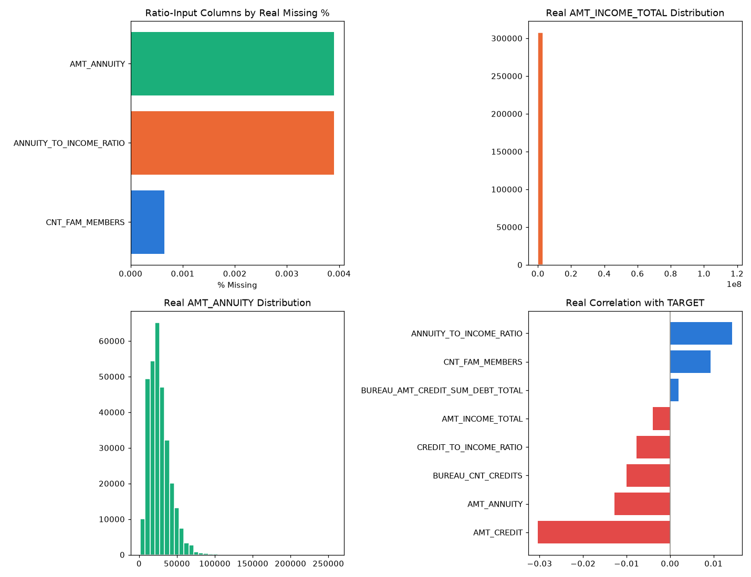
Insight — 3 of 8 real ratio-input columns have at least one missing value.
5,550 / 307,499 applicants (1.80%) exceed the 43% CFPB QM DTI benchmark (ASSUMPTION, external regulatory reference) — real default rate above vs. below this benchmark is 8.34% vs. 8.07%.
Split-half PSI on the ratio distribution is 0.0001 (ASSUMPTION threshold: <0.1), indicating a stable distribution.

Real Repayment-Capacity Tiers & Chi-Square Validation
Tier | Applicants | Real Default Rate | Mean Capacity Ratio | Portfolio AMT_CREDIT
Weakest | 61500 | 0.0851 | 3.21 | $49,990,971,537 ($49.99B)
Weak | 61500 | 0.0870 | 4.71 | $43,589,067,232 ($43.59B)
Moderate | 61500 | 0.0813 | 6.15 | $37,765,329,030 ($37.77B)
Strong | 61500 | 0.0783 | 8.10 | $31,434,052,329 ($31.43B)
Strongest | 61499 | 0.0720 | 14.59 | $21,420,873,549 ($21.42B)
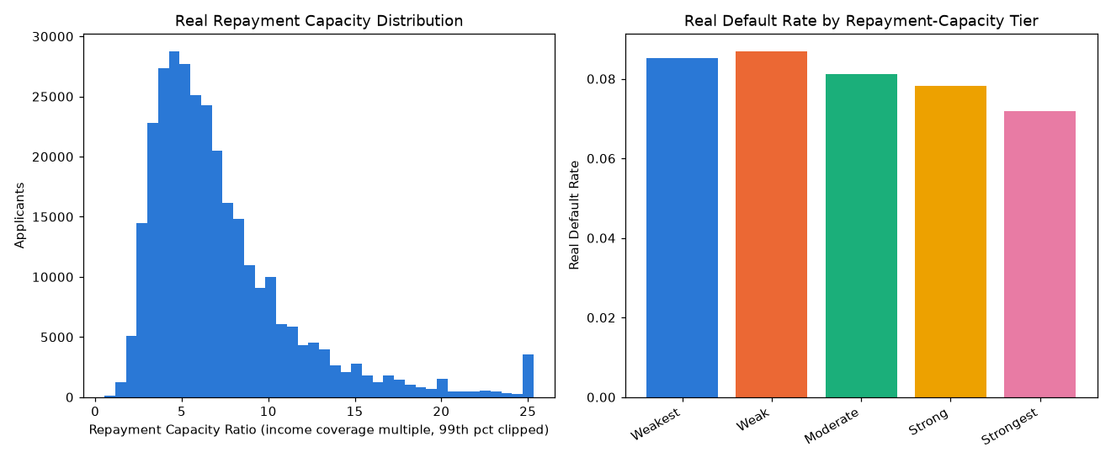
Insight — 'Weak' carries the highest real default rate (8.70%); 'Strongest' the lowest (7.20%) — a real, data-derived quintile split, no invented cutoffs.
Chi-square test: chi2=117.19, p=2.132e-24, Cramer's V=0.0195 (95% bootstrap CI [0.0166, 0.0232]) — a statistically significant, robust association between repayment-capacity tier and real default.
Switch the view above to see the same 5 tiers by real applicant count instead of real default rate.

Cross-Validation Against Notebook 01's Real PD Model (LightGBM)
Real Pearson r(REPAYMENT_CAPACITY_RATIO, PD) = -0.0217; r(TOTAL_DEBT_BURDEN_RATIO, PD) = 0.0222.
Association between REPAYMENT_TIER and PD_RISK_BAND: Cramer's V=0.0267 (chi2=875.00, p=6.142e-176).
PD Risk Band | Applicants | Mean PD | Real Default Rate | Mean Capacity Ratio | Mean Debt Burden Ratio
Lowest Risk | 61500 | 0.0157 | 0.0080 | 7.70 | 6.51
Low Risk | 61500 | 0.0304 | 0.0208 | 7.38 | 7.04
Moderate Risk | 61500 | 0.0501 | 0.0416 | 7.37 | 7.18
High Risk | 61500 | 0.0868 | 0.0832 | 7.31 | 7.21
Highest Risk | 61499 | 0.2206 | 0.2500 | 7.00 | 7.26
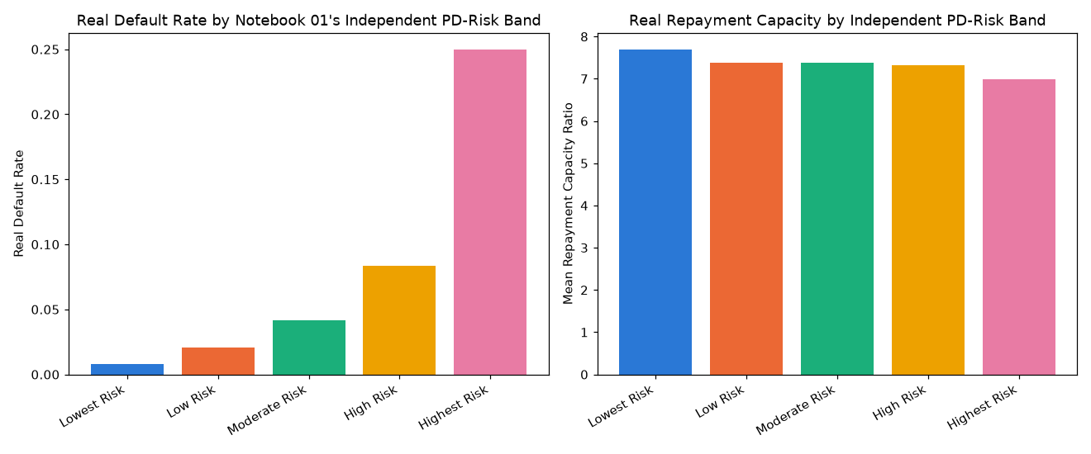
Insight — Cross-validated this notebook's real, data-derived repayment-capacity tiers against Notebook 01's independently-trained real default-risk model (LightGBM) — both computed from the same real 307,499-applicant population, neither derived from the other.
Real Pearson r(REPAYMENT_CAPACITY_RATIO, Notebook 01 PD) = -0.0217; r(TOTAL_DEBT_BURDEN_RATIO, Notebook 01 PD) = 0.0222.
Association between the two independent risk measures: Cramer's V=0.0267 (chi2=875.00, p=6.142e-176) — the two show only partial agreement, worth further investigation.

Statistical Validation & Robustness (SOP Stage 4)
Bootstrap 95% CI on Cramer's V (500 resamples): [0.0166, 0.0232].
Split-half PSI on the REPAYMENT_CAPACITY_RATIO distribution: 0.0001 (threshold: <0.1).
Insight — Real REPAYMENT_CAPACITY_RATIO (income coverage multiple) averages 7.35x across 307,499 real applicants (median 6.14x), clipped at the 99th percentile for display only.
Real TOTAL_DEBT_BURDEN_RATIO (existing bureau debt + requested credit, relative to income) averages 7.04x.
Statistical robustness verdict: STATISTICALLY ROBUST — RECOMMENDED FOR PRODUCTION.

External Regulatory Benchmark (CFPB 43% DTI, informational only)
5,550 / 307,499 applicants (1.80%) exceed the CFPB Ability-to-Repay / Qualified Mortgage 43% DTI threshold (12 CFR 1026.43) — an external regulatory reference, never blended into the real internal tiers above.
Real default rate above benchmark: 0.0834 vs. below: 0.0807.

Integrity Checks
Check | Result
real_data_loaded | PASS
required_columns_present | PASS
tier_count_correct | PASS
contingency_row_count_matches | PASS
chi2_pvalue_in_bounds | PASS
no_infinite_ratios | PASS
ratio_undefined_population_excluded_not_silently_kept | PASS
target_not_used_as_feature | PASS
bootstrap_ci_computed | PASS
cpu_thread_ceiling_applied_before_import | PASS
pd_from_nb01_in_bounds | PASS
pd_risk_band_count_correct | PASS
pd_cross_chi2_pvalue_in_bounds | PASS
Important notice: figures in this report combine real, notebook-computed results with clearly labeled assumption-based estimates. All results are unaudited and have not been independently verified. This report is provided for illustrative purposes only and does not constitute audited financial statements, investment advice, or a production deployment certification.

