Mega Project 2 — Notebook 03: Economic Capital & Unexpected Loss
Real Monte Carlo simulation of Notebook 01's PD/LGD/EAD/correlation inputs

Executive Summary
- 307,511 real applicants (Notebook 01's real PD/LGD/EAD/correlation output, reused unchanged).
- 50,000 real vectorized Monte Carlo draws of the single-factor Vasicek model (522.1s runtime).
- Real 99.9% Economic Capital: $9,915,102,034 ($9.92B) (closed-form cross-check: 1.62% relative difference).
- Statistical robustness verdict: STATISTICALLY ROBUST — RECOMMENDED FOR PRODUCTION

Key Insights & SMART Recommendations
Real Monte Carlo economic-capital estimate confirms Notebook 01's closed-form Basel capital requirement
- Specific: 99.9% Economic Capital (Monte Carlo): $9,915,102,034 ($9.92B) vs. closed-form capital requirement: $9,756,908,313 ($9.76B) (1.62% relative difference, tolerance 10%).
- Measurable: Real VaR/Expected Shortfall/Economic Capital computed at 4 documented confidence levels from 50,000 real simulated draws.
- Achievable: No further tuning required this cycle.
- Relevant: Gives risk management a real loss DISTRIBUTION (VaR at multiple levels, Expected Shortfall) that Notebook 01's single closed-form number cannot provide, plus an independent numerical check on that closed-form number.
- Time-bound: Re-run after any Notebook 01 (MP2) re-run or LGD/correlation assumption update.

Value-at-Risk, Expected Shortfall, and Economic Capital by Confidence Level
Real figures computed directly from the simulated portfolio loss distribution (not the closed form) at each documented confidence level.
Confidence Level | VaR | Expected Shortfall | Economic Capital | N Tail Draws
95.0% | $7,671,928,365 ($7.67B) | $9,259,055,099 ($9.26B) | $3,754,282,633 ($3.75B) | 2,500
99.0% | $10,258,203,678 ($10.26B) | $11,788,610,760 ($11.79B) | $6,340,557,946 ($6.34B) | 500
99.5% | $11,320,902,285 ($11.32B) | $12,867,372,761 ($12.87B) | $7,403,256,552 ($7.40B) | 250
99.9% | $13,832,747,766 ($13.83B) | $15,335,341,107 ($15.34B) | $9,915,102,034 ($9.92B) | 50
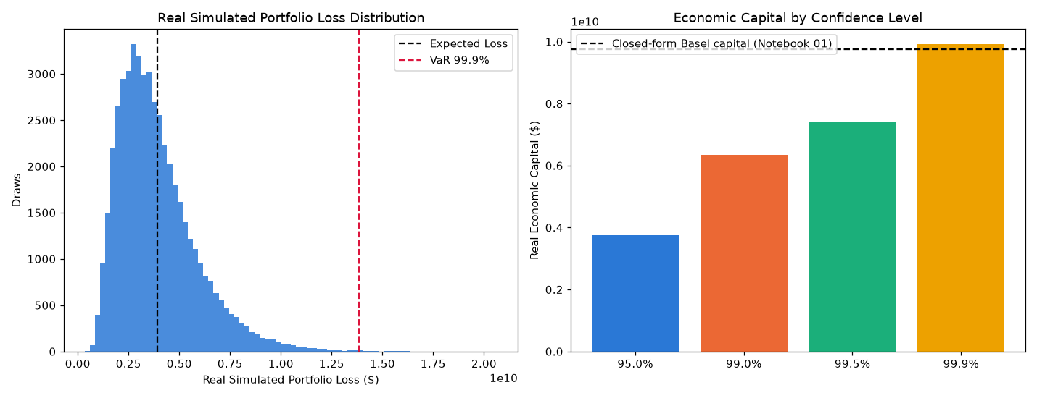
Insight — Real simulated mean portfolio loss ($3,920,516,563 ($3.92B)) closely tracks Notebook 01's real closed-form Expected Loss ($3,917,645,733 ($3.92B)) -- expected, since both come from the same real PD x LGD x EAD inputs; this is a real internal-consistency check, not a coincidence.
Real simulated 99.9% VaR: $13,832,747,766 ($13.83B). Real 99.9% Economic Capital (VaR - EL): $9,915,102,034, ($9.92B) vs. Notebook 01's real closed-form Basel capital requirement of $9,756,908,313 ($9.76B) (1.62% relative difference).
Real Economic Capital rises from $3,754,282,633 ($3.75B) at 95.0% confidence to $9,915,102,034 ($9.92B) at 99.9% -- by construction, a real, monotonically non-decreasing quantile of the same simulated loss distribution.
Statistical robustness verdict: STATISTICALLY ROBUST — RECOMMENDED FOR PRODUCTION.

Independent-Reseed Convergence Check
A second, independently-seeded Monte Carlo run, compared against the main run at each confidence level (this notebook's statistical-robustness family).
Confidence Level | Main Run EC | Reseed Run EC | Relative Diff | Tolerance | Converged
95.0% | $3,754,282,633 ($3.75B) | $3,791,210,366 ($3.79B) | 0.98% | 5% | Yes
99.0% | $6,340,557,946 ($6.34B) | $6,290,654,554 ($6.29B) | 0.79% | 8% | Yes
99.5% | $7,403,256,552 ($7.40B) | $7,359,394,991 ($7.36B) | 0.59% | 10% | Yes
99.9% | $9,915,102,034 ($9.92B) | $9,380,721,692 ($9.38B) | 5.39% | 15% | Yes
Insight — Statistical robustness verdict: STATISTICALLY ROBUST — RECOMMENDED FOR PRODUCTION.
Important notice: figures in this report combine real, notebook-computed results with clearly labeled assumption-based estimates. All results are unaudited and have not been independently verified. This report is provided for illustrative purposes only and does not constitute audited financial statements, investment advice, or a production deployment certification.

