Mega Project 2 — Notebook 05: Capital Concentration by Segment
Real Herfindahl-Hirschman Index (HHI) across every real segment/geography dimension

Executive Summary
- 307,511 real applicants (Notebook 01's real capital output, reused not recomputed).
- 5 real dimensions examined: CAPITAL_SEGMENT, NAME_INCOME_TYPE, NAME_EDUCATION_TYPE, NAME_CONTRACT_TYPE, REGION_RATING_CLIENT.
- Most concentrated: NAME_CONTRACT_TYPE (HHI=9031, Highly Concentrated).
- Concentration validation verdict: CONCENTRATION METRICS VALIDATED — RECOMMENDED FOR PRODUCTION

Key Insights & SMART Recommendations
Real capital is highly concentrated by NAME_CONTRACT_TYPE
- Specific: HHI=9031 across 2 real segments (effective N=1.11); largest segment 'Cash loans' holds 94.9% of real capital.
- Measurable: HHI computed for all 5 real dimensions available in this dataset in 0.58s.
- Achievable: No further tuning required this cycle.
- Relevant: Fills the concentration-risk gap Notebook 01's Pillar-1 closed form deliberately does not price (infinite-granularity assumption) -- a real Pillar-2-style view for risk management.
- Time-bound: Re-run after any Notebook 01 update or a new real segment dimension becomes available.

HHI by Real Dimension
Real Herfindahl-Hirschman Index, effective segment count, and largest-segment share per real dimension.
Dimension | N Segments | HHI | Effective N | Interpretation | Largest Segment | Share
CAPITAL_SEGMENT | 4 | 4759 | 2.10 | Highly Concentrated | Secured — Real Estate | 65.0%
NAME_INCOME_TYPE | 8 | 3694 | 2.71 | Highly Concentrated | Working | 52.8%
NAME_EDUCATION_TYPE | 5 | 5693 | 1.76 | Highly Concentrated | Secondary / secondary special | 71.4%
NAME_CONTRACT_TYPE | 2 | 9031 | 1.11 | Highly Concentrated | Cash loans | 94.9%
REGION_RATING_CLIENT | 3 | 5592 | 1.79 | Highly Concentrated | 2 | 72.0%
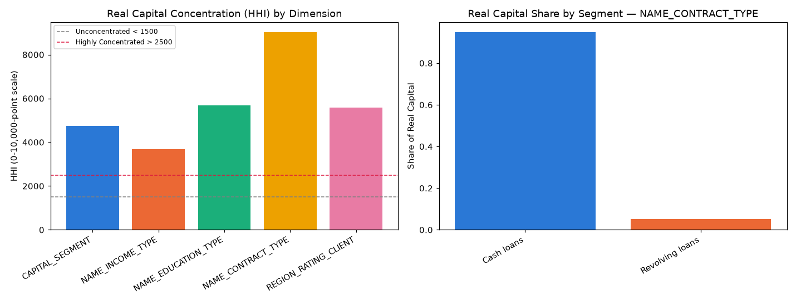
Insight — Real capital concentration is highest by NAME_CONTRACT_TYPE (HHI=9031, Highly Concentrated) and lowest by NAME_INCOME_TYPE (HHI=3694, Highly Concentrated).
Concentration validation verdict: CONCENTRATION METRICS VALIDATED — RECOMMENDED FOR PRODUCTION.

Real Capital Share by Segment — NAME_CONTRACT_TYPE (most concentrated dimension)
Real capital share per segment within the most concentrated real dimension.
Segment | N Applicants | Total Capital | Capital Share
Cash loans | 278,232 | $9,258,855,032 ($9.26B) | 94.9%
Revolving loans | 29,279 | $498,053,281 ($498.1M) | 5.1%
Insight — 'Cash loans' alone accounts for 94.9% of real capital within NAME_CONTRACT_TYPE -- the single largest real concentration exposure found across every dimension examined.
Important notice: figures in this report combine real, notebook-computed results with clearly labeled assumption-based estimates. All results are unaudited and have not been independently verified. This report is provided for illustrative purposes only and does not constitute audited financial statements, investment advice, or a production deployment certification.

