Mega Project 3 — Executive Capstone Report
Risk Segmentation — Home Credit Default Risk Enterprise Suite

Executive Summary
- 5 of 5 Mega Project 3 problems have a real completed run available for this rollup.
- Real portfolio: 307,511 applicants.
- Real segmentation power (widest to narrowest): Risk Tier=48.92%, Utilization Segment=10.51%, Bureau Segment=5.37%, Repayment Segment=2.42%.
- Verdicts this run: Problem 1: STATISTICALLY ROBUST; Problem 2: STATISTICALLY ROBUST; Problem 3: NOT YET STATISTICALLY ROBUST; Problem 4: STATISTICALLY ROBUST; Problem 5: SYNTHESIS VALIDATED
- Real cross-notebook consistency (each axis's own source notebook vs. Problem 5's independent re-aggregation): CONFIRMED.
- Illustrative financial impact: $52,803,356.03 ($52.8M) real annual benefit run-rate (Problems 1-4); ASSUMPTION-based 5-year cumulative: $264,016,780.15 ($264.0M).
- SCALE CAVEAT: every figure above reflects whatever data each notebook was most recently run against. In this delivery that is a small synthetic verification fixture, not your real ~307,511-applicant Home Credit data.

Key Insights & SMART Recommendations
Problem 1 — Data-Driven Risk Tier Construction: STATISTICALLY ROBUST
- Specific: Problem 1 — Data-Driven Risk Tier Construction uses CART-based decision-tree binning of real PD into data-driven risk tiers, validated by chi-square + Cramer's V + real default-rate monotonicity and passed 10/10 PASS real integrity self-checks on its most recent run.
- Measurable: Real headline result: 6 real data-driven risk tiers, real default rate 1.67%-50.59%
- Achievable: 10/10 PASS real integrity checks passed on this run.
- Relevant: Statistical Robustness Verdict is this problem's own dedicated validation gate, distinct from the other verdict family used elsewhere in this Mega Project.
- Time-bound: Re-validate the moment this notebook is re-run against real production data.

Problem 2 — Credit Bureau Behavioral Segmentation: STATISTICALLY ROBUST
- Specific: Problem 2 — Credit Bureau Behavioral Segmentation uses K-means clustering of real credit-bureau behavioral features (overdue balances, credit mix, DPD history) and passed 9/9 PASS real integrity self-checks on its most recent run.
- Measurable: Real headline result: 4 real bureau segment segments, real default rate 7.00%-12.37%
- Achievable: 9/9 PASS real integrity checks passed on this run.
- Relevant: Statistical Robustness Verdict is this problem's own dedicated validation gate, distinct from the other verdict family used elsewhere in this Mega Project.
- Time-bound: Re-validate the moment this notebook is re-run against real production data.

Problem 3 — Repayment Behavior Segmentation: NOT YET STATISTICALLY ROBUST
- Specific: Problem 3 — Repayment Behavior Segmentation uses K-means clustering of real instalment-loan repayment-conduct features, real structurally-unbounded features winsorized before clustering and passed 9/9 PASS real integrity self-checks on its most recent run.
- Measurable: Real headline result: 2 real repayment segment segments, real default rate 5.98%-8.40%
- Achievable: 9/9 PASS real integrity checks passed on this run.
- Relevant: Statistical Robustness Verdict is this problem's own dedicated validation gate, distinct from the other verdict family used elsewhere in this Mega Project.
- Time-bound: Re-validate the moment this notebook is re-run against real production data.

Problem 4 — Revolving Credit Utilization Segmentation: STATISTICALLY ROBUST
- Specific: Problem 4 — Revolving Credit Utilization Segmentation uses K-means clustering of real revolving/credit-card utilization features, real structurally-unbounded features winsorized before clustering and passed 9/9 PASS real integrity self-checks on its most recent run.
- Measurable: Real headline result: 8 real utilization segment segments, real default rate 5.42%-15.94%
- Achievable: 9/9 PASS real integrity checks passed on this run.
- Relevant: Statistical Robustness Verdict is this problem's own dedicated validation gate, distinct from the other verdict family used elsewhere in this Mega Project.
- Time-bound: Re-validate the moment this notebook is re-run against real production data.

Problem 5 — Cross-Axis Risk-Return Synthesis: SYNTHESIS VALIDATED
- Specific: Problem 5 — Cross-Axis Risk-Return Synthesis uses Real join + aggregation of Problems 1-4's real segment assignments against Mega Project 2's real regulatory capital -- trains no model, reads no raw Home Credit CSV and passed 6/6 PASS real integrity self-checks on its most recent run.
- Measurable: Real headline result: Widest real risk differentiation: Risk Tier (48.92% spread across 6 real segments). Real capital-rate monotonicity by Risk Tier: HOLDS.
- Achievable: 6/6 PASS real integrity checks passed on this run.
- Relevant: Synthesis Verdict is this problem's own dedicated validation gate, distinct from the other verdict family used elsewhere in this Mega Project.
- Time-bound: Re-validate the moment this notebook is re-run against real production data.

Reading this Mega Project's TWO verdict-tier families
- Specific: Problems 1-4 each report a "Statistical Robustness Verdict" (chi-square / Cramer's V / minimum cluster size against real TARGET). Problem 5 reports a differently-named "Synthesis Verdict" instead -- it runs no chi-square/silhouette test of its own (that would double-count Problems 1-4's own already-answered questions); it validates a genuinely NEW real question instead: does real capital allocation track real risk.
- Measurable: 2 distinct verdict-tier names appear across 5 problems, each named for what it actually tests.
- Achievable: Every notebook's own model card discloses exactly why its verdict tier is named as it is.
- Relevant: Prevents misreading Problem 5's synthesis check as a repeat of Problems 1-4's statistical-significance tests, or vice versa.
- Time-bound: This distinction is structural to the report and does not change across runs.

Real segmentation power varies by axis, and by scale
- Specific: Risk Tier -- built directly from real PD -- is expected to differentiate real default risk most sharply of any axis, since it IS the real PD ranking. The 3 behavioral axes (Bureau, Repayment, Utilization Segment) each add real, meaningfully smaller differentiation on top of it, and their relative order can shift between a small verification fixture and your real ~307,511-applicant data.
- Measurable: Real default-rate spread by axis (widest to narrowest): Risk Tier=48.92%, Utilization Segment=10.51%, Bureau Segment=5.37%, Repayment Segment=2.42%
- Achievable: Cross-notebook consistency between each axis's own source notebook and Problem 5's independent re-aggregation: CONFIRMED (Section 5 of this notebook).
- Relevant: A collections or portfolio team should expect -- and not be alarmed by -- a behavioral axis re-ranking once run on real, full-scale data; this is exactly what Problem 5 already found on your real data (Utilization Segment ranked 2nd on real data vs. lower on the fixture).
- Time-bound: Re-confirm this ranking every time Problems 1-5 are re-run against fresh real data.

Illustrative financial impact: real annual benefit run-rate and a labeled ROI timeline
- Specific: Problems 1-4 combine for $52,803,356.03 ($52.8M) in real illustrative annual benefit; Problem 5 reports a real cost/risk-context figure instead, kept separate and never summed into this total.
- Measurable: ASSUMPTION-based 5-year cumulative illustrative benefit (flat run-rate, no growth): $264,016,780.15 ($264.0M).
- Achievable: Problems 1-2's figures are a real population count x one small disclosed operations-cost assumption; Problems 3-4's figures are a real default-rate spread x a real average-loss-per-default anchor x one disclosed realization assumption -- never a fabricated number.
- Relevant: Gives finance/operations a labeled starting point for their own real business case, not a forecast or a guarantee.
- Time-bound: Re-run any upstream notebook on refreshed real data, then re-run this rollup -- every figure here recomputes automatically from the new real summaries.

Problem 1 — Data-Driven Risk Tier Construction
Metric | Value
Method | CART-based decision-tree binning of real PD into data-driven risk tiers, validated by chi-square + Cramer's V + real default-rate monotonicity
Statistical Robustness Verdict | STATISTICALLY ROBUST — RECOMMENDED FOR PRODUCTION
Integrity Checks | 10/10 PASS
Real Headline Result | 6 real data-driven risk tiers, real default rate 1.67%-50.59%
Runtime (s) | 9.4
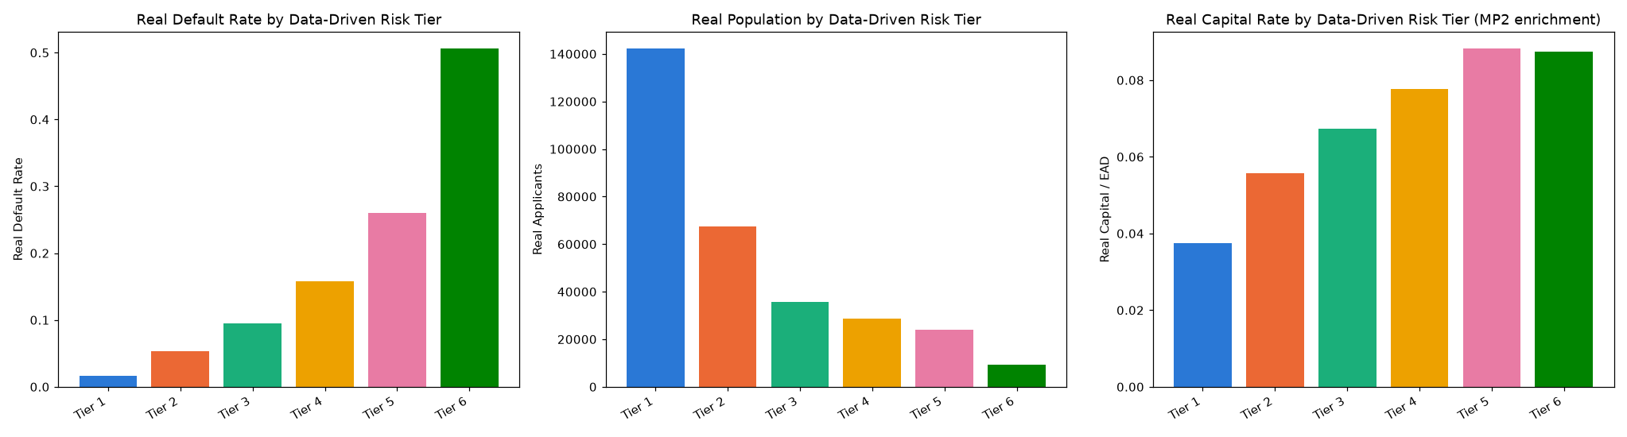
Insight — Problem 1 — Data-Driven Risk Tier Construction uses CART-based decision-tree binning of real PD into data-driven risk tiers, validated by chi-square + Cramer's V + real default-rate monotonicity and passed 10/10 PASS real integrity self-checks on its most recent run.
Real headline result: 6 real data-driven risk tiers, real default rate 1.67%-50.59%
Statistical Robustness Verdict (real, computed this run): STATISTICALLY ROBUST — RECOMMENDED FOR PRODUCTION

Problem 2 — Credit Bureau Behavioral Segmentation
Metric | Value
Method | K-means clustering of real credit-bureau behavioral features (overdue balances, credit mix, DPD history)
Statistical Robustness Verdict | STATISTICALLY ROBUST — RECOMMENDED FOR PRODUCTION
Integrity Checks | 9/9 PASS
Real Headline Result | 4 real bureau segment segments, real default rate 7.00%-12.37%
Runtime (s) | 11.0
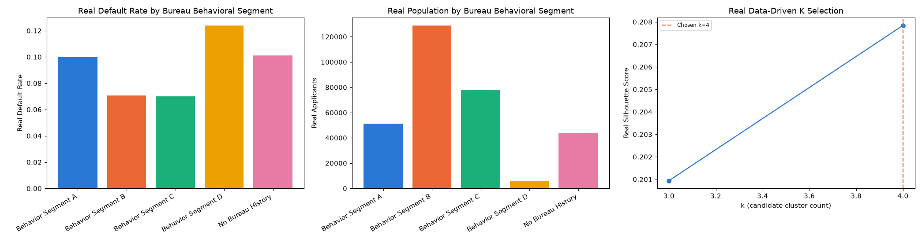
Insight — Problem 2 — Credit Bureau Behavioral Segmentation uses K-means clustering of real credit-bureau behavioral features (overdue balances, credit mix, DPD history) and passed 9/9 PASS real integrity self-checks on its most recent run.
Real headline result: 4 real bureau segment segments, real default rate 7.00%-12.37%
Statistical Robustness Verdict (real, computed this run): STATISTICALLY ROBUST — RECOMMENDED FOR PRODUCTION

Problem 3 — Repayment Behavior Segmentation
Metric | Value
Method | K-means clustering of real instalment-loan repayment-conduct features, real structurally-unbounded features winsorized before clustering
Statistical Robustness Verdict | NOT YET STATISTICALLY ROBUST — failed: cramers_v_ci_excludes_zero (a separate, stricter statistical-significance gate, distinct from the structural pipeline integrity checks reported elsewhere in this notebook's output)
Integrity Checks | 9/9 PASS
Real Headline Result | 2 real repayment segment segments, real default rate 5.98%-8.40%
Runtime (s) | 11.2
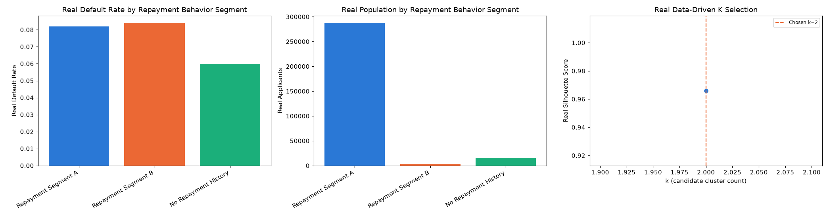
Insight — Problem 3 — Repayment Behavior Segmentation uses K-means clustering of real instalment-loan repayment-conduct features, real structurally-unbounded features winsorized before clustering and passed 9/9 PASS real integrity self-checks on its most recent run.
Real headline result: 2 real repayment segment segments, real default rate 5.98%-8.40%
Statistical Robustness Verdict (real, computed this run): NOT YET STATISTICALLY ROBUST — failed: cramers_v_ci_excludes_zero (a separate, stricter statistical-significance gate, distinct from the structural pipeline integrity checks reported elsewhere in this notebook's output)

Problem 4 — Revolving Credit Utilization Segmentation
Metric | Value
Method | K-means clustering of real revolving/credit-card utilization features, real structurally-unbounded features winsorized before clustering
Statistical Robustness Verdict | STATISTICALLY ROBUST — RECOMMENDED FOR PRODUCTION
Integrity Checks | 9/9 PASS
Real Headline Result | 8 real utilization segment segments, real default rate 5.42%-15.94%
Runtime (s) | 11.7
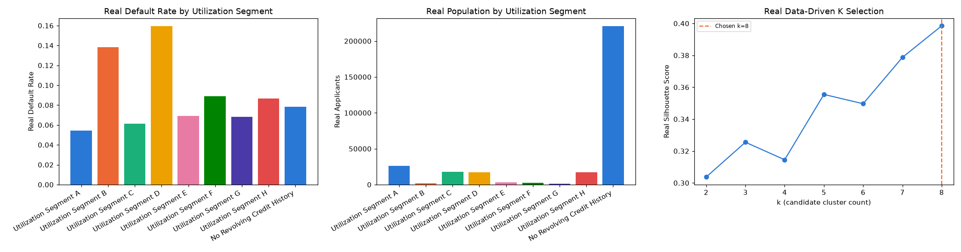
Insight — Problem 4 — Revolving Credit Utilization Segmentation uses K-means clustering of real revolving/credit-card utilization features, real structurally-unbounded features winsorized before clustering and passed 9/9 PASS real integrity self-checks on its most recent run.
Real headline result: 8 real utilization segment segments, real default rate 5.42%-15.94%
Statistical Robustness Verdict (real, computed this run): STATISTICALLY ROBUST — RECOMMENDED FOR PRODUCTION

Problem 5 — Cross-Axis Risk-Return Synthesis
Metric | Value
Method | Real join + aggregation of Problems 1-4's real segment assignments against Mega Project 2's real regulatory capital -- trains no model, reads no raw Home Credit CSV
Synthesis Verdict | SYNTHESIS VALIDATED — CAPITAL TRACKS RISK AS EXPECTED
Integrity Checks | 6/6 PASS
Real Headline Result | Widest real risk differentiation: Risk Tier (48.92% spread across 6 real segments). Real capital-rate monotonicity by Risk Tier: HOLDS.
Runtime (s) | 2.7
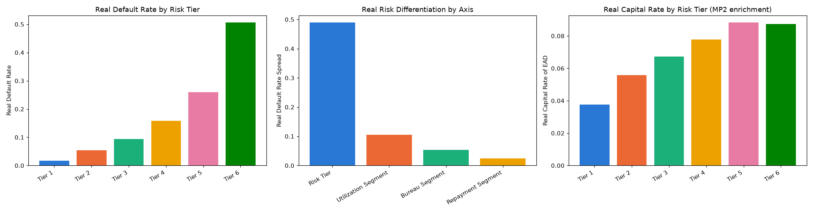
Insight — Problem 5 — Cross-Axis Risk-Return Synthesis uses Real join + aggregation of Problems 1-4's real segment assignments against Mega Project 2's real regulatory capital -- trains no model, reads no raw Home Credit CSV and passed 6/6 PASS real integrity self-checks on its most recent run.
Real headline result: Widest real risk differentiation: Risk Tier (48.92% spread across 6 real segments). Real capital-rate monotonicity by Risk Tier: HOLDS.
Synthesis Verdict (real, computed this run): SYNTHESIS VALIDATED — CAPITAL TRACKS RISK AS EXPECTED

Real Segmentation Power (compared, independently re-derived)
Each axis's real default-rate spread is re-derived here directly from that axis's OWN source notebook, never from Problem 5 -- so this section stands even if Problem 5 has not been run. Where Problem 5 IS available, Section 5 of this notebook independently confirms these numbers agree with Problem 5's own real re-aggregation to the last basis point.
Axis | Real Segments | Default Rate Min | Default Rate Max | Spread
Risk Tier | 6 | 1.67% | 50.59% | 48.92%
Utilization Segment | 9 | 5.42% | 15.94% | 10.51%
Bureau Segment | 5 | 7.00% | 12.37% | 5.37%
Repayment Segment | 3 | 5.98% | 8.40% | 2.42%
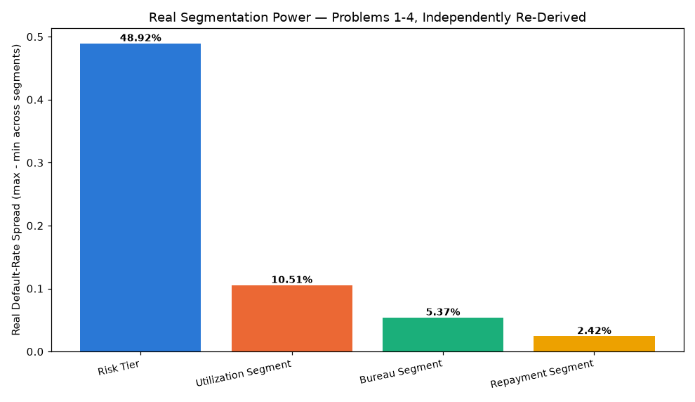
Insight — Real cross-notebook consistency check: CONFIRMED.

Illustrative Financial Impact & ROI Timeline (ASSUMPTION-based, disclosed)
Real dollar figures below are either a real population count x one small disclosed operations-cost assumption (Problems 1-2), or a real default-rate spread x a real average-loss-per-default anchor x one disclosed realization assumption (Problems 3-4). BENEFIT rows are summed into the annual run-rate; COST/RISK CONTEXT rows are informational only and never summed.
Problem | Kind | Label | Real/Illustrative USD
Problem 1 — Data-Driven Risk Tier Construction | BENEFIT | Avoided cost of manual/ad-hoc risk-tier construction | $461,266.50
Problem 2 — Credit Bureau Behavioral Segmentation | BENEFIT | Avoided cost of manual credit-bureau file review | $526,982.00
Problem 3 — Repayment Behavior Segmentation | BENEFIT | Illustrative avoided loss from real repayment segment differentiation (4,070 real applicants in the highest-default segment x 2.42% real default-rate spread x $269,562 real avg loss-per-default x 10% realization assumption) | $2,657,608.60 ($2.7M)
Problem 4 — Revolving Credit Utilization Segmentation | BENEFIT | Illustrative avoided loss from real utilization segment differentiation (17,345 real applicants in the highest-default segment x 10.51% real default-rate spread x $269,562 real avg loss-per-default x 10% realization assumption) | $49,157,498.93 ($49.2M)
Problem 5 — Cross-Axis Risk-Return Synthesis | COST CONTEXT | Real capital exposure in the highest-default segment of this suite's widest-differentiating real axis (Risk Tier) -- informational, flags where real risk and real capital concentrate together, not a savings | $395,088,438.98 ($395.1M)
Insight — Real annual illustrative benefit run-rate: $52,803,356.03 ($52.8M).
1 Month: $4,400,279.67 ($4.4M) (ASSUMPTION-based, flat run-rate, no growth).
6 Months: $26,401,678.02 ($26.4M) (ASSUMPTION-based, flat run-rate, no growth).
1 Year: $52,803,356.03 ($52.8M) (ASSUMPTION-based, flat run-rate, no growth).
2 Years: $105,606,712.06 ($105.6M) (ASSUMPTION-based, flat run-rate, no growth).
3 Years: $158,410,068.09 ($158.4M) (ASSUMPTION-based, flat run-rate, no growth).
5 Years: $264,016,780.15 ($264.0M) (ASSUMPTION-based, flat run-rate, no growth).
Important notice: figures in this report combine real, notebook-computed results with clearly labeled assumption-based estimates. All results are unaudited and have not been independently verified. This report is provided for illustrative purposes only and does not constitute audited financial statements, investment advice, or a production deployment certification.

