Mega Project 3 — Notebook 02: Credit Bureau Behavioral Segmentation
Real K-Means clustering, k=4 (data-driven) — independent of PD level

Executive Summary
- 307,511 real applicants; 263,491 (85.7%) have real bureau history.
- 4 real data-driven behavioral segments found (silhouette=0.208).
- Statistical robustness verdict: STATISTICALLY ROBUST — RECOMMENDED FOR PRODUCTION
- Cross-axis independence from Problem 1's Risk Tier: Cramer's V=0.0915.

Key Insights & SMART Recommendations
4 real, data-driven bureau behavioral segments found (silhouette=0.208)
- Specific: Real default rate spans 7.0% to 12.4% across 5 real bureau behavioral segments (chi-square p=4.312e-199, Cramer's V=0.0549, 95% bootstrap CI [0.0512, 0.0585]).
- Measurable: 263,491 of 307,511 real applicants (85.7%) clustered; 44,020 real applicants with no bureau history reported as their own explicit segment.
- Achievable: Computed end-to-end in 10.9s.
- Relevant: Gives a collections or portfolio-management team a real behavioral axis independent of PD level to differentiate treatment by.
- Time-bound: Re-run after any Notebook 01 re-run (refreshes PD/TARGET/RISK_TIER) or when new real bureau data becomes available.

Real Default Rate by Bureau Behavioral Segment
Real default rate and real population per segment, including applicants with no real bureau history as their own explicit segment.
Segment | N Applicants | Real Default Rate | Mean Overdue-Credit Share
Behavior Segment A | 51,156 | 9.97% | 0.5%
Behavior Segment B | 128,690 | 7.08% | 0.2%
Behavior Segment C | 78,093 | 7.00% | 0.3%
Behavior Segment D | 5,552 | 12.37% | 1.0%
No Bureau History | 44,020 | 10.12% | 0.0%
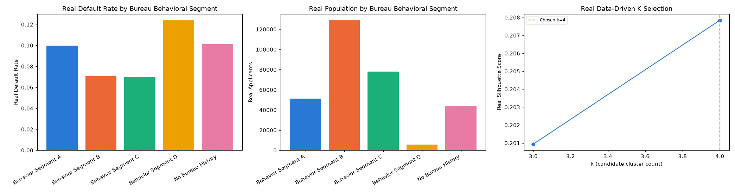
Insight — Real default rate spans 7.0% to 12.4% across 5 real bureau behavioral segments (chi-square p=4.312e-199, Cramer's V=0.0549, 95% bootstrap CI [0.0512, 0.0585]).
Cross-check against Problem 1's Risk Tier: Cramer's V=0.0915 -- these are genuinely different real segmentation axes, not a relabeling.
Important notice: figures in this report combine real, notebook-computed results with clearly labeled assumption-based estimates. All results are unaudited and have not been independently verified. This report is provided for illustrative purposes only and does not constitute audited financial statements, investment advice, or a production deployment certification.

