Mega Project 3 — Notebook 03: Repayment Behavior Segmentation
Real K-Means clustering, k=2 (data-driven) — independent of PD level and bureau behavior

Executive Summary
- 307,511 real applicants; 291,643 (94.8%) have real previous-loan repayment history.
- 2 real data-driven repayment behavior segments found (silhouette=0.965).
- Statistical robustness verdict: NOT YET STATISTICALLY ROBUST — failed: cramers_v_ci_excludes_zero (a separate, stricter statistical-significance gate, distinct from the structural pipeline integrity checks reported elsewhere in this notebook's output)
- Cross-axis independence from Problem 1's Risk Tier: Cramer's V=0.0438. From Problem 2's Bureau Segment: Cramer's V=0.0518.

Key Insights & SMART Recommendations
2 real, data-driven repayment behavior segments found (silhouette=0.965)
- Specific: Real default rate spans 6.0% to 8.4% across 3 real repayment behavior segments (chi-square p=3.249e-22, Cramer's V=0.0179, 95% bootstrap CI [0.0149, 0.0210]).
- Measurable: 291,643 of 307,511 real applicants (94.8%) clustered; 15,868 real applicants with no previous-loan repayment history reported as their own explicit segment.
- Achievable: Computed end-to-end in 19.4s.
- Relevant: Gives a collections or portfolio-management team a real repayment-discipline axis, built from the applicant's own conduct on previous Home Credit loans, independent of PD level and external bureau behavior, to differentiate treatment by.
- Time-bound: Re-run after any Notebook 01 re-run (refreshes PD/TARGET/RISK_TIER) or when new real instalment/POS-cash data becomes available.

Real Default Rate by Repayment Behavior Segment
Real default rate and real population per segment, including applicants with no real previous-loan repayment history as their own explicit segment.
Segment | N Applicants | Real Default Rate | Mean % Instalments Late
Repayment Segment A | 287,573 | 8.18% | 7.4%
Repayment Segment B | 4,070 | 8.40% | 18.4%
No Repayment History | 15,868 | 5.98% | 0.0%
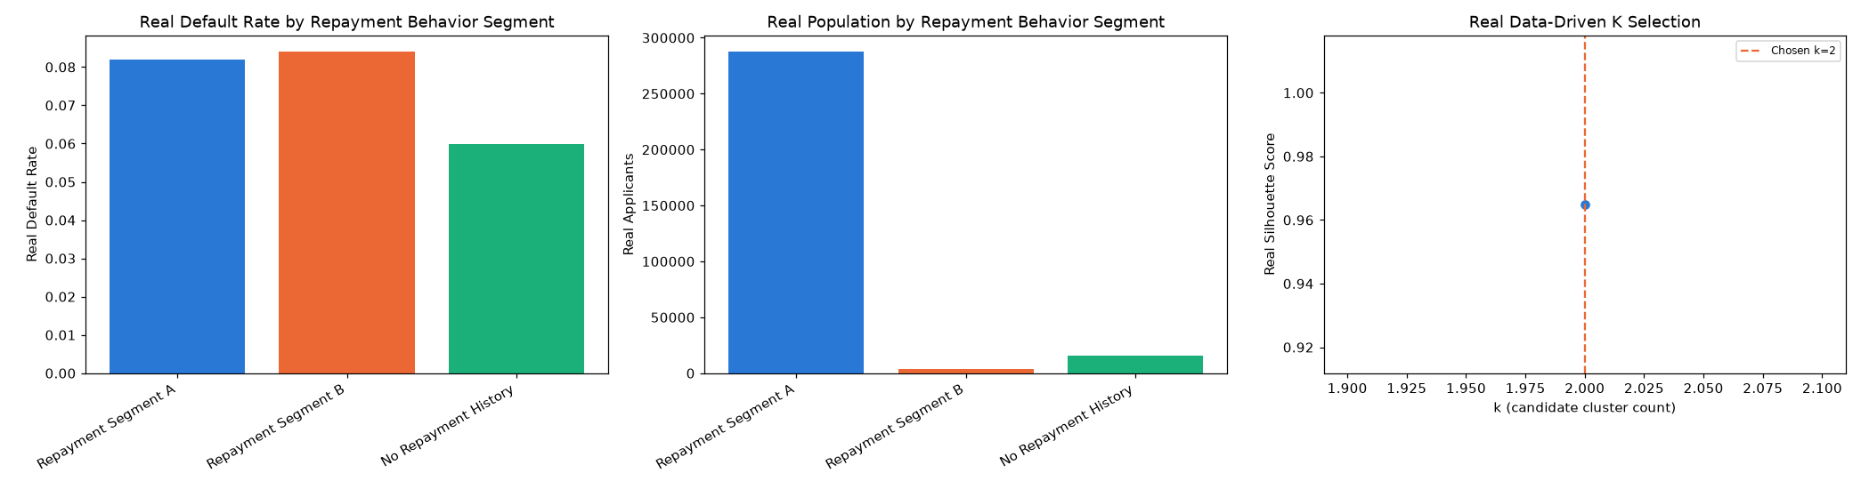
Insight — Real default rate spans 6.0% to 8.4% across 3 real repayment behavior segments (chi-square p=3.249e-22, Cramer's V=0.0179, 95% bootstrap CI [0.0149, 0.0210]).
Cross-check against Problem 1's Risk Tier: Cramer's V=0.0438; against Problem 2's Bureau Segment: Cramer's V=0.0518.
Important notice: figures in this report combine real, notebook-computed results with clearly labeled assumption-based estimates. All results are unaudited and have not been independently verified. This report is provided for illustrative purposes only and does not constitute audited financial statements, investment advice, or a production deployment certification.

