Mega Project 3 — Notebook 05: Cross-Axis Risk-Return Synthesis
4 real segmentation axis(es), no new modeling

Executive Summary
- 307,511 real applicants synthesized across 4 real segmentation axis(es): Risk Tier, Bureau Segment, Repayment Segment, Utilization Segment.
- Widest real risk differentiation: Risk Tier (48.92% spread).
- Synthesis verdict: SYNTHESIS VALIDATED — CAPITAL TRACKS RISK AS EXPECTED

Key Insights & SMART Recommendations
Risk Tier differentiates real risk most sharply (48.92% default-rate spread across 6 real segments)
- Specific: Real default-rate spread by axis (widest to narrowest): Risk Tier=48.92%, Utilization Segment=10.51%, Bureau Segment=5.37%, Repayment Segment=2.42%.
- Measurable: 4 real segmentation axis(es) synthesized across 307,511 real applicants; real capital enrichment included.
- Achievable: Computed end-to-end in 2.6s from already-produced real outputs -- no new modeling, no raw data re-read.
- Relevant: Gives a collections or portfolio-management team a single, honest cross-axis view of which real segmentation (risk level, external bureau behavior, instalment repayment conduct, or revolving-credit usage) most sharply separates real risk and real capital consumption, to prioritize which axis to act on.
- Time-bound: Re-run after any upstream notebook (Notebook 01, MP2 Notebook 01, or this project's Notebooks 02-04) re-run refreshes its real output.

Real Cross-Axis Risk-Return Summary
Real default-rate (and, when available, real capital-rate) spread per real segmentation axis -- the wider the spread, the more sharply that axis differentiates real risk.
axis | n_segments | default_rate_min | default_rate_max | default_rate_spread | capital_rate_min | capital_rate_max | capital_rate_spread
Risk Tier | 6 | 0.016729840155835753 | 0.5059078590785908 | 0.4891780189227551 | 0.03757439964339193 | 0.08821194649213307 | 0.05063754684874114
Utilization Segment | 9 | 0.05421686746987952 | 0.15935428077255692 | 0.1051374133026774 | 0.04904715773642258 | 0.06715459102229428 | 0.0181074332858717
Bureau Segment | 5 | 0.07000627457006389 | 0.12373919308357349 | 0.0537329185135096 | 0.050529605156772156 | 0.06092956442811318 | 0.010399959271341026
Repayment Segment | 3 | 0.05980589866397782 | 0.08402948402948403 | 0.024223585365506208 | 0.04527942121285163 | 0.054840923449040166 | 0.009561502236188534
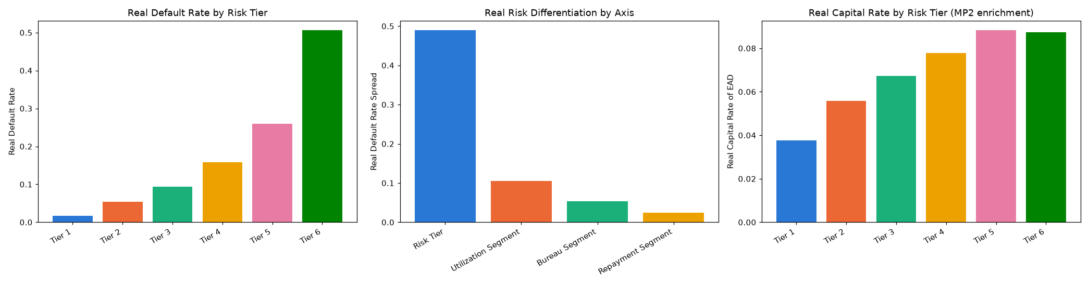
Insight — Real default-rate spread by axis (widest to narrowest): Risk Tier=48.92%, Utilization Segment=10.51%, Bureau Segment=5.37%, Repayment Segment=2.42%.
Synthesis verdict: SYNTHESIS VALIDATED — CAPITAL TRACKS RISK AS EXPECTED
Important notice: figures in this report combine real, notebook-computed results with clearly labeled assumption-based estimates. All results are unaudited and have not been independently verified. This report is provided for illustrative purposes only and does not constitute audited financial statements, investment advice, or a production deployment certification.

