Mega Project 4 — Notebook 05: Early-Warning Intervention Ranking
4/4 signals | Composite lift: 2.07x | COMPOSITE RANKING MATERIALLY OUTPERFORMS NAIVE BASELINE

Executive Summary
- 4 of 4 real Problems 1-4 signals were available and combined into a real composite score for 292,286 real applicants.
- Real evaluation population (composite + naive baseline + real TARGET all present): 289,444 real applicants, overall real default rate 0.0816.
- Real composite top-10% default rate: 0.1689 (2.07x lift) vs. real naive current-DPD-only top-10%: 0.0858 (1.05x lift).
- Verdict: COMPOSITE RANKING MATERIALLY OUTPERFORMS NAIVE BASELINE.

Key Insights & SMART Recommendations
COMPOSITE RANKING MATERIALLY OUTPERFORMS NAIVE BASELINE
- Specific: Real composite top-decile default rate 0.1689 vs. real naive baseline top-decile default rate 0.0858 on 289,444 real applicants.
- Measurable: 4 of 4 real Problem 1-4 signals combined; real coverage distribution reported per applicant, never fabricated for a missing signal.
- Achievable: Composite is computable for any applicant with at least 1 of the 4 real signals -- 292,286 real applicants in this run.
- Relevant: Portfolio-level ranking for proactive-outreach prioritization, combining every currently-performing-loan behavioral signal this Mega Project has built.
- Time-bound: Re-rank on a rolling basis as Notebooks 01-04 are re-run against fresher real data.

Real Signal Availability
Which of Problems 1-4's real per-applicant signals were present for this run (soft dependencies -- never fabricated when absent).
Signal | Available
nb01_installment_behavior | Yes
nb03_revolving_distress | Yes
nb04_pos_cash_trajectory | Yes
nb02_payment_pattern | Yes

Real Coverage Distribution
How many of the 4 available real signals each in-scope applicant actually has.
Coverage Count | Real Applicants
1 | 622
2 | 34
3 | 207575
4 | 84055
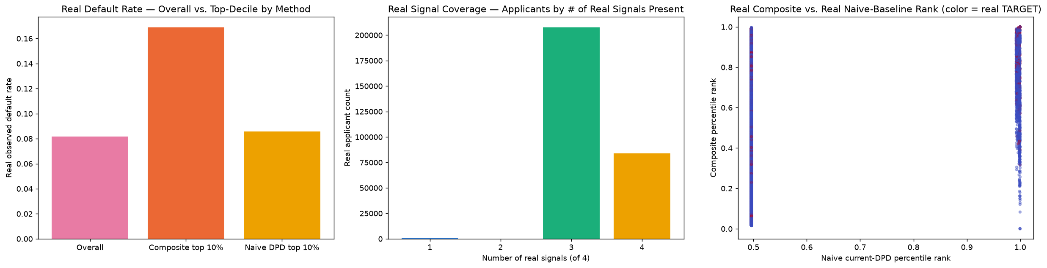

Real Top-Decile Comparison
Real observed default rate captured by each ranking method's top 10% (28,944 real applicants), vs. the real overall rate (0.0816) in the 289,444-applicant real evaluation population.
Method | N | Real Default Rate | Real Lift vs. Overall
Composite ranking | 28944 | 0.1689 | 2.07x
Naive current-DPD-only | 28944 | 0.0858 | 1.05x

Real Statistical Comparison
Real chi-square test on the 2x2 contingency of top-decile membership x real default outcome, comparing the composite ranking's top decile against the naive baseline's top decile.
Real Spearman rank correlation between the two full rankings: rho=0.1100 (p=0).
Statistic | Value
chi2 | 897.5979
dof | 1
p-value | 3.26602e-197
Important notice: figures in this report combine real, notebook-computed results with clearly labeled assumption-based estimates. All results are unaudited and have not been independently verified. This report is provided for illustrative purposes only and does not constitute audited financial statements, investment advice, or a production deployment certification.

