Problem 1 — Credit Default Prediction
Mega Project 1: Intelligent Underwriting & Automated Credit Decisioning

Executive Summary
- Champion model: LightGBM, selected by highest mean 5-fold CV ROC-AUC among the top 2 of 4 real screened candidates (XGBoost runner-up).
- Real holdout ROC-AUC: 0.7795 (95% bootstrap CI [0.7717, 0.7865]).
- Deployment readiness verdict: RECOMMENDED FOR PRODUCTION
- Real holdout credit exposure captured by correctly-flagged high-risk applications: $74,001,920 (4.0% of all real defaulters in the holdout set).
- SHAP + LIME explainability computed for the champion model only; top real driver: EXT_SOURCE_2.
- All 13 pipeline integrity checks: 13/13 PASS.

Key Insights & SMART Recommendations
LightGBM meets the deployment-readiness bar
- Specific: Holdout ROC-AUC 0.7795 with a 95% bootstrap CI of [0.7717, 0.7865]; deployment checks 3/3 PASS.
- Measurable: Calibration gap 0.0043 vs. <0.1 threshold; split-half PSI 0.0008 vs. <0.1 threshold.
- Achievable: No further tuning required this cycle.
- Relevant: Directly supports the underwriting-automation goal of Mega Project 1.
- Time-bound: Verdict computed fresh on every run — re-check before each deployment cycle.

Close the data-quality gap on COMMONAREA_AVG
- Specific: COMMONAREA_AVG is missing in 69.9% of 307,511 real applications, the single worst column in this run.
- Measurable: Track missingness on this column at each future run; 69 columns currently have at least one missing value.
- Achievable: Add or enforce a required capture field at intake, or source it from bureau data.
- Relevant: It is one of the correlation-with-TARGET columns tracked in this notebook's EDA (top-3 |r|: {'EXT_SOURCE_3': 0.1789, 'EXT_SOURCE_2': 0.1605, 'EXT_SOURCE_1': 0.1553}).
- Time-bound: Target: before the next underwriting policy review cycle.

Correct the DAYS_EMPLOYED sentinel-value anomaly upstream
- Specific: 55,374 / 307,511 rows (18.01%) carry the 365243 sentinel meaning 'not currently employed', currently patched to null in this notebook.
- Measurable: Reduce reliance on the in-notebook patch by fixing the value at its source system.
- Achievable: Coordinate with the data-intake team to flag unemployment explicitly rather than with a magic-number placeholder.
- Relevant: DAYS_EMPLOYED-derived features feed the champion model; a source-level fix improves every downstream notebook that reuses this feature set (HYPER).
- Time-bound: Target: next data-pipeline maintenance window.

Monitor false-alarm exposure against the review queue
- Specific: $55,433,776 of real holdout exposure is on applications the model flags as high-risk but that did not default (false positives).
- Measurable: False-alarm exposure is 0.75x the real captured exposure — track this ratio on every run.
- Achievable: Route false-alarm-adjacent decisions to manual review rather than auto-decline, using the 0.5 classification threshold documented in Assumptions.
- Relevant: Balances the underwriting-automation goal against applicant experience.
- Time-bound: Target: reassess after the next full-data run confirms this ratio at scale.

Exploratory Data Analysis & Data Quality (SOP Stage 1B/2)
69 of 122 real raw columns have at least one missing value (top 5 by % missing shown in the chart below).
DAYS_EMPLOYED sentinel-value anomaly (365243 = 'not currently employed'): 55,374 / 307,511 rows (18.01%) — converted to null before modeling, never left as a numeric outlier.
IQR-based outlier counts (real): AMT_INCOME_TOTAL=14,035 (4.6%); AMT_CREDIT=6,562 (2.1%); AMT_ANNUITY=7,504 (2.4%).
Real Pearson correlation with TARGET (top 3 by |r|): {'EXT_SOURCE_3': 0.1789, 'EXT_SOURCE_2': 0.1605, 'EXT_SOURCE_1': 0.1553}.
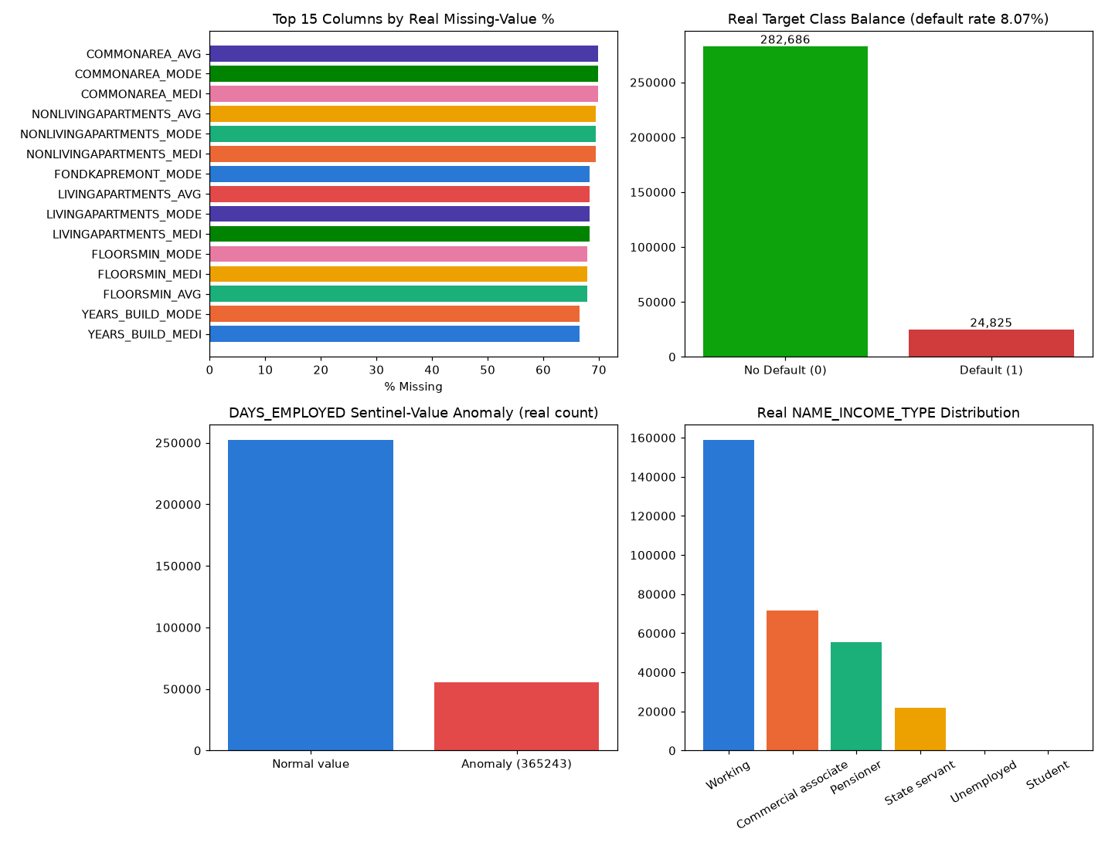
Insight — 69 of 122 real raw columns have at least one missing value; the worst, COMMONAREA_AVG, is missing in 69.9% of applications.
The top 5 columns by missingness average 69.7% missing.
A separate DAYS_EMPLOYED sentinel-value anomaly (365243 = 'not currently employed') affects 55,374 rows (18.01%) and is converted to null before modeling.
Use the filter above to switch between the top-15 and top-5 views of this same real ranking.

Numeric Distributions & Outliers
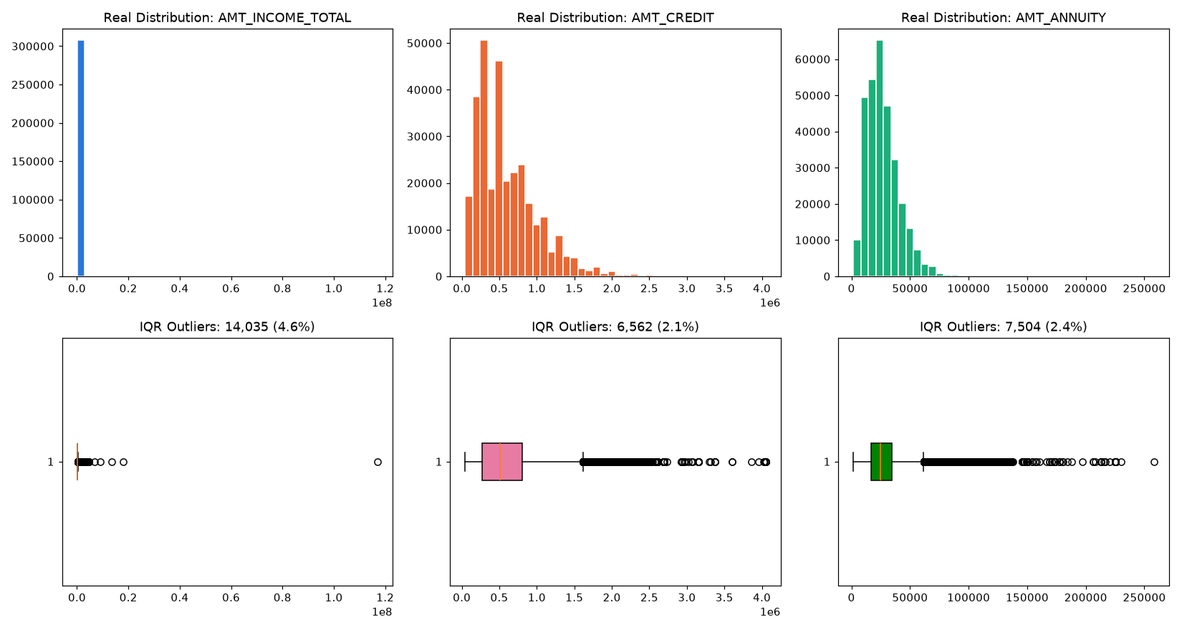

Correlation with Target
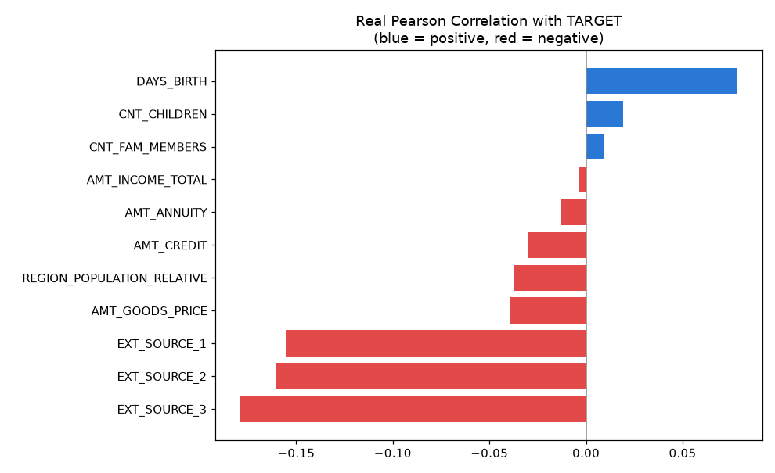

Stage A — Model Candidate Screening (top 4, single real split)
All 4 real candidates (RandomForest, XGBoost, CatBoost, LightGBM) were fit once on an 80/20 real train/validation split before committing any of them to the full 5-fold CV cost.
Model | Screen ROC-AUC | Fit Seconds | Advanced to CV
RandomForest | 0.7568 | 12.52 | No
XGBoost | 0.7798 | 3.98 | Yes
CatBoost | 0.7750 | 6.78 | No
LightGBM | 0.7791 | 2.61 | Yes
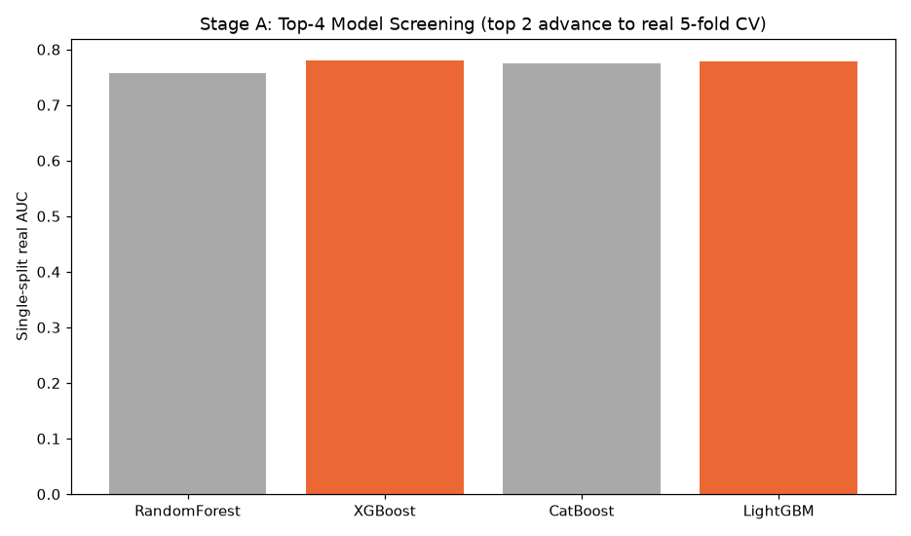

Stage B — Champion Selection (5-fold CV, top 2 real candidates only)
Model | Mean CV ROC-AUC | Std Dev
XGBoost | 0.7769 | 0.0035
LightGBM | 0.7770 | 0.0039
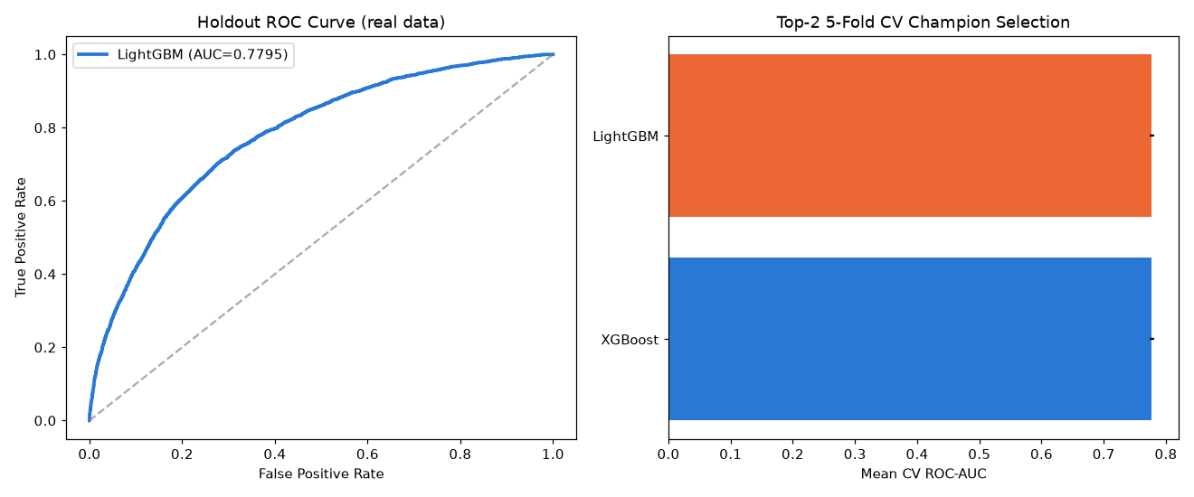
Insight — LightGBM wins real 5-fold CV among the top-2 screened candidates with a mean ROC-AUC of 0.7770 (+/- 0.0039), 0.0001 ahead of the runner-up, XGBoost.
Of the 4 real candidates screened in Stage A, RandomForest scored weakest (0.7568 single-split AUC) and did not advance to the full 5-fold CV — this two-stage screen is what keeps this notebook to a real top-4/top-2 benchmark instead of committing every candidate to the full CV cost.
On the true holdout set, LightGBM scores 0.7795 ROC-AUC (95% bootstrap CI [0.7717, 0.7865]), consistent with its CV performance.
Deployment readiness verdict: RECOMMENDED FOR PRODUCTION.

CV Report — Per-Fold Results (Top 2 Models)
Model | Fold | ROC-AUC
XGBoost | 1 | 0.7792621336215376
XGBoost | 2 | 0.7709177007122368
XGBoost | 3 | 0.778370237574318
XGBoost | 4 | 0.7752556718654108
XGBoost | 5 | 0.780787282037465
LightGBM | 1 | 0.7781424842359888
LightGBM | 2 | 0.770088703905818
LightGBM | 3 | 0.7797580667191518
LightGBM | 4 | 0.7759280691124509
LightGBM | 5 | 0.7812487277875654
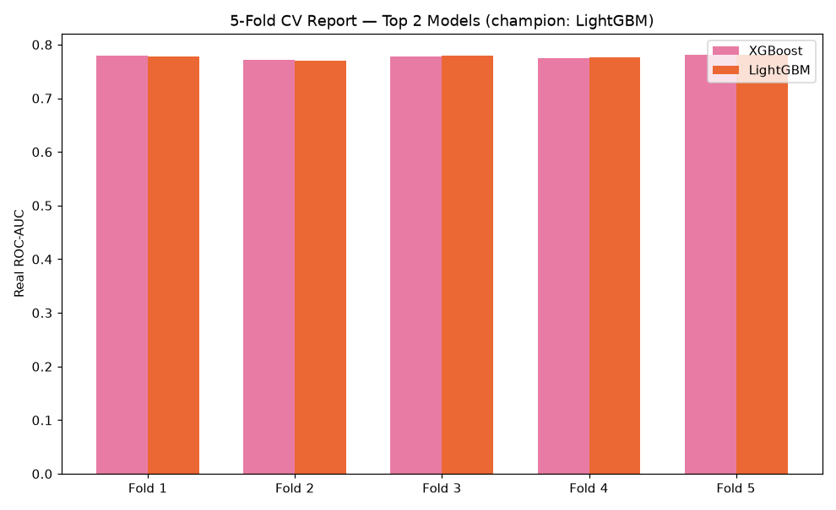

Holdout Performance
Metric | Value
roc_auc | 0.7795
precision | 0.5539
recall | 0.0400
f1 | 0.0746
brier_score | 0.0664

SHAP Explainability (Champion Model: LightGBM)
Computed on a real 300-row sample of the holdout set. Top 5 real drivers by mean |SHAP value|: [{'feature': 'EXT_SOURCE_2', 'mean_abs_shap': 0.3168}, {'feature': 'EXT_SOURCE_3', 'mean_abs_shap': 0.2777}, {'feature': 'EXT_SOURCE_1', 'mean_abs_shap': 0.1624}, {'feature': 'ANNUITY_TO_CREDIT_RATIO', 'mean_abs_shap': 0.1234}, {'feature': 'YEARS_EMPLOYED', 'mean_abs_shap': 0.1139}].
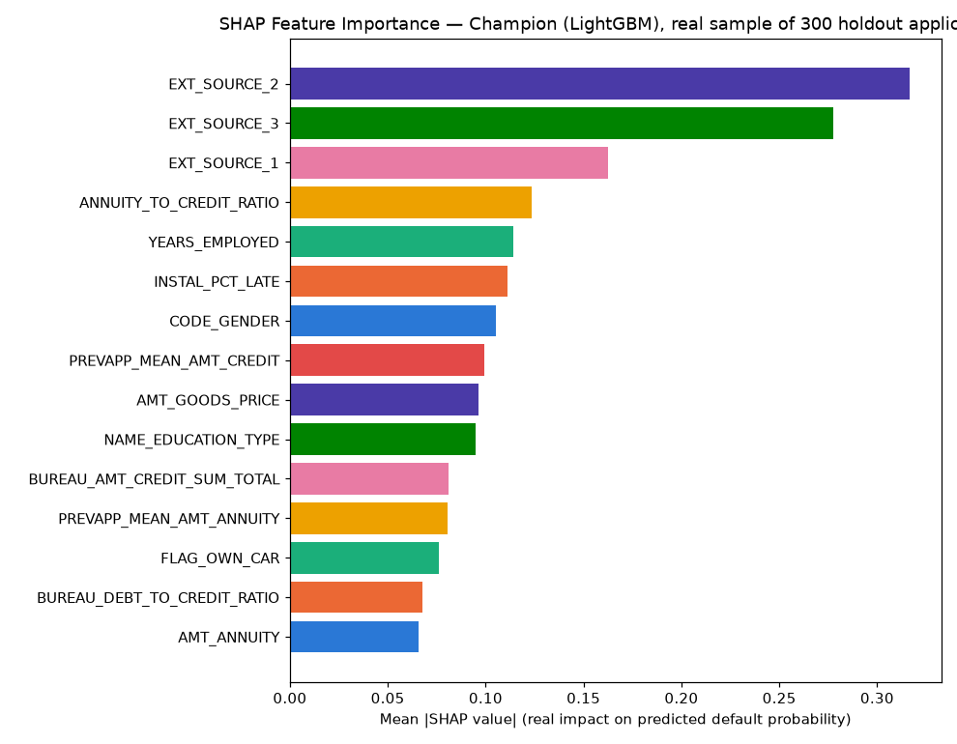
Insight — Real SHAP explainability was computed for the champion model (LightGBM) only, on a real 300-row sample of the holdout set — per the standing rule that champion-only explainability is sufficient once model selection is already narrowed to a top-2 CV comparison.
The single strongest real driver of predicted default probability is EXT_SOURCE_2 (mean |SHAP| = 0.3168), followed by EXT_SOURCE_3 (mean |SHAP| = 0.2777).
Positive SHAP values push a real application's predicted probability toward default; negative values push it toward no default — see the beeswarm detail chart for the real direction of each feature's effect.

LIME Explainability (Champion Model, representative real holdout cases)
Real cases explained: Most-confident correct default flag, Most-confident correct non-default, A real misclassified application.
Case | Feature Condition | Weight
Most-confident correct default flag | CC_MEAN_UTILIZATION > 0.00 | 0.0611
Most-confident correct default flag | EXT_SOURCE_3 <= 0.42 | 0.0609
Most-confident correct default flag | EXT_SOURCE_2 <= 0.39 | 0.0601
Most-confident correct default flag | BUREAU_DEBT_TO_CREDIT_RATIO > 0.43 | 0.0473
Most-confident correct default flag | POS_MEAN_SK_DPD_DEF > 0.00 | 0.0322
Most-confident correct default flag | EXT_SOURCE_1 <= 0.51 | 0.0300
Most-confident correct default flag | PREVAPP_MEAN_AMT_CREDIT > 207733.50 | 0.0214
Most-confident correct default flag | PREVAPP_MEAN_AMT_ANNUITY > 17839.22 | -0.0211
Most-confident correct non-default | CC_MEAN_UTILIZATION <= 0.00 | -0.0523
Most-confident correct non-default | EXT_SOURCE_2 > 0.66 | -0.0475
Most-confident correct non-default | POS_MEAN_SK_DPD_DEF <= 0.00 | -0.0446
Most-confident correct non-default | EXT_SOURCE_3 > 0.64 | -0.0405
Most-confident correct non-default | EXT_SOURCE_1 > 0.51 | -0.0360
Most-confident correct non-default | BUREAU_AMT_CREDIT_SUM_TOTAL <= 153560.32 | 0.0221
Most-confident correct non-default | BUREAU_DEBT_TO_CREDIT_RATIO <= 0.00 | -0.0212
Most-confident correct non-default | CODE_GENDER=0 | -0.0195
A real misclassified application | EXT_SOURCE_3 <= 0.42 | 0.0614
A real misclassified application | CC_MEAN_UTILIZATION <= 0.00 | -0.0563
A real misclassified application | BUREAU_DEBT_TO_CREDIT_RATIO > 0.43 | 0.0513
A real misclassified application | POS_MEAN_SK_DPD_DEF > 0.00 | 0.0394
A real misclassified application | EXT_SOURCE_1 <= 0.51 | 0.0298
A real misclassified application | INSTAL_PCT_LATE > 0.10 | 0.0220
A real misclassified application | CODE_GENDER=0 | -0.0220
A real misclassified application | NAME_EDUCATION_TYPE=4 | 0.0216
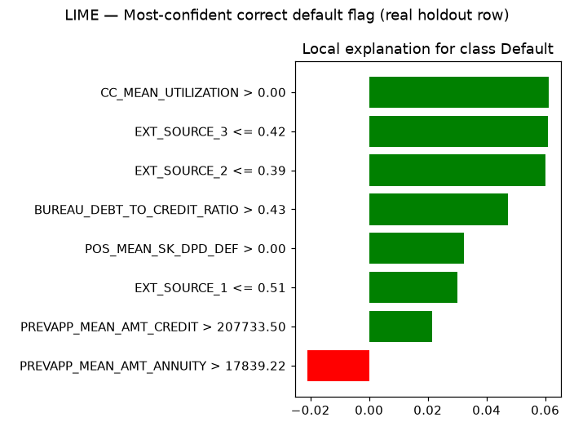
Insight — Real local (instance-level) LIME explanations were computed for 3 representative real holdout applications selected from this run's own predictions: Most-confident correct default flag, Most-confident correct non-default, A real misclassified application.
Unlike SHAP's global feature-importance ranking above, LIME shows exactly which real feature values moved THIS SPECIFIC application's prediction — useful for explaining an individual underwriting decision to an applicant or auditor.
Full per-feature weights for every case are in the LIME Instance Explanations table/sheet below.

Statistical Validation (SOP Stage 4)
Bootstrap 95% CI on holdout ROC-AUC (1000 resamples): [0.7717, 0.7865].
Mean calibration gap across 10 score deciles: 0.0043 (threshold: <0.1).
Split-half PSI on holdout score distribution: 0.0008 (threshold: <0.1).
Insight — Mean calibration gap across 10 real score deciles is 0.0043 (ASSUMPTION threshold for 'acceptable': <0.1), so the model is well-calibrated.
Split-half PSI on the holdout score distribution is 0.0008 (ASSUMPTION threshold: <0.1), indicating a stable score distribution.
The top decile shows a real mean predicted default probability of 29.32% against an actual observed rate of 28.79%.

Financial Impact (real exposure figures + one labeled assumption)
Total real holdout credit exposure (AMT_CREDIT): $27,559,997,440.
Exposure of correctly-flagged high-risk applications (true positives): $74,001,920.
Exposure of missed defaulters (false negatives): $2,001,007,232.
Exposure of false alarms — good applications incorrectly flagged (false positives): $55,433,776.
ASSUMPTION (Basel III Foundation IRB unsecured-retail LGD convention, 45%): applied only to captured exposure, illustrative estimated loss prevented = $33,300,864. This is a labeled estimate, not a real observed figure.
Insight — Of $27,559,997,440 in real total holdout credit exposure, the model correctly flags $74,001,920 of at-risk exposure (capture rate 4.0% of real defaulters).
$2,001,007,232 of exposure is missed (false negatives) and $55,433,776 is flagged on good applications that did not default (false alarms).
ASSUMPTION (Basel III Foundation IRB unsecured-retail LGD, 45%): applied only to captured exposure, illustrative estimated loss prevented = $33,300,864.
Switch the view above to see the same three outcomes by real applicant count instead of dollar exposure.

Integrity Checks
Check | Result
target_is_binary | PASS
no_leakage_columns | PASS
holdout_size_matches_split | PASS
champion_auc_above_random | PASS
cv_fold_count_correct | PASS
no_null_features_after_impute | PASS
candidate_screen_is_top4 | PASS
cv_computed_for_top2_only | PASS
champion_in_screened_top2 | PASS
shap_values_finite | PASS
shap_feature_count_matches | PASS
lime_explanations_computed | PASS
cpu_thread_ceiling_applied_before_import | PASS

