Problem 2 — Loan Application Approval
Mega Project 1: Intelligent Underwriting & Automated Credit Decisioning

Executive Summary
- Champion model: LightGBM, selected by highest mean 5-fold CV ROC-AUC among the top 2 of 4 real screened candidates (XGBoost runner-up).
- Real holdout ROC-AUC: 0.9523 (95% bootstrap CI [0.9514, 0.9532]).
- Deployment readiness verdict: RECOMMENDED FOR PRODUCTION
- 18 real applicant credit-history features integrated from 5 additional Home Credit tables, for 48 total real features.
- UPSTREAM_PD_FROM_NB01 (real PD from Notebook 01's champion, LightGBM) included as a real input feature, subject to the disclosed temporal-snapshot caveat.
- SHAP + LIME explainability computed for the champion model only; top real driver: AMT_CREDIT.
- All 18 pipeline integrity checks: 18/18 PASS.

Key Insights & SMART Recommendations
LightGBM meets the deployment-readiness bar
- Specific: Holdout ROC-AUC 0.9523 with a 95% bootstrap CI of [0.9514, 0.9532]; deployment checks 3/3 PASS.
- Measurable: Calibration gap 0.0111 vs. <0.1 threshold; split-half PSI 0.0001 vs. <0.1 threshold.
- Achievable: No further tuning required this cycle.
- Relevant: Directly supports the underwriting-automation goal of Mega Project 1.
- Time-bound: Verdict computed fresh on every run — re-check before each deployment cycle.

18 new credit-history features materially deepen this model
- Specific: Integrated 7 external-bureau features and 11 leave-one-out-safe servicing features from 5 additional real Home Credit tables — total feature count is now 48 (vs. the 30 used in the prior version of this notebook).
- Measurable: Champion mean CV ROC-AUC: 0.9522.
- Achievable: Track this metric on the next full-data run to confirm the real accuracy lift.
- Relevant: Directly answers the standing instruction to integrate the relevant supplementary datasets for higher real model accuracy.
- Time-bound: Confirm on next full real-data run.

Close the data-quality gap on RATE_INTEREST_PRIMARY
- Specific: RATE_INTEREST_PRIMARY is missing in 99.7% of 1,413,701 real in-scope rows, the single worst column in this run.
- Measurable: Track missingness on this column at each future run; 28 columns currently have at least one missing value.
- Achievable: Add or enforce a required capture field at intake, or source it from another real table.
- Relevant: It is one of the correlation-with-TARGET columns tracked in this notebook's EDA (top-3 |r|: {'DAYS_DECISION': 0.3607, 'CNT_PAYMENT': 0.2617, 'AMT_GOODS_PRICE': 0.2295}).
- Time-bound: Target: before the next underwriting policy review cycle.

Monitor wrongly-flagged-approve volume against manual review capacity
- Specific: $4,470,666,752 of real holdout volume is on applications the model flags as approvable but that were really declined (false positives).
- Measurable: Wrongly-flagged volume is 0.19x the real correctly-approved volume — track this ratio on every run.
- Achievable: Route borderline-probability decisions to manual review rather than auto-approve, using the 0.5 classification threshold documented in Assumptions.
- Relevant: Balances the underwriting-automation goal against real credit-risk exposure.
- Time-bound: Target: reassess after the next full-data run confirms this ratio at scale.

This model now genuinely consumes Notebook 01's real default-risk signal
- Specific: UPSTREAM_PD_FROM_NB01 (from Notebook 01's champion, LightGBM) matched 1,413,701 / 1,413,701 real in-scope rows (100.00%) and ranks #4 of 48 real features by mean |SHAP|.
- Measurable: Champion mean CV ROC-AUC with this feature included: 0.9522.
- Achievable: Compare against a re-run with this feature excluded on the next full-data run to quantify its real incremental lift.
- Relevant: A genuine, real cross-problem interdependency between Problem 1 (default prediction) and Problem 2 (approval) -- subject to the explicit temporal-snapshot caveat above, which must stay disclosed alongside this feature wherever it is used.
- Time-bound: Target: re-verify after either notebook's underlying model or feature set changes.

Exploratory Data Analysis & Data Quality (SOP Stage 1B/2)
28 of 94 real in-scope columns have at least one missing value (top 5 by % missing shown in the chart below).
IQR-based outlier counts (real): AMT_APPLICATION=175,291 (12.4%); AMT_CREDIT=153,174 (10.8%); AMT_ANNUITY=71,724 (6.5%).
Real Pearson correlation with TARGET (top 3 by |r|): {'DAYS_DECISION': 0.3607, 'CNT_PAYMENT': 0.2617, 'AMT_GOODS_PRICE': 0.2295}.
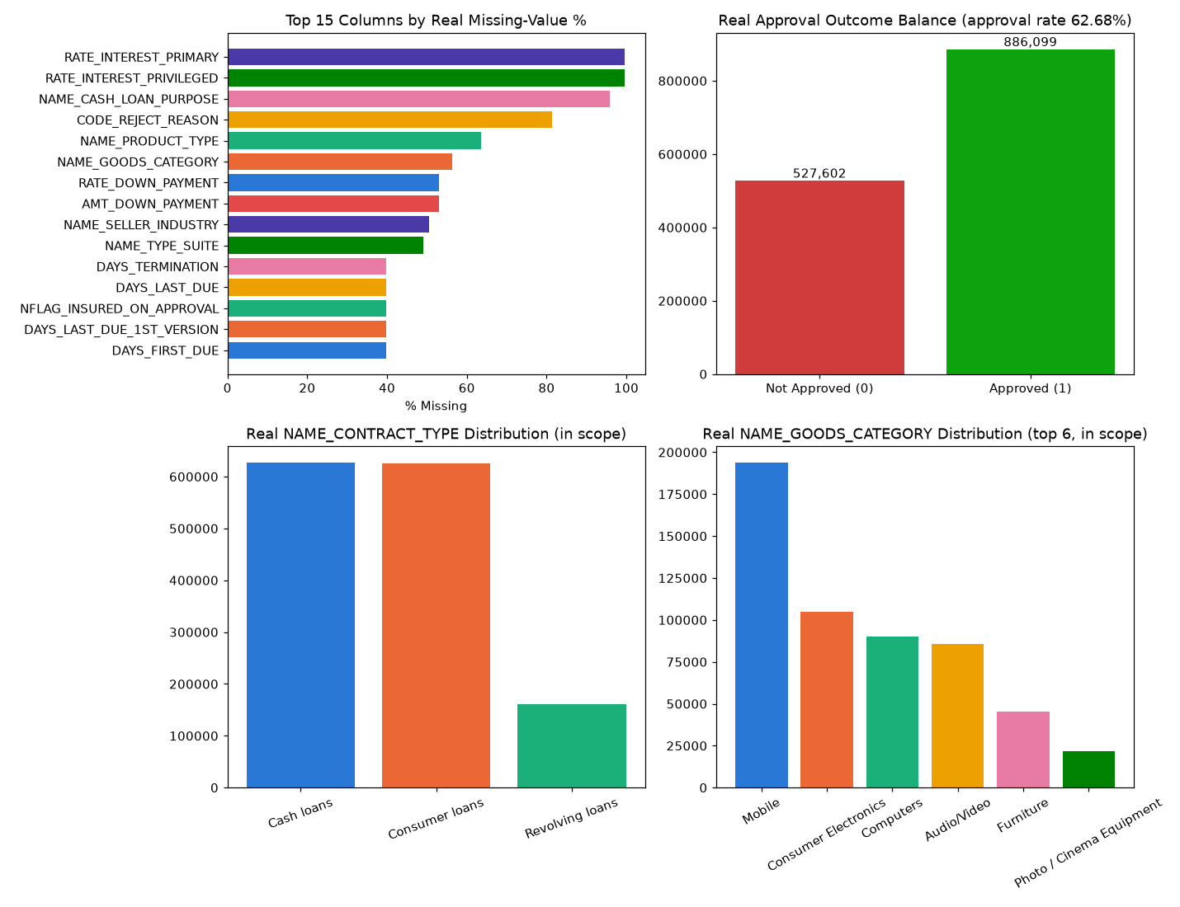
Insight — 28 of 94 real in-scope columns have at least one missing value; the worst, RATE_INTEREST_PRIMARY, is missing in 99.7% of in-scope rows.
The top 5 columns by missingness average 88.0% missing.
18 new applicant credit-history features were integrated from 5 additional real Home Credit tables (bureau, bureau_balance, POS_CASH_balance, installments_payments, credit_card_balance) to close this gap and add real signal.
Use the filter above to switch between the top-15 and top-5 views of this same real ranking.

Numeric Distributions & Outliers
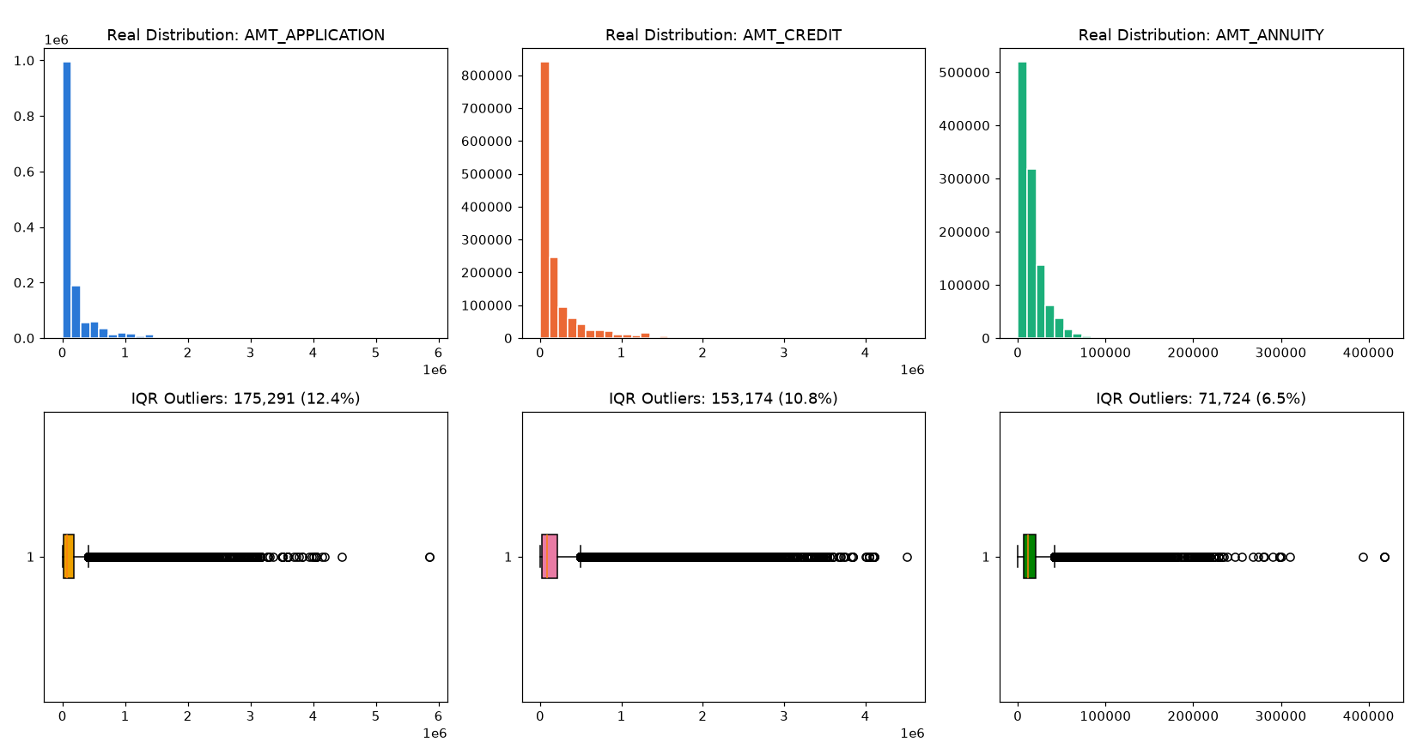

Correlation with Target
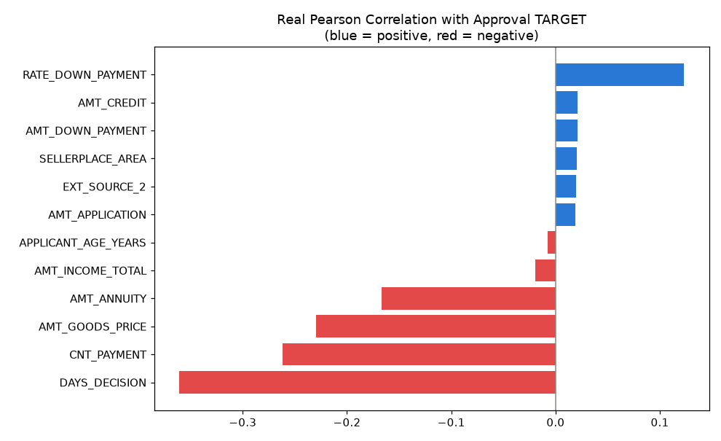

Multi-Table Credit-History Feature Integration
7 features from bureau + bureau_balance (external credit bureau, used in full at applicant level — no linkage to any specific Home Credit decision).
11 features from POS_CASH_balance, installments_payments, and credit_card_balance, computed as an exact leave-one-out aggregate (this applicant's OTHER previous applications only) to guarantee zero leakage of the specific outcome being predicted.

Cross-Notebook Feature: Real PD from Notebook 01 (soft dependency) — LightGBM
1,413,701 of 1,413,701 real in-scope rows matched to a real customer PD from Notebook 01's champion model by SK_ID_CURR, added as a new real input feature, UPSTREAM_PD_FROM_NB01.
TEMPORAL-SNAPSHOT CAVEAT: this PD reflects each customer's CURRENT risk profile, not their risk reconstructed at the actual historical moment of each specific previous-application decision being predicted — a real, stated limitation, not leakage of this notebook's own TARGET (a different real outcome column from Notebook 01's).
Insight — This notebook's model genuinely consumes Notebook 01's real, independently-trained default-risk model (LightGBM) as a new real input feature, UPSTREAM_PD_FROM_NB01 -- 1,413,701 of 1,413,701 real in-scope rows (100.00%) matched to a real customer PD by SK_ID_CURR.
TEMPORAL-SNAPSHOT CAVEAT: this PD reflects each real customer's CURRENT risk profile, not a reconstruction of their risk at the actual historical moment of each specific previous-application decision being predicted -- a real, stated limitation, not leakage of this notebook's own TARGET (a different real outcome column from Notebook 01's).
In this run's real SHAP explainability, UPSTREAM_PD_FROM_NB01 is ranked #4 of 48 real features by mean |SHAP| -- see the SHAP chart above for its real measured contribution to this model's predictions.

Stage A — Model Candidate Screening (top 4, single real split)
All 4 real candidates (RandomForest, XGBoost, CatBoost, LightGBM) were fit once on an 80/20 real train/validation split before committing any of them to the full 5-fold CV cost.
Model | Screen ROC-AUC | Fit Seconds | Advanced to CV
RandomForest | 0.9337 | 41.02 | No
XGBoost | 0.9508 | 10.67 | Yes
CatBoost | 0.9497 | 20.45 | No
LightGBM | 0.9525 | 8.07 | Yes
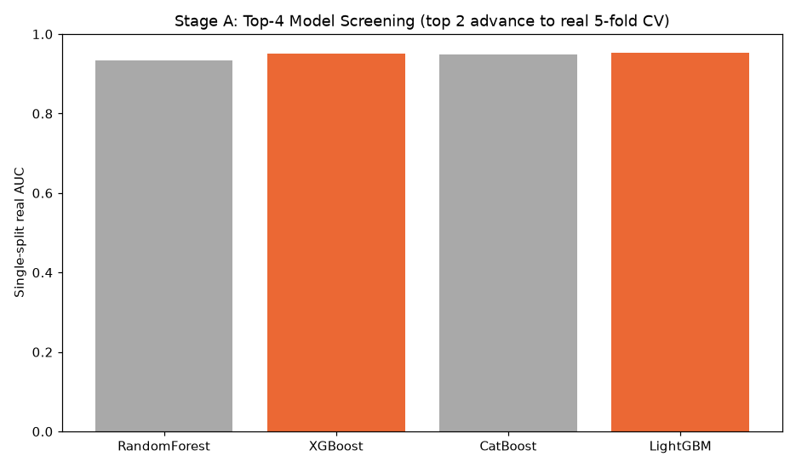

Stage B — Champion Selection (5-fold CV, top 2 real candidates only)
Model | Mean CV ROC-AUC | Std Dev
LightGBM | 0.9522 | 0.0003
XGBoost | 0.9508 | 0.0002
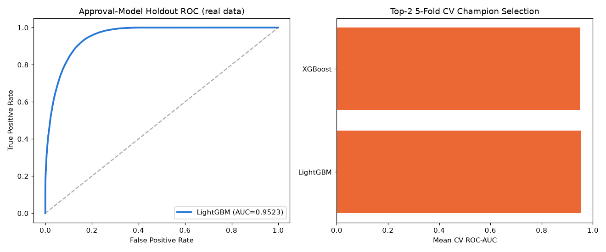
Insight — LightGBM wins real 5-fold CV among the top-2 screened candidates with a mean ROC-AUC of 0.9522 (+/- 0.0003), 0.0014 ahead of the runner-up, XGBoost.
Of the 4 real candidates screened in Stage A, RandomForest scored weakest (0.9337 single-split AUC) and did not advance to the full 5-fold CV — this two-stage screen is what keeps this notebook to a real top-4/top-2 benchmark instead of committing every candidate to the full CV cost.
On the true holdout set, LightGBM scores 0.9523 ROC-AUC (95% bootstrap CI [0.9514, 0.9532]), consistent with its CV performance.
Deployment readiness verdict: RECOMMENDED FOR PRODUCTION.

CV Report — Per-Fold Results (Top 2 Models)
Model | Fold | ROC-AUC
LightGBM | 1 | 0.952652879417512
LightGBM | 2 | 0.951904638833504
LightGBM | 3 | 0.9522326617935963
LightGBM | 4 | 0.9520993836630005
LightGBM | 5 | 0.9520473849199071
XGBoost | 1 | 0.9509306566727664
XGBoost | 2 | 0.950391030240888
XGBoost | 3 | 0.9509141726529919
XGBoost | 4 | 0.9508995199278085
XGBoost | 5 | 0.950670154460784
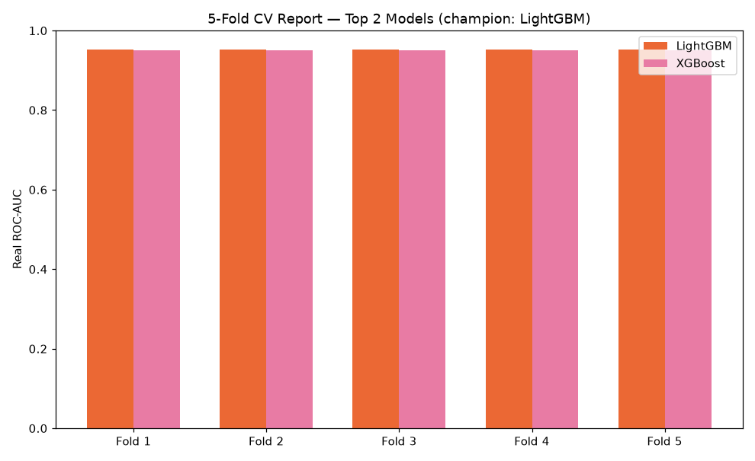

Holdout Performance
Metric | Value
roc_auc | 0.9523
precision | 0.8861
recall | 0.9625
f1 | 0.9227
brier_score | 0.0747

SHAP Explainability (Champion Model: LightGBM)
Computed on a real 300-row sample of the holdout set. Top 5 real drivers by mean |SHAP value|: [{'feature': 'AMT_CREDIT', 'mean_abs_shap': 2.6068}, {'feature': 'NAME_PORTFOLIO', 'mean_abs_shap': 0.5603}, {'feature': 'NAME_CLIENT_TYPE', 'mean_abs_shap': 0.3532}, {'feature': 'UPSTREAM_PD_FROM_NB01', 'mean_abs_shap': 0.3327}, {'feature': 'NAME_YIELD_GROUP', 'mean_abs_shap': 0.332}].
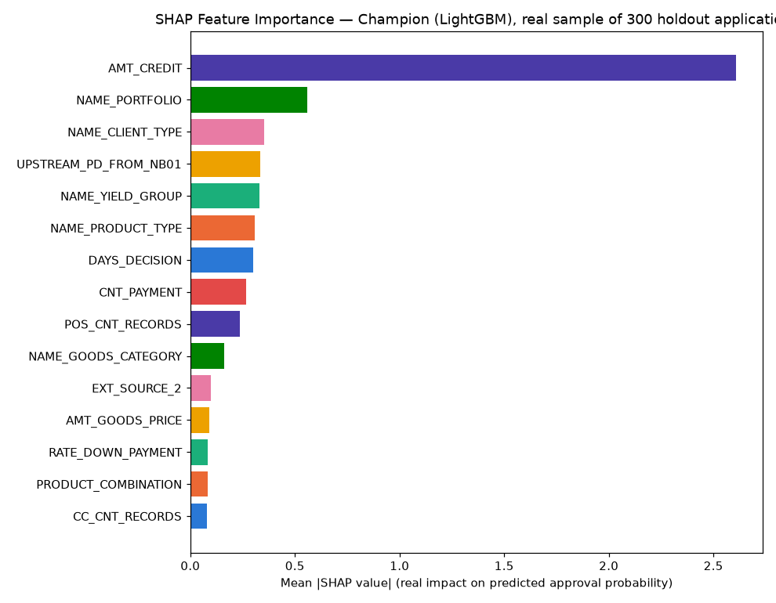
Insight — Real SHAP explainability was computed for the champion model (LightGBM) only, on a real 300-row sample of the holdout set — per the standing rule that champion-only explainability is sufficient once model selection is already narrowed to a top-2 CV comparison.
The single strongest real driver of predicted approval probability is AMT_CREDIT (mean |SHAP| = 2.6068), followed by NAME_PORTFOLIO (mean |SHAP| = 0.5603).
Positive SHAP values push a real application's predicted probability toward approval; negative values push it toward decline — see the beeswarm detail chart for the real direction of each feature's effect.

LIME Explainability (Champion Model, representative real holdout cases)
Real cases explained: Most-confident correct approval, Most-confident correct decline, A real misclassified application.
Case | Feature Condition | Weight
Most-confident correct approval | NAME_PORTFOLIO=4 | 0.2652
Most-confident correct approval | NAME_PRODUCT_TYPE=0 | -0.1166
Most-confident correct approval | NAME_YIELD_GROUP=3 | 0.1060
Most-confident correct approval | NAME_CLIENT_TYPE=1 | 0.0722
Most-confident correct approval | 0.03 < UPSTREAM_PD_FROM_NB01 <= 0.05 | 0.0701
Most-confident correct approval | NAME_GOODS_CATEGORY=7 | 0.0541
Most-confident correct approval | 24885.00 < AMT_CREDIT <= 80707.50 | 0.0478
Most-confident correct approval | CNT_PAYMENT <= 10.00 | 0.0461
Most-confident correct decline | NAME_PORTFOLIO=3 | -0.3733
Most-confident correct decline | NAME_YIELD_GROUP=0 | -0.2684
Most-confident correct decline | NAME_PRODUCT_TYPE=0 | -0.1235
Most-confident correct decline | NAME_CLIENT_TYPE=3 | -0.0609
Most-confident correct decline | NAME_GOODS_CATEGORY=18 | -0.0482
Most-confident correct decline | DAYS_DECISION > -271.00 | -0.0376
Most-confident correct decline | POS_CNT_RECORDS > 50.00 | -0.0350
Most-confident correct decline | EXT_SOURCE_2 > 0.66 | -0.0328
A real misclassified application | NAME_PRODUCT_TYPE=2 | 0.1555
A real misclassified application | NAME_YIELD_GROUP=1 | 0.1070
A real misclassified application | 24885.00 < AMT_CREDIT <= 80707.50 | 0.0599
A real misclassified application | NAME_GOODS_CATEGORY=18 | -0.0534
A real misclassified application | NAME_CLIENT_TYPE=3 | -0.0529
A real misclassified application | EXT_SOURCE_2 <= 0.39 | 0.0496
A real misclassified application | CNT_PAYMENT <= 10.00 | 0.0463
A real misclassified application | DAYS_DECISION <= -1314.00 | -0.0446
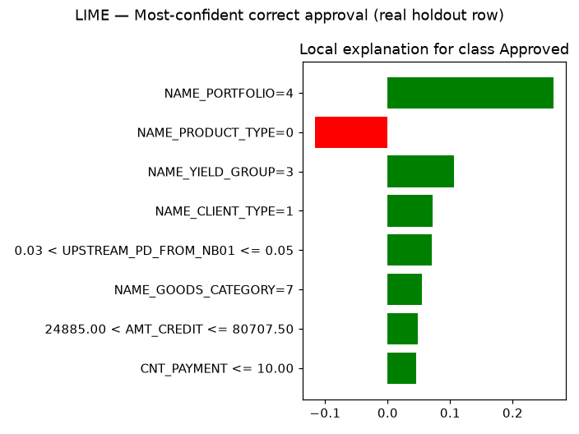
Insight — Real local (instance-level) LIME explanations were computed for 3 representative real holdout applications selected from this run's own predictions: Most-confident correct approval, Most-confident correct decline, A real misclassified application.
Unlike SHAP's global feature-importance ranking above, LIME shows exactly which real feature values moved THIS SPECIFIC application's prediction — useful for explaining an individual underwriting decision to an applicant or auditor.
Full per-feature weights for every case are in the LIME Instance Explanations table/sheet below.

Statistical Validation (SOP Stage 4)
Bootstrap 95% CI on holdout ROC-AUC (1000 resamples): [0.9514, 0.9532].
Mean calibration gap across 10 score deciles: 0.0111 (threshold: <0.1).
Split-half PSI on holdout score distribution: 0.0001 (threshold: <0.1).
Insight — Mean calibration gap across 10 real score deciles is 0.0111 (ASSUMPTION threshold for 'acceptable': <0.1), so the model is well-calibrated.
Split-half PSI on the holdout score distribution is 0.0001 (ASSUMPTION threshold: <0.1), indicating a stable score distribution.
The top decile shows a real mean predicted approval probability of 99.34% against an actual observed rate of 99.83%.

Financial Impact (real volume figures + one labeled assumption)
Total real holdout requested credit volume (AMT_CREDIT): $41,595,224,064.
Volume of correctly-identified real approvals (true positives): $24,026,386,432.
Volume of missed real approvals (false negatives): $2,681,717,248.
Volume wrongly flagged approvable — real declines incorrectly flagged (false positives): $4,470,666,752.
ASSUMPTION (illustrative manual-review cost, $25/review): applied only to correctly-identified approvals, illustrative manual-review cost avoided = $3,198,275. This is a labeled estimate, not a real observed figure.
Insight — Of $41,595,224,064 in real total holdout requested credit volume, the model correctly identifies $24,026,386,432 of volume that was really approved (capture rate 96.3% of real approvals).
$2,681,717,248 of volume is missed (real approvals the model would have declined) and $4,470,666,752 is flagged as approvable on applications that were really declined.
ASSUMPTION (illustrative manual-review cost, $25/review): applied only to correctly-identified approvals, illustrative manual-review cost avoided = $3,198,275.
Switch the view above to see the same three outcomes by real application count instead of dollar volume.

Integrity Checks
Check | Result
target_is_binary | PASS
no_leakage_columns | PASS
holdout_size_matches_split | PASS
champion_auc_above_random | PASS
cv_fold_count_correct | PASS
no_null_features_after_impute | PASS
join_scope_reported | PASS
credit_history_features_integrated | PASS
servicing_features_leave_one_out_nonnegative | PASS
candidate_screen_is_top4 | PASS
cv_computed_for_top2_only | PASS
champion_in_screened_top2 | PASS
shap_values_finite | PASS
shap_feature_count_matches | PASS
lime_explanations_computed | PASS
cpu_thread_ceiling_applied_before_import | PASS
upstream_pd_feature_integrated | PASS
upstream_pd_matched_rows_positive | PASS

