Problem 3 — Credit Score Estimation
Mega Project 1: Intelligent Underwriting & Automated Credit Decisioning

Executive Summary
- Real PDO scorecard built on Problem 1's real LightGBM PD model — 307,511 real customers scored, score range 425-671.
- Real score discrimination: AUC 0.8167 (95% bootstrap CI [0.8141, 0.8193]).
- Deployment readiness verdict: RECOMMENDED FOR PRODUCTION
- Thin-file population (no bureau history): 44,020 (14.31%) of scored customers.
- SHAP + LIME explainability computed for the upstream champion model; top real driver: EXT_SOURCE_2.
- All 11 pipeline integrity checks: 11/11 PASS.

Key Insights & SMART Recommendations
Problem 1's LightGBM model meets the scorecard deployment bar
- Specific: Score AUC 0.8167 (95% bootstrap CI [0.8141, 0.8193]); deployment checks 4/4 PASS.
- Measurable: Calibration gap 0.0118 vs. <0.1 threshold; split-half PSI 0.0000 vs. <0.1 threshold.
- Achievable: No further tuning required this cycle.
- Relevant: Directly supports real-time credit-score display in the underwriting-automation workflow.
- Time-bound: Verdict computed fresh on every run — re-check before each deployment cycle.

Reduce the 14.3% thin-file population's reliance on application-only signal
- Specific: 44,020 of 307,511 real customers have zero bureau credit records and are scored on application fields alone.
- Measurable: Track the thin-file share and its mean score gap vs. bureau-scored customers on every run.
- Achievable: Consider Notebook 02's broader servicing-history feature set (POS_CASH/installments/credit_card) as an alternative-data signal for this specific population in a future cycle.
- Relevant: Directly extends the standing instruction to integrate relevant supplementary datasets for accuracy, applied here to the thin-file sub-population specifically.
- Time-bound: Target: evaluate alongside the next Mega Project 1 feature-harmonization pass.

'Very Poor' band concentrates the real default risk
- Specific: Real default rate 25.00% in the 'Very Poor' band vs. 0.80% in 'Excellent'.
- Measurable: $32,399,409,152 of real portfolio volume sits in this highest-risk band.
- Achievable: Route this band to enhanced manual review or tighter approval terms in the underwriting policy.
- Relevant: Directly supports risk-tiered decisioning across the underwriting-automation workflow.
- Time-bound: Target: incorporate into the next underwriting policy review cycle.

Exploratory Data Analysis & Data Quality of the Scoring Population (SOP Stage 1B/2)
15 of 56 real scoring features have at least one missing value (imputed via Notebook 01's fitted imputer, never dropped).
IQR-based outlier counts (real): AMT_INCOME_TOTAL=14,035 (4.6%); AMT_CREDIT=6,562 (2.1%); AGE_YEARS=0 (0.0%).
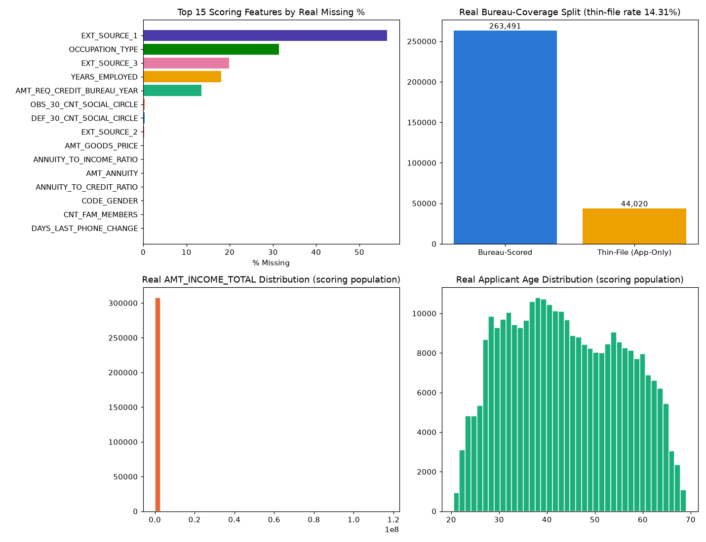
Insight — 15 of 56 real scoring features have at least one missing value; the worst, EXT_SOURCE_1, is missing in 56.4% of the scoring population.
44,020 / 307,511 customers (14.31%) are thin-file (zero real bureau credit records) and are scored on application-only signal — tracked separately throughout, never silently merged.
Use the filter above to switch between the top-15 and top-5 views of this same real ranking.

Numeric Distributions & Outliers
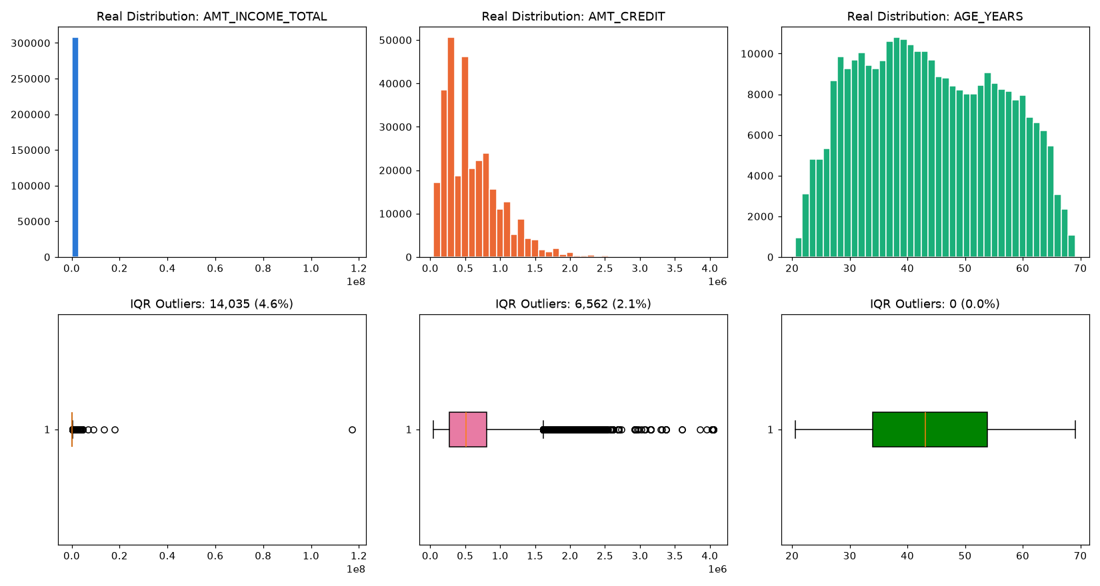

Correlation of Scoring Features with Target
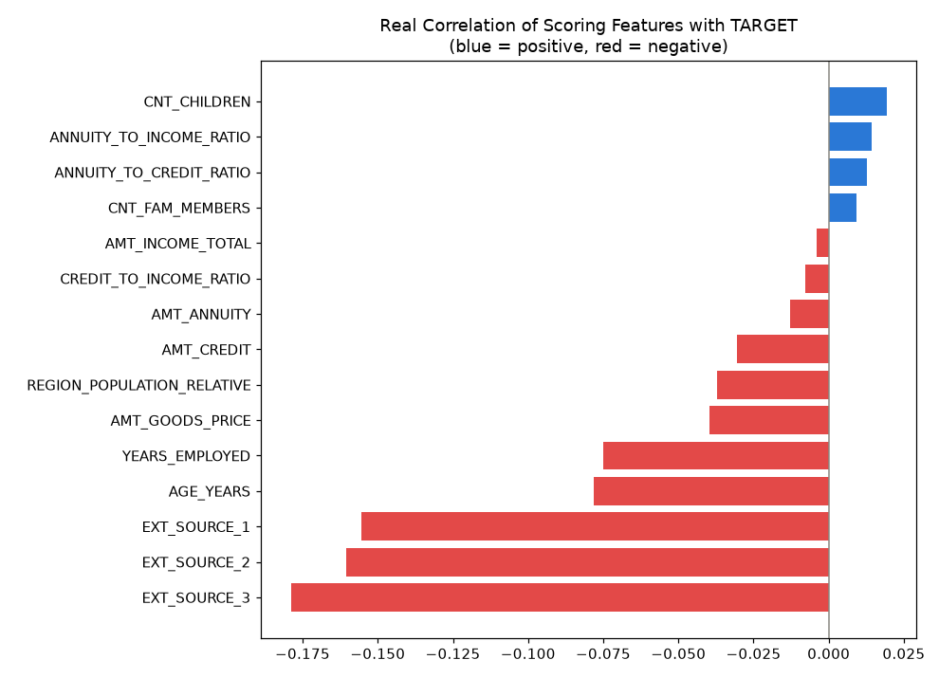

Real Score Distribution & Band Validation
Score Band | Customers | Real Default Rate | Mean Score
Excellent | 61502 | 0.0080 | 608
Fair | 61502 | 0.0416 | 572
Good | 61502 | 0.0208 | 587
Poor | 61502 | 0.0832 | 555
Very Poor | 61503 | 0.2500 | 526
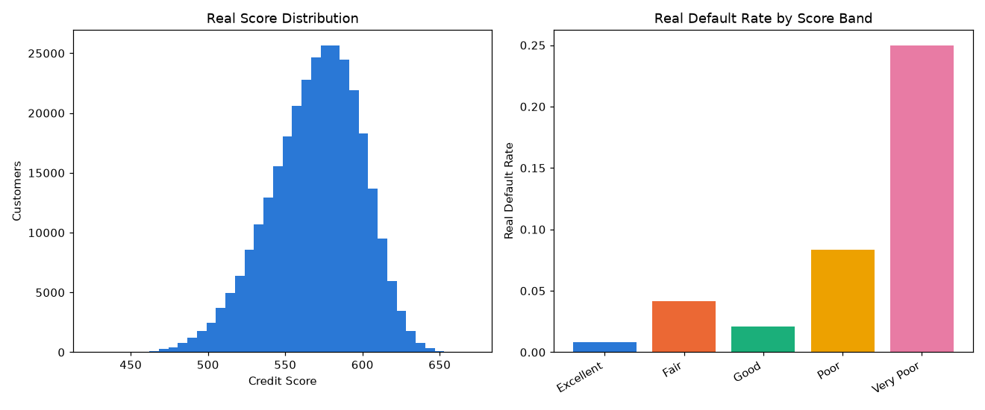
Insight — 'Very Poor' carries the highest real default rate (25.00%, mean score 526); 'Excellent' the lowest (0.80%, mean score 608).
Score-to-default monotonicity holds across all 5 bands (informational — reported, not forced).
Switch the view above to see the same 5 bands by real customer count instead of real default rate.

SHAP Explainability (Upstream Champion Model: LightGBM)
Computed on a real 300-row sample of the scoring population. Top 5 real drivers by mean |SHAP value|: [{'feature': 'EXT_SOURCE_2', 'mean_abs_shap': 0.3333}, {'feature': 'EXT_SOURCE_3', 'mean_abs_shap': 0.2792}, {'feature': 'EXT_SOURCE_1', 'mean_abs_shap': 0.1452}, {'feature': 'ANNUITY_TO_CREDIT_RATIO', 'mean_abs_shap': 0.1251}, {'feature': 'INSTAL_PCT_LATE', 'mean_abs_shap': 0.116}].
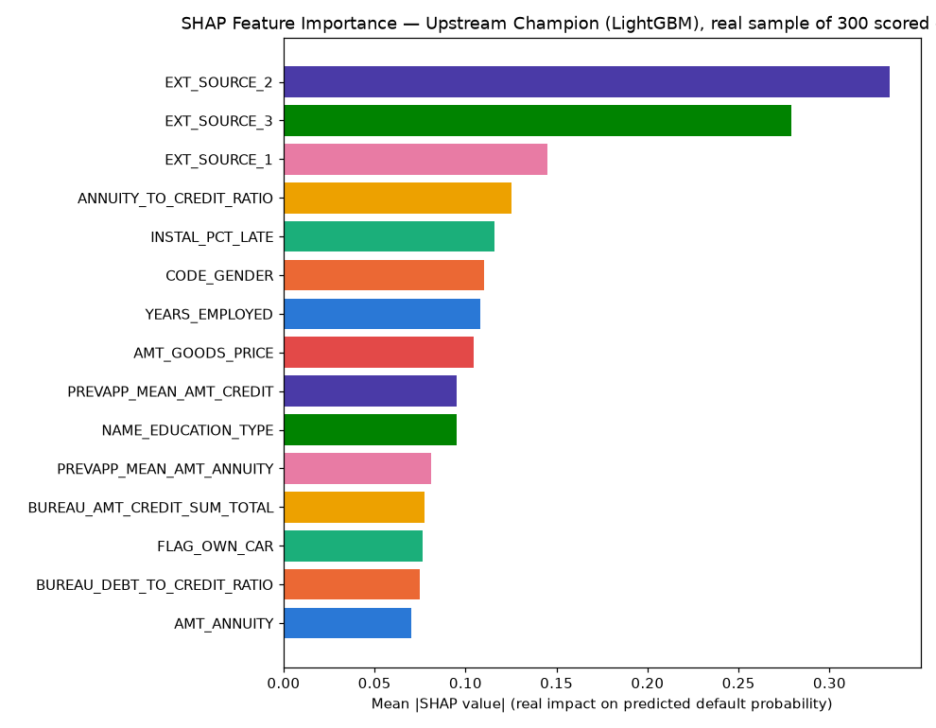
Insight — Real SHAP explainability was computed for Notebook 01's loaded champion model (LightGBM) on a real 300-row sample of this notebook's own scoring population.
The single strongest real driver of predicted default probability is EXT_SOURCE_2 (mean |SHAP| = 0.3333), followed by EXT_SOURCE_3 (mean |SHAP| = 0.2792).
Positive SHAP values push a real customer's predicted default probability (and therefore lower credit score) up; negative values push it down — see the beeswarm detail chart for the real direction of each feature's effect.

LIME Explainability (Upstream Champion Model, representative real scored customers)
Real cases explained: Most-confident correct default flag, Most-confident correct non-default, A real misclassified customer.
Case | Feature Condition | Weight
Most-confident correct default flag | CC_MEAN_UTILIZATION > 0.00 | 0.0618
Most-confident correct default flag | EXT_SOURCE_2 <= 0.39 | 0.0606
Most-confident correct default flag | EXT_SOURCE_3 <= 0.42 | 0.0598
Most-confident correct default flag | BUREAU_DEBT_TO_CREDIT_RATIO > 0.43 | 0.0481
Most-confident correct default flag | POS_MEAN_SK_DPD_DEF <= 0.00 | -0.0316
Most-confident correct default flag | EXT_SOURCE_1 <= 0.51 | 0.0315
Most-confident correct default flag | PREVAPP_MEAN_AMT_ANNUITY > 17828.56 | -0.0219
Most-confident correct default flag | PREVAPP_MEAN_AMT_CREDIT > 207444.60 | 0.0213
Most-confident correct non-default | CC_MEAN_UTILIZATION <= 0.00 | -0.0533
Most-confident correct non-default | EXT_SOURCE_2 > 0.66 | -0.0471
Most-confident correct non-default | POS_MEAN_SK_DPD_DEF <= 0.00 | -0.0414
Most-confident correct non-default | EXT_SOURCE_1 > 0.51 | -0.0359
Most-confident correct non-default | NAME_CONTRACT_TYPE=1 | -0.0258
Most-confident correct non-default | BUREAU_DEBT_TO_CREDIT_RATIO <= 0.00 | -0.0198
Most-confident correct non-default | NAME_EDUCATION_TYPE=1 | -0.0186
Most-confident correct non-default | CODE_GENDER=1 | 0.0184
A real misclassified customer | EXT_SOURCE_2 <= 0.39 | 0.0640
A real misclassified customer | CC_MEAN_UTILIZATION <= 0.00 | -0.0567
A real misclassified customer | POS_MEAN_SK_DPD_DEF <= 0.00 | -0.0430
A real misclassified customer | EXT_SOURCE_1 <= 0.51 | 0.0325
A real misclassified customer | PREVAPP_MEAN_AMT_CREDIT > 207444.60 | 0.0232
A real misclassified customer | BUREAU_DEBT_TO_CREDIT_RATIO <= 0.00 | -0.0221
A real misclassified customer | PREVAPP_MEAN_AMT_ANNUITY > 17828.56 | -0.0215
A real misclassified customer | NAME_CONTRACT_TYPE=0 | 0.0208
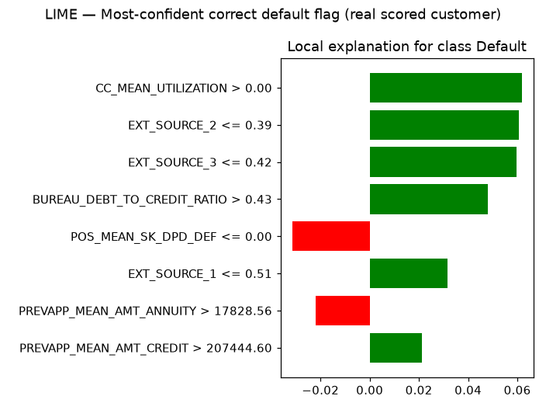
Insight — Real local (instance-level) LIME explanations were computed for 3 representative real scored customers selected from this run's own predictions: Most-confident correct default flag, Most-confident correct non-default, A real misclassified customer.
Unlike SHAP's global feature-importance ranking above, LIME shows exactly which real feature values moved THIS SPECIFIC customer's score — useful for explaining an individual credit-score result to a customer or auditor.
Full per-feature weights for every case are in the LIME Instance Explanations table/sheet below.

Statistical Validation (SOP Stage 4)
Bootstrap 95% CI on score AUC (1000 resamples): [0.8141, 0.8193].
Mean calibration gap across 10 PD deciles: 0.0118 (threshold: <0.1).
Split-half PSI on the SCORE distribution: 0.0000 (threshold: <0.1).
Insight — Mean calibration gap across 10 real PD deciles is 0.0118 (ASSUMPTION threshold: <0.1), so the score is well-calibrated.
Split-half PSI on the real SCORE distribution is 0.0000 (ASSUMPTION threshold: <0.1), indicating a stable score distribution.

Portfolio & Financial Impact (real volume figures + one labeled assumption)
Total real scored portfolio volume (AMT_CREDIT): $184,207,081,472 across 307,511 real customers.
ASSUMPTION (illustrative manual-scoring cost, $3.00/customer): applied only to the automated-scoring count, illustrative cost avoided = $922,533. This is a labeled estimate, not a real observed figure.

Integrity Checks
Check | Result
upstream_model_loaded | PASS
feature_set_matches_upstream | PASS
all_customers_scored | PASS
score_within_declared_range | PASS
no_pd_out_of_bounds | PASS
band_count_correct | PASS
score_auc_above_random | PASS
shap_values_finite | PASS
shap_feature_count_matches | PASS
lime_explanations_computed | PASS
cpu_thread_ceiling_applied_before_import | PASS

