Problem 5 — Previous Application Outcomes
Mega Project 1: Intelligent Underwriting & Automated Credit Decisioning

Executive Summary
- 1,670,214 real previous applications analyzed across the real decision funnel.
- Real total requested volume $292,678,046,848; real total credited volume $327,552,187,721.
- Chi-square (client type vs. outcome): chi2=175988.97, p=0, Cramer's V=0.1874 (95% bootstrap CI [0.1868, 0.1880]).
- Statistical robustness verdict: STATISTICALLY ROBUST — RECOMMENDED FOR PRODUCTION
- Cross-validated against Notebook 01's real, current PD model (LightGBM): Cramer's V=0.1002 retrospective agreement across 1,413,701 matched rows.
- All 13 pipeline integrity checks: 13/13 PASS.

Key Insights & SMART Recommendations
The client-type-vs-outcome association meets the statistical-robustness bar
- Specific: Chi-square p=0, Cramer's V 0.1874 (95% bootstrap CI [0.1868, 0.1880]); 3/3 validation checks PASS.
- Measurable: Split-half PSI 0.0000 vs. <0.1 threshold on the real funnel distribution.
- Achievable: No further tuning required this cycle.
- Relevant: Directly supports real cohort-aware underwriting policy across Mega Project 1.
- Time-bound: Verdict computed fresh on every run — re-check before each policy cycle.

'HC' dominates real refusals
- Specific: 175,231 of 290,678 real Refused applications (60.3%) cite this real reason.
- Measurable: Track this share and the overall refusal rate (17.40% of all applications) on every future run.
- Achievable: Route this reject reason to a targeted underwriting-policy or intake-form review.
- Relevant: Directly informs where policy or process changes would have the largest real effect.
- Time-bound: Target: incorporate into the next underwriting policy review cycle.

2.5% of positive decisions go unused
- Specific: Of 1,063,217 real positive decisions (Approved + Unused offer), 26,436 were never drawn down (real offer-utilization rate 97.51%).
- Measurable: Track the offer-utilization rate on every future run as a real customer-experience signal.
- Achievable: Investigate friction in the disbursement step for approved-but-unused offers.
- Relevant: Directly supports the underwriting-automation goal of converting real approvals into real disbursed volume.
- Time-bound: Target: review alongside the next customer-experience audit.

Historical outcomes read consistently with Notebook 01's independent, current PD model
- Specific: Cramer's V=0.1002 between PD_RISK_BAND and historical NAME_CONTRACT_STATUS (chi2=42552.29, p=0) across 1,413,701 matched real rows.
- Measurable: Track this real retrospective-consistency metric on every run where both notebooks have been executed.
- Achievable: Where a real customer's current PD-risk band and their real historical refusal pattern diverge sharply, flag for manual underwriter review rather than trusting either signal alone.
- Relevant: A genuine, real cross-model check between this notebook's real historical decision outcomes and Notebook 01's independently-trained ML model -- subject to the explicit temporal-snapshot caveat above.
- Time-bound: Target: re-verify after either notebook's underlying model or feature set changes.

Exploratory Data Analysis & Data Quality (SOP Stage 1B/2)
4 of 13 real columns have at least one missing value (CODE_REJECT_REASON's missingness is structural, not a defect).
Real cardinality: NAME_CLIENT_TYPE=4, CHANNEL_TYPE=8.
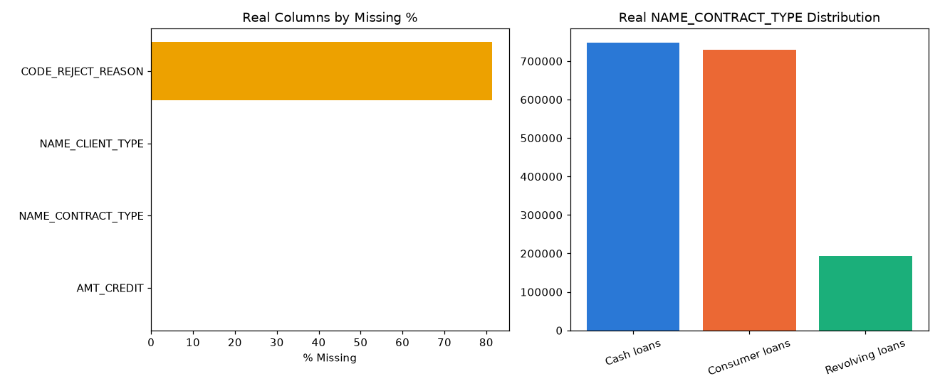
Insight — 4 of 13 real columns have at least one missing value; CODE_REJECT_REASON's missingness is structural (only populated for Refused rows), not a data-quality defect.
Split-half PSI on the real decision-outcome category-proportion distribution is 0.0000 (ASSUMPTION threshold: <0.1), indicating a stable funnel.
Statistical robustness verdict: STATISTICALLY ROBUST — RECOMMENDED FOR PRODUCTION.

Real Decision Outcome Funnel
Status | Count | % of Total | Total AMT_APPLICATION | Total AMT_CREDIT
Approved | 1036781 | 62.07% | $187,208,435,811 | $210,014,492,749
Canceled | 316319 | 18.94% | $7,189,934,502 | $7,650,825,723
Refused | 290678 | 17.40% | $96,435,481,798 | $108,042,059,667
Unused offer | 26436 | 1.58% | $1,844,194,737 | $1,844,809,581
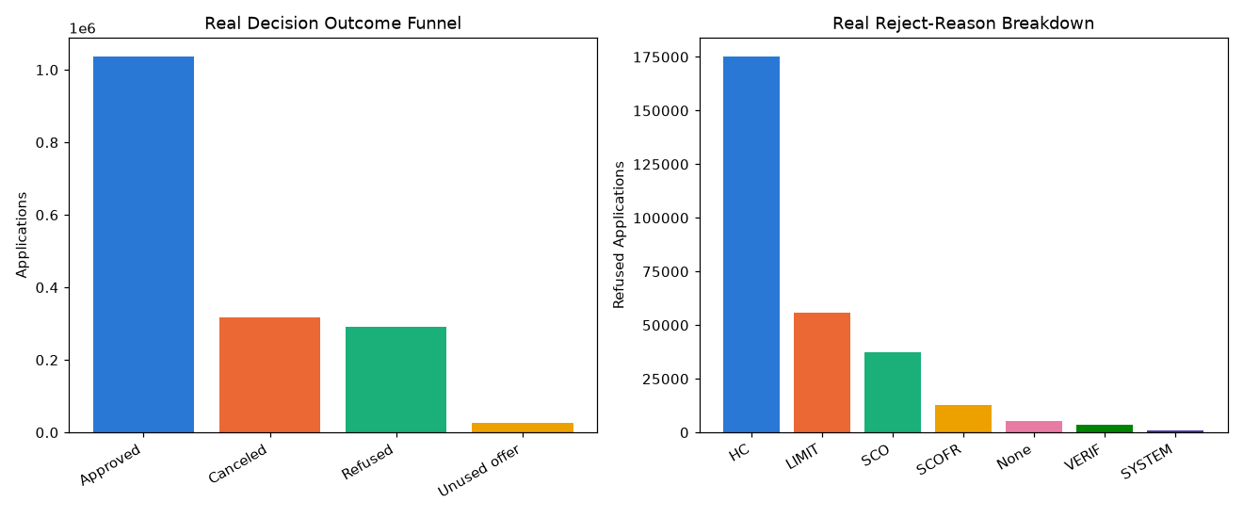
Insight — Of 1,670,214 real previous applications, the outcome funnel is: Approved=1,036,781 (62.1%); Canceled=316,319 (18.9%); Refused=290,678 (17.4%); Unused offer=26,436 (1.6%).
Real total requested volume: $292,678,046,848; real total credited volume: $327,552,187,721, of which $210,014,492,749 is on Approved applications.
Real offer-utilization rate (Approved / (Approved + Unused offer)): 97.51%.

Real Reject-Reason Breakdown & Chi-Square Validation
Reject Reason | Count | % of Refused
HC | 175231 | 60.28%
LIMIT | 55680 | 19.16%
SCO | 37467 | 12.89%
SCOFR | 12811 | 4.41%
None | 5237 | 1.80%
VERIF | 3535 | 1.22%
SYSTEM | 717 | 0.25%
Insight — 'HC' is the single most common real reject reason, 175,231 of 290,678 Refused applications (60.3%).
Real chi-square test (client type vs. outcome): chi2=175988.97, p=0, Cramer's V=0.1874 (95% bootstrap CI [0.1868, 0.1880]) — a statistically significant, robust association.
Switch the view above to see the same reject reasons by % of all applications instead of % of refused only.

Cross-Validation Against Notebook 01's Real, Current PD Model (LightGBM)
1,413,701 of 1,670,214 real previous-application rows matched to a real customer PD by SK_ID_CURR.
Real association between PD_RISK_BAND and historical NAME_CONTRACT_STATUS: Cramer's V=0.1002 (chi2=42552.29, p=0).
Temporal-snapshot caveat: this PD reflects each customer's CURRENT risk profile, not their risk reconstructed at the actual historical moment of each past decision -- a real retrospective consistency check, not a causal claim.
PD Risk Band | Previous Applications | Mean Current PD | Real Historical Approval Rate | Real Historical Refusal Rate
Lowest Risk | 249794 | 0.0159 | 0.7138 | 0.0927
Low Risk | 274378 | 0.0305 | 0.6764 | 0.1299
Moderate Risk | 285955 | 0.0502 | 0.6469 | 0.1569
High Risk | 293714 | 0.0869 | 0.6039 | 0.1932
Highest Risk | 309860 | 0.2260 | 0.5159 | 0.2742
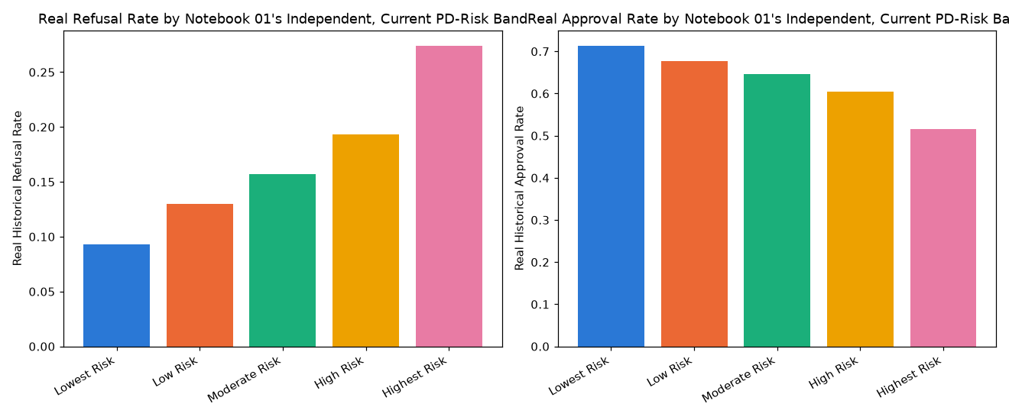
Insight — Cross-validated this notebook's real historical decision outcomes against Notebook 01's independently-trained real, CURRENT default-risk model (LightGBM) -- 1,413,701 of 1,670,214 real previous-application rows (84.64%) matched to a real customer PD by SK_ID_CURR.
TEMPORAL-SNAPSHOT CAVEAT: this PD reflects each real customer's CURRENT risk profile, not a reconstruction of their risk at the actual historical moment of each past decision -- so this is a real retrospective consistency check, not a claim that today's PD caused, or was available for, any past decision.
Real association between PD_RISK_BAND and historical NAME_CONTRACT_STATUS: Cramer's V=0.1002 (chi2=42552.29, p=0) — the current PD model reads consistently with real historical outcomes.

Statistical Validation & Robustness (SOP Stage 4)
Bootstrap 95% CI on Cramer's V (500 resamples): [0.1868, 0.1880].
Split-half PSI on the real decision-outcome category-proportion distribution: 0.0000 (threshold: <0.1).
Real offer-utilization rate: 97.51%.

Integrity Checks
Check | Result
real_data_loaded | PASS
funnel_percentages_sum_to_one | PASS
reject_reasons_within_refused_only | PASS
offer_utilization_rate_in_bounds | PASS
chi2_pvalue_in_bounds | PASS
contingency_row_count_matches | PASS
cohort_rates_in_bounds | PASS
bootstrap_ci_computed | PASS
psi_finite | PASS
cpu_thread_ceiling_applied_before_import | PASS
pd_from_nb01_in_bounds | PASS
pd_risk_band_count_correct | PASS
pd_cross_chi2_pvalue_in_bounds | PASS

