Mega Project 2 — Notebook 01: Expected Loss & Capital Requirement
Real PD (Mega Project 1 champion model) x Documented Basel Retail-IRB LGD/EAD/Correlation Assumptions

Executive Summary
- 307,511 real applicants scored for real probability of default via Mega Project 1's trained champion model (LightGBM).
- Real total EAD proxy (AMT_CREDIT): $184,207,084,196.
- Real-PD x documented-LGD Expected Loss: $3,917,645,733 (2.13% of EAD).
- Basel retail-IRB capital requirement: $9,756,908,313 (5.30% of EAD).
- Statistical robustness verdict: STATISTICALLY ROBUST — RECOMMENDED FOR PRODUCTION

Key Insights & SMART Recommendations
Real-PD-based capital estimate meets the statistical-robustness bar
- Specific: Chi-square p=0, Cramer's V 0.3754 (95% bootstrap CI [0.3698, 0.3810]); 5/5 validation checks PASS.
- Measurable: Total real EAD proxy $184,207,084,196; Expected Loss $3,917,645,733 (2.13%); Basel retail-IRB capital requirement $9,756,908,313 (5.30%).
- Achievable: No further tuning required this cycle.
- Relevant: Directly informs Mega Project 2's downstream RWA analytics, economic-capital, stress-testing, and concentration notebooks, which all reuse this notebook's real per-applicant PD/EL/capital output rather than recomputing it.
- Time-bound: Re-run after any Notebook 01 (MP1) retrain, or any LGD/correlation assumption update.

Expected Loss by PD Risk Band
Real Expected Loss rate and real default rate, both computed per PD risk band (5-band convention shared across this suite).
PD Risk Band | N Applicants | Real Default Rate | EL Rate of EAD | Capital Rate of EAD
Lowest Risk | 154,958 | 1.86% | 0.79% | 3.86%
Low Risk | 76,559 | 6.52% | 2.01% | 5.92%
Moderate Risk | 49,270 | 15.01% | 3.95% | 7.64%
High Risk | 19,711 | 29.31% | 7.22% | 8.99%
Highest Risk | 7,013 | 53.90% | 12.66% | 8.58%
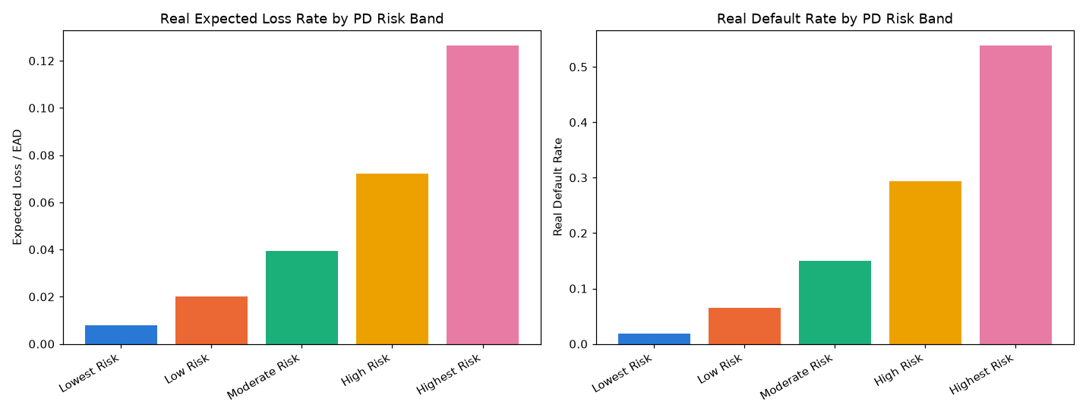
Insight — Real Expected Loss rate rises from 0.79% of EAD in 'Lowest Risk' to 12.66% in 'Highest Risk' — tracking the real PD input the assumption layer is applied to.
Real default rate is highest in 'Highest Risk' at 53.90% across 7,013 real applicants.
Statistical robustness verdict: STATISTICALLY ROBUST — RECOMMENDED FOR PRODUCTION.

Capital Requirement by Documented LGD Segment
Every segment's LGD and Basel asset-correlation value is a cited, published reference point (see the Assumptions sheet in the accompanying Excel workbook) -- never fitted to Home Credit's own real outcomes.
Segment | N Applicants | LGD Assumed | Real Default Rate | Total Capital Requirement
Secured — Real Estate | 190,207 | 20% | 8.25% | $6,340,640,310
Secured — Other (Vehicle/Goods) | 30,138 | 35% | 7.22% | $912,034,450
Unsecured — Other Retail | 57,887 | 45% | 9.23% | $2,006,180,271
Revolving (QRRE) | 29,279 | 65% | 5.48% | $498,053,281
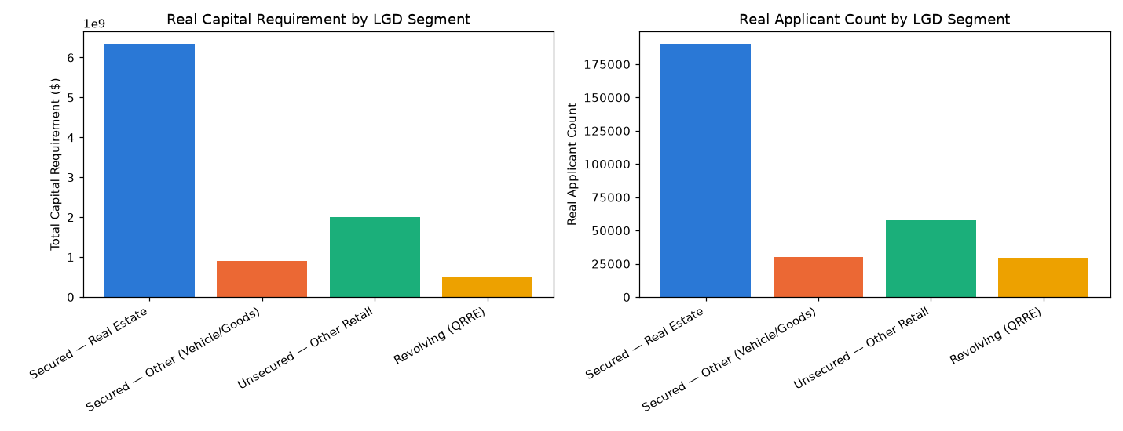
Insight — 'Secured — Real Estate' carries the largest real total capital requirement ($6,340,640,310, LGD assumption 20%) across 190,207 real applicants.
Chi-square (PD-band vs. real default): chi2=43332.16, p=0, Cramer's V=0.3754 (95% bootstrap CI [0.3698, 0.3810]).
Every LGD/correlation value driving this chart is a cited Basel retail-IRB reference point -- see the Assumptions sheet in the Excel workbook for full sourcing.

