Mega Project 2 — Notebook 02: Basel RWA Portfolio Analytics
Real per-applicant RWA (Notebook 01), analyzed across real portfolio segment cuts

Executive Summary
- 307,511 real applicants (Notebook 01's output, reused not recomputed).
- Real portfolio RWA density: 66.21%.
- Highest real RWA density segment: NAME_INCOME_TYPE=Unemployed (90.22%).
- Statistical robustness verdict: STATISTICALLY ROBUST — RECOMMENDED FOR PRODUCTION

Key Insights & SMART Recommendations
Portfolio RWA density meets the statistical-robustness bar
- Specific: Chi-square p=0, Cramer's V 0.3754 (95% bootstrap CI [0.3698, 0.3810]); 3/3 validation checks PASS.
- Measurable: Portfolio RWA density 66.21%; highest-density segment NAME_INCOME_TYPE=Unemployed (90.22%).
- Achievable: No further tuning required this cycle.
- Relevant: Identifies which real portfolio segments concentrate capital demand -- informs Problem 5 (Capital Concentration by Segment).
- Time-bound: Re-run after any Notebook 01 (MP2) re-run or LGD/correlation assumption update.

RWA Density by PD Risk Band
Real RWA density and real default rate per PD risk band.
PD Risk Band | N Applicants | Real Default Rate | RWA Density
Lowest Risk | 154,958 | 1.86% | 48.31%
Low Risk | 76,559 | 6.52% | 74.05%
Moderate Risk | 49,270 | 15.01% | 95.55%
High Risk | 19,711 | 29.31% | 112.35%
Highest Risk | 7,013 | 53.90% | 107.23%
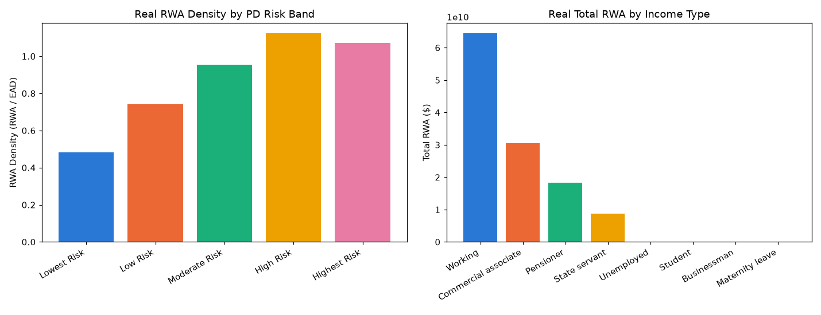
Insight — Real RWA density rises from 48.31% in 'Lowest Risk' to 107.23% in 'Highest Risk' -- higher-PD bands carry a higher capital charge by construction of the Basel K() formula (Notebook 01).
Portfolio-wide real RWA density: 66.21% ($121,961,353,912 RWA / $184,207,084,196 EAD).
Statistical robustness verdict: STATISTICALLY ROBUST — RECOMMENDED FOR PRODUCTION.

Top Segments by Total RWA
Real total RWA, RWA density, and default rate across every segment cut (income type, education, contract type, region rating).
Dimension | Segment | N Applicants | Total RWA | RWA Density
NAME_CONTRACT_TYPE | Cash loans | 278,232 | $115,735,687,895 | 66.24%
REGION_RATING_CLIENT | 2 | 226,984 | $87,786,179,260 | 66.50%
NAME_EDUCATION_TYPE | Secondary / secondary special | 218,391 | $87,103,856,440 | 69.83%
NAME_INCOME_TYPE | Working | 158,774 | $64,446,300,841 | 70.35%
NAME_INCOME_TYPE | Commercial associate | 71,617 | $30,526,225,212 | 63.63%
NAME_EDUCATION_TYPE | Higher education | 74,863 | $29,384,937,404 | 56.89%
REGION_RATING_CLIENT | 3 | 48,330 | $20,765,705,661 | 74.91%
NAME_INCOME_TYPE | Pensioner | 55,362 | $18,262,894,490 | 60.80%
REGION_RATING_CLIENT | 1 | 32,197 | $13,409,468,990 | 54.80%
NAME_INCOME_TYPE | State servant | 21,703 | $8,698,900,534 | 59.84%
Insight — 'Cash loans' (NAME_CONTRACT_TYPE) carries the largest real total RWA ($115,735,687,895) across 278,232 real applicants.
'Unemployed' (NAME_INCOME_TYPE) shows the highest real RWA density (90.22%) -- a capital-efficiency signal, not necessarily the largest dollar exposure.

